

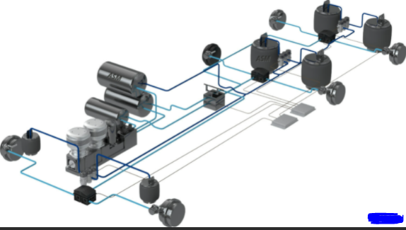
RQF LEVEL : 5

TRADE: AUTOMOTIVE TRANSMISSION AND CONTROL SYSTEM TECHNOLOGY

Module name: MAINTAIN PNEUMATIC SYSTEM

MODULE CODE: ATCPM501
TEACHER’S GUIDE

Table of content
Contents
Table of content 2
Acronyms 4
Introduction 5
Learning Unit 1: Describe pneumatic system 2
Learning outcome 1.1. Describe air properties 3
Learning outcome objectives : 3
Indicative content 1.1: Describe air propities 4
1.2: Composition of air 6
1.3: Properties of air 6
Indicative content 1.2: Differentiate Pneumatic Circuits 9
Indicative content 1.3: Describe Hydro-pneumatic Circuits 14
Learning Outcome 1. 4 : Describe pneumatic system components 27
Theoretical learning Activity 28
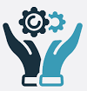Practical learning Activity 28
Learning Units 2. Dismount pneumatic system components 29
Learning outcome objectives : 30
Indicative content 2.1: Select materials, tools and Equipment’s 31
Learning Outcomes : 2.2 : Clean and dismount pneumatic system components 36
Indicative content 2.3: Dismount pneumatic system components 37
Indicative content. 2. 3 : Inspect pneumatic system components 38
Theoretical learning Activity 39
Practical learning Activity 39
Learning Unit 3: Maintain pneumatic system circuit 40
Learning outcome objectives : 40
Indicative content 3.1: Select materials, tools and Equipments 42
Indicative content 3.2 : Clean and drain periodically pneumatic System circuit 42
Indicative content 3.3 : Replace and grease pneumatic system components 43
Theoretical learning Activity 44
Practical learning Activity 44
Learning Unit 4. Remount pneumatic system components and test pneumatic system 45
Learning outcome objectives : 45
Indicative content 4.1 : Select materials, tools and Equipments 47
Indicative content : 4.2. Remount pneumatic system components 48
Indicative content 4.3: Test pneumatic system 48
Theoretical learning Activity 49
Practical learning Activity 50
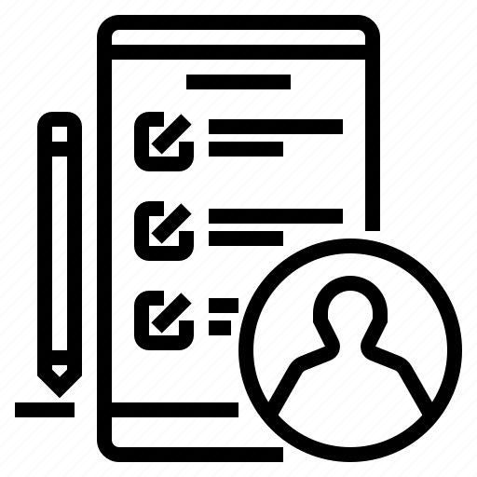Learning outcome 1 formative assessment 50
References: 57

Acronyms
ATC: Automotive transmission and control system technology
RQF: Rwanda qualifications framework
DIN: Deutsches Institut fur Normung E.V
IC: Indicative Content
P: Pressure
T: Temperature
V: Volume

Introduction

A pneumatic system is a type of mechanical system that uses compressed air to transmit and control power. Pneumatic systems are widely used in various industrial applications, such as manufacturing, assembly lines, and transportation. Maintaining a pneumatic system is critical to ensure its longevity and smooth operation.

The following steps can be taken to maintain a pneumatic system:

1. Regular inspection: Regular inspection of the pneumatic system is essential for identifying any potential issues. Inspect the system for leaks, damaged hoses or fittings, and worn-out components.

2. Lubrication: Proper lubrication of the system's moving parts is essential to prevent wear and tear. Lubricate the system's components regularly to ensure smooth operation.

3. Filter maintenance: The pneumatic system's filters need to be checked regularly and replaced when necessary to ensure that the compressed air is clean and free of contaminants.

4. Pressure regulation: Ensure that the system's pressure is regulated to prevent over pressurization, which can cause damage to the system.

5. Component replacement: Replace any worn-out or damaged components promptly to prevent further damage to the system.

6. Proper usage: Proper usage of the pneumatic system is essential to prevent damage. Ensure that the system is used correctly and not overloaded beyond its capacity.

In summary, maintaining a pneumatic system requires regular inspection, lubrication, filter maintenance, pressure regulation, component replacement, and proper usage. By following these steps, you can ensure that the pneumatic system functions smoothly and efficiently.

Module Code and Title: ATCPM501 MAINTAIN PNEUMATIC SYSTEM

Learning Units:
1. Describe pneumatic system
2. Dismount pneumatic system components
3. Maintain pneumatic system circuit
4. Remount pneumatic system components and test pneumatic system
2
3
n
1
2
3
n

Learning Unit 1: Describe pneumatic system

Picture/s reflecting the Learning unit 1

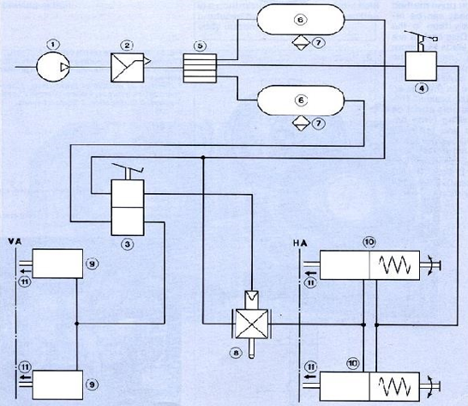

Learning outcomes:
1.1. Describe air properties
1.2. Differentiate pneumatic circuit
1.3. Describe Hydro-pneumatic system circuits
1.4. Describe pneumatic system component

Learning outcome 1.1. Describe air properties

Duration: 10hrs

Learning outcome objectives :
By the end of the learning outcome, the trainees will be able to:
- Define pneumatic system
- Describe Composition of air
- Describe Properties of air
- Application of pneumatic system

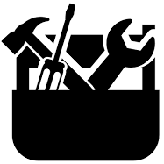Resources
Equipment | Tools | Materials
- PPE  - Hydraulic Jack  - jack stand  - Wheel rock  - Service pit | - Spanners  - Screw drivers  - Hummers  - Pliers  - Brushes | - Grease.  - Sand papers  - Seals  - Gasket  - Water  - Powder soap  - Liquid soap  - Rugs
Advance preparation:
PPE and workplace must be well cleaned
Vehicle equipped with pneumatic system
you must have Hydraulic Jack, jack stand, Wheel rock, Sand papers, Water, Powder soap, Liquid soap, Rugs.




Indicative content 1.1: Describe air propities

INTRODUCTION
The term “pneumatics” has been derived from the Greek word “pneuma” which means air, wind, or breath.
- Definition: the pneumatic may be defined as that branch of engineering science which deals with the study of the behaviour and application of compressed air.
- Like hydraulics, pneumatic is a branch of fluid power technology. Thus, the pneumatic is the technology that deals with the generation, control, and transmission of power using pressurized air.
    - pneumatic systems
- Pneumatic system is the one that uses a pressurized gas to transmit and control power.
- However, almost all pneumatic systems prefer to use air rather than some other gas as their fluid medium.
- The air is popularly used as the fluid medium in pneumatic system due to the following reasons:
- Air is abundantly available.
- It is safe to use (as it has the fire-proof characteristics)
- It is very cheaper in cost
- Easier maintenance and easy handling.
- It can be exhausted easily to the atmosphere after use.
Advantage of pneumatic system over hydraulic systems
(What are the reasons for considering the use of pneumatic system instead of hydraulic system)
In many applications, the pneumatic systems are preferred over the hydraulic systems, due to the following reasons:
- Since the weight density of gas is many times lesser than liquid, therefore inertia effect of pneumatic components are lesser than hydraulic system components. Thus, the force required to accelerate gas (air) is much lesser than that required to accelerate an equal volume of oil.
- Since viscosity of air is much lesser than that of oil, therefore the pneumatic systems experience lesser friction pressure and power losses than the hydraulic systems.
- Unlike in hydraulic systems, pneumatic systems can be exhausted its fluid medium (air) to the atmosphere after completing its assigned task. This reduces the requirements of special designs for reservoirs and leak-proof systems.
- Pneumatic systems are comparatively cheaper in cost than the hydraulic systems.
- Pneumatic systems provide better operation advantages when compared to hydraulic systems.
- Compared to hydraulic systems, pneumatic are lesser in weight.
- Unlike in hydraulic systems, leakage of air in pneumatic system will not affect the system performance very much (because the air compressor supplies the pressurized air continuously).
Disadvantages of pneumatic systems

The main disadvantages of pneumatic system are given below:
- Due to the high compressibility of air, pneumatic systems cannot provide precise actuator control and precise positioning control.
- Due to compressor design limitations, pneumatic systems can be applied only to low pressure (less than 17bars) applications; whereas hydraulic systems can be applied to high-pressure (up to 700bars) applications.
    - Application of pneumatic system
Like hydraulic systems, the application of pneumatic systems can be found in almost all industries/fields. However, some of the industrial applications are listed below:
- Stamping
- Drilling
- Punching
- Clamping
- Hoisting
- Assembling
- Riveting
- Material handling
- Logic control and
- Hammering
    - Selection of hydraulic pneumatic system
For a Given application, there is no and fast rule to follow to decide which of the system should be used. However, the following guidelines may be followed for the selection:
- If the application requires a very high pressure or extremely accurate feed, then an oil hydraulic system can be used.
- If the application requires speed, a medium of pressure, and only a fairly accurate feed, then an air pneumatic system can be used.
- If the application requires only a medium amount of pressure and a feed of great accuracy, then a combination of air and hydraulic system can be used.

1.2: Composition of air

What is the composition of air?
- Actually, speaking air is a mixture of gases. Air is invisible, colorless, and tasteless
- Composition: the main constituents of air by volume are 78% of nitrogen, 21% of oxygen and 1% other gases such argon and carbon dioxide.
- The gaseous layer of air around the earth is known as Atmosphere

1.3: Properties of air
- Compressibility: this is the quality of being compressible or the property of being able to occupy less space.
- Expansibility: the capacity of being expanded or to increase in size or bulk
- Invisibility: the state or the quality of being invisible or the quality of not being perceivable by the eyes
- No odor
- Takes up spaces
- No color
- Impacted by temperature
- Tasteless

Pressure Relationship
- Atmospheric pressure: the air surrounding the earth exerts a pressure on the earth’s surface. The pressure prevailing directly on the earth’s surface is known as atmospheric pressure.
- The atmospheric pressure is also referred to as reference pressure. Normally it considers the sea level as its reference point.
- The atmospheric pressure may be calculated from the fundamental principle of barometer which states that the barometer reads the pressure due to the height of mercury (Hg) in the tube and it weight.

1.Atmospheric pressure = pgh
Where p: Density of Hg =13600kg/m³
g: Acceleration due to gravity= 9.81m/s², and
h: Height of Hg column =760mmof Hg at normal sea level.
Substituting the above values in equation, we get
Atmospheric pressure= 13600x9.81x0.76 = 101396N/m² =1.013bar
But for easy and simple calculation, we take the atmospheric pressure as 1 bar.
- Gauge Pressure
If the pressure is measured with reference of the atmospheric pressure, then it called gauge pressure
It is the pressure, measured with the help of pressure measuring instrument, in which the atmospheric pressure is taken as datum. The atmospheric pressure on the scale is marked as zero.
Gauge pressure measure is universally used in most of the hydraulic and pneumatic systems.
The pressure of the liquid may be above or below the atmospheric pressure. If it is below the atmospheric pressure, then the gauge is designated as “vacuum gauge” and the pressure is known as “vacuum pressure” the vacuum (i.e., negative) pressure indicates the amount by which the pressure of the liquid is below the atmospheric pressure.
- Absolute pressure
Any pressure measured above the absolute zero pressure is termed as an “absolute pressure”. In other words, the pressure measured with respect to vacuum is called an “absolute pressure”.
Absolute pressure is important in the comparison of the compression of gases.
- Differential Pressure
Some pressure transduces or transmitters measure the pressure difference between the two parts and it is known as differential pressure.
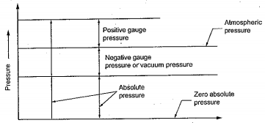
Figure: Pressure Relationship
It can be stated that,
Absolute pressure = Gauge pressure + Atmospheric pressure
Vacuum pressure = Atmospheric pressure – Absolute pressure

Example1.1: a mercury manometer connected to a tank containing gas indicates a gauge pressure of 138mmHg. If the barometer reads 752 mmHg, determine the absolute pressure inside the tank.
Answer: Absolute pressure inside the tank = Gauge pressure + Atmospheric pressure
= 138+752 = 890 mmHg
Absolute pressure = 890 mmHg
Example1.2: A bourdon pressure gauge indicates a pressure of 500kPa. Determine the absolute pressure in kPa, if the barometer shows an Atmospheric pressure of 985mbar.
Answer: Atmospheric pressure = 985mbar
= 0.985bar
= 98.5 kPa (since 1 bar = 100kPa)
Absolute pressure = Gauge pressure + Atmospheric pressure
= 500+98.5
= 598.5kPa
Absolute pressure = 598.5kPa
Perfect Gas Laws
1. Boyle’s Laws
Boyle’s law states that if temperature remains constant, the pressure of a confined mass of gas will vary inversely with its volume.
Mathematically, P & 1/V when T = constant or PV = constant
P1V1 = P2V2 = P3V3 = ……PnVn
2. Charles ‘Law
Charles’ law states that pressure remaining constant, the volume of a given mass of gas will vary directly as its absolute temperature.
Mathematically, V&T when P= constant or V/T = constant
V1/T1 = V2/T2 = V3/T3 =…………...Vn/Tn
3. Gay-Lussac’s Law
Gay-Lussac’s law states that volume remaining constant, the pressure of a confined mass of gas will vary directly as its absolute temperature.
Mathematically, P& T when V= constant or P/T = constant
P1/T1=P2/T2=P3/T3=……………. Pn/Tn

4. General Gas Law
Boyle’s, Charles’, and Gay-Lussac’s law can be combined to obtain the general gas law and is given by,
PV/T = constant
P1V1/T1 = P2V2/T2 = P3V3/T3 =……….. PnVn/Tn

Indicative content 1.2: Differentiate Pneumatic Circuits

Brake system
There are many important things on a commercial vehicle. One of the most important is the brake system.
Function of brake system
1. It has to reduce the speed of the vehicle or
2. It has to keep the speed of the vehicle constant on downhill gradient.
3. It has to bring the vehicle stop and keep it stopped even on a slope when the driver is not there.
There is various compressed-air brake system depend depending on the type and size of the vehicle: for trucks, buses and special vehicles. This booklet informs you of the construction and operation of seven commonly found compressed-air brake systems.
Basic components of a brake system
Every brake system can be broken down into four basic components:
• Energy supply
• Control
• Transmission
• Brake
The control controls the flow of energy from the energy supply through the transmission to the brake which acts on the wheels.
Energy Supply
The source of energy supplies the energy required for braking. Devices for regulating, conditioning and where necessary, storing the energy are also counted as part of the energy supply in so far as they do not belong to the transmission. The most important types of braking energy are pneumatic, hydraulic and mechanical energy as well as the muscle power of the driver. The braking equipment of commercial vehicles may be based exclusively on compressed air or may also be operated by several types of energy, for example in truck with a compressed air service brake and secondary braking system and a muscle-power- operated parking brake system.
Control
The control comprises those parts of a brake system which control the operation of the system. The control ends where the transmission of the braking energy begins. In compressed-air brake systems the control is triggered either by the driver by means of brake pedal or hand brake level, or automatically e.g. if the trailer breaks away.
Transmission
The transmission includes all those parts of brake system which the energy is transmitted to the brake lever and ends at the wheel brake circuits including the protection of these brake circuits is considered as part of the transmission.
Brake
the brake is that part of the brake system which produces the forces the forces which oppose the motion of the vehicle or its tendency to move. These braking forces convert the kinetic energy of the vehicle into heat.
Brake can be broken down into friction brakes and retarders.
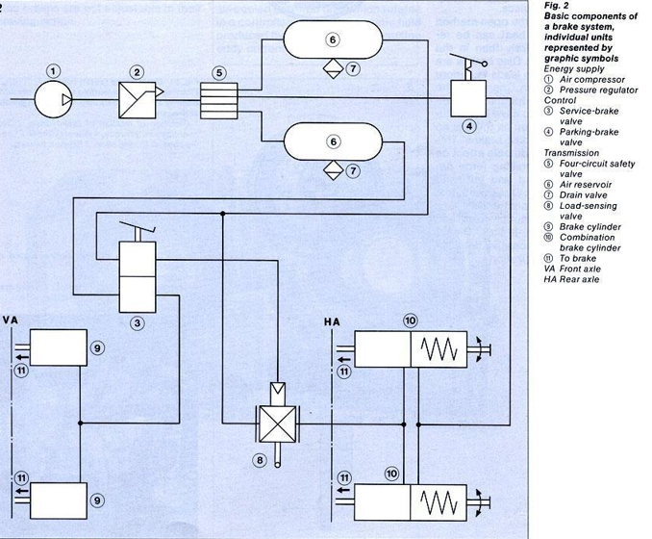
Classification of brake system
brake systems can be classified according to four features:
- purpose
- type of energy used
- type of transmission
- number of connecting lines in vehicle combinations
- Brake systems classified according to purpose
Legal requirements dictate that the three functions of the braking equipment mentioned in the introduction be distributed over three brake systems:
- Service brake system
- Secondary braking system
- Parking brake system
- Service brake system
The service brake system (foot brake) can be used firstly, to reduce the speed of the vehicle or to keep the speed constant on a downhill gradient. Secondly, it can be used to bring the vehicle to a stop. This system is used in normal vehicle operation. It can be stepless foot-operated and acts on all wheels.
- Secondary braking system
If the service brake system fails, the secondary braking system must assume both these functions with reduced effect. The secondary braking system need not be an independent third brake system (in addition to the service brake and parking brake systems) having a special control, but may be either the intact brake circuit of a dual-circuit service-brake system or a variable parking-brake system.
- Parking brake system
The parking brake system (hand brake, parking brake) fulfils the third function of the braking equipment. It must hold the vehicle stationary, even on a slope and when the driver is not there.
For safety reasons, the parking brake system must be fully effective even if there is a failure in the pneumatic or hydraulic energy. For this reason, there must be a continuous mechanical connection between energy supply and wheel brake e.g. by means of a linkage or cable between hand brake lever and wheel brake or by means of a spring brake cylinders which are mechanical connected to the wheel brake.
The parking brake system on the tractor vehicle is operated from the driver’s seat, usually by means of hand brake lever, and the trailer by means of a hand brake lever mounted on the trailer. It acts on the wheels of one axle there are variable and non-variable parking brake system.
- Brake systems classified according to type energy used
Depending on whether a brake system is operated totally, partially or not at all by muscle power, a distinction is made between
- Muscle-power brake systems
- Power-assisted brake systems
- Power brake system

- Muscle-power brake system
With this system found in passenger cars and lightweight commercial vehicles the muscle power applied to the foot pedal or hand brake lever is transmitted mechanically (by means of linkage or cable) or hydraulically to the brakes.
- Power-assisted brake system
This system is installed in installed in passenger cars and lightweight to medium- weight commercial vehicles. The muscle power of the driver is boosted in the brake servo-unit cylinder by an auxiliary force generated by compressed air vacuum or hydraulic fluid. Transmission to the wheel brakes may be either mechanical or hydraulic. Owing to the continuous connection between the control and the brake the vehicle can still be braked by muscle power should the auxiliary force fail, albeit with reduced braking action or with greater expenditure of effort.
- Power-brake system
Heavy commercial vehicles are equipped with a power-brake system. The vehicle is braked exclusively by an external force generated by compressed air, vacuum or hydraulic fluid the muscle power of the driver serves only to control the system and cannot generate any brake force should there be a total energy failure.
Brake systems (service-brake systems) classified according to type of transmission
Single circuit brake system: in the simplest case the braking energy is transmitted to all brakes through one single transmission usually referred to as brake circuit. We then speak of a single-circuit brake system. If a defect occurs on such a brake system the entire system is then inoperative.
Dual-circuit brake system: for increased safety, the transmission of the service-brake system is of dual-circuit design. In commercial vehicles the front axle and real axle brake cylinders are usually each controlled by an independent brake circuit. If there is a failure in one of the two brake circuits in a dual-circuit service brake system, the other intact brake circuit remains in operation. Providing it has sufficient effect, the remaining circuit can serve as a secondary braking system.
Brake system in vehicle combinations
In vehicle combinations (tractor vehicle with trailer or semitrailer) the tractor vehicle has an additional device for the energy supply and control of the trailer braking equipment. This is because the tractor vehicle has to transmit the braking energy and control forces to the brakes of the vehicle being towed. Transmission takes place between tractor and trailer by means of a single line in the cases of single-line systems, and by two or more lines in multi-line (e.g. dual line) systems.
Single line brake system: in single line brake systems one line fills the energy storage device (air compressor) in the trailer i.e. supplies it with braking energy and controls the trailer brakes by way of the trailer brake valve which operated by pressure drop. The disadvantage of single line brake systems is that no supply air can flow to the trailer during braking. Constant braking on long downhill gradients can exhaust the supply of compressed air in the trailer air reservoir.
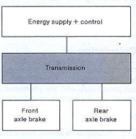
Figure: single circuit brake system

Dual line brake system: in dual line brake systems both parts of a vehicle combination are connected by two lines. One supply line and one brake line which works on the principle of a rise in pressure. Since compressed air can continuously flow through the supply line to refill the trailer air reservoir, the trailer brake system can never be exhausted, usually the coupling heads of both lines are such that the supply and brake lines cannot be connected the wrong way round. If the trailer breaks away from the tractor the resulting pressure drop in the supply line causes the trailer to brake.
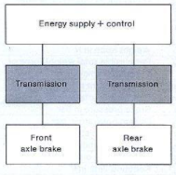
Figure: dual circuit brake system

Indicative content 1.3: Describe Hydro-pneumatic Circuits

This section describes the application, construction and operation principle of seven compressed-air brake systems. There is a constant expansion in the scope of equipment used where by each subsequent system description is based on the description of the preceding brake systems. Each brake system is composed of equipment groups which are put together using the “building block” principle.
- Equipment group A:
Compressed-air supply (generating and storing of compressed air)
- Equipment group B:
Service brake system
- Equipment group C:
Parking brake system
- Equipment group D:
Trailer control
- Equipment group E:
pneumatic suspension
- Equipment group F:
Door control
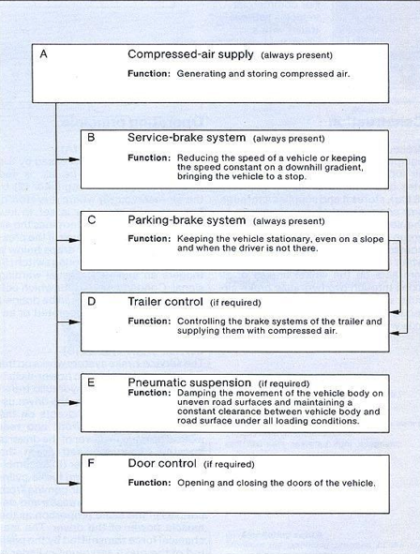
Equipment groups A to C represent the “basic equipment” and are to be found in every compressed-air brake system. Other equipment groups are only encountered if the vehicle is equipped for towing a trailer, if it has pneumatic suspension or if the doors are operated pneumatically. The individual units are represented in the diagrams of the seven compressed-air brake systems by graphic symbols according to DIN 74253.
The identification of connections used in conjunction with the graphic symbols are accordance with DIN 74254 whereby the first digits signify:
0 Intake connection
1 Energy input
2 Energy output (not for output into the atmosphere: see identification 3)
3 Connection to atmosphere
4 Control connection (inlet on equipment)
5 Unoccupied
6 Unoccupied
7 Antifreeze connection
8 Lubricating-oil connection
9 Coolant connection
A second digit is to be provided if there are several similar connections, e.g.
21 Energy output to energy-storage device (compressed-air reservoir)
22 Energy output (switching connection)
If one connection can fulfil several functions, it must be identified by two (first) digits. These are to be separated from each other by means of a dash,
e.g. 1- 2 Either energy input or energy output
The graphic symbols according to DIN 74253 are also used for the lines and connections between the individual units:
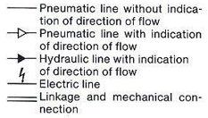
Not all the brake systems described in the following are based exclusively on compressed air. As is common practice, the brake systems of light-weight solo vehicles (commercial vehicle not equipped for towing a trailer) as well as trailer brake systems may incorporate hydraulic or mechanical controls and transmissions.
1.3.1. Description of: single circuit, power assisted compressed-air brake system (low pressure) with mechanical parking brake
For commercial vehicles without trailer with a gross vehicle weight up to approx. 5 tonnes
Construction
Brake system 1 is composed of three equipment groups. The compressed-air brake supply (equipment group A) generates compressed air at low pressure (8bar), stores it and supplies it through one compressed-air supply circuit to the service brake system (equipment group B) where the compressed air boosts the muscle power of the driver when braking. The service-brake system acts on the wheel brakes of all axles through two hydraulic brake circuits while the parking-brake system (equipment group C) acts on the rear axle wheel brakes through a linkage.
Operating principle
Compressed air supply (A)
Air is drawn in and compressed by the air compressor (1) the air is fed through the pressure regulator (2) to the air reservoir (3) where it is stored. the pressure regulator is set to low pressure (8 bar) and determines the air pressure in the reservoir. If the pressure in the air reservoir drops below a set minimum, the monitoring switch (5) triggers an audible or visual warning signal. Condensation water which collects in the air reservoir can be drained through the manually-operated or automatic drain valve (4).
Service brake system B
The service-brake system works on the principle of pneumatic power-assisted brake system with hydraulic transmission. It is operated by the drive using the brake pedal and acts on the wheel brakes of the front and rear axles. The muscle power of the driver is boosted by compressed air in the brake servo-unit cylinder (6), a combination of the brake valve and brake cylinder. The compressed air coming from the air reservoir (3) increases and decreases in the same proportion as the muscle power of the driver. The mechanical force transmitted by the push rod of the brake servo-on tandem master cylinder (7) and is transmitted to the wheel cylinders (8) of the front and rear axles through hydraulic brake circuits.
Secondary braking system
If there is a failure in the compressed air supply circuit or in one of the hydraulic brake circuits, the service-brake system acts as a secondary braking system. On the principle of a muscle-power brake system in the event of a compressed-air failure. The muscle power of the driver is then boosted by compressed air, but this together with the action of the intact hydraulic brake circuit are sufficient to achieve the minimum retardation required of a secondary braking system.
In contrast to brake system 2 to 6 which are intended for heavier vehicles, it is sufficient in this case to have one compressed-air supply circuit in order to be able to use the service-brake system as a secondary braking system.
Parking-brake system (C)
The parking-brake system works on the principle of a muscle-power brake system. It is operated by the driver using the hand brake lever (9) and acts through a linkage on the rear axle wheel brakes.
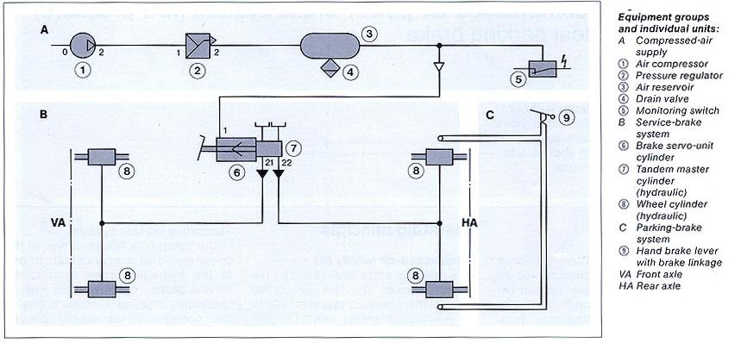

Function of each component
- Air compressor: generates compressed air by drawing in the air and compressing it.
- Pressure regulator: regulates the operating pressure of the compressed-air brake system.
- Air reservoir: stores the energy necessary for braking
- Drain valve: is used for draining condensation water from the compressed-air brake system
Left: manually operated, right: automatic
- Monitoring switch: monitors the operating pressure of the compressed-air brake system.
- Brake servo-unit cylinder: boosts the muscle power of the driver when braking (installation: exhaust at bottom)
- Tandem master cylinder (hydraulic): converts mechanical force into hydraulic force for two brake circuits.
- Wheel cylinder (hydraulic): produces the actuating force in drum brakes

1.3.2: Dual-circuit, compressed-air power system (low pressure) with mechanical parking brake
For commercial vehicles without trailer with gross vehicle weight from approx. 6 to 9 tonnes
As in air brake system 1 there are three equipment groups: compressed-air supply(A), service-brake system (B) and parking brake system (C). there are the following differences from brake circuit 1:
- Two compressed-air supply circuits (instead of one compressed-air supply circuit)
- Dual-circuit safety valve (additional)
- Low- pressure indicator (instead of monitoring switch)
- Dual-circuit brake assembly (instead of brake servo-unit cylinder)
Operating principle

Compressed-air supply (A)

Air is drawn in and compressed by the air compressed by the air compressor (1). The air is fed through the pressure regulator (2) to the dual-circuit safety valve (3). The pressure regulator is set to low pressure (8 bar) and determines the air pressure in the air reservoir (4) the dual-circuit safety valve distributes the compressed air coming from the pressure regulator to two compressed-air supply circuits 21 and 22 and ensures that if one of the supply circuits fails the compressed-air supply to the other undamaged circuit is maintained.
From the dual-circuit safety valve the compressed air flows to the two-air reservoir (4) where it is stored. If the pressure drops below a set minimum the low-pressure indicator (6) provides the driver with a visual warning signal by swinging a large, easily visible pointer into his field of vision.
Condensation water which collects in the air reservoir can be drained through the manually-operated or automatic drain valves (5).

Service-brake system (B)

The service brake system works on the principle of a pneumatic power-brake system with hydraulic transmission. It is operated by the driver using the brake pedal and acts on the wheel brakes of the front and rear axles. The more the driver depresses the brake pedal, the more compressed flows from the two-air reservoir (4) into the dual-circuit service-brake valve and dual-circuit actuating cylinder. In the dual-circuit brake assembly the compressed air causes the working pistons to perform a stroke proportional to the muscle power applied by the driver. This mechanical force is converted into hydraulic force in the flanged-on tandem master cylinder (8) and is transmitted to the front and rear axle wheel cylinder (9) through hydraulic brake circuits.

Secondary braking system

In event of a failure in one of the compressed-air supply circuits or one of the hydraulic brake circuits, the service-brake system acts as a secondary braking system. It one of the compressed-air supply circuits fails, there is no change in the braking forces transmitted to the wheel cylinders (9). If one the hydraulic fails, only that axle connected to the intact brake circuit is braked however the minimum retardation required of a secondary braking system is achieved.

Parking-bake system (C)

The parking brake system works on the principle of a muscle-power brake system as in system 1. It is operated by the driver using hand brake lever (10) and acts through a linkage on the rear axle wheel brakes.

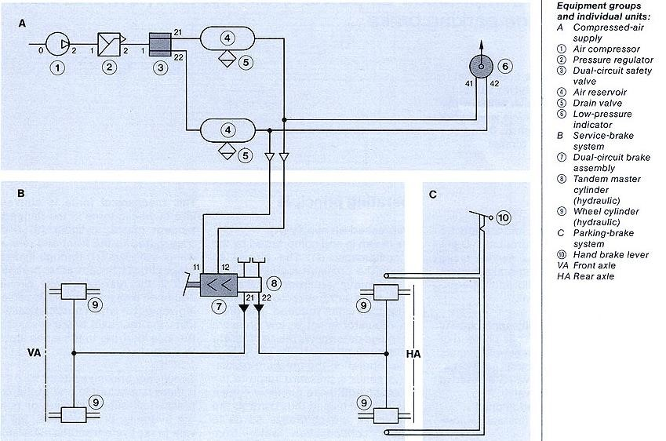

Function of new component
3. Dual-circuit safety valve: Distributes the compressed air coming from the pressure regulator to two compressed-air supply circuit and, should one circuit fail, maintains the supply to the intact circuit.
6. Low- pressure indicator: swings a pointer into the field of vision of the driver if the pressure in one of the compressed-air supply circuit drops below a set minimum.
7. Dual-circuit brake assembly: actuates the hydraulic transmission through compressed-air when braking (installation: connections and exhaust at bottom)
1.3.3. Dual-circuit, compressed-air brake system (low pressure) with no-linkage parking brake.
For commercial vehicles without trailer with a gross vehicle weight from approx..8 to 15 tonnes
Construction
As in brake systems 1 and 2 there are three equipment groups: compressed-air supply (A), service-brake system (B) and parking brake system (C). there are the following differences from brake system 2
Four compressed-air supply circuits with three air reservoirs (instead of two compressed-air supply circuits with two air reservoir)
- Four-circuit safety valve (instead of dual-circuit safety valve)
- Antifreeze pump (additional)
- Monitoring switch (switch of low-pressure indicator)
- Hydraulic load-sensing valve (additional)
- No-linkage pneumatic power parking brake system instead of mechanical muscle-power parking brake system)

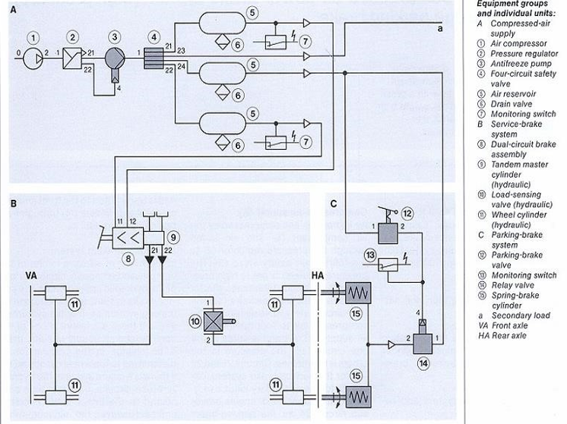

Function of new component
3.Antifreeze pump: supplies antifreeze to the braking equipment to prevent condensation water from freezing
4.four-circuit safety valve: distributes the compressed air coming from the pressure regulator to four individual compressed-air circuits and ensures that if one circuit fails the pressure remaining circuits is maintained.
10. load-sensing valve (hydraulic): regulates the brake pressure as a function of the loading condition of the vehicle.
14. relay valve: accelerates the admission of air and removal of air from the brake cylinder.
15. spring-brake cylinder: converts the potential energy stored in a spring into mechanical energy, e.g. into braking energy for the parking brake.

1.3.4: Dual circuit compressed-air power brake system (hight pressure) with no-linkage parking brake
For commercial vehicles without trailer with a gross vehicle weight from approx. 6 to 13 tonnes
Construction
As in brake systems 1 and 3 there are three equipment groups: compressed-air supply(A), service brake system (B) and parking-brake system (C). There are the following differences from brake system 3:
- High-pressure operation for service-brake system
- No anti-free pump
- Service-brake valve and actuating cylinder for brake master cylinder (instead of dual-circuit brake assembly)
- Pressure limitation for parking-brake system and secondary loads
- No hydraulic load-sensing valve
- No relay valves

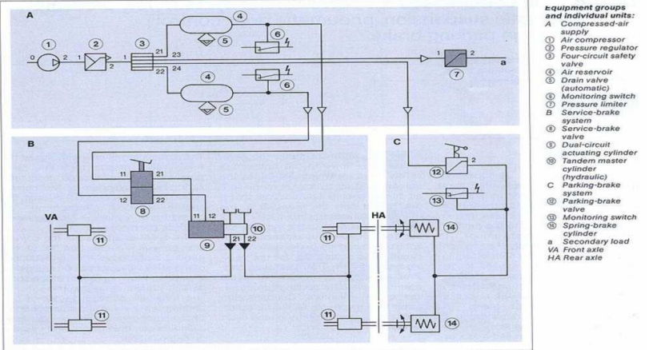
Function of new component
7. pressure limiter: limits the air pressure to a given level
9.dual-circuit actuating cylinder: converts pneumatic force into mechanical force for actuating hydraulic master cylinder
8. service brake valve: actuates the air-controlled brake circuits of a service-brake system
Top: for high pressure, bottom, for low pressure

1.3.5: Dual-circuit, compressed-air power-brake system (low pressure) With pneumatic suspension, pneumatic door control and no linkage parking brake
For bus with pneumatic suspension
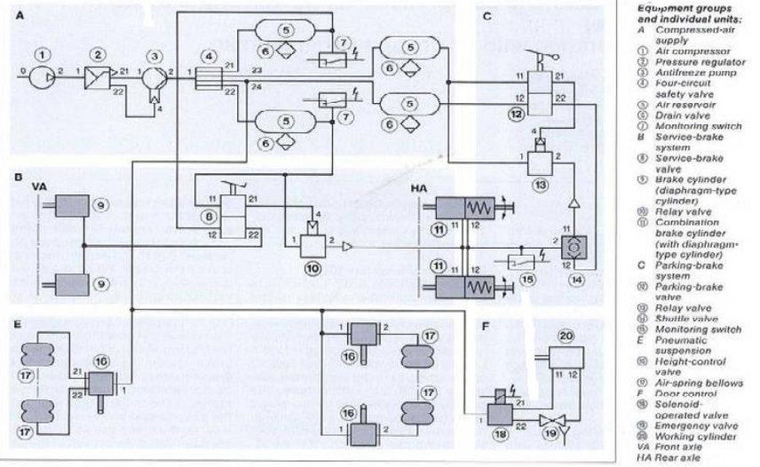
Function of new component
9.brake cylinder (diaphragm-type cylinder): acts on the wheel brakes when the service-brake system is operated
11.combination brake cylinder (with diaphragm-type cylinder) acts on the wheel brakes when the service-brake system is operated.
14. shuttle valve: of two compressed-air inlets, connects the higher-pressure inlet to the compressed-air outlet
16. height -control valve: regulates the amount of air in the spring bellows so that the vehicle body and road surfaces. Also ensures that there is the same clearance between body and road surface irrespective of vehicle loading.
17. air-spring bellows: damp the vehicle body when the road surface is uneven and maintain the surface irrespective of vehicle loading.
18. solenoid-operated valve: converts electric pulses into compressed-air surges for actuating the working cylinders for opening the vehicle doors.

1.3.6: Dual-circuit, dual-line compressed-air power-brake system (low pressure)
For trailer operation with no-linkage parking brake
For commercial vehicle for trailer operation with a gross vehicle weight above 16 tonnes
Construction
The brake system is composed of four equipment groups. The compressed air supply group A generates compressed air at low pressure 8 bar stores it and delivers it to the service brake system group B to the parking brake system group C and through the trailer control group D to the trailer air reservoir. A part from the absence of pneumatic suspension and door control, there are the following differences from brake system 5:
- Trailer control for supplying and controlling the trailer-brake systems
- Pneumatic load-sensing valve
- Combination brake cylinders with piston actuators instead of diaphragm-type cylinders
- Non-return valve for safeguarding the parking-brake system

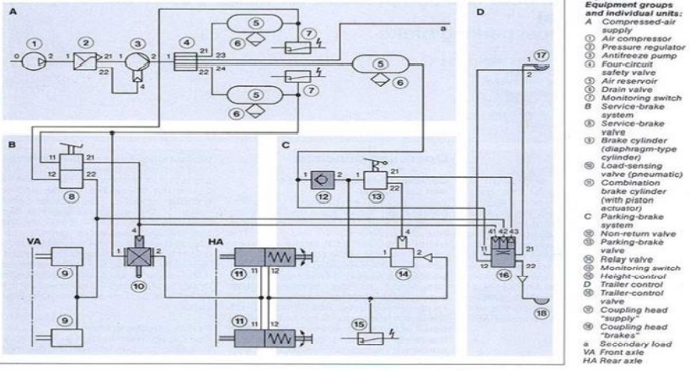
Function of new component
10.load-sensing valve (pneumatic): regulates the brake pressure as a function of the loading condition of the vehicle.
11. combination brake cylinder (with piston actuator): acts on the wheel brakes when the service brake system is actuated.
12. non-return valve: allows compressed air to flow in but prevents it from flowing back.
16. trailer control valve: transmits the control pressure of the brake systems of the tractor vehicle through the brake line to the trailer.
17. coupling head “supply”: connects the supply line between tractor and trailer.
18. coupling head “brakes”: connects the line between tractor and trailer.
1.3.7. Single-circuit, dual-line compressed-air trailer power-brake system (low pressure) with mechanical parking brake
For trailers with single-circuit dual-line brake system and a gross weight of not more than 16 Tonnes
Construction
The brake system is composed of three equipment groups : the compressed-air supply and control (equipment group A) supplies the system with compressed air from the tractor vehicle and controls the service-brake system (equipment group B) in accordance with the pressures applied to the brake line from the tractor vehicle the service brake system acts pneumatically on the wheel brakes of all axles. The parking system (equipment C) acts on the rear axle wheel brakes through a linkage.

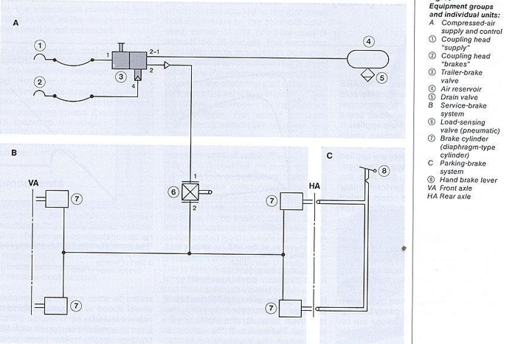

3.Trailer-brake valve : is pneumatilly controlled and actuates the service-brake system in the trailer.

Learning Outcome 1. 4 : Describe pneumatic system components

- Air compressor
- Pressure regulator
- Antifreeze pump/ air
- dryer
- Overflow valve
- Circuit protection valves
- Air reservoir
- Drain valve
- pressure relief element
- Brake servo unit
- dual circuit brake
- assembly
- service brake valve
- dual circuit actuating
- cylinder for the brake
- cylinder
- Master cylinder
- Load sensing valve
- Wheel brake cylinder
- Combined brake cylinder
- (with diaphragm and
- piston)
- parking brake valve
- relay valve
- Shuttle valve
- Spring brake cylinder
- Check valve
- Trailer-control valve
- coupling heads
- trailer brake valve
- Height-control valve with
- damping
- Air spring bellows
- solenoid valve
- working cylinder

Theoretical learning Activity
- Trainer ask trainee to brainstorming on the advantage of pneumatic system over hydraulic systems
- Class demonstration on Application of pneumatic system
- Trainer ask trainee to describe the function of brake system
- Trainer ask trainee to describe all pneumatic system components

Practical learning Activity
- Trainer ask trainee in pair to select tools, material and equipment needed when maintaining pneumatic system
- Trainer ask trainee to identify the main component of pneumatic brake system.

Points to Remember (Take home message)
- Unlike in hydraulic systems, pneumatic systems can be exhausted its fluid medium (air) to the atmosphere after completing its assigned task. This reduces the requirements of special designs for reservoirs and leak-proof systems.
- Pneumatic systems are comparatively cheaper in cost than the hydraulic systems.
- Pneumatic systems provide better operation advantages when compared to hydraulic systems.
- Compared to hydraulic systems, pneumatic are lesser in weight.
- Unlike in hydraulic systems, leakage of air in pneumatic system will not affect the system performance very much (because the air compressor supplies the pressurized air continuously).

Learning Units 2. Dismount pneumatic system components

Picture/s reflecting the Learning unit 2

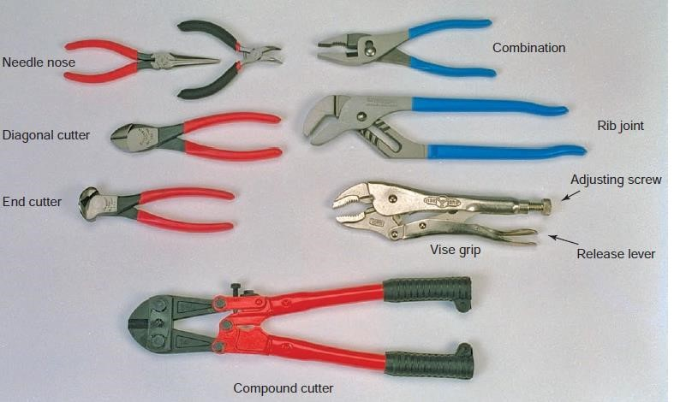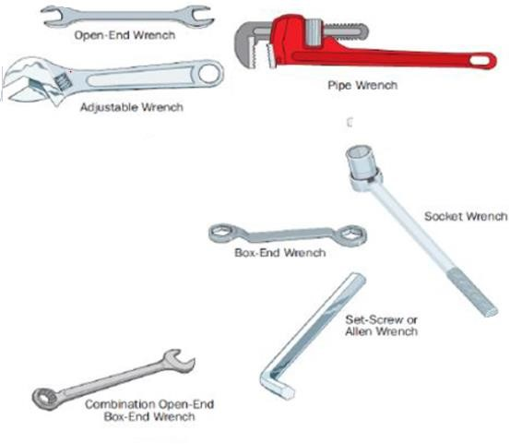
Learning outcomes:
2.1. Select materials, tools and Equipments
2.2 Clean pneumatic system components
  - Dismount pneumatic system components
  - Inspect pneumatic system components

Duration:10hrs

Learning outcome objectives :
By the end of the learning outcome, the trainees will be able to:
1. Select materials, tools and Equipments
2. Clean pneumatic system components
3. Dismount pneumatic system components
4. Inspect pneumatic system components

Resources
Equipment | Tools | Materials
PPE  Jack  Safety stand  Bench vices  Bench work | Spanners  Screw drivers  Hummers  Pliers  Files  Sand papers  Cutters  Punches and chisels  Bench vise  scraper  Bolts extractors  Brushes  Hack saw  Pullers  Air impact spanners  Air brow gun  Drilling machine (portable)⎫ Angle grinding machine ⎫ Sucking pump  Tap and die | Grease.  Brake fluid  Seals  Gasket  Water  Powder soap  Liquid soap  Cleaning Agents  Rugs
Advance preparation:
PPE and workplace must be well cleaned
Vehicle equipped with pneumatic system
you must have Hydraulic Jack, jack stand, Wheel rock, Sand papers, Water, Powder soap, Liquid soap, Rugs.

Indicative content 2.1: Select materials, tools and Equipment’s

1. Hand tools
Hand tools are tools that are powered manually. Hand tools include anything from axes to wrenches
I. Wrenches:
A wrench is a tool for twisting and/or holding bolt heads or nuts

II. Screwdrivers
A screwdriver drives a variety of threaded fasteners used in the automotive industry
Standard Tip Screwdriver: A slotted screw accepts a screwdriver with a standard or blade-type tip
Phillips Screwdriver: The tip of a Phillips screwdriver has four prongs that fit the four slots in a Phillips head screw
Pozidriv Screwdriver: The Pozidriv screwdriver is like a Phillips but its tip is flatter and blunter.
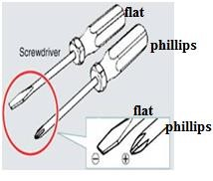

- Pliers
Pliers are gripping tools used for working with wires, clips, and pins.

- Hammers
Hammers are identified by the material and weight of the head. There are two groups of hammer heads: steel and soft faced
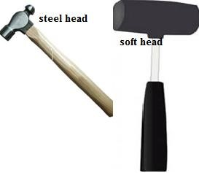

- Chisels and Punches
Chisels are used to cut metal by driving them with a hammer.
Punches are used for driving out pins, rivets, or shafts; aligning holes in parts during assembly; and marking the starting point for drilling a hole.
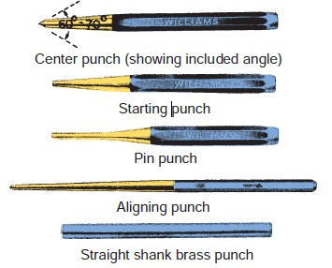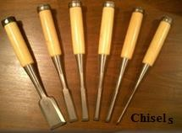

- Files
Files are commonly used to shape or smooth metal edges. Files typically have square, triangular, rectangular (flat), round, or half-round shapes
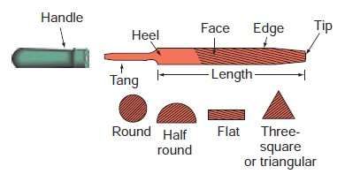

- Gear and Bearing Pullers
Many precision gears and bearings have a slight interference fit (press fit) when installed on a shaft or housing.

2. power tools
They operate faster and with more torque than hand tools. However, power tools require greater safety measures.
Power tools do not stop unless they are turned off. Power is furnished by air (pneumatic), electricity, or hydraulic fluid.

  - Impact Wrench
An impact wrench is a portable handheld reversible wrench
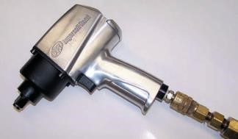

  - Air Ratchet
An air ratchet, like the hand ratchet, has a special ability to work in hard-to-reach places. Its angle drive reaches in and loosens or tightens where other hand or power wrenches just cannot work

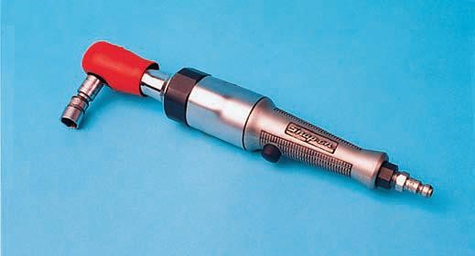

  - Blowgun
Blowguns are used for blowing off parts during cleaning.

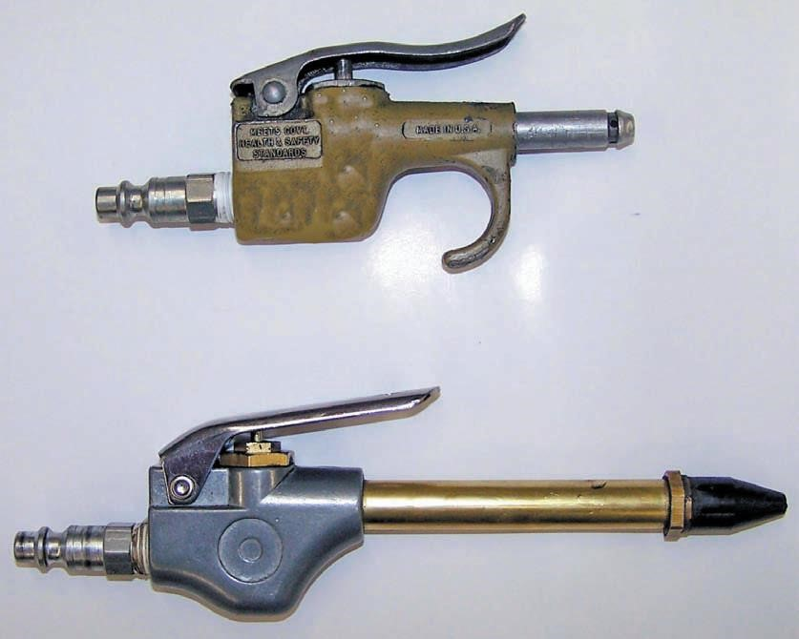

Equipment
Bench Vises
Often repair work is completed with a part or assembly removed from the vehicle. The repairs are typically safely and quickly made by securing the assembly. • Bench Grinder
Three types of wheels are available with this bench tool:
- Grinding wheel, for a wide variety of grinding jobs from sharpening cutting tools to deburring
- Wire wheel brush, for general cleaning and buffing, removing rust, scale, and paint, deburring, and so forth
- Buffing wheel, for general purpose buffing, polishing, and light cutting
  - Presses
Many automotive jobs require the use of powerful force to assemble or disassemble parts that are press fit together. Removing and installing piston pins
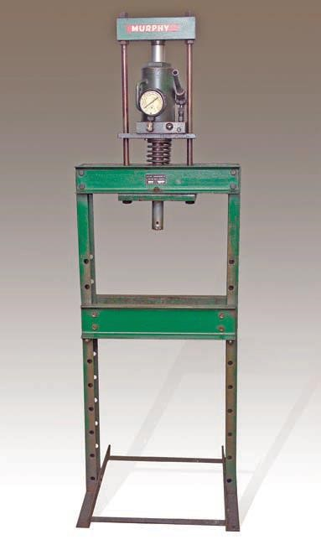
Figure: hydraulic press

  - Grease Guns
Some shops are equipped with air-powered grease guns, while in others, technicians use a manually operated grease gun. Both types can force grease into a grease fitting. Hand-operated grease guns are often preferred because the pressure of the grease can be controlled by the technician.



Learning Outcomes : 2.2 : Clean and dismount pneumatic system components

Method of cleaning : Dry cleaning
Air blowing
Solvent
Cleaning pneumatic system component
- Verification of marks on fixing system and component
- Cleaning of pneumatic components listed above by using compressed-air or solvent (wet or dry)
- Note : when cleaning, do not use cotton waste or other cloths that have lint
- When changing a cylinder, plug the hose ends to keep impurities out
- When cleaning pneumatic cylinders, give special attention to blind ends and piston rods with links.

Indicative content 2.3: Dismount pneumatic system components

The process for dismounting pneumatic system components can vary depending on the specific component being removed and the system in which it is installed. However, in general, the following steps can be used as a guide :
1. Turn off the air supply to the system and release any pressure in the system by opening a valve downstream of the component being removed.
2. Remove any fittings or connections that are attaching the component to the system. This may involve using a wrench or other tool to loosen and remove nuts, bolts, or other fasteners.
3. Carefully lift the component out of its mounting location, being careful not to damage any surrounding components or hoses.
4. If necessary, disconnect any hoses or tubing that are connected to the component. This may involve loosening or removing hose clamps or other fittings.
5. Inspect the removed component for damage or wear, and replace it if necessary.
6. Before re-installing the component, inspect the surrounding area for any signs of damage or wear that could affect the operation of the system.
7. Re-install the component by reversing the steps used to remove it. Be sure to use the appropriate fittings and tighten them to the correct torque specifications.
8. Turn on the air supply to the system and check for leaks or other issues. If everything appears to be working properly, the system is ready for use.



Indicative content. 2. 3 : Inspect pneumatic system components
- Checking of pneumatic components : Leakage
Pressure
Wear
Performance
- Verification of service indicator
Inspecting pneumatic system components is an important part of preventative maintenance and involves checking the components for signs of wear, damage, or other issues that could affect the performance of the system. Here are some general steps to follow when inspecting pneumatic system components :
1. Turn off the air supply to the system and release any pressure in the system by opening a valve downstream of the component being inspected.
2. Visually inspect the component for any signs of wear or damage, such as cracks, corrosion, or deformation. Pay particular attention to areas where stress or vibration may be present.
3. Check all fittings, connections, and fasteners for tightness and signs of wear. Look for signs of leaks, such as oil or rust stains, around fittings and connections.
4. Inspect any hoses or tubing connected to the component for signs of wear or damage, such as cracks or abrasions. Check hose clamps or other fittings for tightness and signs of wear.
5. Check any moving parts for proper operation and lubrication. Look for signs of excessive wear or damage to bearings, pistons, or other components.
6. If the component has a filter or regulator, inspect these components for signs of wear or damage. Check the filter element for dirt or other contaminants and replace if necessary.
7. After completing the inspection, re-install the component and turn on the air supply to the system. Check for any leaks or other issues that may have been missed during the inspection.
By regularly inspecting pneumatic system components, you can identify and address potential issues before they cause a system failure or downtime.

Theoretical learning Activity
- Ask trainee to discuss on methods of cleaning pneumatic components in groups
- Ask trainee, what are checking must carried out on pneumatic system

Practical learning Activity
- After understanding the method of cleaning, by using different methods clean pneumatic components.

Points to Remember (Take home message)

- Differentiate tools, materials and equipments
- Methods of cleaning
- Checking of pneumatic components

Learning Unit 3: Maintain pneumatic system circuit

Learning outcomes:
  - Select materials, tools and Equipments
  - . Clean and drain pneumatic system circuit
3.3. Replace and grease pneumatic system components

Duration:10hrs

Learning outcome objectives :
By the end of the learning outcome, the trainees will be able to:
1.Select materials, tools and Equipments
2. Clean and drain pneumatic system circuit
3. Replace and grease pneumatic system component

Resources
Equipment | Tools | Materials
PPE  Jack  Safety stand  Bench vices  Bench work | Spanners  Screw drivers  Hummers  Pliers  Files  Sand papers  Cutters  Punches and chisels  Bench vise  scraper  Bolts extractors  Brushes  Hack saw  Pullers  Air impact spanners  Air brow gun  Drilling machine (portable)⎫ Angle grinding machine ⎫ Sucking pump  Tap and die | Grease.  Brake fluid  Seals  Gasket  Water  Powder soap  Liquid soap  Cleaning Agents  Rugs
Advance preparation:
PPE and workplace must be well cleaned
Vehicle equipped with pneumatic system
you must have Hydraulic Jack, jack stand, Wheel rock, Sand papers, Water, Powder soap, Liquid soap, Rugs.

Indicative content 3.1: Select materials, tools and Equipments

Tools
The following are tools required to disassemble and inspect compressed-air brake component:
Spanners, Screw, drivers, Hummers, Pliers, Files,Sand papers, Cutters, Punches, and chisels Bench, vise scraper, Bolts extractors, Brushes, Hack saw, Pullers,Air impact, spanners, Air brow gun, Drilling machine (portable),Angle grinding machine, Tap and die Dial indicator Feeler gauge
Materials
The following are tools required to disassemble and inspect compressed-air brake component: Grease, Brake fluid, Seals, Gasket, Water, Powder soap, Liquid soap.
Equipment:
The following are tools required to disassemble and inspect compressed-air brake component:
- Jack stand
- Bench vice
- Work bench

Indicative content 3.2 : Clean and drain periodically pneumatic System circuit
Cleaning of pneumatic system components
Draining of: Air tank (Daily) Compressor oil (periodically)
Periodic cleaning and draining of a pneumatic system circuit is an important part of preventative maintenance and can help ensure the system operates smoothly and efficiently. Here are some general steps to follow when cleaning and draining a pneumatic system circuit:
1. Turn off the air supply to the system and release any pressure in the system by opening a valve downstream of the component being inspected.
2. Locate the drain valve or valves in the circuit. These are typically located at the lowest points in the system and are used to remove any accumulated condensate or debris.
3. Open the drain valve(s) and allow any condensate or debris to drain out of the system. Depending on the size of the system and the amount of accumulated debris, it may be necessary to repeat this process several times.
4. Once the system has been drained of condensate, use compressed air to blow out any remaining debris or moisture. This can be done by connecting a blowgun or air hose to the system and using it to blow air through the circuit.
5. If the system has filters or regulators, inspect these components for signs of wear or damage. Check the filter element for dirt or other contaminants and replace if necessary.
6. After cleaning and draining, re-install any components that were removed and turn on the air supply to the system. Check for any leaks or other issues that may have been missed during the cleaning process.
By periodically cleaning and draining a pneumatic system circuit, you can help ensure that the system operates smoothly and efficiently, and prevent issues such as clogs or corrosion from causing downtime or equipment failure.

Indicative content 3.3 : Replace and grease pneumatic system components

Replacing and greasing pneumatic system components is an important part of preventative maintenance and can help extend the life of the system. Here are some general steps to follow when replacing and greasing pneumatic system components:
1. Turn off the air supply to the system and release any pressure in the system by opening a valve downstream of the component being replaced.
2. Remove any fittings or connections that are attaching the component to the system. This may involve using a wrench or other tool to loosen and remove nuts, bolts, or other fasteners.
3. Carefully lift the component out of its mounting location, being careful not to damage any surrounding components or hoses.
4. If the component is a bearing or other moving part, remove any old grease or lubricant and clean the area thoroughly.
5. Apply a small amount of new grease or lubricant to the component, taking care not to over-grease or use the wrong type of lubricant. Check the manufacturer's recommendations for the correct type and amount of lubricant to use.
6. If necessary, replace any seals or gaskets that may have been damaged during removal of the component.
7. Before re-installing the component, inspect the surrounding area for any signs of damage or wear that could affect the operation of the system.
8. Re-install the component by reversing the steps used to remove it. Be sure to use the appropriate fittings and tighten them to the correct torque specifications.
9. Turn on the air supply to the system and check for leaks or other issues. If everything appears to be working properly, the system is ready for use.
By regularly replacing and greasing pneumatic system components, you can help prevent wear and damage to the system and ensure that it operates smoothly and efficiently.

Theoretical learning Activity
- Ask trainee to discuss on general steps to follow when cleaning and draining a pneumatic system circuit

- Ask trainee, to give example of material needed to clean pneumatic system

Practical learning Activity
- After understanding the operation principle of pneumatic system to grease moving parts of pneumatic system

Points to Remember (Take home message)

To drain air tank by using drain valve

Learning Unit 4. Remount pneumatic system components and test pneumatic system

Learning outcomes:
4.1. Select materials, tools and Equipments
4.2. Remount pneumatic system components
4.3. Test pneumatic system

Duration:10hrs

Learning outcome objectives :
By the end of the learning outcome, the trainees will be able to:
1.Select materials, tools and Equipments
2. Remount pneumatic system components
3. Test pneumatic system
Resources
Equipment | Tools | Materials
PPE  Jack  Safety stand  Bench vices  Bench work | Spanners  Screw drivers  Hummers  Pliers  Files  Sand papers  Cutters  Punches and chisels  Bench vise  scraper  Bolts extractors  Brushes  Hack saw  Pullers  Air impact spanners  Air brow gun  Drilling machine (portable)⎫ Angle grinding machine ⎫ Sucking pump  Tap and die | Grease.  Brake fluid  Seals  Gasket  Water  Powder soap  Liquid soap  Cleaning Agents  Rugs
Advance preparation:
PPE and workplace must be well cleaned
Vehicle equipped with pneumatic system
you must have Hydraulic Jack, jack stand, Wheel rock, Sand papers, Water, Powder soap, Liquid soap, Rugs.

Indicative content 4.1 : Select materials, tools and Equipments

Tools
The following are tools required to disassemble and inspect compressed-air brake Component :
Spanners, Screw, drivers, Hummers, Pliers, Files,Sand papers, Cutters, Punches, and chisels Bench, vise scraper, Bolts extractors, Brushes, Hack saw, Pullers,Air impact, spanners, Air brow gun, Drilling machine (portable),Angle grinding machine, Tap and die Dial indicator Feeler gauge
Materials
The following are tools required to disassemble and inspect compressed-air brake component: Grease, Brake fluid, Seals, Gasket, Water, Powder soap, Liquid soap.
Equipment:
The following are tools required to disassemble and inspect compressed-air brake component:
- Jack stand
- Bench vice
- Work bench

Indicative content : 4.2. Remount pneumatic system components

Service and Spring Brake Chambers
Visually check air chamber clamp bands and mounting nuts for tightness. Torque chamber mounting nuts. Check chambers for damage or dents and sign of leaks.
CAUTION : Disassembly and repair of any spring brake is a dangerous and complex task that should not be undertaken by an inexperienced mechanic. Special tools and information are required if serious personal injury is to be avoided. Send these repairs to Palmer Leasing or an experienced mechanic.
Remounting of compressed- air brake components pipes
Brake Tubing, Lines, Fittings & Hoses
Visually inspect brake lines and hoses for loose connections, chafing, cracks, breaks, cuts, bruises, brokenout sections and deterioration. Replace immediately upon first sign of the above. Exercise extreme caution when working or welding around nylon tubing, if so equipped. It is recommended that tubing in areas where welding operations are performed be removed prior to welding operations and reinstalled after welding is completed. If tubing removal is not practical, the tubing must be shielded from welding sparks and/or heat damage.

Indicative content 4.3: Test pneumatic system

Routine Maintenance

Reservoir Tank
The first requirement in an air brake system is clean air at proper pressure. The operator must open the drain cock on the underside of the reservoirs until all moisture has escaped.
Drainage should be done periodically to remove water and sludge from the system. This is especially important in cold weather to forestall freezing and obstruction of the lines and valves. Each tank must be drained completely to insure removal of condensation. After removing moisture, close the drain cock and inspect reservoirs for looseness or damage. Make sure all connections are tight and brake lines are properly supported.
Glad hands/ COUPLINGS
Inspect glad hands to insure proper operation without obstructions. With the trailer connected to the truck tractor and air in the system, coat the glad hands and mounting with soapsuds to make sure there is no leakage. Be certain glad- hands seals are in good condition and not saturated with grease, oil or other foreign material. We recommended annual replacement of glad hands seals.
Air Valves
Inspect all air valves for leaks. If excessive leakage is found, the valve must be repaired or replaced. We recommend that air valves be replaced when necessary with new or rebuilt valves. Palmer Leasing will replace valves at our facility.
Brake Lining
Inspect and check the brake lining thickness. Brake lining must be replaced if excessively worn or if coated with oil, grease, or foreign material.
Brake Drums
Inspect brake drums. Any accumulation of mud, dirt or rust on the drums should be removed. Any broken or cracked drums should be removed from service.

Theoretical learning Activity
- Ask trainee after replacement any component from pneumatic system to discuss how to text pneumatic system (in groups)

Practical learning Activity
- Trainee in pair to perform selection of tools, material and equipment required when working on pneumatic system

Points to Remember (Take home message)

- Text pneumatic system

Learning outcome formative assessment
Written assessment
- Choose the correct answers on the following questions:
A) Which of the following is not including on hand tools?
- scriber
- center punch
- metal brush
- powder soap
B) The application of pneumatics is:
- to transmit torque
- to transmit power
- none above
- A and B is a correct
C) The service brake is used:
- To keep the vehicle stop when the driver is not around.
- to bring the vehicle moving down
- increase the speed of the vehicle
- keep the vehicle speed constant on downhill slope
- Which part of the pneumatic system stores the compressed air
- Air dryer
- Air compressor
- Air reservoir
- Air lubricator
- Air lubricator Which among the following is disadvantage of pneumatic system
- Pneumatic system can be applied only to low pressure
- Run continuously
- Easier maintenance and handling
- None of these
C) In which type of system does power transmission takes place through compressed air?
- Fluid power system
- Hydraulic system
- Pneumatic system
- Stepper motors

- Enumerate any five (5) components of air brake system
Answer:
- Air compressor
- Pressure regulator
- Air reservoir
- Drain valve
- Safety valve
- 2. With pneumatic graphic symbols, represent and name the compressed air brake system circuit called single circuit ,power assisted compressed air brake system with mechanical parking brake
Answer: 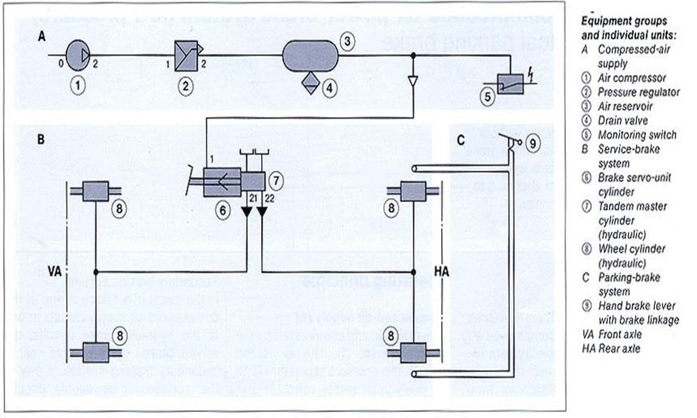
- What are the classification of brake system according to the purpose
and give function for each brake system
answer:
- Service brake system: is used to reduce the speed of the vehicle
and keep the speed constant on dawn hills gradients
- Parking brake system: bring the vehicle stationary, even on slope
and when the driver is not there.
- Secondary brake system: if the service brake fails the secondary
brake system must assume both function with reducing effect
- Name the following digit used in pneumatic system 5marks
9,8,7,6,5,4,3,2,1,0
Answer:
0: Intake connection
1: Energy input
2: Energy output
3: Connection to atmosphere
4: Control connection (inlet on equipment)
5: Unoccupied
6 Unoccupied
7: Antifreeze connection
8: Lubricating-oil connection
9: Coolant connection
- A quantity of gas at pressure of 720mmhg and temperature of 17oC occupies a volume of 2.4 liters. Reduce the volume of gas to STP

Given data: P1=720mmHg
V1=2.4l
T1= 170C =17+2730K=2900K
T2=2730K
P2=760mmHg
S.T.P means Standard Temperature and Pressure
Standard T=2730K
P=760mmHg
Required V2?
P1V1 = P2V2
T1 T2
V2= P1V1T2
P2T1
V2= 720x2.4x273 = 2.1l
760x290
- What are the equipment’s groups that found on compressed air brake system and their functions
Answer:
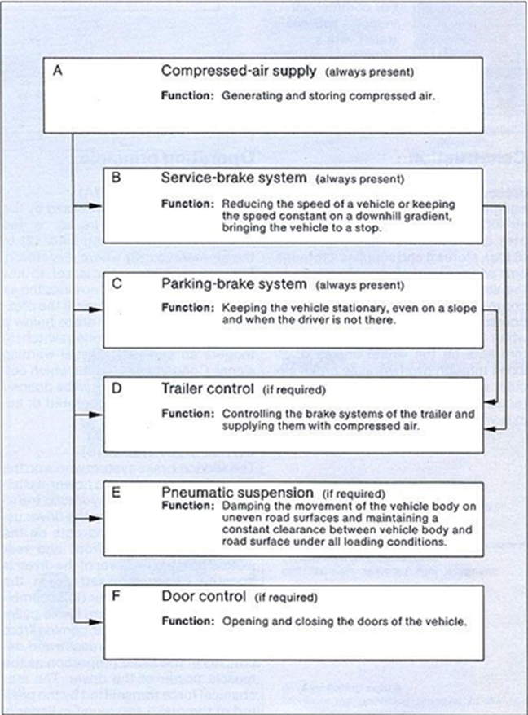

- Give the symbols and their function /5marks
- Anti-freeze pump: supplies antifreeze to the braking equipment to prevent condensation water from freezing
Symbol: 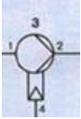
- Brake service valve: The dual-circuit service brake valve controls two independent pneumatic or pneumo-hydraulic service brake circuit in a tractor vehicle and by way of the trailer-control valve, the service brake system of trailer
Symbol: 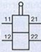

- Load sensing valve: regulates the brake pressure as a function of the loading condition of the vehicle.
Symbol: 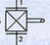
- Brake wheel cylinder (diaphragm): produce the actuating force in drum brake
Symbol: 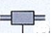
- Trailer control valve: is pneumatically controlled and actuates the service-brake system in the trailer.
Symbols: 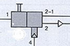
- Below is a list of compressed air supply system components. By mean of circuit, show how they are interconnected./5marks
- Air compressor
- Pressure regulator
- Anti-freeze pump
- Four circuit protection valve
- Air reservoir
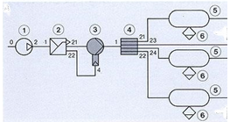
- Give the essential materials needed when servicing a pneumatic system
Ans: Grease, seal, gaskets, water, powder soap, air filter
- Determine any four (4) components used for trailer control
Ans:
      - Trailer supply valve / trailer control valve
    - Trailer air reservoir
    - Trailer brake cylinder
    - Trailer brake valve
- List five components included in the components group C
Ans:
Parking brake valve
Shuttle valve
Spring brake cylinder
Check valve
Quick release valve
- By using sketch differentiate single circuit to dual circuit brake system
Ans:
Single circuit:
Dual circuit:

 Please mix different assessment tools for triangulation and relevancy of assessment

Practical assessment
Driver Peter transports sand with the truck branded IVECO 160E21 4X2
for road construction from Mayange in Bugesera district to Kibagabaga
in Gasabo District. After deposing the sand on construction site, the
driver observes on label located at steering wheel that the truck needs
general maintenance for pneumatic system and he decided to send it at
MUHIP garage at Kicukiro center for maintenance.
The MUHIP Garage manager is requested you as a Hydro- Pneumatic
technician to maintain the truck brake system within 4hours.

Tools:
Spanners
Screw drivers
Hummers
Pliers
Brushes
Materials:
Sand papers
Grease.
Seals
Gasket
Water
Powder soap
Liquid soap
Rugs
Equipment:
PPE
Hydraulic Jack
jack stand
Wheel rock
Service pit

References:

1. Applied hydraulics and pneumatics by V. JAYAKUMAR, 2009, Anna University
2. Compressed air brake systems, Bosch 1985
3. Airbrake-diagrams-1985, Bosch
4. Hydraulics and Pneumatics, ISBN: 0750644192, Publisher: Elsevier Science & Technology
Books, Pub. Date: March 1999
5. Advanced troubleshooting guide for air brake compressors, BW1971.2004 Bendix Commercial vehicle system LLC.9/14/04.printed in USA.
6. Pneumatic hand book, 8th edition by antony barber, c.Eng.,M.Sc.,F.I.Mech.E.,M.R.Ae.s.
7. Bosch technical instruction, Compressed air Brake systems Equipment, Published by
Robert Bosch GmbH,1985, Postfach 50.D-7000 Stuttgart1.
8. http://www.energysolutionscenter.org/Learn/Air_Compressor_Tutorial.htm
9. http://www.howstuff works.com
10. http://www.google search.com

