

TRADE: ROAD CONSTRUCTION
Module name: DEFLEXION TEST EXECUTION
MODULE CODE: RCTDT501
TEACHER’S GUIDE
RQF LEVEL: 5

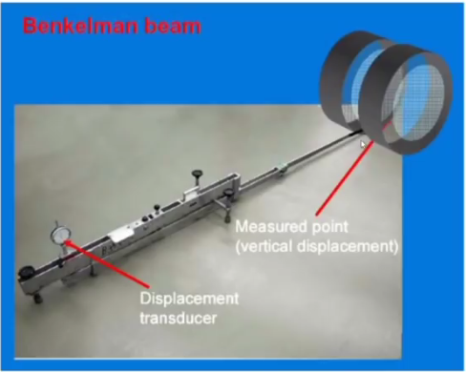
Table of content
Contents
Acronyms 3
Introduction 4
Module Code and Title: RCTDT501 and DEFLEXION TEST EXECUTION 1
Learning Unit 1: Prepare workplace, tools and equipment 2
STRUCTURE OF LEARNING UNIT1: Prepare workplace, tools and equipment 2
Learning outcome 1.1 prepare tools and equipment 3
Content 1.1.1: Identification of tools according to the work 4
Learning outcome 1.2 : Prepare workplace 6
Learning outcome 1.3 maintain tools and equipment 9
LEARNING UNIT 2: SET BENKELMAN BEAM 13
STRUCTURE OF LEARNING UNIT2 14
Learning outcome 2.1 Localize the trial points 14
Define the following term used in selecting points : 18
Learning outcome 2.2: Place the tip of the beam between the dual wheel of loaded truck. 18
Learning outcome 2.3: Check pressure gauge according to the specifications. 20
STRUCTURE OF LEARNING UNIT 3 MANIPULATE DEFLEXION 23
Learning outcomes: 23
Learning outcome 3.1 Apply the prepared load to the specifications 23
Learning outcome 3.2: Measure the pavement surface rebound 28
Learning outcome3.3 Record the gauge results according to specification 33
STRUCTURE OF LEARNING UNIT 4 INTERPRET THE RESULTS 36
Learning outcome 4.1 Analyze obtained results 36
Learning outcome 4.2 draw graph of deflexion 43
Learning Outcome 4.3: Elaborate a report 48
• Deflexion value 51
CONCLUSION 51
References 52

Acronyms
FWD: falling weight deflectometer
RCTDT: Road construction deflection test
PM: Preventive maintenance
PPM: Planned preventive maintenance
RM: Remedial maintenance
km/h: Kilometer per hour
m: meter
mm: millimeter
BR: beam ratio
Do: Initial deflection
Di: intermediate deflection
Df: final deflection

Introduction
Deflection testing is a very important and a non-destructive tool for evaluating pavement layers. There are a number of different methods of determining pavement deflection depending on the type of information required. Deflection testing can estimate the remaining life of a pavement, detect soft or wet areas of a new formation or provide the basis for determining areas of existing pavement that require rehabilitation. Note that deflection surveys are moisture sensitive and if testing after prolonged periods of wet weather the results will be higher than if testing in drought conditions. Deflection testing will only give an indication of the formation or pavement stiffness at the particular location at the particular time of testing. (Anthony Bretreger, Deflection testing of earthwork and pavement layers, February 2015).
Engineers have always recognized the usefulness of pavement deflection data to evaluate and monitor pavement response (e.g., maximum deflection, radius of curvature) and existing pavement structural conditions (by means of back calculation of layer moduli). The Texas Department of Transportation has been, and continues to be, one of the leaders in using deflection data operates a large fleet of falling weight deflectometer [FWD] as well as in developing and implementing devices used to measure pavement deflections.
Pavements are one of the most crucial (Extremely important) factors to connect the society. Health of the pavements is assessed(determined) from time to time and it results in their poor performance not only leading(causing) to many accidents but also increased running cost.
The condition of pavement gets deteriorated as time passes unless maintenance is properly done.
Deflection testing is a very important and a non-destructive tool for evaluating pavement layers. There are a number of different methods of determining pavement deflection depending on the type of information required.
This test procedure covers the determination of the rebound deflection of a pavement under a standard wheel load and tire pressure. This test is necessary for pavement structural evaluation and in overlay design. (Saeed I. , 2019-2020)

Module Code and Title: RCTDT501 and DEFLEXION TEST EXECUTION
Learning Units:
1. Prepare workplace, tools and equipment
2. Set benkelman beam
3. Manipulate deflexion
4. Interpret results

2
3
n

Learning Unit 1: Prepare workplace, tools and equipment

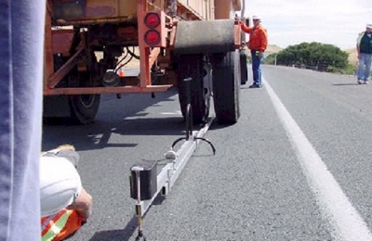

STRUCTURE OF LEARNING UNIT1: Prepare workplace, tools and equipment
Learning outcomes:
  - Prepare tools and equipment
  - Prepare workplace
  - Maintain tools and equipment

Learning outcome 1.1 prepare tools and equipment

Duration: 2hrs
Learning outcome 1 objectives:
By the end of the learning outcome, the trainees will be able to:
1. Prepare Cleary tools and equipment required to perform deflexion test execution
2. use Cleary tools and equipment used in Deflexion test.
3. select well all tools and equipment used during deflection test
Resources
Equipment | Tools | Materials
Projector  Board  wheel loader  cutting machine  wheel loader  truck  gauges | Reference book  Handout  Tape measure  Levels  Springs and nuts | Internet  Pen  Chalks  Markers  materials to be loaded
Advance preparation:
- Having prepared the working place.
- Having arranged tools, equipment and materials according to the task to be performed.
Having made trainee’s groups in order to facilitate them to work in good conditions


Content 1.1.1: Identification of tools according to the work
During perform the deflection test they are different tools and Equipment required which have different categories :
Identification of tools according to the work:
- cutting tools
The various types of cutting tool materials are used in tools for remove trees and glasses from work place. Generally, the tool must be harder than the work material.
- Saw/ hacksaw: is used for cutting metal by hand. It consists of a frame which holds a thin blade
-Pick for cutting asphalt layers
- Setting out tools
For each of the levelling, referencing or pipe nails are provided tools for placing and setting the nails correctly and accurately. The tools also help to prevent deformation of nails and avoid injury.
Marking-out tools consist of six main types:
- Squares: it is a tool used for making and referencing a 90⁰ angle though miter square are used for 45⁰ angle.
- Tape measure: it is a flexible ruler and it is used to measure distance.
- Markers: an object used to indicate a position, place, or route.
- Fixing tools: cover a wide range, but most either have a driving or turning action. The main types available are:
- Hammers
- Screwdrivers
- Pincers



Content1.1.2classification of equipment:
- Heavy duty machine(equipment)
Are those equipment which have many weights used in deflection test example of them are:

- TRUCK

2. Portable machine(equipment):
A portable machine or device is designed to be easily carried or moved
Examples of them are:
- Benkelman beam
- Deflectograph,
- Falling Weight
- Deflectometer and
- Dynamic cone penetrometer

Theoretical learning Activity
- Trainees in groups brainstorm about tools and equipment required to perform deflexion test and their uses
Practical learning Activity
Trainees select tools and equipment to carry out deflexion capacity test

Points to Remember (Take home message)
1.All tools used in deflection test have three categories such as cutting, setting out, and mearing tools
2.All equipment used in deflection test have two (2) categories such as heavy duties equipment and portable equipment

Learning outcome 1 formative assessment
Written assessment
Answer by TRUE OR FALSE for the following statement as represent Marking-out tools in deflexion test
1. Tape measure: I t is a flexible ruler and it is used to measure distance. TRUE
2. Markers: An object used to indicate a position, place, or route. TRUE
3. list all tools and equipment used in deflection test and give their uses.
(Saeed L. I., In-situ Pavement Deflection Test, 2019-2020)

Learning outcome 1.2 : Prepare workplace
Duration: 1hr
Learning outcome 1 objectives:
By the end of the learning outcome, the trainees will be able to:
1. identify all procedures of prepare workplace during perform deflexion test
2. Prepare Cleary workplace where deflexion test is to be performed

Resources
Equipment | Tools | Materials
Projector  Board  wheel loader  wheel loader  truck  gauges | Reference book  Handout  Tape measure  Levels  Springs and nuts | Internet  Pen  Chalks  Markers  materials to be loaded
Advance preparation:
Having prepared the working place.
Having arranged tools, equipment and materials according to the task to be performed.
Having made trainee’s groups in order to facilitate them to work in good conditions

Content 1.2.1: Key elements for workplace preparation

Workplace is a place (such as a shop or factory) where work is done.
During the prepare workplace, the elements you should be follow are:
- Mark area in which test have to be conducted
- Clean out each disturbance which can affect the work
- Prepare Benkelman beam components
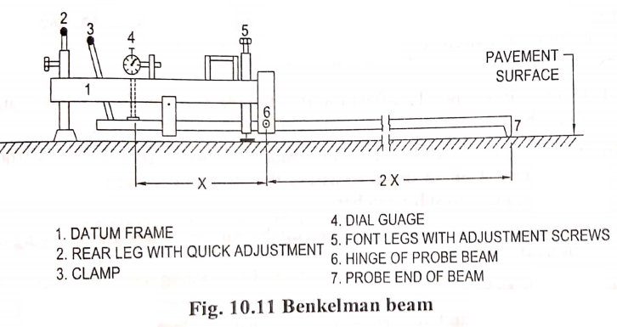
- Loaded truck
- Prepare gauges

Theoretical learning Activity
- In groups trainees discuss about how to Prepare Workplace.

Practical learning Activity
In group of (5) five trainees, each group is required to do Practical exercises on deflexion workplace preparation

Points to Remember (Take home message)
Key elements for workplace preparation are:
- Mark area in which test have to be conducted
- Clean out each disturbance which can affect the work
- Prepare Benkelman beam components
- Loaded truck
- Prepare gauges

Learning outcome 1.2 formative assessment
Written assessment
- Choose the true elements for workplace preparation from listed below:
- Mark area in which test have to be conducted
- Clean out each disturbance which can affect the work
- Prepare Benkelman beam components
- Adjustment of bolts and nuts
- Stability of Benkelman beam
ANSWER:
- Mark area in which test have to be conducted
- Clean out each disturbance which can affect the work
- Prepare Benkelman beam components

Learning outcome 1.3 maintain tools and equipment
Duration: 2hr
Learning outcome 1 objectives:
By the end of the learning outcome, the trainees will be able to:
1. know well how tools and equipments are maintained during perform deflexion test
2.identify cleary types of maintainance according to the tools and equipements used during permance of deflexion test
Resources
Equipment | Tools | Materials
Projector  Board  wheel loader  wheel loader  truck  gauges | Reference book  Handout  Tape measure  Levels  Springs and nuts | Internet  Pen  Chalks  Markers  materials to be loaded
Advance preparation:
- Having prepared the working place.
- Having arranged tools, equipment and materials according to the task to be performed.
Having made trainee’s groups in order to facilitate them to work in good conditions

Content 1.3.1Type of maintenance of tools and equipment

The technical meaning of maintenance involves functional checks, servicing, repairing or replacing of necessary devices, equipment, machinery.
- Type of maintenance of tools and equipment are the following:
- Preventive maintenance (PM) is "a routine for periodically inspecting" with the goal of "noticing small problems and fixing them before major ones develop. Ideally, "nothing breaks down.
The main goal behind PM is for the equipment to make it from one planned service to the next planned service without any failures caused by fatigue,
neglect, or normal wear (preventable items), which Planned Maintenance and Condition Based Maintenance help to achieve by replacing worn components before they actually fail. Maintenance activities include partial or complete overhauls at specified periods, oil changes, lubrication, minor adjustments, and so on. In addition, workers can record equipment deterioration so they know to replace or repair worn parts before they cause system failure.
Main objective of PM is:
➢ Enhance capital equipment productive life.
➢ Reduce critical equipment breakdown.
➢ Minimize production loss due to equipment failures.
Preventive maintenance (PM) is subdivided into three categories
➢ Planned maintenance
➢ Predictive replacement
➢ Condition-based maintenance
Planned preventive maintenance (PPM), more commonly referred to as simply planned maintenance (PM) or scheduled maintenance, is any variety of scheduled maintenance to an object or item of equipment. Specifically, planned maintenance is a scheduled service visit carried out by a competent and suitable agent, to ensure that an item of equipment is operating correctly and to therefore avoid any unscheduled breakdown and downtime
Predictive replacement: is the replacement of an item that is still functioning properly.
Some examples of using predictive maintenance and predictive maintenance sensors include vibration analysis, oil analysis, thermal imaging, and equipment observation.
Condition-based maintenance is maintenance performed, on possibility, depending upon the condition of the equipment or system.
Benefits of condition based maintenance
improved equipment availability, reliability, and worker safety. minimized time spent on maintenance (by doing maintenance work only when needed) repairs can be scheduled during non-peak times. increased asset lifetime

- Remedial maintenance (corrective maintenance) Maintenance that is performed after a fault, in hardware or software, has been found, in order to correct that fault. Compare preventive maintenance.

Theoretical learning Activity
- Group discussion about the maintenance of tools and equipment used during performing deflection test

Practical learning Activity
In group of 5 trainees each group are required to do Practical exercises on tools and equipment maintenance

Points to Remember (Take home message)

- Type of maintenance of tools and equipment are:
- Preventive maintenance (PM)
- Remedial maintenance (RM)

Learning outcome 1.3 formative assessment

- Outline any three categories of Preventive maintenanceand their Main objective:
Answer
➢ Planned maintenance
➢ Predictive replacement
➢ Condition-based maintenance
- Write in full word this abbreviation used in tools and equipment maintain
- PM
- RM

LEARNING UNIT 2: SET BENKELMAN BEAM

STRUCTURE OF LEARNING UNIT2
Learning outcomes:
2.1 Localize the trial points
2.2 Place the tip of the beam between the dual wheel of loaded truck
2.3 Check gauges

Learning outcome 2.1 Localize the trial points

Duration: 3hrs
Learning outcome 2.1 objectives:
By the end of the learning outcome, the trainees will be able to:
- Select properly the points where test is performed
- know clearly different method of selecting points.

Resources
Equipment | Tools | Materials
Benkelman beam | Reference book  Pen  Handout  Projector  Board  Tape measure  Levels Springs and nuts | materials to be loaded  Internet  Chalks  Markers  Pen
Advance preparation:
. Having prepared the working place.
Having arranged tools, equipment and materials according to the task to be performed.
Having made trainee’s groups in order to facilitate them to work in good conditions

.
.

Content 2.1.1: Localization of trial points method
- Benkelman Beam is a simple lever-arm device that measures the deflection of flexible pavements under the action of moving wheel loads.
This test procedure covers the determination of the rebound deflection of a pavement under a standard wheel load and tyre pressure.
The Benkelman (portable)Beam apparatus is a convenient, cost effective and accurate device used for measuring the deflection of flexible pavements under moving wheel loads.

With the Benkelman Beam measurement method, the vertical deflection of the road surface is measured after a defined load of 5 tons has rolled away. (Anthony Bretreger, Deflection testing of earthwork and pavement layers, February 2015)
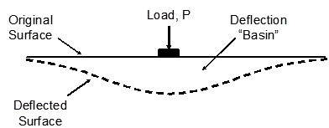
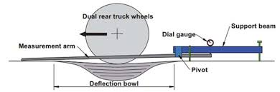

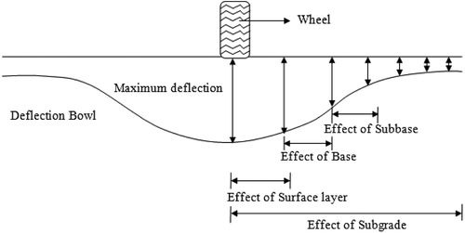
Localization of trial points method:
- Systematic localization: is a method used to select the points where deflexion test is performed according to the conditions.
- Random localization: is a method used to select the points where deflexion test is performed without any conditions, is like Randomly selection.

Theoretical learning Activity
- Groups discussion about method of localization of trial points

- Practical learning Activity
In groups of 5 (five) trainees, each group is required to make Practical exercises on localization of trial points
Points to Remember (Take home message)
- Method of localization of trial points are:
- Systematics
- Random

Learning outcome 2.1 formative assessment

Define the following term used in selecting points :
- Systematic
- Random
ANSWER

Systematic
Systematic localization: is a method used to select the points where deflexion test is performed according to the conditions.
- Random
ANSWER
Random localization: is a method used to select the points where deflexion test is performed without any conditions, is like Randomly selection.

Learning outcome 2.2: Place the tip of the beam between the dual wheel of loaded truck.
Duration: 3hrs
Learning outcome 2.2 objectives:
By the end of the learning outcome, the trainees will be able to:
1.Insert properly Benkelman beam between the dual wheel
2.follow clearly all the process of placing Benkelman beam apparatus

Resources
Equipment | Tools | Materials
Benkelman beam  loaded truck | Reference books  Hand out  gauges  Springs (screw driver) | materials to be loaded  Internet
Advance preparation:
- . Having prepared the working place.
- Having arranged tools, equipment and materials according to the task to be performed.
Having made trainee’s groups in order to facilitate them to work in good conditions

Content2.2.1: Benkelman beam placing process:
- Adjustment of Benkelman beam
- Checking of dual wheel to a loaded truck
- Connect Benkelman beam between dual wheel of loaded truck
- Connect gauges into their port

Theoretical learning Activity
- brainstorm about process of Benkelman beam placing .
- Practical learning Activity
Practical exercises on placing Benkelman between the dual wheels of loaded truck.
Points to remember (take home message)

The procedures of pacing benkelman beam following below:

- Adjustment of benkelman beam
- Checking of dual wheel to a loaded truck
- Connect Benkelman beam between dual wheel of loaded truck
- Connect gauges into their port

Learning outcome 2.2 formative assessment
Answer by true or false for the following statements
1.the first procedures of placing Benkelman is Adjustment of Benkelman beam. TRUE
2. place Benkelman beam between dual wheel of loaded truck is necessary during performing deflection test. TRUE

Learning outcome 2.3: Check pressure gauge according to the specifications.
Duration: 4hrs
Learning outcome 2.3 objectives:
By the end of the learning outcome, the trainees will be able to:
1.Check properly pressure of truck by using pressure gauge
2.follow properly all elements of pressure gauge.
Resources
Equipment | Tools | Materials
 | Reference books  Hand out  Springs  Bolts and nuts  Pressure gauge | Internet
Advance preparation:
. Having prepared the working place.
Having arranged tools, equipment and materials according to the task to be performed.
Having made trainee’s groups in order to facilitate them to work in good conditions

Content 2.3.1Gauge status checking elements
- Gauge installation process:
- Check the gauge ports
- Check the gauge threads
- Fix gauge clock wisely to their port

- Gauge maintenance methods:

- Temporally method
- Permanent method

Theoretical learning activity
- Groups discussion about Gauge installation process and it’s maintenance Practical learning activity
- Practical exercises on gauge checking for deflexion test
Points to Remember (Take home message)

- To remember the Gauge maintenance methods:
- Temporally method
- Permanent method

Learning outcome 2.3 formative assessment
Written assessment
- Assessment tools
Open questions
- List all procedures of gauge installation
ANSWER:
- Check the gauge ports
- Check the gauge threads
- Fix gauge clock wisely to their port

Multiple choice
- Choose true the methods gauge maintenance from listed below:
- Systematic localization
- Random localization
- trial points localization
- clock wisely localization
- Temporally method
- Permanent method
ANSWER:
e. Temporally method
f. Permanent method

STRUCTURE OF LEARNING UNIT 3 MANIPULATE DEFLEXION

Learning outcomes:
3.1. Apply the prepared load to the specifications
3.2. Measure the pavement surface rebound as the truck is moved forward
3.3. Record the gauge results according to specification

Learning outcome 3.1 Apply the prepared load to the specifications

Duration: 4 hrs
Learning outcome 3.1 Objectives:
By the end of the learning outcome, the trainees will be able to:
- Choose method to be used during truck loading
- Check the balance of truck to be used
- set truck on selected point
- Record the gauge result after truck moving
Resources
Equipment | Tools | Materials
Truck | tape measure  Pencils  Squares Levels  Spades  Pick axes  Wheelbarrows  Hoes | reference books  Hand out  Internet
Advance preparation:
• Having prepared the working place.
•Having arranged tools, equipment and materials according to the task to be performed.
•Having made trainee’s groups in order to facilitate them to work in good conditions.

Content3.1.1: Loading truck
- choice of material to load
- choice method to be used method used during truck loading by put load into truck which is equal to 5tones
- check truck balance: The truck must have an 8.2 t ± 0.15 t rear axle load with, this load being evenly distributed over both sets of rear wheels and remain within these tolerances whenever testing.

Theoretical learning Activity
- Ask trainees to brainstorm about all materials need in truck loading and all methods used during truck loading
- Instruct them that each group will have time to share the outcome of their discussion with others. Give them to do the activity.
- After, create an interaction environment by asking one volunteer from each group to share with others the outcome from their group discussion. Then, give more clarification on the activity
Practical learning Activity
Practical exercises on truck loading to carry out deflexion test and recording of gauge results.
- Trainees during truck loading we need tools and equipment. Give them all tools, and equipment needed to accomplish the activity.
- As trainer, facilitate the activity process by crossing from one group to another to help them to get the answers of question they may have/encounter.
Points to Remember (Take home message)
During truck loading ,Truck to be used during should have axles with dual wheels in order to insert probe end of Benkelman in it during checking deflection

Content 3.1.2: truck movement for deflexion processing:
- Place truck on assigned area: The truck shall initially be positioned with the test wheel between 100 and 150mm to the rear of the test spot, ie position
- Position the Benkelman beam
The Benkelman (portable) Beam apparatus is a convenient, cost effective and accurate device used for measuring the deflection of flexible pavements under moving wheel loads
Position the centre of the dual wheels of the vehicle over the start point to within ± 300 mm. 5. Insert the tip of the beam between the dual wheels:
- Record gauge results as truck moving: The locking device shall be released and the rear of the beam adjusted so that the plunger is in contact with the dial gauge.
The dial gauge shall be set to read between 9 and 11mm (the actual reading need not be recorded) and the vibrator set in operation.

Theoretical learning Activity
- Ask trainees to discuss about Benkelman beam as equipment used in deflection.
- Instruct them that each group will have time to share the outcome of their discussion with others. Give them to do the activity.
- After, create an interaction environment by asking one volunteer from each group to share with others the outcome from their group discussion.
- Then, give more clarification on the activity

Practical learning Activity
- Practical exercises on truck loading to carry out deflexion test and recording of gauge results.
- Trainees discuss about how to record data during deflection test by using dial gauge of Benkelman apparatus.
- Give them all tools, equipment and materials needed to accomplish the activity.
- As trainer, facilitate the activity process by crossing from one group to another to help them to get the answers of question they may have/encounter.
Points to Remember (take home message)
Data recorded by dial gauge is not deflection road is data used in interpret of deflection of road

Learning outcome 3.1 formative assessment
Written assessment
- What are the specific weight of truck required during deflection test performing?
Answer:
Load required is equal to 5t
- What are the process of truck movement for deflexion?
Answer
- Place truck on assigned area
- Position the Benkelman beam
- Record gauge results as truck moving

Learning outcome 3.2: Measure the pavement surface rebound
Duration: 3 hrs
 Learning outcome 3.2 Objectives:
By the end of the learning outcome, the trainees will be able to:
1.Differentiate clearly all method used during measuring
2.Define direct and indirect measuring
3.Make practically direct and indirect measuring
Resources
Equipment | Tools | Materials
Theodolite  total station  P.P.E | tape measure  board  reference books  Hand tools | Internet
Advance preparation:
Having prepared the working place.
Having arranged tools, equipment and materials according to the task to be performed.
Having made trainee’s groups in order to facilitate them to work in good conditions.

Content 3.2.1: direct measuring methods
- In deflection method direct measurements, the value of the unknown quality is determined with the help of measuring instruments having a calibrated scale indicating the quantity under the measurement directly, such as measurement by current by an ammeter. This process is also less time consuming
- Direct measuring methods: is method used to measure deflection data directly on asphalt paved road by using following equipment
• The portable beam Benkelman. A labour intensive but cost effective means of testing conformance on new construction or testing short lengths of existing roads to determine areas requiring rehabilitation treatment. Generally tested at 10 m intervals.
• Deflectograph. This device is Commonly used for surveying existing roads in long lengths.
The deflectograph tests the road at 3 to 4 km/h.
• Falling Weight Deflectometer (FWD). The FWD is used to estimate the in situ stiffness of pavement and subgrade layers.

The response of the pavement is measured in terms of vertical deflection, over a given area using seismometers. trailer mounted which allows it to move onto a site, test and move off a site very quickly. When testing on public roads the above three methods all require traffic control (Anthony Bretreger, Deflection testing of earthwork and pavement layers, February 2015)

Theoretical learning Activity
Ask trainees to brainstorm about all equipment used during direct measuring.
Practical learning Activity
Practical exercises on measuring the pavement surface rebound.

Trainer and trainees go in workshop and allow trainees to touch on that equipment used in direct measurement
Points to Remember (Take home message)
- Direct measuring is done direct on road where equipment shows you deflection
directly without make interpretation of data
- Direct measuring is simple method used to measure deflection of paved road

Content 3.2.2: indirect measuring
- Indirect measuring is method used to measure data on site and then ofter you make interpretation of those data in order to know deflection of road. in this method you can use the Benkelman (Portable beam) test methods which is not automatically
This test procedure covers the determination of the rebound deflection of a pavement under a standard wheel load and tyre pressure.

The Benkelman (portable) Beam apparatus is a convenient, cost effective and accurate device used for measuring the deflection of flexible pavements under moving wheel loads.

The beam is commonly used as a tool for evaluating compaction and moisture content in new construction projects.

The Benkelman Beam (Figure 4) measuring process commences between the wheels of a stationary truck and records the latter half of the deflection bowl as the truck moves away.
The full rebound of the pavement can be assessed from continuously reading the dial gauge after the truck has moved.
3. Description of Benkelman Beam Equipment
The Benkelman Beam shown in attached sketch has a movable beam attached through a fulcrum to a fixed base which rests on the pavement surface. The beam apparatus is placed on the road surface with the extreme end or tip of the beam resting and remaining on the pavement surface at the point where the deflection is to be measured.

Movement of the tip of the beam is measured by a dial gauge, which is in contact with the other end of the beam. The fulcrum of the beam is at a point one third of the distance between the tip and dial gauge. This causes the movement recorded by the dial gauge to be one half of the actual pavement deflection.

Since pavement deflection depends on wheel loading, tyre characteristics, and wheel and axle configuration, these factors are specified in the standard test. The test vehicle is suitably ballasted to impose a load on the rear axle of 6350 kg and is fitted with dual wheels.
4. Details of beams
Essentially the device consists of:
a. Aluminum base section
b. Aluminum probe beam - 2 sections
c. Battery operated buzzer
d. Adjustable rear support
e. Dial gauge (25 mm travelling distance, 0.01 mm graduation) mounted with a 45° mirror
f. Spirit level

Theoretical learning Activity
Ask trainees to discuss on all essential parts of Benkelman.
Practical learning Activity
Practical exercises on measuring the pavement surface rebound.
Trainer after show trainees all parts of Benkelman beam apparatus and how it connected ask every trainee to assemble Benkelman beam apparatus.

Points to Remember (Take home message)
Indirect measuring is difficult compare to the direct measuring because it required data interpretation

Learning outcome 3.2 formative assessment
Written assessment
Differentiate direct and indirect methods used to Measure rebound of pavement surface
Answer:
Direct measuring methods: is method used to measure deflection data directly on asphalt paved road while Indirect measuring is method used to measure data on site and then ofter you make interpretation of those data in order to know deflection of road.

Learning outcome3.3 Record the gauge results according to specification

Duration: 3 hrs
 Learning outcome 3.3 Objectives:
By the end of the learning outcome, the trainees will be able to:
- Set clearly gauge
- Read well data from gauge recorded
- Record well data recorded by gauge
Resources
Equipment | Tools | Materials
Books  Internet  Helmet | squares Levels  Spades  Pick axes  Wheelbarrows  Hoes | Internet  marker
Advance preparation:
- Having prepared the working place.
- Having arranged tools, equipment and materials according to the task to be performed.
- Having made trainee’s groups in order to facilitate them to work in good conditions

Content 3.3. 1 Gauges record data:
- Load applied(KN): is required to load until 5tonnes
- Deflexion: recording deflection data
- Test duration: is the period of time required to perform deflection test. good period for perform deflection is at morning and evening period because sun can affect properties of asphalt roads.
- Distance moved: The truck shall be moved forward at creep(quiet) speed so that the test wheel passes over the test spot and continues advancing to position 8 which is 2.7 ± 0.1 metres beyond the test spot.

A dial gauge readable to 0.01 mm and meeting the accuracy is mounted on the external Frame and makes contact with the beam at a point 1. 22 m from the pivot point. The majority of beams use a dial gauge for measuring deflection value and this involves manually recording the measurements. A deflection applied to the tip results in, because of the 2:1 lever arm ratio, half that deflection being recorded on the dial gauge.

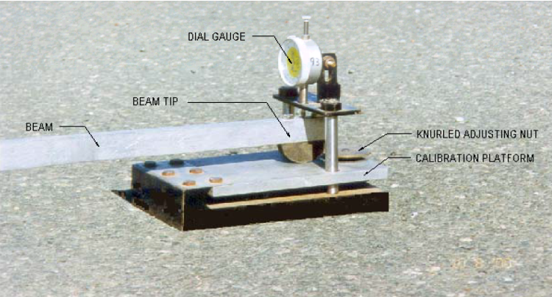

Theoretical learning Activity
- Ask trainees to brainstorm about using dial gauge.
- Ask trainees to brainstorm about read, and record data taken by dial gauge
Practical learning Activity
- Trainees make Practical exercises on gauge elements

Points to Remember (Take home message)
Data taken by dial gauge is not deflection is data which is used to interpret deflection of road

Learning outcome 3.3: formative assessment
Practical assessment: is to make practice about read and record data by using dial gauge of Benkelman.

STRUCTURE OF LEARNING UNIT 4 INTERPRET THE RESULTS

Learning outcomes:

4.1. Analyze obtained results
4.2. Draw graph of deflexion
4.3. Elaborate of a report

Learning outcome 4.1 Analyze obtained results
Duration: 2 hrs
Learning outcome 4.1 Objectives:
By the end of the learning outcome, the trainees will be able to:
- Analyze well all data need in calculation of deflection
- Analyze if in road there is any deflection by using data taken by Benkelman
- Make calculation of deflection correctly.

Resources
Equipment | Tools | Materials
Standard | reference books  Handout  Projector  Pen  Notebook  calculator | Internet
Advance preparation:
- Having prepared the working place.
- Having arranged tools, equipment and materials according to the task to be performed.
- Having made trainee’s groups in order to facilitate them to work in good conditions

Content 4.1.1: Verification of errors occurs in test processing
- Systematic error: Systematic errors are errors that affect the accuracy of a measurement. Systematic errors cause readings to differ from the true value by a consistent amount each time a measurement is made, so that all the readings are shifted in one direction from the true value

- accident error: these are the errors that occur due to inexperience, inattention, carelessness, lack of judgment, or poor judgment. Doesn't have any fixed pattern. Cannot be eliminated by adopting any standard methods of observation

Content 4.1.2: revising recorded parameters to describe precision
- working sheet data analyses
- calculation analyses
Record of Measurement: A standard form is attached for record purpose
Calibration of Equipment
The beam and the dial gauge should be calibrated annually.
This test method sets out the procedure for determining the stiffness and homogeneity of a road formation using a portable deflection beam by statistically analyzing the data.

It is very important that lots are homogeneous so that they behave as a whole, a lot that has wet areas can exhibit differential shrink and swell characteristics causing problems with overlaying layers.
The testing proceeds, but to make a valid statistical analysis of the lot being tested there is a requirement of a minimum of twelve tests evenly spaced over the entire lot.
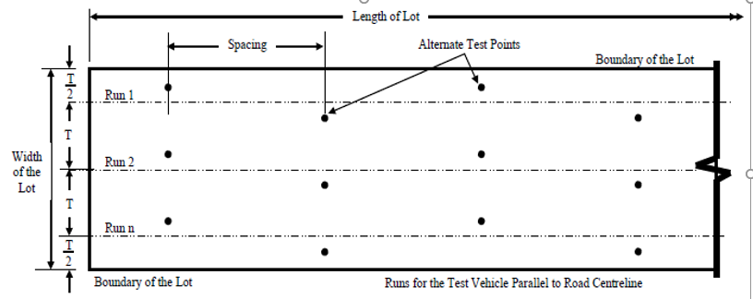
Example sample pattern for test points within a lot

The spacing must not be more than 10 m, test points must not be within 0.5 m of the boundaries of the lot and runs (T) must be positioned to equally cover the lot, these runs are not to be more than 3.6 m transversely apart. The test is conducted in alternate wheel paths to ensure the lot is adequately covered with test points.

This test method reports two main values, namely the Coefficient of Variation and Deflection.
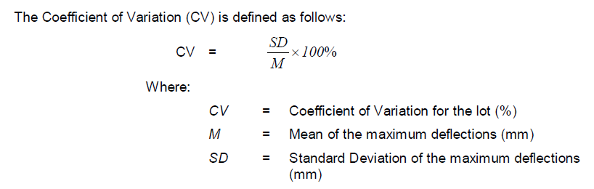
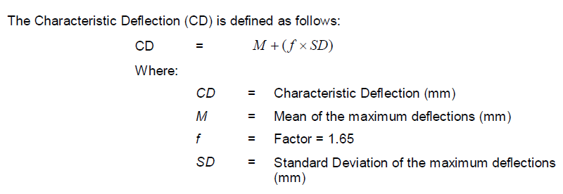
The Roads and Maritime earthwork specifications R44 requires the Characteristic Deflection to not exceed 1.2 mm, with a standard deviation of less than 0.2 mm. If the Characteristic Deflection does exceed 1.2 mm then the Coefficient of Variation must not exceed 25%.

Curvature of the deflection bowl
The curvature function (CF) of a deflection bowl is given by;

CF = D0 - D200
Where;

D0 = maximum deflection (mm) for a test point

D200 = the deflection measured at the test point when the test load is 200 mm from the point at which the maximum deflection at the test point was produced (in the direction of travel) (mm)

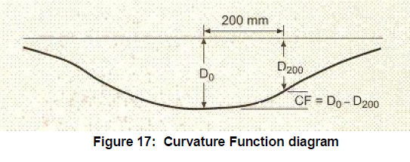
Be very careful if determining the curvature from Portable Beam readings, the portable beam measures rebound deflection.

So the D200 figure in the above equation is not the 200 mm reading as recorded. D200 will actually be the 200 mm reading subtracted from the Maximum Deflection, the beam ratio (2:1 or 3:1) correction must be applied to this calculation.

For Portable Beams;

CF = (D9m x BR) – ((D9m x BR) – (D200 x BR))
Where;
D9 m = the reading recorded at 9 m. (The 9 m reading is deemed to be the maximum deflection)
D200 = the reading as recorded at 200 mm.
BR = the beam ratio factor.
But this can be further simplified to:
CF = D200 x BR
The portable beam reading at 200 mm multiplied by the Beam Ratio factor.

CALCULATIONS

The rebound deflection of the pavement shall be calculated in the following manner:

(a) Two pavement rebound indicators shall be established by subtracting the intermediate and final readings from the start reading, ie: 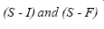
(b) If the indicators so obtained agree within 0.03mm the true rebound deflection at temperature T shall be calculated as: X_{T} =2(S-F)
(c) If the indicators (S - I) and (S - F) differ by more than 0.03mm*** the initial shape of the bowl has been such as to influence the front support legs of the instrument and the calculations shall be adjusted as follows:
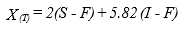
(d) The pavement rebound deflection at a standard temperature of 20°C shall be calculated from the above figure by applying the formula: 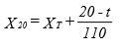
X20: temperature corrected rebound deflection in Millimetres and
t = temperature in degrees Celsius 40mm below the surface of the pavement.
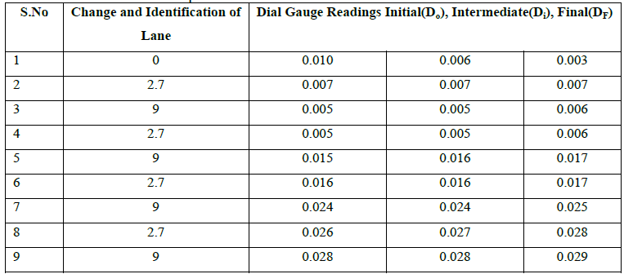
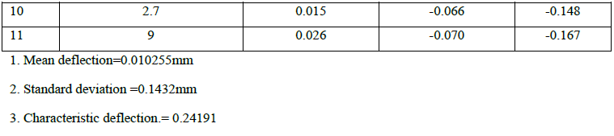
(Saeed L. I., In-situ Pavement Deflection Test, 2019-2020)
Theoretical learning Activity
- Ask trainees to brainstorm about how we can calculate deflection within groups.
- Ask trainees to brainstorm about formulae of calculate the deflection within groups.
Practical learning Activity
- Demonstrate all procedures of calculate the deflection by using formula
- Group discussion on results analysis.

Points to Remember (Take home message)
CF = D200 x BR

CF = D0 - D200

Learning outcome 4.1: formative assessment
Calculate the rebound deflection of the following data:
Test 1: start reading(DO)=0.00mm, Intermediate reading(DI)=0.51mm, final reading (DF)=0.57mm.
Test 2: start reading(DO)=0.02mm, Intermediate reading(DI)=0.25mm, final reading (DF)=0.30mm.
Answer:

For test 1:
Do=0.00mm Df-Di=0.57mm-0.51mm=0.06mm>0.025mm
Di=0.51mm D=2(Df-Do) +2K(Df-Di), K=2.91
Df=0.57mm D=2(0.57-0.00) + 2*2.91(0.57-0.51)
=1.14+0.3492=1.4892mm
For test 2
Do=0.02mm Df-Di=0.30mm-0.25mm=0.05mm>0.025mm
Di=0.25mm D=2(0.30-0.02) + 2*2.91(0.30-0.25)
Df=0.30mm =0.56+0.291=0.851mm
Average=(1.4892mm+0.851mm)/2=1.17mm

Learning outcome 4.2 draw graph of deflexion
Duration: 2 hrs
Learning outcome 4.2 Objectives:
By the end of the learning outcome, the trainees will be able to:
- interpret correctly the schematic diagram of deflection
- draw Cleary deflection graph
Resources
Equipment | Tools | Materials
 | Reference books  Handout  drawing tools  drawing paper  Pen  calculator | internet
Advance preparation:
- Having prepared the working place.
- Having arranged tools, equipment and materials according to the task to be performed.
- Having made trainee’s groups in order to facilitate them to work in good conditions

Content4.2.1: Method of drawing deflexion graph
- Manual Method
Deflection Bowl - Is a representation of the shape of the deformation of the pavement surface caused by a load being applied to the surface.
Maximum Deflection - The measured maximum vertical movement of the pavement.
Curvature - Is an indication of the shape of the Deflection Bowl which is determined by calculating the difference between the maximum deflection and the measured deflection at a point 200 mm away.
The curvature of the deflected pavement gives an indication of the fatigue performance of the pavement.

Portable beams work by measuring the rebound deflection of the road, as the truck loads the formation, moves off and the beam measures the road returning to the unloaded position as shown in Figure .5
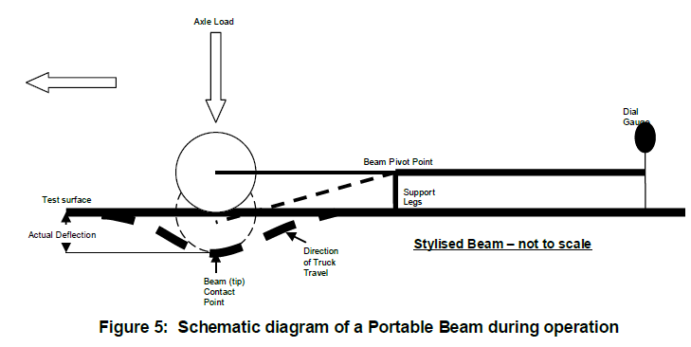
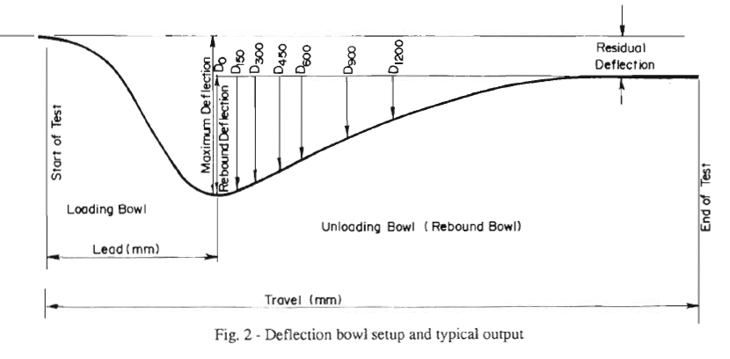

- Using Spreadsheet
2: Graph main elements:
- Time
- Load
- Deflexion (intersection)

Theoretical learning Activity
- Ask trainees to have a discussion on how we draw deflection graph within groups
- After, ask at least 4 trainees from different groups what they have discussed. Ask others to listen clearly what others are sharing.
- Then, collect and rectify various ideas from each group in order to make common understanding on the discussed topic.
Practical learning Activity
- Ask trainees to make Practical exercises on deflexion capacity graph drawing

Points to Remember (Take home message)
Always deflection should have concave shape (concave diagram)

Learning outcome 4.2: formative assessment

- What are elements required to draw Cleary deflection graph?
Answer:
- Time
- Load
- Deflexion (intersection)

- One of required drawing of Cleary deflection graph is ……………………………….
- Duration
- Client
- Time
- Designer
ANSWER:
C) Time

Learning Outcome 4.3: Elaborate a report

Duration: 1 hrs
Learning outcome 4.3 Objectives:
By the end of the learning outcome, the trainees will be able to:
- interpret Cleary the report of deflection
- identify all elements of report

Resources
Equipment | Tools | Materials
 | Reference books  Handout  drawing tools  Pen  calculator | Pen  Internet  drawing paper
Advance preparation:
- Having prepared the working place.
- Having arranged tools, equipment and materials according to the task to be performed.
- Having made trainee’s groups in order to facilitate them to work in good conditions



Content 4.3.1: Key components of working sheet

Key components of working sheet:
- Title Project Lab no
- date
- location
- Client
- Company name
- Responsible technician
- Approver Checker
- Test method
- Duration of test
- Deflexion value
Identify deflexion test report elements:
- Type of road pavement
- Reference of this procedure
- Current gauge recorded.
- The deflexion Values
- Duration of the test
Note: If the dial gauge has been modified to read pavement deflection directly, the questions in 4.1(b) and (c) must be divided by 2. If the dial gauge is graduated in an anti-clockwise direction the terms within which the brackets will have to be reversed to give a positive value.

d) The date and time of readings.

Where temperature readings are required:
(a) The pavement temperature.
(b) The depth at which the temperature is recorded.
(c) The time the temperature is taken.
Note: A larger difference can be tolerated if it is confirmed while testing that the legs of the beam are not sitting in the bowl

Theoretical learning Activity
- Ask trainees to brainstorm about elements of report within groups.
- After give each group five minutes to share what they brainstormed with others so that they can have a common understanding to the discussed topics.
Practical learning Activity
- Practical exercises on report elaboration for Deflexion capacity test

Points to Remember (Take home message)
Every report should have the following elements:
1.Type of road pavement
2.Reference of this procedure
3.Current gauge recorded.
4.The deflexion Values Duration of the test
Learning outcome 4.3: formative assessment
Written assessment
1. State ten elements of deflection test report.
Answer:
- Title
- Project
- Lab no
- date
- location
- Client
- Company name
- Responsible technician
- Approver
- Checker
- Test method
- Duration of test
- Deflexion value

CONCLUSION

From the Benkelman beam deflection technique conducted on the required stretch, the observations obtained are calculated and a design thickness of the overlay required is obtained. Hence overlay thickness of 12cm is to be laid on the existing pavement in order to sustain the increasing axle load for future 10 years. Bituminous concrete is to be laid on the existing flexible pavement

References

Anthony Bretreger, E. L. (February 2015). Deflection testing of earthwork and pavement layers. George Vorobieff, Principal Engineer, Pavements and Geotechnical,.
Anthony Bretreger, E. L. (February 2015). Deflection testing of earthwork and pavement layers. George Vorobieff, Principal Engineer, Pavements and Geotechnical,.
Anthony Bretreger, E. L. (February 2015). Deflection testing of earthwork and pavement layers. George Vorobieff, Principal Engineer, Pavements and Geotechnical,.
Saeed, I. (2019-2020). In-situ Pavement Deflection Test. Highway and Transportation Engineering.
Saeed, L. I. (2019-2020). In-situ Pavement Deflection Test. Highway and Transportation Engineering.
Saeed, L. I. (2019-2020). In-situ Pavement Deflection Test. Highway and Transportation Engineering.

