

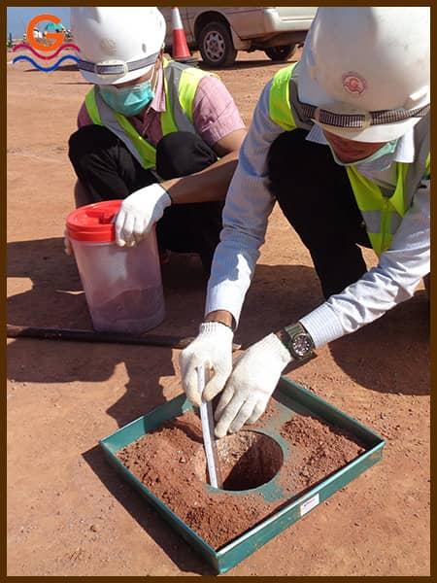
Module name: IN SITU DENSITY TEST
MODULE CODE: RCTSD501
TEACHER’S GUIDE
TRADE Road Construction
RQF LEVEL 5

Table of content

TABLE OF CONTENT I
ACRONYMS III
INTRODUCTION IV
LEARNING UNIT 1: PREPARE TOOLS, EQUIPMENT, MATERIAL AND WORKPLACE 2
LEARNING OUTCOME 1.1 PREPARE TOOLS, EQUIPMENT AND MATERIAL 3
CONTENT 1.1.1: TOOLS USED FOR DENSITY IN SITU 4
CONTENT 1.1.2 : EQUIPMENT USED FOR DENSITY IN SITU 7
CONTENT 1.1.3 : MATERIALS USED FOR DENSITY IN SITU 8
LEARNING OUTCOME 1.2 IDENTIFY TEST PROCEDURES 10
CONTENT 1.2.1: THE METHODS USED IN SITU DENSITY TEST 11
CONTENT 1.2.2: IN SITU DENSITY TEST PROCEDURES 13
LEARNING UNIT 2: EXECUTE TEST PROCEDURES 19
LEARNING OUTCOME 2.1: LOCALIZE THE TRIAL POINT 19
CONTENT 2.1.1 : THE METHODS OF POINT SELECTION 20
CONTENT 2.1.2 : THE TYPES OF MATERIALS BY LAYERS 24
CONTENT 2.1.3: STATUS OF GROUND 25
LEARNING OUTCOME 2.2 DIG AND HANDLE THE SAMPLE 27
CONTENT 2.2.1: CLEAN THE SURFACE 28
CONTENT 2.2.2: SET THE DENSITOMETER 29
CONTENT 2.2.3 : EXCAVATE (DIG) THE TRIAL HOLE 30
CONTENT 2.2.4 : MEASURE THE TRIAL HOLE 31
CONTENT 2.2.5 : MEASUREMENT OF THE MATERIALS 32
LEARNING OUTCOME 2.3: DETERMINE MOISTURE CONTENT 36
CONTENT 2.3.1 : THE MOISTURE CONTENT DETERMINATION PROCEDURES 37
CONTENT 2.3.2: CALCULATE WET AND DRY DENSITY 40
LEARNING UNIT 3: MAKE REPORT 60
LEARNING OUTCOME 3.1: ELABORATE WORKING SHEET 60
CONTENT 3.1.1: ELABORATE WORKING SHEET 61
LEARNING OUTCOME 3.2 IDENTIFY IN SITU DENSITY TEST REPORT ELEMENTS 65
CONTENT 3.2.1 : IDENTIFY IN SITU DENSITY TEST REPORT ELEMENTS 66
LEARNING OUTCOME 3.3 DESCRIBE THE FINAL RESULT 69
CONTENT 3.3.1: DESCRIBE THE FINAL RESULT 70
References: 72

Acronyms

RTB: Rwanda TVET Board
RQF: Rwanda Qualification Framework
TVET: Technical and Vocational Education and Training
MDD: Maximum Dry Density
OMC: Optimum Moisture Content
MC: Moisture Content
ASTM: American Society for Testing and Materials
MD: Mass of Density
PPE: Personal Protective Equipment

INTRODUCTION
The dry density of compacted soil or pavement materials is a common measure of the amount of the compaction achieved during the construction.
This method of test is intended for determining the in-situ density of soil.
The in situ density of natural soil is needed for:
- The determination of bearing capacity of soil
- Stability analysis of slopes,
- Determination of pressures on underlying strata for the calculation of settlement and the design of underground structures.
It is very quality control test, where compaction is required, in the cases like embankment and pavement construction.
SCOPE:
- In-situ density is widely used to control the field compaction of earthworks and pavement layers.
- Dry density of the compacted soil or pavement material is a common measure of the amount of the compaction achieved during construction.
Therefore, field density test is importance as a field control test for the compaction degree of soil or any other pavement layer

Module Code and Title: RCTSD501 IN SITU DENSITY TEST

Learning Unit 1: Prepare tools, equipment, material and workplace
Learning Unit2: Execute test procedures
Learning Unit 3: Make a report

LEARNING UNIT 1: PREPARE TOOLS, EQUIPMENT, MATERIAL AND WORKPLACE
Learning Units:
- Prepare tools, equipment, materials and workplace
- Executes test procedures
- Make a reports
2
3
n

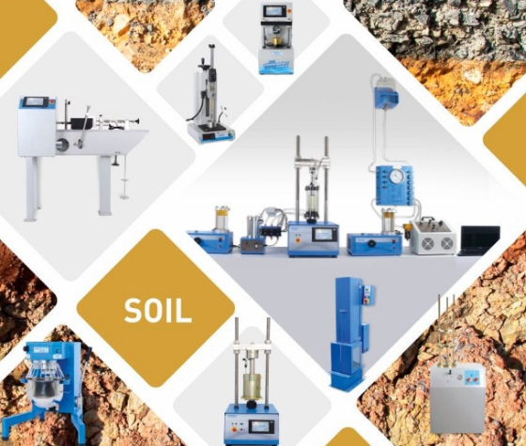

STRUCTURE OF LEARNING UNIT
Learning outcomes:
1.1 Prepare tools, equipment and material
1.2 Identify test procedures
1.3 Prepare testing point

LEARNING OUTCOME 1.1 PREPARE TOOLS, EQUIPMENT AND MATERIAL
Duration: 30min
Learning outcome 1.1 objectives :
By the end of the learning outcome, the trainees will be able to:
- Identify properly tools, equipment and materials used for density in situ

Resources
Equipment | Tools | Materials
- Balance  - Membrane densitometer Sand densitometer  - Personal protective equipment (PPE) | - Scraper  - Hammer  - specimen  - Dibber  - Trowel  - Cylindrical core cutter  - Steel Dolly  - Sand pouring cylinder  - Steel Dolly  - Steel rammer  - Calibrating container  - Metal tray  - Glass plate  - Palette knife  - Straight edge  - Sample extruder or excavating tool | - Ottawa sand  - In situ Soil
Advance preparation:
- Check if tools, equipment and materials are available.
- Check the physical status of tools, equipment and materials




CONTENT 1.1.1: TOOLS USED FOR DENSITY IN SITU

Tools used for density in situ

- Cylindrical core cutter

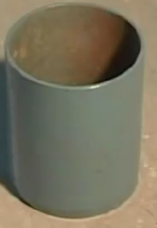

- Steel Dolly
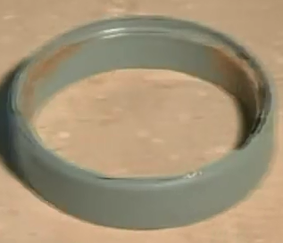
- Steel rammer
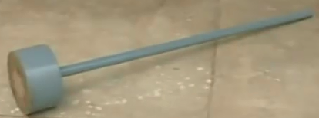

- Calibrating container
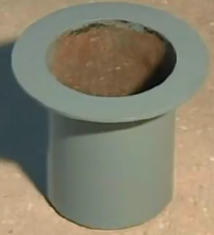

- Sand pouring cylinder
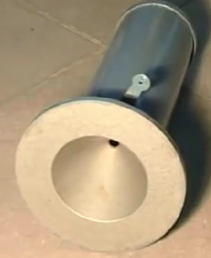

- Metal tray
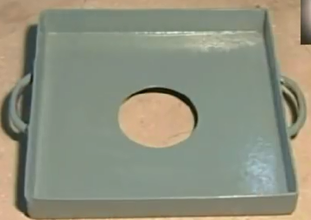

- Glass plate
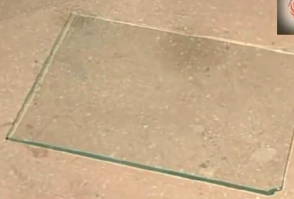

- Palette knife
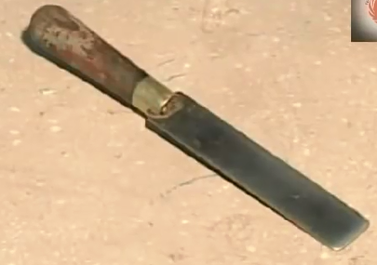
- Straight edge

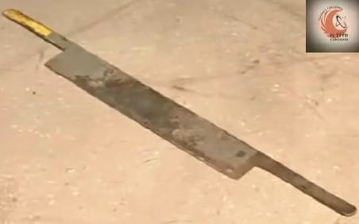

- Sample extruder or excavating tool
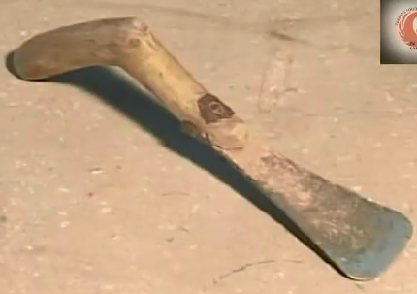

Theoretical learning Activity

In group of 4 trainees, discuss on the different tools used for density in situ

Practical learning Activity
Individual learner select different tools used for density in situ
Points to Remember (Take home message)
- Tools used for density in situ test

CONTENT 1.1.2 : EQUIPMENT USED FOR DENSITY IN SITU
- Balance: suitable balance of 15 or 30kg capacity with accuracy of 1.0 g.
- Membrane densitometer
- Sand densitometer
- Personal protective equipment

Theoretical learning Activity

In group of 2, discuss on the different equipment used for density in situ

Practical learning Activity
Ask trainees to select different equipment used to perform density in situ
Points to Remember (Take home message)

- Equipments used to perform density in situ test

CONTENT 1.1.3 : MATERIALS USED FOR DENSITY IN SITU
A. Ottawa sand: sand that can be used in Sand Cone Method for determining in situ soil density

Properties of Sand Used in Sand Cone Method
According to ASTM (1989) properties and requirements of sand that can be used in Sand Cone Method for determining in situ soil density are described below:
- Sand should be clean, dry, uniform uncemented, durable and free flowing.
- Any gradation may be used that has uniformity coefficient (C = D_{6o} I D₁₀) less than 2, a maximum particle size less than 2.00 mm (No. 10 sieve) and less than 3% by weight passing 250 tm (No. 60 sieve)
- Uniform sand is needed to prevent segregation during handling, storage and use. Sand free of fines and fine sand particles is needed to prevent significant bulk density changes with normal daily changes in atmospheric humidity.
- Sand comprised of durable, natural surrounded or rounded particles is desirable. Crushed sand or sand having angular particles may not be free flowing, a condition than can cause bridging resulting in inaccurate determinations
- In selecting sand from a potential source, five separate bulk density determinations shall be made on each container or bag of sand. To be acceptable sand, the variation between any determination and average shall not be greater than 1% of the average.
- Before using sand in density determinations it shall be dried. Then allowed to reach an air dried state in the general location where it is to be used.
- Sand shall not be reused without removing any contaminating soil, checking the gradation and drying.
- Bulk density tests shall be made at intervals not exceeding 14 days, always after any significant changes in atmospheric humidity, before reusing and before using a new batch from a previously approved supplier.

B. In situ Soil/compacted: All of the soil excavated from every hole to be tested. As you are digging the hole put the retrieved soil into the plastic bag in order that the soil does not lose moisture.
Theoretical learning Activity
Discuss on materials used for density in situ (within group of four trainees)

Practical learning Activity
Ask individual trainee to select the appropriate materials used to perform density in situ
Points to Remember (Take home message)
- The appropriate materials used to perform in situ density test (Ottawa sand and in situ soil)
- Properties of Sand Used in Sand Cone Method

Learning outcome 1.1 formative assessment
Written assessment
1. Answer the below questions by True or False answers (T or F)
- The sand should be stored in a clean container and should be clean and dry…TRUE
- In-situ density is widely used to control only the field compaction of earthwork…. FALSE
2. Multiple choice questions. Circle the letter corresponding to the correct answer
- Tool for levelling surface for in situ density test
- Panga
- Sprit level
- Scraper
- Dibber
- The height of Cylindrical steel core cutter
- 130 cm
- 13 mm
- 13 cm
- 1300 mm
Practical assessment
Ask trainees to select the appropriate materials used to perform density in situ

LEARNING OUTCOME 1.2 IDENTIFY TEST PROCEDURES

Duration:1 hr

Learning outcome 1.2 objectives :
By the end of the learning outcome, the trainees will be able to:
1. Identify the different methods used in situ density test
2. Describe clearly the methods used in situ density test
3. Identify all procedures used to perform in situ density test
Resources
Equipment | Tools | Materials
- Balance  - Membrane densitometer  - Sand densitometer  - Personal protective equipment (PPE) | - Scraper  - Hammer  - specimen  - Dibber  - Trowel  - Cylindrical core cutter  - Steel Dolly  - Sand pouring cylinder  - Steel Dolly  - Steel rammer  - Calibrating container  - Metal tray  - Glass plate  - Palette knife  - Straight edge  - Sample extruder or excavating tool | - Ottawa sand  - In situ Soil
Advance preparation:
- Method of in situ density test to be used according to the types of soil
- Identify in situ density test procedures

CONTENT 1.2.1: THE METHODS USED IN SITU DENSITY TEST

Methods used to perform In situ density test
- Sand replacement method/ Sand cone method
- Core cutter method
- Rubber balloon method
- Water replacement method
- Heavy oil method

- Sand replacement method /Sand cone method: The sand replacement method is the most widely used in-situ density test. Although the test takes slightly longer to perform than some other in-situ density tests, the test may be carried out on most type of materials.

- Core cutter method: This method is only used on fine-grained cohesive soils which do not contain stones. It is, therefore, very useful for control of earthworks and subgrade materials but is not suitable for coarse grained pavement materials.

- Rubber balloon method: The same as the sand cone, except a rubber balloon is used to determine the volume of the hole

Water Replacement Method : Is utilized to determine the dry density of soil. It’s suitable for evaluating the in-place dry density of cohesive soil because of the nature of the specimen required.

The soil sample ought to be trimmed to obtain a regular shape and then coated to make it impervious to water. After that, the total volume of this waxed specimen is found by determining the volume of water displaced from the specimen.
Even if they are many but only the two common methods are considered here. These are the “sand replacement method” and “core cutter method”.
❖One of the common methods of determining field density of fine-grained soil is core cutter method.
❖But this method has a major limitation in the case of soils containing coarse-grained particles such as:
- Gravel
- Stones and
- Aggregates

❖Under such circumstances, field density test by sand replacement method is an advantageous as the presence of grained particles will adversely affect the test results.

Theoretical learning Activity
In group of 2 trainees, identify all methods used to perform in situ density test

Points to Remember (Take home message)
- Methods used to perform in situ density test

CONTENT 1.2.2: IN SITU DENSITY TEST PROCEDURES

Test procedures
- Hole excavation: Dig up a 10 to 15 cm deep hole.
- Measuring of excavated soil weight
- Measuring of excavated soil volume
- Measuring of excavated soil moisture content
- Calculate Dry density

Theoretical learning Activity
In group of 2 trainees, identify all procedures used to perform in situ density test
Points to Remember (Take home message)
- Test procedures to perform in situ density test

Learning outcome 1.2 formative assessment
Written assessment
1. Answer the below questions by True or False answers (T or F)
- The sand should be stored in a clean container and should be clean and dry…TRUE
- In-situ density is widely used to control only the field compaction of earthwork…. FALSE

2. Multiple choice questions
- Tool for levelling surface for in situ density test
- Panga
- Sprit level
- Scraper
- Dibber
- The height of Cylindrical steel core cutter
- 130 cm
- 13 mm
- 13 cm
- 1300 mm
Practical assessment
Ask trainees to select the appropriate materials used to perform density in situ

LEARNING OUTCOME 1.3: PREPARE TEST POINT
Duration: 30 min

Learning outcome 1.3 objectives :
By the end of the learning outcome, the trainees will be able to:
- Identify the three main steps of preparing test point
- Outline the preparation techniques of in situ density workplace
- Perform all procedures of test point preparation
Resources
Equipment | Tools | Materials
- Balance  - Membrane densitometer  - Sand densitometer  - Personal protective equipment (PPE) | - Scraper  - Hammer  - specimen  - Dibber  - Trowel  - Cylindrical core cutter  - Steel Dolly  - Sand pouring cylinder  - Steel Dolly  - Steel rammer  - Calibrating container  - Metal tray  - Glass plate  - Palette knife  - Straight edge  - Sample extruder or excavating tool | - Ottawa sand  - In situ Soil
Advance preparation:
- Proper use of tools and equipment used to prepare test point
- Localize the test point
- Prepare the test point

CONTENT 1.3.1: TEST POINT PREPARATION PROCEDURES

Test point preparation procedures
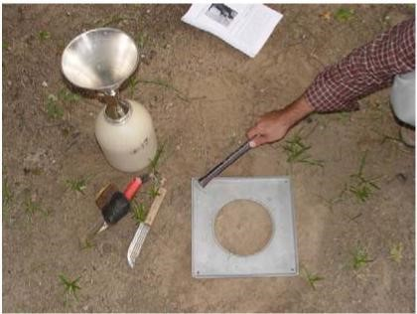
- Levelling
- Swiping
- Placing plate

Preparation techniques of in situ density workplace
- Remove hazardous products
- Mark trial points

The procedures of test point preparation
- Expose an area of about 450mm square on the surface of the soil mass. Trim the surface down to a level surface using a scrapper tool.
- Place the metal tray on the levelled surface.
- Excavate the soil though the central hole of the tray, using the hole in the tray as a pattern. The depth of the excavated hole should be about 150mm.
- Collect all the excavated soil in a metal container, and determine the mass of the soil (M).
- Remove the metal tray from the excavated hole.
- Fill the sand pouring cylinder within 10mm of its top.
Determine its mass (M).
- Place the cylinder directly over the excavated hole. Allow the sand to run out the cylinder by opening the shutter. Close the shutter when the hole is completely filled and no further movement of sand is observed.
- Remove the cylinder from the filled hole. Determine the mass of the cylinder (M).
- Take a representative sample of the excavated soil.
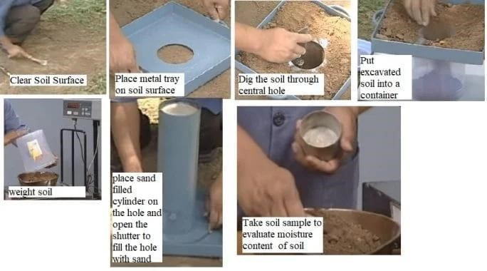

Theoretical learning Activity

In group of 4 trainees, discuss on the procedures of test point preparation

Practical learning Activity
Ask trainees (in group of 4), to prepare area and make the procedures of test point preparation.
Points to Remember (Take home message)
- Three main steps of preparing test point
- Preparation techniques of in situ density workplace
- The procedures of test point preparation

LEARNING UNIT 2: EXECUTE TEST PROCEDURES

STRUCTURE OF LEARNING UNIT 2: EXECUTE TEST PROCEDURES

Learning outcomes:
2.1. Localize the trial point
2.2. Dig and handle the sample
2.3. Determine moisture content

LEARNING OUTCOME 2.1: LOCALIZE THE TRIAL POINT

Duration: 5 hrs
Learning outcome 2.1 objectives :
By the end of the learning outcome, the trainees will be able to:
1. Describe properly the methods of point selection
2. Identify the types of materials by layers
3. Discuss about the Status of ground
Resources
Equipment | Tools | Materials
- The oven-dry  - Sand pouring cylinder  - Container  - Balance | - scraper  - Dibber or elongated trowel | - Ottawa sand  - In situ Soil  - Mar rum  - Water
Advance preparation:
- The appropriate methods of point selection
- Appropriate tools and equipment required for point selection
- Types of hazardous products

CONTENT 2.1.1 : THE METHODS OF POINT SELECTION

Methods of point selection are:
- Randomly
- Systematically
- Randomly
Simple random sampling is a type of probability sampling in which the researcher randomly selects a subset of participants from a population. Each member of the population has an equal chance of being selected. Data is then collected from as large a percentage as possible of this random subset.

Random sampling offers two primary advantages.
- Lack of Bias
- Each point has an equal chance of being chosen
- Simplicity (easy to implement)
Disadvantages of a Simple Random Sample
- Difficulty Accessing Lists of the Full Population
In simple random sampling, an accurate statistical measure of a large population can only be obtained when a full list of the entire population to be studied is available. In some instances, details on a population of students at a university or a group of employees at a specific company are accessible through the organization that connects each population
- Time Consuming
When a full list of a larger population is not available, individuals attempting to conduct simple random sampling must gather information from other sources. If publicly available, smaller subset lists can be used to recreate a full list of a larger population, but this strategy takes time to complete. Organizations that keep data on students, employees, and individual consumers often impose lengthy retrieval processes that can stall a researcher's ability to obtain the most accurate information on the entire population set
- Costs
In addition to the time it takes to gather information from various sources, the process may cost a company or individual a substantial amount of capital. Retrieving a full list of a population or smaller subset lists from a third-party data provider may require payment each time data is provided. If the sample is not large enough to represent the views of the entire population during the first round of simple random sampling, purchasing additional lists or databases to avoid a sampling error can be prohibitive.
- Sample Selection Bias
Although simple random sampling is intended to be an unbiased approach to surveying, sample selection bias can occur. When a sample set of the larger population is not inclusive enough, representation of the full population is skewed and requires additional sampling techniques.
- Systematic Sampling
Systematic sampling is simple rand more straightforward than random sampling.
It can also be more conducive to covering a wide study area. On the other hand, systematic sampling introduces certain arbitrary parameter sin the data. This can cause over-or under representation of particular patterns.
Systematic sampling is popular with researchers because of its simplicity.
Researchers generally assume the results are representative of most normal populations, unless a random characteristic disproportionately exists with every "nth" data sample (which is unlikely).
Systematic Sampling Example
In a systematic sample, chosen data is evenly distributed. For example, in road construction you are given a compacted road to test in situ density, the road measures ten kilometre (10Km) and you are asked to take sample systematically in three parallel points every fifty metre (50m), one point in the middle another point at the right side and other one at left side of the road.
Advantages of Systematic Sampling
The pros of systematic sampling include:
- Easy to Execute and Understand
Systematic samples are relatively easy to construct, execute, compare, and understand. This is particularly important for studies or surveys that operate with tight budget constraints.
- Control and Sense of Process
A systematic method also provides researchers and statisticians with a degree of control and sense of process. This might be particularly beneficial for studies with strict parameters or a narrowly formed hypothesis, assuming the sampling is reasonably constructed to fit certain parameters.
- Clustered Selection Eliminated
Clustered selection, a phenomenon in which randomly chosen samples are uncommonly close together in a population, is eliminated in systematic sampling. Random samples can only deal with this by increasing the number of samples or running more than one survey. These can be expensive alternatives.
- Low Risk Factor
Perhaps the greatest strength of a systematic approach is its low risk factor. The primary potential disadvantages of the system carry a distinctly low probability of contaminating the data.
Disadvantages of Systematic Sampling
There are also drawbacks to this research method:
- Assumes Size of Population can be Determined
The systematic method assumes the size of the population is available or can be reasonably approximated. For instance, suppose researchers want to study the size of rats in a given area. If they don't have any idea how many rats there are, they cannot systematically select a starting point or interval size.
- Need for Natural Degree of Randomness
A population needs to exhibit a natural degree of randomness along the chosen metric. If the population has a type of standardized pattern, the risk of accidentally choosing very common cases is more apparent.
For a simple hypothetical situation, consider a list of favorite dog breeds where (intentionally or by accident) every evenly numbered dog on the list was small and every odd dog was large. If the systematic sampler began with the fourth dog and chose an interval of six, the survey would skip the large dogs.

- Greater Risk of Data Manipulation
There is a greater risk of data manipulation with systematic sampling because researchers might be able to construct their systems to increase the likelihood of achieving a targeted outcome

Theoretical learning Activity

In a group of 4 trainees, discuss on the methods of point selection

Practical learning Activity
Individual trainee, localize the trial points randomly.
Points to Remember (Take home message)
- Identify the methods of point selection
- Advantages and disadvantages of random sampling
- Advantages and disadvantages of Systematic Sampling

CONTENT 2.1.2 : THE TYPES OF MATERIALS BY LAYERS
- Platform: is the layer directly in contact with traffic loads and generally contains superior quality materials. They are usually constructed with dense graded asphalt concrete (AC).
The functions and requirements of this layer are:
- It provides characteristics such as friction, smoothness, drainage, etc.
- It will prevent the entrance of excessive quantities of surface water into the underlying base, sub-base and sub-grade.
- It must be tough to resist the distortion under traffic and provide a smooth and skid- resistant riding surface.
- It must be water proof to protect the entire base and sub-grade from the weakening effect of water.
- Foundation: The pavement foundations generally consist of two layers: the sub-base and the base course
These layers must perform the following functions:
  - Provide a level surface with a good bearing capacity and act as a satisfactory temporary wearing course during works.
  - Once pavement construction is complete, provide the roadbed with thermal protection and give the pavement sufficient strength to withstand the vertical loads generated by traffic.
- Marrum (well graded lateritic soil): Murrum is widely used material for the construction of pavement shoulders. Sometimes the available murrum may not satisfy the requirement of CBR and hence need to be modified. The locally available granular material like sand and/ or the crusher dust may be mixed to the soil to obtain the desired characteristics.
- Base course: The base course is the layer of material immediately beneath the surface of binder course and it provides additional load distribution and contributes to the sub-surface drainage it may be composed of crushed stone, crushed slag, and other untreated or stabilized materials.

Theoretical learning Activity

In a group of 4 trainees, discuss on the types of materials by layers
Points to Remember (Take home message)
- Identify the types of materials by layers
- The function of layers
- The functions and requirements of platform layer

CONTENT 2.1.3: STATUS OF GROUND

1. Ground clearing
Clearing and grubbing involves the removal of trees and brush on a piece of land. Depending on the size, location, and purpose of the land, the excavation may require professional land clearing equipment.
Pushover, cut, grind and burning are three of the most used land clearing methods.
- The pushover method of land clearing often involves the use of major construction equipment. The trees are pushed over and hauled off the land with the roots intact. Once the trees are moved to a central location, they are often processed for sale or ground for use as a mulching material.
- Cut and grind. This method begins with cutting down the trees on the piece of land. These trees are often moved to a processing location, but the stumps are left in the ground. These stumps can be ground into mulching material or pulled out of the ground using a large piece of construction machinery.
- Control burn for land clearing. It can be one of the most dangerous methods. Burning involves starting a controlled fire and maintaining that fire until all trees and brush are burned to the ground. After the fires are extinguished, the land can be cleared using a bull dozer or other piece of construction equipment.

2. Ground levelling
Ground levelling is the process of clearing debris from worksites, and creating an even surface. It’s a key function at constructions sites, for road building.

Importance of ground levelling at construction sites
Ground levelling is one of the most important tasks on a construction site. It provides a level, well-compacted, and stable surface on which to build sturdy foundations.
Once the site is perfectly even, and the foundations are laid, grading is required to adjust the slope and elevation of the site so that water flows away from the foundations.
Grading is also the technique used to create landscaping features on a property. Properly graded slopes prevent water from pooling, and eroding driveways and paths, damaging plants and shrubs, and attracting mosquitos.

Importance of ground levelling at road building sites
During road construction, one of the first steps is to level the ground to create an even surface on which to build a solid base.
Theoretical learning Activity

In group of 2 trainees, discuss clearly the Status of Ground
Points to Remember (Take home message)
- Ground clearing
- Ground levelling

Learning outcome 2.1 formative assessment
Written assessment
1. What are the methods of selection point location of sample?
Ans/ Methods of selection point location of sample are Randomly and Systematic
Practical assessment
In a group of 2 trainees, localize the trial points randomly.

LEARNING OUTCOME 2.2 DIG AND HANDLE THE SAMPLE

Duration: 10 hrs

Learning outcome 2.2 objectives :
By the end of the learning outcome, the trainees will be able to:
- Clean the surface
- Set the densitometer
- Excavate (dig) the trial hole
- Measure the trial hole
- Measurement of the material
Resources
Equipment | Tools | Materials
- Balance  - Membrane densitometer  - Sand densitometer  - Personal protective equipment (PPE) | - Scraper  - Hammer  - specimen  - Dibber  - Trowel  - Cylindrical core cutter  - Steel Dolly  - Sand pouring cylinder  - Steel Dolly  - Steel rammer  - Calibrating container  - Metal tray  - Glass plate  - Palette knife  - Straight edge  - Sample extruder or excavating tool | - Soil  - Sand
Advance preparation:
- Appropriate tools and equipment required for Cleaning the surface
- Check the availability and status of densitometer
- Appropriate use of densitometer
- Check the availability and status of Excavating tools and equipment
- Check the availability and status of measuring tools for the trial hole
- Check the availability and status of balance for measuring the materials

CONTENT 2.2.1: CLEAN THE SURFACE

Sampling process
- Surface cleaning: Expose a flat area, approximately 600mm square (approximately 450mm square for the small cylinder method) of the soil to be tested and trim it down to a level surface. Brush away any loose material which is not part of that being tested. The surface should be as level as possible in order to reproduce the laboratory calibration conditions.

Theoretical learning Activity

In a group of 2 trainees, discuss on how the surface should be cleaned

Practical learning Activity

Individual trainee, clean the surface as level as possible in order to reproduce the laboratory calibration conditions.
Points to Remember (Take home message)
- How to clean the surface?

CONTENT 2.2.2: SET THE DENSITOMETER
Setting of densitometer: place the metal tray and fasten the 4 screws. Lay the metal tray on the prepared surface with the hole over the portion of the soil to be tested. Run a trowel or other sharp tool around the outside of the tray, marking square on the surface of the soil being tested. This will help to position the pouring cylinder during the later stages of the test. It is often helpful for the tray to be nailed to the ground to stop it moving during the excavation of the test hole

Theoretical learning Activity

In a group of 2 trainees, discuss on how to use densitometer

Practical learning Activity

Individual trainee, have to determine the density by using densitometer.
Points to Remember (Take home message)
- Setting of densitometer

CONTENT 2.2.3 : EXCAVATE (DIG) THE TRIAL HOLE
Excavation (digging): Dig up a 10 to 15 cm deep hole. Using the hole in the metal tray as a pattern, excavated a round hole, approximately 200 mm in diameter (100 mm for the small cylinder method) and the depth of the layer to be tested up to a maximum of 250 mm deep (150 mm for the small cylinder method). Do not leave loose material in the hole and do not distort the immediate surround to the hole. Carefully collect all the excavated soil from the hole and determine its mass, mw to the nearest 10g (1 g for the small cylinder method). Remove the metal tray before placing the pouring cylinder in position over the excavated hole.
Note: Take care in excavating the hole to see that the hole is not enlarged by levering the excavating tool against the side of the hole, as this will result in lower densities being recorded.
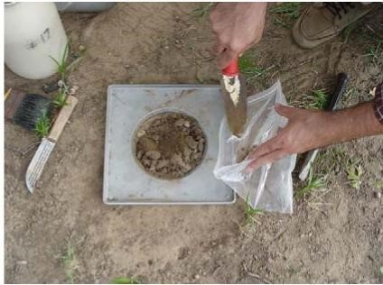
As you are digging the hole put the retrieved soil into the plastic bag in order that the soil does not lose moisture. All of the soil including the soft soil at the bottom of the hole is poured into the bag as well.

Theoretical learning Activity

In a group of 2 trainees, discuss on how to excavate (dig) the trial hole according to the standard measurement.

Practical learning Activity

In a group of 2 trainees, have to excavate the trial hole of 13cm deep.
Points to Remember (Take home message)
- Using the hole in the metal tray as a pattern, excavate a round hole

Content 2.2.4 : Measure the trial hole

Measurement of the hole
After flow of sand stops close the valve and pick the assembly up, the sand in the cone will be poured into the tray. This sand will be left there in the field. (Notice, unlike this picture, the plastic bag should be kept closed while transferring to the lab to avoid moisture loss and consequently weight of the soil)
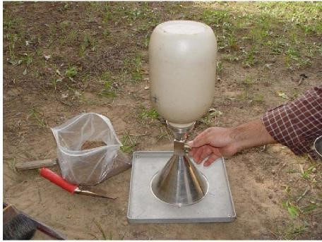

Theoretical learning Activity

In a group of 2 trainees, discuss on how to measure the hole according to the standard measurement.

Practical learning Activity

In a group of 2 trainees, ask trainees to measure the excavated hole (refer to the content 3)
Points to Remember (Take home message)
- Measurement of the hole

Content 2.2.5 : Measurement of the materials

Measurement of the materials: Measure the weight of plastic Gallon+Cone+Sand,
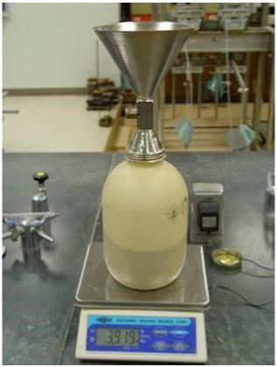

Practical learning Activity
Individual trainee, ask trainee to measure the excavated materials (refer to the content 3)
Points to Remember (Take home message)
- Measurement of excavated materials

Learning outcome 2.2 formative assessment
Written assessment
- Answer the below questions by True or False answers (T or F)
- It is not advised to leveller and remove all loose material on the area to be tested during sampling……...FALSE
- The sand should be stored in a clean container and should be clean and dry……… TRUE
- Choose the correct answer. Suitable balance of 15 or 30kg capacity with accuracy of
- 1.0 mg
- 1.0 kg
- 1.0 g
- 10 g
- Enumerate all steps followed while sampling
Answer:
- Clean the surface
- Set the densitometer
- Excavate (dig) the trial hole
- Measure the trial hole
- Measurement of the material
Practical assessment
In a group of two trainees, perform all steps of sampling process
Observation checklist

Criteria  Passing Line | Indicators:  Compulsory(C); Tolerable(T) | Score per indicator | Mark |  | Observation/Remarks
Quality of process | - Personal grooming is respected (Wearing PPE)  (C) |  |  | ......./
Quality of process | - Tools and equipment are well selected (C) |  |  | ......./
Quality of process | - Tools and equipment are well used (C) |  |  | ......./
Quality of product | Surface is well cleaned (C) |  |  | …../
Quality of product | Densitometer is well set (C) |  |  | …../
Quality of product | The trial hole is well excavated (C) |  |  | …../
Quality of product | The trial hole is well measured (C) |  |  | …../
Quality of product | The materials is well measured (C) |  |  | …../
Relevance | - Time is respected (T) |  |  | …./
Relevance | - Dimension of trial hole is respected (C) |  |  | …./
Relevance | - Cleaning the site is well done (C) |  |  | …./
Total Global passing line 70/100 to be declared COMPETENT

Comments:
Success of the criteria: all the compulsory indicators (C) have to be passed in order to succeed the criterion; passing line per task as competent is 12 indicators out of 15 indicators have to be succeeded by the learner in order to succeed and declared competent in the assessment of the task.
DECISION OF PANNEL
Competent

Not Yet Competent:

LEARNING OUTCOME 2.3: DETERMINE MOISTURE CONTENT

Duration: 10 hrs

Learning outcome 2.3 objectives :
By the end of the learning outcome, the trainees will be able to:
1. Recognize the moisture content determination procedures.
2. Calculate the wet and dry density
3. Describe properly the method used to calculate wet and dry density
Resources
Equipment | Tools | Materials
- Sand pouring cylinder  - Container  - Balance  - Cylindrical steel core cutter  - Glass weighing bottles  - Oven | - Scraper  - Dibber  - Elongated trowel  - Steel rammer  - Palette knife  - Steel rule  - Pickaxe  - Straight edge  - Short-handled hoe  - Spade  - Scoop  - Desiccator | - Sand  - Soil  - Gypsum
Advance preparation:
. Measurement of the materials

. Proper use of tools and equipment required for Moisture content determination procedures

CONTENT 2.3.1 : THE MOISTURE CONTENT DETERMINATION PROCEDURES

Moisture content determination procedures
- Sample weight
- Specimen weight
- Specimen weight with wet materials
- Specimen weight with dry materials

Water is present in most naturally occurring soils and has a profound effect in soil behaviour.
A knowledge of the moisture content is used as a guide to the classification. It is also used as a subsidiary to almost all other field and laboratory tests of soil.
The oven-drying method
It is the definitive method of measuring the moisture contents of soils
The oven-drying method (standard method) Apparatus
- Thermostatically controlled drying oven capable of operating to 105±50C.
- Glass weighing bottles or suitable metal containers (corrosion-resistant tins or trays).
- Balance (to the required sensitivity).
- Desiccator containing anhydrous silica gel.
- Scoop, other small tools as appropriate.

Optional: Test sieves - 2 mm, 20 mm, and 37.5 mm (to check classification of sample, in order to confirm required sample size).

Test procedure
- One clean container with the lid (if fitted) is taken and the mass in grams is recorded (m1) together with container number.
Note: The container plus lid or bottle plus stopper should have the same number and be used together.
- The sample of wet soil is crumbled and placed in the container. The container with the lid on is weighed in grams (m2).
- The lid is removed and both lid and container are placed in the oven. The sample is then dried in a thermostatically controlled drying oven which is maintained at a temperature of 105±50C. A period of 16 to 24 hours is usually sufficient, but this varies with soil type. It will also vary if the oven contains a large number of samples or very wet samples. The soil is considered dry when the differences in successive weightings of the cooled soil at 4 hour intervals do not exceed 0.1% of the original mass.
Note.
- For peats and soils containing organic matter a drying temperature of 600C is to be preferred to prevent oxidation of organic matter.
- For soils containing gypsum a maximum drying temperature of 800C is preferred. The presence of gypsum can be confirmed by heating a small quantity of soil on a metal plate. Grains of gypsum will turn white within a few minutes, but most other mineral grains will remain unaltered.

d) The container is removed from the oven. For medium and coarse-grained soils, the lid should be replaced (if fitted) and the sample allowed to cool. For fine-grained soils, the container and lid, or bottle and stopper if used, should preferably be placed in a desiccator and allowed to cool. After cooling, the lids or stoppers should be replaced and the container plus dry soil weighed in grams (m3).

Moisture content, 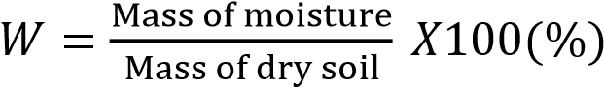

The sand-bath method is used, where oven drying is not possible, mainly on site
Moisture content, 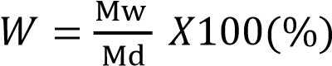
Where, Md = mass of water
Md = dry mass of sample
Sample mass. The mass required for the test depends on the grading of the soil, as follows;
- Fine-grained soils*, not less than 30 grams
- Medium-grained soils*, not less than 300 grams
- Coarse-grained soils*, not less than 3 kg

Soils group
- Fine-grained soils: Soils containing not more than 10% retained on a 2 mm test sieve.
- Medium-grained soils: Soils containing more than 10% retained on a 2 mm test sieve but not more than 10% retained on a 20 mm test sieve.
- Coarse-grained soils: Soils containing more than 10% retained on a 20 mm test sieve but not more than 10% retained on a 37.5 mm test sieve.
Accuracy of weighing. The accuracy of weighing required for test samples is as follows;
- Fine-grained soils: within 0.01 g.
- Medium-grained soils: within 0.1 g.
- Coarse-grained soils: within 1g.

Safety aspects
- Heat-resistant gloves and / or suitable tongs should be used to avoid personal injury and possible damage to samples.
- If glass weighing bottles are used, they should be placed on a high shelf away from heating elements. A heat-insulated pad should always be used to place hot glassware of any description.

Theoretical learning Activity

In a group of 4, Discuss on the moisture content determination procedures
Points to Remember (Take home message)
- Moisture content determination procedures

CONTENT 2.3.2: CALCULATE WET AND DRY DENSITY
Density determination
- Weight of sand pouring in cylinder and sand filled up to 10mm from top edge
- Weight of sand in the cone, mean value
- Weight of cylinder and the sand after pouring into the calibration container and cone
- Weight of cylinder and sand after pouring into the excavated hole and cone
- Volume of excavating container
- Weight of the materials from the excavated hole

Methods commonly used to calculate wet and dry density
- Core cutter method
- This method is only used on fine-grained cohesive soils which do not contain stones.
- It is, therefore, very useful for control of earthworks and subgrade materials but is not suitable for coarse grained pavement materials.
- The test involves jacking or hammering a steel cylinder of known mass and volume into the soil,
- Excavating it and finding the mass of soil contained in the cylinder.
Apparatus:
The following apparatus is required for the test:
- Cylindrical steel core cutter. 130 mm long and of 100±2 mm internal diameter, with a wall thickness of 3mm beveled at one end, of the type illustrated
The cutter shall be kept lightly greased.
Note: If the average density over a smaller depth is required, then the appropriate length of cutter should be used.
- Steel dolly, 25 mm high and of 100 mm internal diameter, with a wall thickness of 5mm, fitted with a lip to enable it to be located on top of the core cutter
- Steel rammer.
- Balance, readable to 1 g.
- Palette knife, a convenient size is one having a blade approximately 200 mm long and 30 mm wide.
- Steel rule, graduated to 0.5 mm.
- Short-handled hoe, or spade, and pickaxe.
- Straight edge, e.g. a steel strip about 300 mm long 25 mm wide and 3 mm thick with one beveled edge.
- Apparatus for moisture content determination.
- Apparatus for extracting samples from the cutter (optional).
Care of apparatus.
- The condition of the cutting edge should be frequently checked as any damage will lead to inaccuracy in the test.
- A badly damaged edge may be reformed on a lathe taking care to cut the new edge square to the long axis of the mold.
- Any repair to the cutting edge will require the mold factor to be predetermined.

Preparation of apparatus
- Calculate the internal volume of the core cutter in cubic centimeters from its dimensions which shall be measured to the nearest 0.5 mm (Vc)
- Weigh the cutter to the nearest 1 g (mc).
- Mold factor,
  - To assist in the calculation of the bulk density of the soil it can be useful to calculate a mold factor for each cutter and to stamp or paint the value on the mold.
  - For the size of core cutter detailed above, the mold factor ratio F/H calculates as 0.979.
  - This value would be used as a multiplier for the mass of wet soil in the core cutter (in g).
Alternatively, a mold factor can be calculated as:
Mold Factor: F$=\frac{p}{4}X\frac{D²XH}{1000²}X1000$
F = 0.7854 x $\frac{D²XH}{1000²}$
Where,
D is the diameter of the mold in mm.
H is the height of the mold in mm.
The value obtained from this calculation is used as a divisor to the mass of wet soil in the core cutter (in g).
Procedures:
1) First, levelled and remove all loose material on the area to be tested.
2) Placed lightly greased mold with driving dolly fixed, in position with the cutting edge on the prepared surface.
3. Then, drive a mold slowly into the soil by use of a jack or with a suitable rammer
  - Take care not to rock the mold and drive the cutter until only about 10 mm of the dolly remains above the surface of the soil.
  - The use of a jack is to be preferred as this causes least disturbance to the soil.
  - However, some form of reaction weight such as a vehicle is required.
  - To use a jack, a block of wood is first placed on the top of the dolly and a hydraulic or screw jack is then placed between the wood block and the underside or the reaction weight (normally a jeep).
4. Then, extended jack so that the mold is driven squarely into the ground until only about 10mm of dolly is remaining above the surface.
5. Continue driving until the soil completely fills the mold. If the soil fills in the dolly, there is a danger of compressing the soil in the mold, thus giving incorrect results.
6. Dig out the mold, dolly and soil from the ground using a spade. The soil in the mold should not be disturbed during this operation.
7. Then, remove the driving dolly from the mold and the soil protruding from each end of the mold trimmed off using a straight edge.
8. Weigh the mold and soil, m_{s}.
9. Then, remove the soil in the mold; crumble (crush) and representative samples taken for moisture content.

Calculation and expression of results from core cutter methods
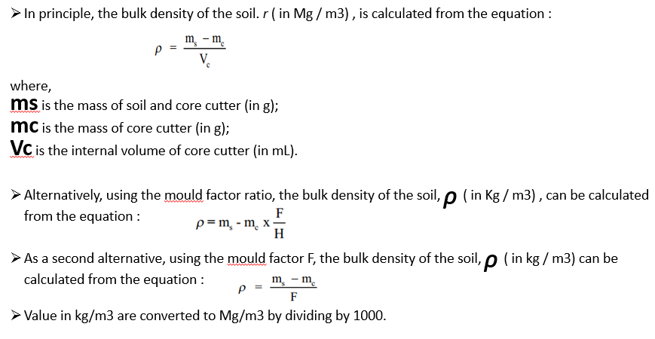

- Calculate the dry density, ᵨd (Mg/m3) from equation:
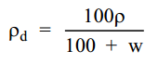
- Where, W is the moisture content of the soil (in %).
- The in-situ bulk and dry densities of the soil (Mg/m3), are expressed to the nearest 0.01 Mg/m³.
EXAMPLES:
- Check the compaction degree from the following taken data:
- Weight of core cutter, M1= 50.7g
- Weight of wet soil + core cutter, M2= 118.4g
- Weight of dry soil + core cutter, M3= 105g
- Volume of container, Vc= 1020.5g
- Maximum dry density of soil is 1.67g/cm³

- Check the compaction degree from the following taken data:
- Weight of core cutter, M1= 995g
- Weight of wet soil + core cutter, M2= 2,834g
- Weight of dry soil + core cutter, M3= 2,796.94g
- Volume of container, Vc= 1020.5g
- Maximum dry density of soil is 1.84g/cm³

- Determine the weight of water from the following taken data
- Mass of wet soil + core cutter (M1) =2,834g
- Mass of core cutter (mc) = 995g
- Mass of dry soil + core cutter (M2) =2,792g

Answer:
Weight of water, w= M1-M2
Weight of water, w= 2,834g-2,792g = 42g
- Determine the weight of water from the following taken data
- Mass of wet soil + container (M1) is 142.27g
- Mass of dried soil (Ms) is 90.3g
- Mass of container (M3) is 37.06 g
Answer:
- Mass of wet soil= 142.27g- 37.06g=105.21g
- Weight of water= 105.21g – 90.3g= 14.91g
- Determine the dry density of soil from the following taken data:
- Bulk density= 1.80g/cm³
- Moisture content of the soil (in %)= 16.5%

Answer:

- $Dry density =\frac{1.80g/cm3}{1+16.5\%}$ =1.54g/cm³

- Determine the dry density of soil from the following taken data:
- Bulk density= 1.47g/cm³
- Moisture content of the soil (in %)= 15.3%

Answer:

- $Dry density=\frac{1.47g/cm3}{1+15.3\%}$= 1.27g/cm³

- Check the compaction percentage from the following taken data.

- Dry density of soil =1.80g/cm³
- Maximum dry density 1670kg/m³
Answer:
$Compaction percentage=\frac{1.80g/cm3}{1.67g/cm3}$ ^{X} 100= 92%
- Check the compaction percentage from the following taken data and analyze the decision to be taken as if you are the one who is in charge.
- Weight of soil (Ws)=1501.2 g
- Volume of container, Vc=1020.5cm³
- Moisture content, W= 24.6%
- Maximum dry density =1.67 g/cm³

Answer:
- $Bulk density, P=\frac{1501.2 g }{1020.5cm3}$ ⁼ 1.47 g/cm³
- $Dry density, Pd=\frac{1.47 g/cm3 }{1+24.6\%}$= 1.18g/cm³

- $Degree of compaction=\frac{1.18g/cm3 }{1.67g/cm3}$ ^{X} 100 = 70.6%
Compaction degree of soil which is well compacted varies between 90-100%
Degree of compaction obtained is 70.6%. So, the compaction must be done again.
b) Sand replacement method
- The basic principle of sand replacement method is to measure the in situ volume from which the material was excavated from the weight of sand with known density filling in the hole.
- The in situ density of the material is given by the weight of excavated material divided by in situ volume
Apparatus:
- Sand pouring cylinder equipment:
    - Small pouring cylinder
    - Large pouring cylinder
    - Medium pouring cylinder

- Tools for leveling and excavating
    - Scraper with handle for leveling surface
    - Dibber or elongated trowel for digging and excavating material
c) Container: metal containers of any convenient size (about 150mm diameter and 200mm depth) with removable lid for collecting the excavated material.
d) Sand: dry and clean test sand of uniform gradation, passing 1.0mm and retained in 600-micron sieve.
e) Balance: suitable balance of 15 or 30kg capacity with accuracy of 1.0 g.
Prepare test point
Test point preparation procedures
A. Leveling
B. Swiping
C. Placing plate

Procedures:
- Expose an area of about 450mm square on the surface of the soil mass. Trim the surface down to a level surface using a scrapper tool.
- Place the metal tray on the leveled surface.
- Excavate the soil though the central hole of the tray, using the hole in the tray as a pattern. The depth of the excavated hole should be about 150mm.
- Collect all the excavated soil in a metal container and determine the mass of the soil (M).
- Remove the metal tray from the excavated hole.
- Fill the sand pouring cylinder within 10mm of its top.
- Determine its mass (M).
- Place the cylinder directly over the excavated hole. Allow the sand to run out the cylinder by opening the shutter. Close the shutter when the hole is completely filled and no further movement of sand is observed.
- Remove the cylinder from the filled hole. Determine the mass of the cylinder (M).
- Take a representative sample of the excavated soil.
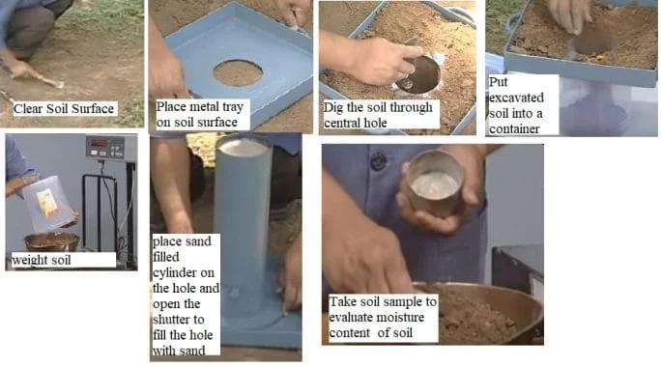

Procedures:
The test requires two stages:
- Calibration of apparatus
- Measurement of field density

- Calibration of apparatus
The determination of volume of the excavated hole is based on weight of sand filling the hole and the cone and the density of the sand.
Calibration includes:
- Determination of density of test sand used in the experiment under identical height and pouring conditions of the sand into the test hole
- Determination of the weight of the sand occupying the cone of the sand pouring cylinder.
Calibration procedures
- Clean and dry test sand of sufficient quantity required for at least three to four sets of tests.
- Remove top cap of sand pouring cylinder and close the shutter.
- Fill the cylinder with dry test sand and the cap is replaced.
- Determine the weight of cylinder with the sand with accurate to one gram. W1.
- Place the sand pouring cylinder over the calibration cylinder or one of the test holes already excavated, open the shutter and the sand equal to the volume of the calibration cylinder or excavated test hole is allowed to flow out and the shutter is closed.
- Place the pouring cylinder on clean plane surface (glass or Perspex plate), and keep the shutter open till the sand fills up the cone fully.
- Remove the cylinder on the surface and the sand which occupies the cone is carefully collected from the plate and weighed, W2.
- Refill sand pouring cylinder with sand such that the initial weight is regained W1.
- Place the cylinder centrally on the top of the calibration container and open the shutter, when the sand fills up calibration container, close the shutter
- Weight the sand pouring cylinder and the remaining sand is weighted, W3
- Repeat the above steps three times and the mean value of W2 and W3 are determined.
- Determine the volume of calibration container either by measuring the internal dimensions or by filling with water and weighing. From the weight of sand Wa and its volume V in the calibrating container, the density of sand is determined.
      - Measurement of field density
        - Field density test site is to be conducted should be clean and levered using a scraper for an area of about 450mm square.
        - Metal tray central hole is placed on the prepared surface.
        - The soil/materials is excavated through the central hole as pattern using dibber or a trowel up to a required depth.
        - The loose material removed is carefully collected in the metal container and is weighted W.
        - The sand pouring cylinder is refilled with sand such that its weight is again W1
        - Sand pouring cylinder is placed over the excavated hole; the shutter is open till the sand fills the excavated hole. And the cone completely.
        - The shutter is closed and the cylinder is weighted again W4.
        - So, the weight of sand filling the excavated hole alone Wb can be found.
        - Moisture content of the excavated soil, W% is determined by taking sample of soil from it in a moisture content dish, weighing, drying in the oven at 110°C and reweighing.
        - Or W% is determined by placing the entire excavated soil from the hole of weight W in the oven and finding its dry weight Wd.
NOTE: The above steps (weight of excavated soil, the weight of sand filling the hole and the weights of sample for moisture content) should be repeated at least three times and the average values taken for determination of field density (wet and dry) values
CALCULATIONS
- Degree of compaction= $\frac{ρd }{ρd Max } x 100$
- ρ_{d =} $\frac{100 ρ }{100+W}$
- $ρ=\frac{Ww }{Wb}$ x ρ_{s}
- Wb= W1-W4-W2
- $ρs=\frac{Wa}{V}$
- Wa= W1-W3-W2
Where:
- ρ_{d:} Dry density of soil
- ρ_{d} Max.: Maximum dry density of soil
- ρ: Bulk density of soil
- W: Moisture content of the soil
- Ww: Weight of wet soil from the hole
- Wb: Weight of sand required to fill the hole
- W1: Weight of sand + cylinder before pouring
- W2: Weight of sand in the cone
- W3: Weight of sand + cylinder after pouring into the calibrating container and cone
- W4: Weight of sand + cylinder after pouring into the excavated hole and cone
- ρ_{s:} Bulk density of sand
- Wa: Weight of sand in calibrating container
- V: Volume of excavating container
EXAMPLES:
- Check the compaction degree from the following data:
- Weight of sand + cylinder before pouring, W1= 1104g
- Mean weight of sand in cone (of pouring cylinder) , W2= 450g
- Weight of sand + cylinder after pouring into the calibrating container and cone, W3= 9120g
- Weight of sand + cylinder after pouring into the excavated hole and cone, W4=8840g
- Volume of excavating container, V=980cm³
- Weight of wet soil from the hole, Ww=2310g
- Water content, W=18.48

SOLUTION
Given data
- W1= 1104g
- W2= 450g
- W3= 9120g
- W4=8840g
- V=980cm³

- Calculation of in situ bulk density of sand
No | Description | Determination
1. | Mean weight of sand in cone (of pouring cylinder) W2 in g | 450
2. | Volume of calibrating container (V) in cm³ | 980
3. | Weight of sand + cylinder before pouring W1 in g | 11040
4. | Mean weight of sand + cylinder after pouring W3 in g | 9120
5. | Weight of sand to fill calibrating container Wa= W1-W3-W2 | 1470
6. | Bulk density of sand  ρ_{d =} Wa X 1000kg/m³  V | 1500kg/m³

- Calculation of soil density
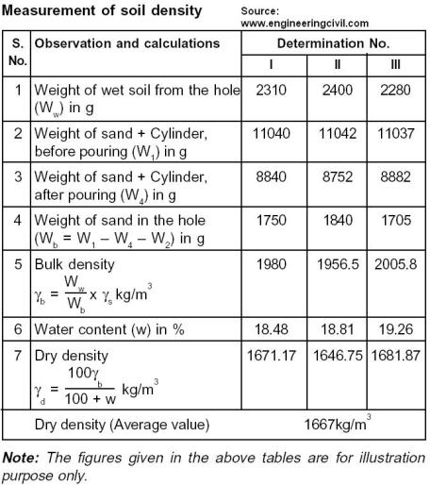
c) Rubber balloon method
The same as the sand cone, except a rubber balloon is used to determine the volume of the hole
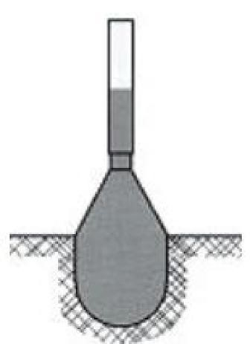

d) Nuclear Density (ASTM D2292-91)
- Nuclear Density meters are a quick and fairly accurate way of determining density and moisture content.
- The meter uses a radioactive isotope source (Cesium 137) at the soil surface (backscatter) or from a probe placed into the soil (direct transmission).
- The isotope source gives off photons (usually Gamma rays) which radiate back to the mater's detectors on the bottom of the unit.
- Dense soil absorbs more radiation than loose soil and the readings reflect overall density.
- Water content (ASTM D3017) can also be read, all within a few minutes.

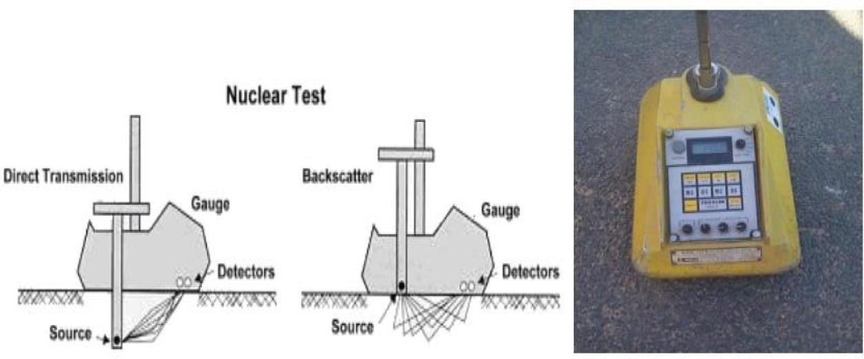

Theoretical learning Activity
In group of 4 trainees,
- Determine the weight of water from the following taken data
- Mass of wet soil + core cutter (M1) =2,834g
- Mass of core cutter (mc) = 995g
- Mass of dry soil + core cutter (M2) =2,792g

Answer:
Weight of water, w= M1-M2
Weight of water, w= 2,834g-2,792g = 42g
- Determine the weight of water from the following taken data
- Mass of wet soil + container (M1) is 142.27g
- Mass of dried soil (Ms) is 90.3g
- Mass of container (M3) is 37.06 g
Answer:
- Mass of wet soil= 142.27g- 37.06g=105.21g
- Weight of water= 105.21g – 90.3g= 14.91g
- Determine the dry density of soil from the following taken data:
- Bulk density= 1.80g/cm³
- Moisture content of the soil (in %)= 16.5%

Answer:

Practical learning Activity
In group of 4 trainees,
ABC Company Ltd offered a tender on an earth road Rehabilitation connecting NR1 with main road (asphalt road) Kigali-Huye of 700m due to its damage. L5 RCT Company Ltd won the tender. The company sends you as a lab technician to perform in situ density test and check the compaction degree of compacted earth road.
Tasks:
- List all tools, materials and equipment required to perform in situ density test.
- Choose only one method to be used according to the size of aggregate
- Determine the in situ density
- Check the compaction percentage
NB: All parameters required for this activity will be given by L5 RCT Company Ltd.

WORKING SHEET
……………………………………………………………………………………………………
Lab name……. IN SITU DENSITY TEST . (Core cutter Method)
Contract: ---------------------------------------------------------------------------
Origin of sample: --------------------------------------------------------------
Description of soil: --------------------------------------------------------------
Date of test: ----------------------------------------------------------------------

Test number | 1 | 2 | 3
Core cutter number
Mass of soil + core cutter (ms)
Mass of core cutter (mc)
Weight of soil, Ws= ms-mc
Bulk density of soil , p=ms-mc
Vc

MOISTURE CONTENT DETERMINATIONS
Container number | 1 | 2 | 3
Mass of wet soil+ container, m₁ g
Mass of dried soil+ container m₂ g
Mass of moisture, m₃=m₁-m₂ g
Mass of container,m₄ g
Mass of dry soil, ms=m₂-m₄ g
Moisture content, W=m3/msx100 %
Average moisture content, W %
Dry density, pd=100p g/cm³
100+W
Maximum dry density g/cm³
Relative compaction

Points to Remember (Take home message)

Calculate wet and Dry density

Learning outcome 2.3 formative assessment
Written assessment
- Check the compaction percentage from the following taken data.
- Mass of core cutter (mc) is 995 g
- Weight of soil, Ws=(Ms-Mc) is 1839 g
- Mass of wet soil + container (M1) is 142.27g
- Mass of dried soil + container (M2) is 127.36g
- Mass of container (M4) is 37.06 g
- Maximum dry density 1.67Mg/m³
ANSWER:
Given:
Mc = 995g
Ws = 1839 g
M1= 142.27 g
M2= 127.36g
M4= 37.06 g
Max.dry density= 1.67g/cm³

Formula:
- Dry density
- Bulk density ms: mass of soil + core cutter
mc: mass of core cutter
vc: internal volume of core cutter
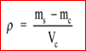

- Moisture content
W=w/x2 w: weight of water, x2= Dry weight
- Weight of water, w= M1-M2
- Dry weight = M2-M4
Solution
- Dry weight=127.36g-37.06g= 90.3g
- Weight of water, w= 142.27g- 127.36g= 14.91g
- Moisture content ,W= 14.91g/90.3g × 100= 16.5%
- Volume, Vc = (10cm)² × 3.14/4 × 13cm= 1,020.5cm³
- Mass of core cutter, mc= 995g + 1,839g = 2,834g
- Bulk density, p=2,834g – 995g/ 1,020.5g/cm³ = 1839g/1,020.5cm³ =1.80g/cm³
- Dry density (Pd)= 1.80g/cm³ / (1+ 16.5/100)= 1.54g/cm³
Compaction percentage=1.80g/cm³/1.67g/cm³ × 100 = 92%
Practical assessment
XY Company Ltd offered a tender on an earth road Rehabilitation connecting NR2 with main road (asphalt road) Kigali-Gicumbi of 400m due to its damage. L5 RCT Company Ltd won the tender. The company sends you as a lab technician to perform in situ density test and check the compaction degree of compacted earth road.
Tasks:
- List all tools, materials and equipment required to perform in situ density test.
- Choose only one method to be used according to the size of aggregate
- Determine the in situ density
- Check the compaction percentage
NB: All parameters required for this activity will be given by L5 RCT Company Ltd.

WORKING SHEET
……………………………………………………………………………………………………
Lab name ……. IN SITU DENSITY TEST . (Core cutter Method)
Contract: ---------------------------------------------------------------------------
Origin of sample: --------------------------------------------------------------
Description of soil: --------------------------------------------------------------
Date of test: ----------------------------------------------------------------------

Test number | 1 | 2 | 3
Core cutter number
Mass of soil + core cutter (ms)
Mass of core cutter (mc)
Weight of soil, Ws= ms-mc
Bulk density of soil , p=ms-mc
Vc

MOISTURE CONTENT DETERMINATIONS
Container number | 1 | 2 | 3
Mass of wet soil+ container, m₁ g
Mass of dried soil+ container m₂ g
Mass of moisture, m₃=m₁-m₂ g
Mass of container,m₄ g
Mass of dry soil, ms=m₂-m₄ g
Moisture content, W=m3/msx100 %
Average moisture content, W %
Dry density, pd=100p g/cm³
100+W
Maximum dry density g/cm³
Relative compaction

LEARNING UNIT 3: MAKE REPORT
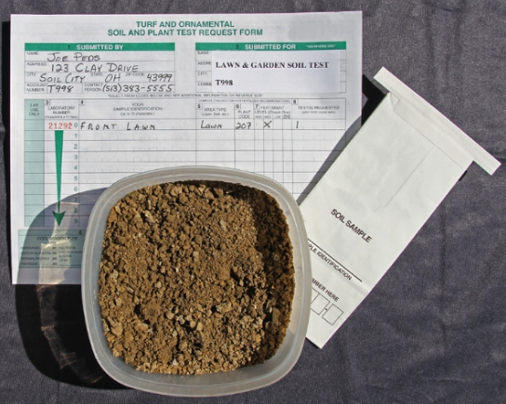

STRUCTURE OF LEARNING UNIT
Learning outcomes:
3.1. Elaborate working sheet
3.2. Identify in situ density test report elements
3.3. Describe the final result

LEARNING OUTCOME 3.1: ELABORATE WORKING SHEET

Duration: 1 hr
Learning outcome 3.1 objectives :
By the end of the learning outcome, the trainees will be able to:
- Identify properly the contents of in situ Density test working sheet.
Resources
Equipment | Tools | Materials
- Flipchart stand  - Computer  - Projector | - Chalkboard | - Flipchart  - Papers  - Chalk  - Pen
Advance preparation:
- Working Sheet for in Situ Density Test
- Moisture content determinations
- Calculate Wet And Dry Density

CONTENT 3.1.1: ELABORATE WORKING SHEET

Contents of in situ Density test working sheet
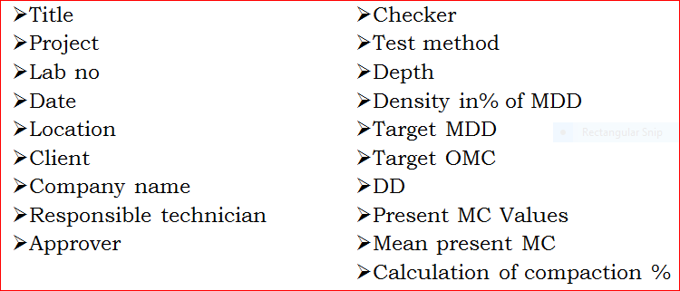

WORKING SHEET
……………………………………………………………………………………………….……………………

Lab name IN SITU DENSITY TEST
(Core cutter method)
Client name: …………………………………………………………
Origin of sample: ……………………………………………………
Description of soil: …………………………………………………
Date of soil sample: ………………………………………………………..

Test Number | 1 | 2 | 3
Core cutter number (g)
Weight of core cutter, M1 (g)
Weight of wet soil + Core cutter, M2 (g)
Weight of dry soil + Core cutter, M3 (g)
Weight of wet soil, Ws = M2-M1 (g)
Weight of dry soil, Wd =M3-M1 (g)
Weight of water, w =M2-M3 (g)
Moisture content,W = w x 100 (%)
Ws
Bulk density, $ρ=\frac{M2-M1}{Vc}$ (g/cm³)
Dry density, ρ_{d =} $\frac{100 ρ }{100+W}$ (g/cm³)
Compaction degree = $\frac{ρd }{Max. dry density}$ _{(%)}

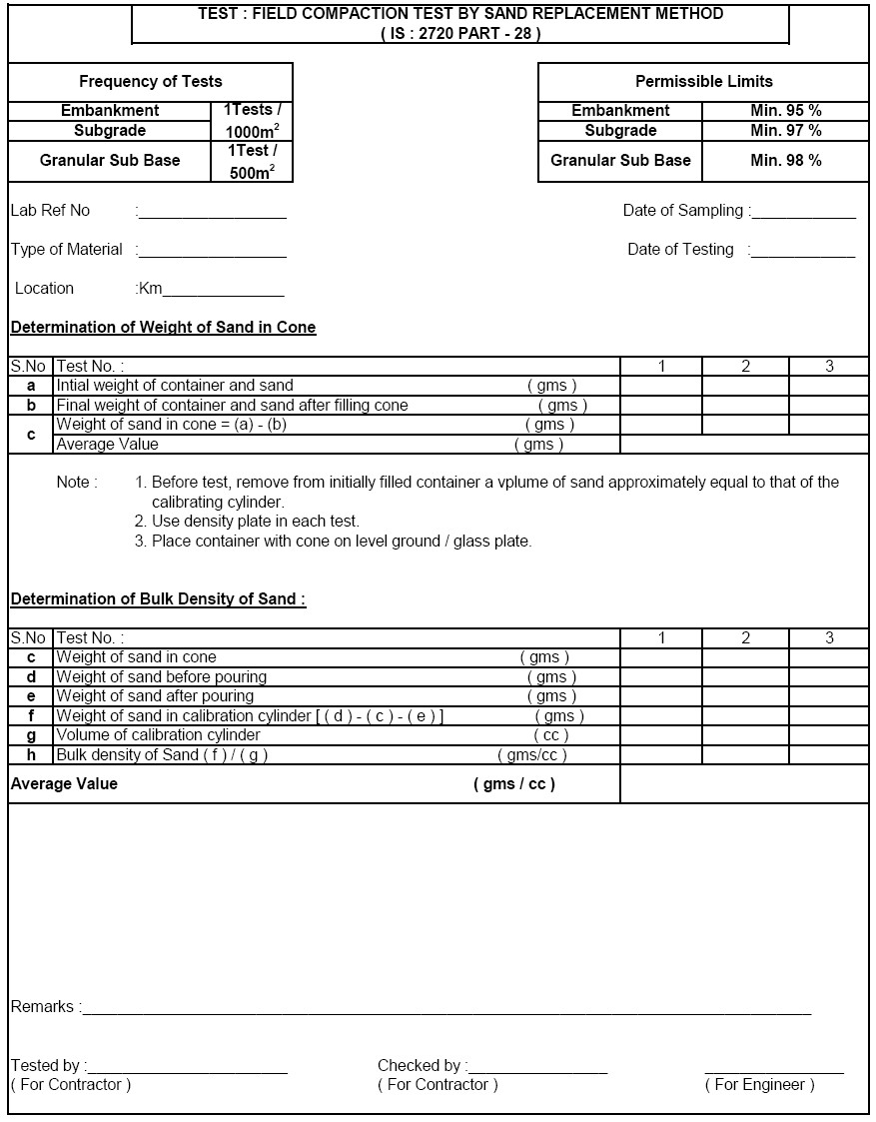
Theoretical learning Activity
In group of 2, identify clearly the Contents of in situ Density test working sheet

Points to Remember (Take home message)
- Contents of in situ density test working sheet

Learning outcome 3.3 formative assessment
Written assessment

Outline any five (5) contents of In situ Density test working sheet
Answer:

LEARNING OUTCOME 3.2 IDENTIFY IN SITU DENSITY TEST REPORT ELEMENTS

Duration: 1 hr

Learning outcome 3.2 objectives :
By the end of the learning outcome, the trainees will be able to:
1. Identify in situ density test report elements
Resources
Equipment | Tools | Materials
- Flipchart stand  - Computer  - Projector | - Chalk board | - Flipchart  - Papers  - Chalk  - Pen
Advance preparation:
- Working Sheet for in Situ Density Test
- Moisture content determinations
- Calculate Wet And Dry Density

CONTENT 3.2.1 : IDENTIFY IN SITU DENSITY TEST REPORT ELEMENTS

In situ density test element
- Types of material and sample identification
- Reference of this procedure
- Wet density result
- Moisture content result
- Dry density result
- Percentage of compaction
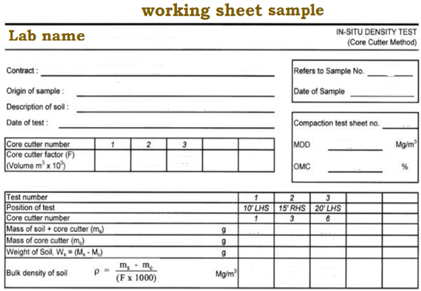
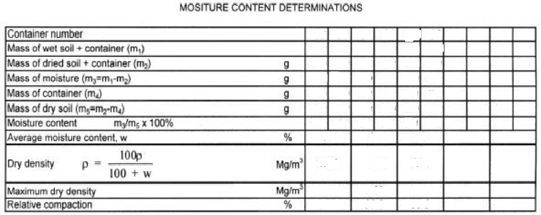
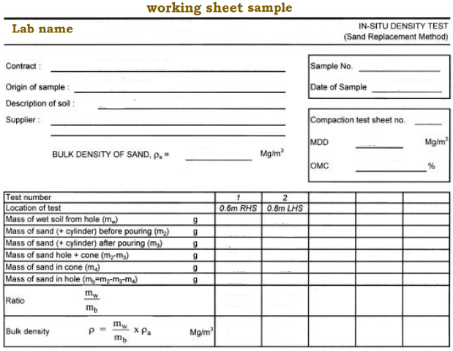
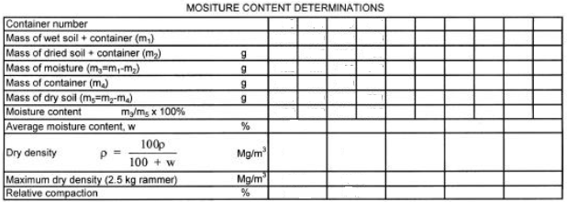
Theoretical learning Activity

In group of 4, Discuss on the in situ density test report elements
Practical learning Activity

Individual trainee, make a report of in situ density test (Trainees in pair perform)
Points to Remember (Take home message)

- The element of in situ density test report
- Working sheet sample of in situ density test

Learning outcome 3.2 formative assessment

Written assessment

Outline any five (5) elements of In situ density test
Answer:
The in situ density test element are:
- Types of material and sample identification
- Reference of this procedure
- Wet density result
- Moisture content result
- Dry density result
- Percentage of compaction
- Etc

LEARNING OUTCOME 3.3 DESCRIBE THE FINAL RESULT

Duration: 1 hr

Learning outcome 3.3 objectives :
By the end of the learning outcome, the trainees will be able to:
1. Describe the final result
Resources
Equipment | Tools | Materials
- Flipchart stand  - Computer  - Projector | - Chalk board | - Flipchart  - Papers  - Chalk  - Pen
Advance preparation:
- Working Sheet for in Situ Density Test
- Moisture content determinations
- Calculate Wet And Dry Density

CONTENT 3.3.1: DESCRIBE THE FINAL RESULT

Types of decisions
The decision of test will depend of the degree of compaction obtained compared to the required for the project.
There exist two types of decisions as follow:
- Rejected materials
- Acceptable materials
Theoretical learning Activity

In group of 4, discuss on the final result for in situ density test
Points to Remember (Take home message)

- Types of decisions

Learning outcome 3.3 formative assessment
Written assessment
- Outline any two (2) types of decisions to be taken after performing in situ density test
Answer:
Two types of decisions to be taken after performing in situ density test are: Rejected materials and acceptable materials

References:
- AASHO (1966) "Standard Specifications for Highway Materials and Methods of Sampling and Testing", Part-Il General Office, Ninth Edition.
- ALAM SINGH (2002) "Soil Engineering in Theory and Practice", Vol. 1, 41h Edition.
- ARORA, K. R. (1992) "Soil Mechanics and Foundation Engineering" Third Edition.
- ASTM D1556-00. (2007). “Standard Test Method for Density and Unit Weight of Soil in Pl. by the Sand-Cone Method,” Annual Book of ASTM Standards, Vol.04.08,
- LAMBE, T.W. (1993) "Soil Testing for Engineers", John Wiley & Sons, Inc., Fifth Reprinting.
- https://www.engineeringcivil.com Determine the In-Situ Dry Density of Soil by Sand Replacement Method “retrieved May 26, 2020
- https://www.soilmanagementindia.com How to Determine the In-Situ Density of Soils? “retrieved May 26, 2020
- http://geotech.uta.edu/lab/Main/SandCone Field Test Method for Density by the Sand-Cone Method

