 



**ROAD CONSTRUCTION**

**Module name: ROAD CONSTRUCTION SITE RECORDS**

**MODULE CODE: RCTSR501**

**TEACHER’S GUIDE**

**RQF LEVEL 5**

**Table of content**

Contents

**Table of content** i

Acronyms ii

Introduction iii

**Module Code and Title: RCTSR501 CONSTRUCTION SITE RECORDS** 1

Learning unit 1: Identify site documents 2

STRUCTURE OF LEARNING UNIT 2

Learning Outcome 1.1: Differentiate site documents 3

Learning Outcome 1.2: Identify data to be recorded 14

Learning Outcome 1.3: Select necessary documents 18

19

LU2: Use site documents 25

STRUCTURE OF LEARNING UNIT 26

Learning outcome 2.1: Collect data about works done. 27

Learning Outcome 2.2: Collect data about site resources. 34

Learning Outcome 2.3: Fill site forms. 40

LU3: Manage site records 57

**STRUCTURE OF LEARNING UNIT** 57

Learning outcome 3.1 Arrange site documents 58

Learning Outcome 3.2: Safe guard site documents 64

Learning Outcome 3.3: Report site records 73

➢ Integrated situation 77

➢ Checklist: 78

References: 81

# Acronyms

**RTB:** Rwanda TVET Board

**CVI:** Confirmation of verbal instructions

**P O:** Purchase order

**L.O:** Learning outcome

**L.U:** Learning unit

**RCT:** Road Construction

**RFI:** Request for information

# Introduction

This module describes the knowledge, skills and attitudes required for the road construction supervisor to keep necessary records in his work.

**Module Code and Title: RCTSR501 CONSTRUCTION SITE RECORDS**

|  |
| --- |
| **Learning unit 1: Identify site documents**  **Learning unit 2: Use site documents**  **Learning unit 3: Manage site records** |

# Learning unit 1: Identify site documents

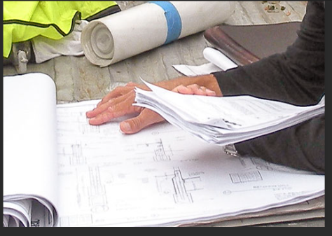

# STRUCTURE OF LEARNING UNIT

|  |
| --- |
| **Learning outcome:**   * 1. **Proper differentiation of site documents**   2. **Proper identification of data to be recorded**   3. **Convenient selection of necessary documents.** |

## Learning Outcome 1.1: Differentiate site documents

|  |  |  |
| --- | --- | --- |
| **Duration: 4hrs** | | |
| Learning outcome 1.1: objectives:  By the end of the learning outcome, the students will be able to:   * Differentiate properly of site documents. * Interpret appropriately construction documents. | | |
| **Resources** | | |
| **Equipment** | **Tools** | **Materials** |
| * Computers * Projector * Projection screen * Printers * Drawing board | * Workshop * Internet * Drawing set | * Chalks * Pens * Papers * Flip-chart * pictures |
| **Advance preparation:**   * Having complete equipment, tools and materials * Well prepared working place * Availability of facilities such as electricity. | | |



**Content 1.1: Differentiate site documents**

**General Introduction to site records**

**A record** is a collection of fields, possibly of different data types, typically in fixed number and sequence.

Records are recorded information that is a vital information or knowledge resource for your organization.

Records are often created and kept because they are needed in order to conduct business, as evidence of past business, because they are required to meet legal obligations or because the community expects that they will be kept.

Can be in any form

Records may be paper, any digital formats, or in other forms such as photographs, video footage, audio recording or microfilm.

**Site** is place in which the works are roll up for people activities

**Site management** is the art or science of organizing, managing, and planning resources to complete construction project preferably on time and under budget.

**Records** are generated when written instructions are followed. In other words, after data, information, or results are recorded onto a form, label, etc, then it becomes a record.

**Documents** are written policies, process descriptions, and procedures used to communicate information. They provide written instructions for how to do a specific task. Blank forms are also considered documents. Forms are used to capture data or information from performing a procedure.

Documents and records may be paper (hard copy) or electronic (soft copy).

**Site record** is a Document that memorializes and provides objective evidence of activities performed, events occurred, results achieved, or statements made. Records are created/received by an organization in routine transaction of its business or in pursuance of its legal obligations. A record may consist of two or more documents.

All documented information, regardless of its characteristics, media, physical form, and the manner it is recorded or stored. Records include accounts, agreements, books, drawings, letters, magnetic/ optical disks, memos, micrographics, etc. generally speaking, records function as evidence of activities, whereas documents function as evidence of intentions.

(Joia, 1998)

**All records that are created during the administration of a construction project can be placed in one of two categories:**

**Permanent Records,** records kept by the Headquarters and State Archives for future reference, and Temporary Records,records kept by the Region for a limited period of time after which they are discarded by the Region.

**Permanent Records consist of the following, Records provided by Headquarters:**

* Contracts
* Change Orders
* Contract Estimate Payments

**Examples of Temporary Final Records include:**

* Item Quantity Tickets
* Project Engineer’s Copy of Estimates
* Project Correspondence
* The original Project Personnel and Signature Listing
* Inspector’s Record of Field Tests
* Concrete Pour Records
* Approval of Source of Materials
* Quantity Computation Sheets
* Surfacing Depth Check Records
* Contractor’s Payrolls

(Beastall, 1998)

**Importance of site records**

The purpose of the Project Record Documents is to provide the County with factual information regarding all aspects of the Work, both concealed and visible.

a. For providing evidence in case of disputes: Construction site records may be used for your own protection in disputes

b. Keeping field records may be beneficial for your client

c. Site diary helps in refreshing our memory about activities at construction site

d. Record keeping in construction projects helps you get clearer insight to what happened on site

e. To ensure continuity in administration

f. To ensure tax-payer’s interest is protected at all times

g. For planning & scheduling organization activities

h. For historical value

i. To make available needed facts, figures, correspondence etc

j. Documentation of workforce performance

k. Provide evidence about past actions and decisions

l. For accountability and transference purpose

**Here are some tips for good record-keeping:**

**a.** Understand the information to be collected*.* Before you record any information, make sure that you understand what is to be collected

**b.** Record the information every time.Record on the appropriate form each time you perform a procedure.

**c.** Record all the information.Make sure you have provided all the information requested on a form.

**d.** Record the information the same way every time.Be consistent in how you record information

Site documents to be kept

* Daily diary (Logbook)
* Requests for Information (RFI) –
* Confirmation of verbal instructions (CVI).
* Drawing register –
* Minutes of meetings –
* Approvals and inspections books
* Photographs
* Work program (planner)
* Instruction books
* Site Reports
* Query and request forms
* Purchase order
* Goods receipt note

**1.Daily diary (Logbook)**

A **logbook** (a ship's logs or simply log) is a record of important events in the management, operation, and navigation of a ship. It is essential to traditional navigation, and must be filled in at least daily.

**Roles of work diary**

The roles of work diary

1. A site diary is admissible in court in case of disputes as documentary evidence.

2. Work cover will request to see the site diary in accident investigation.

3. A site diary helps maintain and monitor hire equipment, it is crucial to record off-hire numbers to save further hire changes.

4. It can be used to records attendances to allow for invoicing and charge out rates for contractors

5. All lines not used must be crossed out so that daily records are not altered after an event or a work day has ended.

6. A site diary is also known as construction log, site journal, company log.

**Details need to be entered in the work diary**

* Weather at site
* Important materials brought to site with their approximate quantity
* Type of transport working at site
* Types of tools and plants being used at site important items of works completed and passed on the particular date.
* Important items of works completed and passed on the particular date
* Visits of VIPs and their remarks if any.

(Gyampoh-Vidogah, 2003)

**2.Requests for Information (RFI)**

A **request for information** (**RFI**) is a standard [business](https://en.wikipedia.org/wiki/Business) process whose purpose is to collect written information about the capabilities of various suppliers. Normally it follows a format that can be used for comparative purposes.

An RFI is used in the construction industry when a project's construction documentation lacks information that is required to proceed with any given scope of work.

**3.Confirmation of verbal instructions (CVI)**

**Confirmation of verbal instructions (CVI):** is an oral confirmation sheet. It is common for contracts to allow instructions to be given verbally, for example during a meeting, a site visit or in emergency.

**Work that site engineer will require CVI (confirmation of verbal instruction) before implementing of that works**

* To vary the works.
* To postpone the works.
* To remedy workmanship, goods or materials which are not in accordance with the contract
* To sanction a variation made by the contractor.
* In relation to the expenditure of provisional sums.
* To open up work for inspection.
* To carry out tests.
* To exclude persons from the site.

**4.Drawing register**

**Drawing register:** is the controlled register of a list of drawings relating to a project and is used in the distribution of formal drawings to Architects, Engineers, Sub-contractors, Vendors, Fabricators, Government bodies and other parties in the form of a document identifying the information that is included in the drawing register.

**5.Minutes of meetings**

• A written account of what went on and was discussed during a meeting

• They help members of an organization to remember decisions and plans they have made

**Minutes of meeting**: Minutes that capture the purpose of the meeting and its agreed outcomes are a record that can be referred back to and can be used for follow-up purposes. Effective meeting minutes are clear and to the point, but at the same time, they do not leave out important information.

**The minutes basically follow the same format as the agenda.**

* They include the date and time of the meeting,
* The participants,
* The agenda,
* Summary of notes (optional),
* Apologies (people who couldn’t make it),
* The approval of the last meeting’s minutes,
* A summary of the agenda items (including actions taken, results, next steps),
* Any other business
* The date of the next meeting.

**6.Approvals and inspections books**

Is a book used to avoid costly errors and corrective work on site by note being fully up to speed with the ever?

**7.Photographs**

**Photograph**s: the essential purpose of photography is communication. Few people take picture solely to please themselves.

Event-driven shoots used to create a complete photographic record of your construction site at critical milestones. Capture the current conditions of your site, adjoining properties, or construction progress in between contractors with Multivista’s suite of existing-conditions services

CONSTRUCTION SITE PROGRESS PHOTOGRAPHY

Performed at regular intervals to document the progress of exterior and interior construction, from beginning to end.

* Update the visual record with regular interior and exterior progress updates, taken approximately once a month throughout construction, from broad and encompassing angles.
* Flip through several progression shots with the click of a button for a detailed account of construction progress.

**The tips of site photography**

* **Use scale in your pictures**
* Whether it’s with a measuring tape, your phone, or a hard hat, put an object in your picture that will show the image scale.
* **Make notes and annotations**
* If your picture needs explaining – then do so! Annotate your picture with arrows and free drawing if needed.
* **Use a flash**
* If you have a dark jobsite, then you will need to invest in a flash to ensure that the image quality in your picture captures everything that you need.
* **Keep your photos organized**
* You don’t want to be sifting through every jobsite picture you’ve ever taken, just to find the right one. Arrange your photos in folders by project and date or milestone.

(Lam, 2002)

**8.Work program (planner)**

**What is a Construction Project Planners Role?**

 Planning is one of the most important parts of [construction management](https://esub.com/products/). It involves making careful choices on ways to complete tasks so that projects can be finished on time and within budget. The role of a construction planner is to develop a plan to complete a construction project based on budget, work schedule, and available resources. Construction planners also make organizational decisions such as which subcontractors to use for the given project.

 Broadly speaking, construction planners are given a result and need to do what is necessary to make the result come to life

**Work program (planner)**:  is a plan established by a business to help reintegrate injured workers into the workplace. The goal is to return employees to the workplace as soon as they are medically able. A well-run RTW program affords benefits to both employers and their workers.

**9.Instruction books**

✓ Instruction books: is a book used for using or operating some piece of equipment. A book to which you can refer for authoritative facts, “the contributed articles to the basic reference work on that topic.

**10.Site Reports**

Summary of hourly- and daily-conditions and events at a worksite on every workday, prepared for the offsite project administrators. An essential document in construction projects, it records the number of workers/ employees and equipment in construction site, exact time the work began and ended, job progress, whether, accidents (if any), etc. On no-work days it reports “No work today” and serves as an evidence in case of disputes.

**Types of Reporting Documents**

**Daily report:** This is a report sheet filled every day by a worker in which he/she has write a brief description of all activities performed per day, the tools/machinery/equipment and methodology used to perform that activity, and number of hours per day taken to perform all those activities.

**Weekly report**: It is weekly sheet as a development of a daily report sheet filled by a worker where he /she mentions a brief description of a whole week activities performed, the tools/machinery/equipment and methodology used to perform that activity, and number of hours per day taken to perform all those activities.

**Site Reports**: a site usage report provides a detailed summary of where a specific contributor data file or native document is being used.

**11.Query and request forms**

**Query and request forms**: is a request for information from database table or combination of tables**.**

**12.Purchase order**

What is a construction purchase order?

Purchase order (PO): A purchase order (PO) is a commercial document and first official offer issued by a buyer to a seller indicating types, quantities, and agreed prices for products or services. It is used to control the purchasing of products and services from external suppliers.

[**Purchase orders**](https://esub.com/purchase-orders/)are messages sent from buyers to sellers with a request for an order for a product. In other words, they are contracts binding the buyer and the seller through the product being sold. A purchase order should include descriptions, quantities, discounts, and prices of the product. Ideally, they should also state payment terms and shipment dates. Purchase orders are important in the construction industry because they are contracts that list the agreement between the buyer and the seller.

When a seller accepts a purchase order, a legally bound contract is formed between the two parties. It is important that the buyer makes specific request clear, and that the seller includes specific product information so that confusion is avoided in the agreement.

**13.Goods receipt note**

Record of goods received at the point of receipt. This record is used to confirm all goods have been received and often compared to a purchase order before payment is issued.

**Goods receipt note**: The goods receipt note is an internal document produced after inspecting delivery for proof of order receipt. ... It's used by stores, procurement and finance to raise any issues, update your stock records and to be matched against the original purchase order and supplier invoice, to allow payment to be made.

(Caldas, 2003)

Theoretical learning Activity

Brainstorm about identification of site documents

**Points to Remember** (Take home message)

* **Terminologies of site records**
* **Different site documents.**

 Learning outcome 1.1 formative assessment

Q1. The Good way of managed site is to keep and fill day to day construction site document. Highlight any five important documents to be fill on construction site

**Answer**

* Daily diary (work force &work done form)
* Requests for Information (RFI) –
* Confirmation of verbal instructions (CVI),
* Drawing register –
* Minutes of meeting – minutes
* Approvals and inspections books
* Work program (Planner)
* Instruction’s book
* Site Reports

Q2. Define the following terms used in site records.

1. Purchase order
2. Good receipt notes
3. Site records

**Answer**

1. **Purchase order:** This is an official document issued by buyer committed to pay the seller of specific products or services to be delivered in the future.
2. **Good receipt notes:** This is a document created by buyer on receipt of merchandise which describes each good and details the quantity of received.
3. **Site records:** Site record is a document required to prove any construction activity has taken place at site during billing or any other claims.

## Learning Outcome 1.2: Identify data to be recorded

|  |  |  |
| --- | --- | --- |
| **Duration: 3hrs** | | |
| Learning outcome1.2: objectives:  By the end of the learning outcome, the students will be able to:   * Identify appropriately data to be recorded. * Explain properly the data to be recorded on the site. | | |
| **Resources** | | |
| **Equipment** | **Tools** | **Materials** |
| * Computers * Projector * Projection screen * Printers * Drawing board | * Workshop * Internet * Drawing set | * Chalks * Pens * Papers * Flip-chart * pictures |
| **Advance preparation:**   * Having complete equipment, tools and materials * Well prepared working place * Availability of facilities such as electricity. | | |



**Content 1.2: Identify data to be recorded**

**Data to be recorded on site**

* Information on workforce
* Information on work done
* Meeting schedules and meeting notes
* Information on materials usage
* Information on plant and equipment usage
* Suppliers and deliveries
* Any other aspects of recording work related
* Information (Ex: Incident, Challenges etc.)
* Weather conditions

**Recording:**

When the operation to be studied is selected the method or process by which it is carried out must be recorded.

**Data to be recorded on site**

* **Information on workforce**

Workforce meaning:

The people engaged in or available for work, either in a country or area or in a particular firm or industry

The workforce is the total number of people in a country or region who are physically [able](https://www.collinsdictionary.com/dictionary/english/able_1) to do a job and are [available](https://www.collinsdictionary.com/dictionary/english/available) for work.

The workforce is the total number of people who are employed by a particular company.

* **Information on work done**

Work meaning

Work is something which you produce as a result of an activity or as a result of doing your job.

to exert oneself physically or mentally especially in sustained effort for a purpose or under compulsion or necessity

a specific task, duty, function, or assignment often being a part or phase of some larger activity

* **Meeting schedules and meeting notes**

**Schedule meaning**

A plan for carrying out a process or procedure, giving lists of intended events and time

Timetable for a program or project showing how activities and milestone events are sequenced and phased over the allotted period.

Meeting agenda:

An agenda is a list of meeting activities in the order in which they are to be taken up, beginning with the call to order and ending with adjournment. It usually includes one or more specific items of business to be acted upon.

**Meeting note**

**Meeting notes** are special type of notes which are compiled at meetings by an appointed note-taker. They provide a written report about the meeting, which includes the place, date and time of the meeting, the purpose of the meeting, who attended the meeting and a list of the things which were discussed at the meeting.

* **Information on materials usage**

How materials are used

* **Information on plant and equipment usage**

How plant and equipment are used

* **Suppliers and deliveries**

**Supplies**

a person or organization that provides something needed such as a product or service.

**Delivery**

Delivery is the process of transporting goods from a source location to a predefined destination. There are different delivery types. Cargo are primarily delivered via roads and railroads on land, shipping lanes on the sea and airline networks in the air.

* **Information (Ex: Incident, Challenges etc.)**

**Incident**

An incident, in the context of occupational health and safety, is an unintended event that disturbs normal operations.

Untoward event which (depending on the circumstances) may lead to a damage, disaster, or loss.

* **Weather conditions**

the atmospheric conditions that comprise the state of the atmosphere in terms of temperature and wind and clouds and precipitation

(Sommerville, 2004)

 Theoretical learning Activity

In groups discuss on data to be recorded on site,

Trainees brainstorm on data to be recorded on site.

**Points to Remember** (Take home message)

The necessary data to be recorded on the site.

Learning outcome 1.2 formative assessment

Q1. State at least five Data to be recorded on site

**Answer**

* Information on workforce
* Information on work done
* Meeting schedules and meeting notes
* Information on materials usage
* Information on plant and equipment usage
* Suppliers and deliveries
* Any other aspects of recording work related
* Information (Ex: Incident, Challenges etc.)
* Weather conditions

## Learning Outcome 1.3: Select necessary documents

|  |  |  |
| --- | --- | --- |
| **Duration: 3hrs** | | |
| Learning outcome 1.3 objectives:  By the end of the learning outcome, the students will be able to:   * Select properly the necessary documents. * Elaborate properly the forms for particular cases. | | |
| **Resources** | | |
| **Equipment** | **Tools** | **Materials** |
| * Computers * Projector * Projection screen * Printers * Drawing board | * Workshop * Internet * Drawing set | * Chalks * Pens * Papers * Flip-chart * pictures |
| **Advance preparation:**   * Having complete equipment, tools and materials * Well prepared working place * Availability of facilities such as electricity. | | |

## 



**Content 1.3: Select necessary documents**

Identification of specific forms:

* Work force form (attendance list….)
* Equipment & plant form
* Material request form
* Material receipt form
* Meeting minutes form
* Site instruction form
* Suppliers and deliveries form
* Measurement sheet

Elaboration of forms for particular cases:

* Incident /Challenge form
* Claim form
* Weather
* Emergency form

Division of Human Resources and Service Quality

Incident Report

|  |  |  |  |
| --- | --- | --- | --- |
| Time and Date of Incident: |  | | |
| Date and Reporting Time line: |  | | |
| Bureau/Office/Division: |  | | |
| HRSQ Staff Conducting the Investigation |  | |  |
| Parties Involved:1)  2) | | | |
| Allegation(s): 1)  2) | | | |
| Findings:  1)  2)  3)  4) | | | |
| Investigation Summary: | | | |
| Recommendations (specific to individual and/or group):  1)  2)  {parties name}: {training and/or activity recommendation or requirement} | | | |
| CONCURRENCE SIGNATURES: | | | |
| company, Director, Date Division of Human Resources | | ,Director secretary Division, Date signature | |
|  | |  | |

* **Claim form**

|  |  |  |  |  |  |  |  |
| --- | --- | --- | --- | --- | --- | --- | --- |
| **Expenses Claim Form** | | | |  | | | |
| **This form must be signed by claimant & a committee member and then returned to the Treasurer** | | | | | | | |
| **Part A. - All claims** | | |  |  |  |  |  |
| **Name:** | |  |  |  | **Please provide your address:** | | **ONLY if you wish** |
| **Tel:** | |  |  |  | cheque by post |  |  |
| **Email:** | |  |  |  |  |  |  |
| **Committee:** | |  |  |  |  |  |  |
| **Receipt** | **Date** | **Purpose of Journey / Expenditure** | | |  |  | **frw** |
| **Ref** | **Suffered** |  |  |  |  |  |  |
| 1 |  |  |  |  |  |  |  |
| 2 |  |  |  |  |  |  |  |
| 3 |  |  |  |  |  |  |  |
| 4 |  |  |  |  |  |  |  |
|  |  |  |  |  |  |  |  |
|  |  |  |  |  | **TOTAL** |  |  |
|  |  |  |  |  |  |  |  |
|  | **I certify that the amounts claimed arise from Friend's activities and that I have read and understood the Guidance notes** | | | | | | |
|  |
|  |  |  | **Signature of Claimant:** | | |  |  |
|  |  |  |  |  |  |  |  |
|  |  |  | Date: | |  |  |  |
|  | I approve this claim for payment | | | | |  |  |
|  |  |  | **Authorizing Signature:** | | |  |  |
|  |  |  |  |  |  |  |  |
|  |  |  |  | Date: |  |  |  |

* **Emergency form**

EMPLOYEE EMERGENCY CONTACT FORM

Name ______________________________________________________________________________

Department __________________________________________________________________________

**Personal Contact Info:**

Home Address________________________________________________________________________

City, State,______________________________________________________________________

Home Telephone # ____________________________

**Emergency Contact Info:**

(1) Name_______________________________________Relationship___________________________

Address _____________________________________________________________________________

City, State, _______________________________________________________________________

Home Telephone # ____________________________

Work Telephone # _______________________________ Employer _____________________________

(2) Name_______________________________________Relationship___________________________

Address _____________________________________________________________________________

City, State, ZIP _______________________________________________________________________

Home Telephone # ____________________________

Work Telephone # _______________________________ Employer _____________________________

**Medical Contact Info:**

Doctor Name. ______________________________________ Phone # __________________________

Dentist Name ______________________________________ Phone # __________________________

I have voluntarily provided the above contact information and authorize my employer and its representatives to contact any of the above on my behalf in the event of an emergency.

I choose not to furnish any emergency contact information to my employer at this time.

Employee Signature __________________________ Date __________________________________

(Veal, 2001)

Theoretical learning Activity

Trainees Brainstorm on elaboration of forms

Practical learning Activity

Practical exercise on elaboration of forms

**Points to Remember**

* Selection of necessary documents.
* Elaboration of forms for particular cases.

Learning outcome 1.3: formative assessment

Q1. By using table, separate specific forms to the forms for particular cases

Given forms:

* Material receipt form
* Meeting minutes form
* Claim form
* Material request form
* Site instruction form
* Suppliers and deliveries form
* Challenge form
* Weather

**Answer**

|  |  |
| --- | --- |
| **specific forms** | **forms for particular cases** |
| Material receipt form | Challenge form |
| Meeting minutes form | Weather |
| Suppliers and deliveries form | Claim form |

Q2. Answering the following questions by using true and false:

those forms are used for particularcases:

**Answer**

a) Incident /Challenge form: **TRUE**

b) Work force for (attendance list: **FALSE**

c) Emergency form: **FALSE**

d) Site instruction form: **FALSE**

**Checklist:**

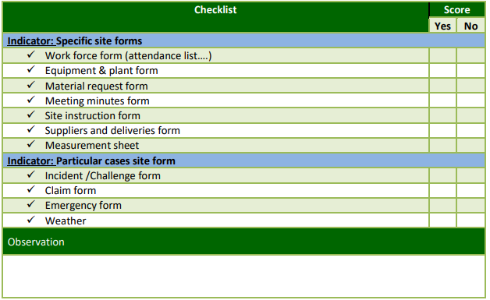

# 

# LU2: Use site documents



# STRUCTURE OF LEARNING UNIT

|  |
| --- |
| **Learning outcomes:**  **2.1. Proper data collection about works done**  **2.2. Proper data collection about site resources.**  **2.3. Correct filling of site forms** |

## Learning outcome 2.1: Collect data about works done.

|  |  |  |
| --- | --- | --- |
| **Duration: 5hrs** | | |
| Learning outcome 2.1: Objectives:  By the end of the learning outcome, the trainees will be able to:   * Precise information about work done. * Identify properly the methods of site data collection. | | |
| **Resources** | | |
| **Equipment** | **Tools** | **Materials** |
| * boards, * Projector * Computer | * Tape measure Decameter * Tape measure, | * Site documents * Chalk * Pens * White board * pencils |
| **Advance preparation:**   * Having complete equipment, tools and materials * Well prepared working place * Availability of facilities such as electricity. | | |

## 



**Content 2.1: Collect data about works done.**

Information about activities꞉

* Quantities of works done
* Procedures of work done

Methods of site data collection

* Site Investigation
* Field Measurement
* Site Observation

**WORK PERFORMANCE EVALUATION FACTOR DEFINITIONS**

JOB SKILLS AND ABILITY

A. Job Understanding-The degree to which the employee perceives clearly and fully the nature and functioning of his/her job in the organizational setting and assignment.

B. Job Knowledge and Skills-The extent to which the employee possesses the knowledge or skill to perform the job.

C. Analytical Ability-The ability to analyse facts, arrive at alternative solutions and provide acceptable recommendations.

D. Judgment-The ability to interpret correctly a situation and make sound evaluations as demonstrated by practical decisions and the results.

E. Initiative in Work Improvement-The extent to which the employee applies himself or herself to the irresponsibility and seeks to improve the level of work by initiating action on their own to accomplish the task without direction.

F. Supervision required-The amount of supervision needed to assure that the employee will perform his or her assigned duties in inacceptable and timely manner.

G. Physical Condition-The extent to which the employee is physically capable of performing them or strenuous aspects of the job.

**Information about activities**

As a project is made up of a group of interrelated work activities, every construction project should have a series of activities that should be characterized by the following information.

**The following are Information about activities to be recorded during and/or at their completion.**

a) **Quantities of works done:** this refers to how many tasks performed? And how many resources used to perform?

b) **Procedures of work done:** this refers to what steps and techniques have been adopted to perform a certain activity?

**Quantity of work done**

Amount of Work Performed-The volume of work produced in relation to the amount of work requiring completion or attention.

Completion of Work on Schedule-The extent to which an employee completes work within given or reasonable time limits.

**Quality of work done**

Accuracy-The extent to which work is free from errors or omissions

Thoroughness-The extent to which work is completed, with all details covered, avoiding then necessity to perform further work to complete it.

Neatness of Work Product-The extent to which a finished work product exceeds the acceptable standard for legibility, cleanliness and orderliness.

Oral Expression-The extent to which an employee is capable of verbally expressing himself or herself clearly, briefly and effectively to others.

Written Expression-The extent to which an employee is capable of expressing his or her thoughts in writing in a logical manner and sequence, using appropriate grammar, punctuation and sentence structure.

**Work habits**

Observance of working hours-The extent to which an employee deviates, without permission, being prompt and/or present during designated work periods.

Attendance-The extent to which an employee absences himself or herself from the job.

Observance of Rules and Procedures-The extent to which an employee follows established

County and departmental rules and procedures.

Follows Instructions-The ability to perform according to written or verbal instructions.

Attention to Duty-The extent to which an employee accomplishes work goals with a minimum amount of time and effort.

Care of Equipment-The extent to which County equipment is properly expended, used and cared for.

(Joia, 1998)

**Methods of site data collection**

The Data Collection is a process by which the researcher collects the information from all the relevant sources to find answers to the research problem, test the hypothesis and evaluate the outcomes.

**i. Site Investigation**

A site investigation simply is the process of the collection of information, the appraisal of data, assessment, and reporting with the use of interview, questionnaire, etc... About how the works were performed.

**ii. Field Measurement**

It is a method of collecting data for finished works

**iii. Site Observation**

Is the methods of collecting data in construction work at the time of work is been performed. And this method is very important and precise because they provide exact data.

1. **Site investigation**

Site Investigation is the gathering of the information about the proposed location of a project, e.g. highway or buildings.

The Purpose of Site Investigation

**a.** The site investigation is aimed at providing sufficient reliable subsurface information for most economical, satisfactorily safe foundation for the proposed structure.

**b.** The site investigation should reveal sufficient subsurface information for the design and construction of a stable foundation safe from both collapse and detrimental movements.

The Scope of Site Investigation

* Topography
* Soil profile
* Ground-water condition

The Stages of Site Investigation in general, a site investigation program should comprise four stages, i.e.:

* Desk study and site reconnaissance,
* Preliminary ground investigation,
* Detailed ground investigation,
* Monitoring
* Desk study and site reconnaissance

The desk study is the first stage of the site investigation process which involves researching the site to gain as much information as possible, both geological and historical. You may use survey map and old map. Generally, the desk study and reconnaissance is aimed at the feasibility study of the being planned. If the desk study shows that the site is feasible for the structure, then preliminary investigation should follow.

* Preliminary Investigation

Preliminary Investigation is aimed at predicting the geological structures, soil profiles and the position of

ground water table by geophysical method or by making a few boreholes.

The investigation should give information on the existence on ground structures that may need closer

examination: for example,

1. The extent of disturbed strata,

2. The location and extend of natural cavities and mine workings.

3. Fractures and river crossings or alluvial areas that may have buried soft material o, their liability to cause subsidence, surface movements or instability

4. Information on suitability of soil for fills work, ground water condition and the possibility of flooding should be provided at this stage.

* Detailed Investigation

At this stage, the extent of the test, number and depth of boreholes, selection of appropriate equipment for field testing and the choice of laboratory testing are made. Soil exploration consists of three steps:

1. Boring and in-situ testing,

2. Sampling,

3. Laboratory testing.

* Monitoring

Monitoring during construction and maintenance period is required whether the expectations of the proceeding investigation have been realize. No one can ensure that the soil parameters used for design is the most representative of the soil conditions at the site unless the response is observed. Field observation can help for early diagnosis and redemption of any problem that might be encountered during construction.

Among the measurement made during the monitoring stage are the settlement, displacement, deformation,

and pour water pressure.

**2. Field Measurement**

It is vitally important that measurement practice applied to buildings is both accurate and consistent. There are a number of situations that require a quantity surveyor to measure and record dimensions from both drawings as well as on site, depending on the stage of the project.

**3**. **Site Observation**

The purpose of the special observations assures the project is being built in general conformance with the contract documents and according to the design concept.

The site report serves as an important project document which helps companies and workers understand:

* What were the activities which took place on day 'X', and were these activities expected and in accordance with good work practices?
* How things are going overall (are we on track, behind schedule etc.)
* In the day-to-day execution of work, have we been disordered with safety or environmental actions
* Is there anything we have missed?

It also serves to help inform multiple stakeholders of progress. A site observation report may be shared with subcontractors and a contractor scheduled for work to help them understand what’s happening, and will certainly be shared internally to keep functions and teams on the same page.

(Beastall, 1998)

Theoretical learning Activity

Trainees discuss about data collection on information about activities.

Practical learning Activity

Practical exercise on data collection

**Points to Remember** (Take home message)

* **How to collect data on work done.**
* **Different methods of data collection.**

Learning outcome 2.1: formative assessment

**Q1.** The Data Collection is a process by which the researcher collects the information from all the relevant sources to find answers to the research problem, test the hypothesis and evaluate the outcomes.AS Filed collector how many field collection methods and list them

**Answer**

* Site Investigation
* Field Measurement
* Site Observation

Q2. Identify two (2) main characteristics of construction project.

**Answer**

1. Quantities of works done
2. Procedures of work done

**Checklist:**

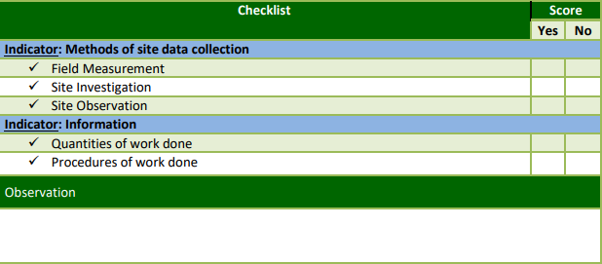

## 

## Learning Outcome 2.2: Collect data about site resources.

|  |  |  |
| --- | --- | --- |
| **Duration: 5hrs** | | |
| Learning outcome 2.2: objectives:  By the end of the learning outcome, the trainees will be able to:   * Enumerate correctly data collection about site resources. * Identify properly the forms used to correct data on site resources . | | |
| **Resources** | | |
| **Equipment** | **Tools** | **Materials** |
| * boards, * Projector * Computer | * Tape measure Decameter * Tape measure, | * Site documents * Chalk * Pens * White board * pencils |
| **Advance preparation:**   * Having complete equipment, tools and materials * Well prepared working place * Availability of facilities such as electricity. | | |



**Content 2.2: Collect data about site resources.**

Site resources

* Workforce
* Material used
* Plant and equipment in use
* Suppliers/deliveries
* Petty cash
* Transportation means

Forms used to collect data on site resources:

* Work force form
* Material request form
* Material receipt form
* Equipment forms
* Suppliers/delivery form

**Site resources**

**Site resources** can be defined as those requirements needed to perform tasks in project implementation.

* Workforce or Human resources
* Materials and product used
* Plant, tools and equipment in use
* Suppliers/deliveries
* Petty cash /finance
* Transportation means
* **Workforce**

Human resource management (HRM or HR) is the strategic approach to the effective management of people in an organization, so that they help the business gain a competitive advantage.

* **Materials used**

A material is something that is used for a process but gets changed either temporarily or permanently and is what the process is being carried out on by a tool.

* **Plant and equipment in use**

Equipment refer to tangible and durable [assets](https://www.differencebetween.com/difference-between-inventory-and-vs-assets/) that are used in the production of other goods and services.

* **Suppliers/deliveries**

Delivery is the process of transporting goods from a source location to a predefined destination.

* **Petty cash**

Petty cash is a small amount of discretionary funds in the form of cash used for expenditures where it is not sensible to make any disbursement by cheque, because of the inconvenience and costs of writing, signing, and then cashing the cheque

* **Transportation means**

The different modes of transport are air, water, and land transport, which includes rail road transport/road and off-road transport

**Forms used to collect data on site resources**

* Work force form

Attendance list

* Material request form

STOCK ROOM MATERIAL REQUEST FORM

NAME…………………… TODAY’S DATE………………

COURSE……………… DATE WANTED………………

|  |  |  |  |
| --- | --- | --- | --- |
| Quantity | Site/ Amount | Item | Location |
|  |  |  |  |
|  |  |  |  |

Material request forms are documents that are used in order to communicate the list of materials that are need by a certain company, business or department of a company in order to carry out their task and function.

* Material receipt form

**MATERIAL RECEIPT FORM**

DATE……………………

PSCA N0…………… BC NO………………

COUNTRY/CITY/ INSTITUTION/AGENCY…………………………

RECEIVED FROM…………………………..FEIN………………….

VENDOR

RECEIVED AT……………………………….DATE RECEIVED……………..

LOCATION

|  |  |  |  |
| --- | --- | --- | --- |
| Quantity | Unit | Article  Make full report of any shortage or Damage | Condition |
|  |  |  |  |
|  |  |  |  |

I hereby certify that I have received and checked the articles listed above and that they are of the kind, quantity and condition noted.

Checked by………………………….received by………………………

Signature….. signature…………

* Equipment forms

**FORM OF EQUIPMENT**

|  |  |  |
| --- | --- | --- |
| Equipment description | Serial/ ID No | Condition |
|  |  |  |
|  |  |  |

|  |  |  |  |
| --- | --- | --- | --- |
| Issue |  | Return |  |
| Date issued |  | Date returned |  |
| Issued name |  | Employee signature |  |
| Issued signature |  | Manager names |  |
| Employee name |  | Manager signature |  |
| Employee signature |  |  |  |

* Suppliers/delivery form

SUPPLIERS FORM (DELIVERY FORM)

SUPPLIER INFORMATION

|  |  |  |  |  |
| --- | --- | --- | --- | --- |
| General information | | Payment information | | |
| Company type | |  | | |
| Supplier Name | | TAX ID | | |
| Bank Name | | Account No |
| Authorized person | Contact person | Payment term | * 15days * 30days * others | |
| Supplier site | Supplier site | Payment method | * TT(Tegraphic Transfer) * Cheque * Others | |
| Address | | | | |
| Register Address  City, State  Country, Postal code  Phone/ Fax No  Website/Email | | Billing address  City, State  Country, postal code  Phone/ Fax No | | |

(Pennock, 2006)

Theoretical learning Activity

In group trainees discuss about data collection

Trainees brainstorm about data collection

**Points to Remember**

* Identify forms used to collect data on site resources
* Collection of data on site from different resources

Learning outcome 2.2: formative assessment

1. Outline different forms used to collect data on site resources.

**Answer**

a) Work force form

b) Material request form

c) Material receipt form

d) Equipment forms

e) Suppliers/delivery form

Q2. Highlight any five (5) Site resources.

**Answer**

* Workforce or Human resources
* Materials and product used
* Plant, tools and equipment in use
* Suppliers/deliveries
* Petty cash /finance
* Transportation means

## Learning Outcome 2.3: Fill site forms.

|  |  |  |
| --- | --- | --- |
| **Duration: 10hrs** | | |
| Learning outcome 2.3 objectives:  By the end of the learning outcome, the trainees will be able to:   * Fill correctly the site forms. | | |
| **Resources** | | |
| **Equipment** | **Tools** | **Materials** |
| * Boards, * Projector * Computer | * Tape measure Decameter * Tape measure, | * Site documents * Chalk * Pens * White board * pencils |
| **Advance preparation:**   * Having complete equipment, tools and materials * Well prepared working place * Availability of facilities such as electricity. | | |

**Content 2.3: Fill site forms.**



Site documents to be filled

* Daily diary (work force &work done form)
* Requests for Information (RFI) –
* Confirmation of verbal instructions (CVI),
* Drawing register –
* Minutes of meeting – minutes
* Approvals and inspections books
* Work program (Planner)
* Instructions book
* Site Reports
* Query and request forms

SITE DOCUMENTS TO BE KEPT

* Daily diary (Logbook)

Project: <PROJECT NAME>

Project Manager: <PROJECT MANAGER NAME>

DAILY LOG

|  |  |
| --- | --- |
| **Purpose** | A Daily Log is used to record informal issues, required actions or significant events not caught by other registers or logs. It acts as the project diary for the Project Manager. |
| **Advice** | Entries are made when the Project Manager or Team Manager feels it is appropriate to log some event. Often entries are based on thoughts, conversations and observations.  A Daily Log can take a number of formats including a Document or Spreadsheet; Desk diary or log book; Electronic diary/calendar/task lists or Entry in a project management tool. |

Log Contents

|  |  |  |  |  |
| --- | --- | --- | --- | --- |
| **Date of Entry** | **Problem, action, event or comment** | **Person Responsible** | **Target Date** | **Results/Comments** |
|  |  |  |  |  |
|  |  |  |  |  |
|  |  |  |  |  |
|  |  |  |  |  |
|  |  |  |  |  |
|  |  |  |  |  |
|  |  |  |  |  |
|  |  |  |  |  |
|  |  |  |  |  |
|  |  |  |  |  |
|  |  |  |  |  |
|  |  |  |  |  |
|  |  |  |  |  |
|  |  |  |  |  |

* Requests for Information (RFI)

A **request for information** (**RFI**) is a standard business process whose purpose is to collect written information about the capabilities of various suppliers. Normally it follows a format that can be used for comparative purposes.

**REQUEST FOR INFORMATION (RFI)**

For

CONSTRUCTION COMPANIES IN RWANDA

Date of Request: ___________

Completed request must be submitted no later than ___________ (date) by __:___ P.M. CST

RFI issued by:

_____________________________ (company name)

_______________________________________ (company address)

Contact Person: ___________

Contact Person Title: ___________

Contact Person Phone Number: ___________

Contact Person Email: ___________

Please read RFI carefully!

(Cover Page)

(Gyampoh-Vidogah, 2003)

* **Confirmation of verbal instructions (CVI).**

[Construction contracts](https://www.designingbuildings.co.uk/wiki/Construction_contracts) generally give the [contract administrator](https://www.designingbuildings.co.uk/wiki/Contract_administrator) the [power](https://www.designingbuildings.co.uk/wiki/Power) to issue instructions to the [contractor](https://www.designingbuildings.co.uk/wiki/Contractor).

Broadly, instructions may be given:

* To vary the [works](https://www.designingbuildings.co.uk/wiki/Works).
* To postpone the [works](https://www.designingbuildings.co.uk/wiki/Works).
* To remedy [workmanship](https://www.designingbuildings.co.uk/wiki/Workmanship), [goods](https://www.designingbuildings.co.uk/wiki/Goods) or [materials](https://www.designingbuildings.co.uk/wiki/Materials) which are not in accordance with the [contract](https://www.designingbuildings.co.uk/wiki/Contract).
* To sanction a [variation](https://www.designingbuildings.co.uk/wiki/Variations) made by the [contractor](https://www.designingbuildings.co.uk/wiki/Contractor).
* In relation to the expenditure of [provisional sums](https://www.designingbuildings.co.uk/wiki/Provisional_sums).
* To open up [work](https://www.designingbuildings.co.uk/wiki/Works) for [inspection](https://www.designingbuildings.co.uk/wiki/Inspection).
* To carry out tests.
* To exclude persons from the [site](https://www.designingbuildings.co.uk/wiki/Site).

The [contractor](https://www.designingbuildings.co.uk/wiki/Contractor) must comply with the instructions within certain limitations. They have the right to ‘reasonably object’ to an instruction, and instructions can only be given as empowered by the [contract](https://www.designingbuildings.co.uk/wiki/Contract).

Generally, instructions must be made formally, in writing, following a procedure set out in the [contract](https://www.designingbuildings.co.uk/wiki/Contract). However, it is common for [contracts](https://www.designingbuildings.co.uk/wiki/Contract) to allow instructions to be given verbally, for example during a meeting, a [site visit](https://www.designingbuildings.co.uk/wiki/Site_visit), or in an emergency situation. In this case, either the [contract administrator](https://www.designingbuildings.co.uk/wiki/Contract_administrator) should then confirm the instruction in writing to the [contractor](https://www.designingbuildings.co.uk/wiki/Contractor), or the [contractor](https://www.designingbuildings.co.uk/wiki/Contractor) should confirm the instruction in writing to the [contract administrator](https://www.designingbuildings.co.uk/wiki/Contract_administrator). If the receiving party does not dissent from the written confirmation, then the instruction will take effect.

This confirmation is referred to as a confirmation of verbal instruction (CVI) or an [oral confirmation sheet](https://www.designingbuildings.co.uk/wiki/Oral_confirmation_sheet). The [contract](https://www.designingbuildings.co.uk/wiki/Contract) should set out the exact procedures and the timescales for issuing such an instruction and dissenting from it.

|  |  |
| --- | --- |
| Confirmation of Verbal Instruction |  |

**To Site / Contract**

|  |  |  |
| --- | --- | --- |
| Attention of: |  | Contract: |
|  |  |

|  |  |  |
| --- | --- | --- |
| Issue Date: |  | Issue No: CVI |

Confirmation of instruction

|  |  |  |  |  |
| --- | --- | --- | --- | --- |
|  | | | | |
|  | | | | |
| This work will be charged at: | | | | Please note: |
| Schedule of rates prices | | | | We are making the necessary arrangements to carry out this work and request that your formal written instructions be issued within 5 days. |
| Day work rates | | | |  |
| Specified price of: | | | |  |
| Price to be agreed. Our quotation will follow | | | | We will not proceed with this work until a formal written instruction is received. |
| As ⇨ | | | |  |
| Issued by: | | | | Confirmation of Instruction |
| Signature: | | | | Please proceed with the works as detailed on this instruction. |
| Date: | | | | Signature: |
| For and on behalf of KWIZERA Engineering | | | | Date: |
| Original distributed by: | Hand | Fax | Post | For and on behalf of: |

* **Drawing register**

A **Drawing Register** is the controlled register of a list of drawings relating to a project and is used in the distribution of formal drawings to Architects, Engineers, Sub-contractors, Fabricators, Government bodies and other parties in the form of a document identifying the information that is included in the drawings being delivered.

**DOCUMENT AND DRAWING ISSUE SHEET**

|  |  |  |  |  |  |  |  |  |  |  |  |  |  |  |  |  |  |
| --- | --- | --- | --- | --- | --- | --- | --- | --- | --- | --- | --- | --- | --- | --- | --- | --- | --- |
| **Project Name:** | | | | | | | | | | | **Page:1 Sheet:** | | | | | | |
| **ProjectNo:2519** | |  | **Date of Issue:** | | | | | | | | | | | | | | |
| **Service:**  **Electrical Services** | | **Day:** | 16 |  |  |  |  |  |  |  | |  |  |  |  |  |  |
| **Month:** | 11 |  |  |  |  |  |  |  | |  |  |  |  |  |  |
| **Year:** | 19 |  |  |  |  |  |  |  | |  |  |  |  |  |  |
| **Drawing Description:** | | **Drawing No:** | **Amendments:** | | | | | | | | | | | | | | |
|  | |  |  |  |  |  |  |  |  |  | |  |  |  |  |  |  |
|  | |  |  |  |  |  |  |  |  |  | |  |  |  |  |  |  |
| Electrical Services | |  | x |  |  |  |  |  |  |  | |  |  |  |  |  |  |
| Installation Layout | |  |  |  |  |  |  |  |  |  | |  |  |  |  |  |  |
|  | |  |  |  |  |  |  |  |  |  | |  |  |  |  |  |  |
|  | |  |  |  |  |  |  |  |  |  | |  |  |  |  |  |  |
|  | |  |  |  |  |  |  |  |  |  | |  |  |  |  |  |  |
|  | |  |  |  |  |  |  |  |  |  | |  |  |  |  |  |  |
| Electrical Services Specification | |  | x |  |  |  |  |  |  |  | |  |  |  |  |  |  |
|  | |  |  |  |  |  |  |  |  |  | |  |  |  |  |  |  |
|  | |  |  |  |  |  |  |  |  |  | |  |  |  |  |  |  |
|  | |  |  |  |  |  |  |  |  |  | |  |  |  |  |  |  |
|  | |  |  |  |  |  |  |  |  |  | |  |  |  |  |  |  |
|  | |  |  |  |  |  |  |  |  |  | |  |  |  |  |  |  |
| **Role** | **Company** | **Contact** | **Number of Copies:** | | | | | | | | | | | | | | |
|  |  |  |  |  |  |  |  |  |  |  | |  |  |  |  |  |  |
| Architect | KWIZERA Architects | KIGALI-KICUKIRO | 1 |  |  |  |  |  |  |  | |  |  |  |  |  |  |
|  |  |  |  |  |  |  |  |  |  |  | |  |  |  |  |  |  |
|  |  |  |  |  |  |  |  |  |  |  | |  |  |  |  |  |  |
|  |  |  |  |  |  |  |  |  |  |  | |  |  |  |  |  |  |
|  |  |  |  |  |  |  |  |  |  |  | |  |  |  |  |  |  |
|  |  |  |  |  |  |  |  |  |  |  | |  |  |  |  |  |  |
| **Method of Issue(see below)** | | | E |  |  |  |  |  |  |  | |  |  |  |  |  |  |
| **Purpose of Issue(see below)** | | | T |  |  |  |  |  |  |  | |  |  |  |  |  |  |
| **Pa:Paper E:Email CD: Compact Disc D:Dwg P:PdfPF:ProjectFile** | | | | | | | | | | | | | | | | | |
| **I:InformationCm:CommentD:Draft A:Approval T:Tender C:Construction** | | | | | | | | | | | | | | | | | |

* **Minutes of meetings**

Meeting minutes are the detailed notes that serve as an official written record of a meeting or conference. After the meeting, attendees should be able to verify what decisions were made and what actions are to be taken. Meeting minutes act as a measuring stick. Minutes record meeting decisions, which makes them a useful review document when it comes time to measure progress. They also act as an accountability tool because they make it clear who's duty it was to perform which action.

**MEETING AGENDA**

| Meeting/Project Name: |  | | |
| --- | --- | --- | --- |
| Date of Meeting: (MM/DD/YYYY) |  | Time: |  |
| Meeting Facilitator: |  | Location: |  |

|  |
| --- |
| 1. Meeting Objective |
|  |

|  |  |  |  |
| --- | --- | --- | --- |
| 2. Attendees | | | |
| Name | Department/Division | E-mail | Phone |
|  |  |  |  |
|  |  |  |  |
|  |  |  |  |
|  |  |  |  |

|  |  |  |
| --- | --- | --- |
| 3. Meeting Agenda | | |
| **Topic** | **Owner** | **Time** |
|  |  |  |
|  |  |  |
|  |  |  |
|  |  |  |

**MEETING MINUTES**

| Meeting/Project Name: | | |  | | | | | | | | | | | |
| --- | --- | --- | --- | --- | --- | --- | --- | --- | --- | --- | --- | --- | --- | --- |
| Date of Meeting: (MM/DD/YYYY) | | |  | | | | Time: | | | |  | | | |
| Minutes Prepared By: | | |  | | | | Location: | | | |  | | | |
| 1. Meeting Objective | | | | | | | | | | | | | | |
|  | | | | | | | | | | | | | | |
| 2. Attendance at Meeting | | | | | | | | | | | | | | |
| Name | | | | Department/Division | | | | E-mail | | | | | Phone | |
|  | | | |  | | | |  | | | | |  | |
|  | | | |  | | | |  | | | | |  | |
|  | | | |  | | | |  | | | | |  | |
|  | | | |  | | | |  | | | | |  | |
| 3. Agenda and Notes, Decisions, Issues | | | | | | | | | | | | | | |
| **Topic** | | | | | | | | | | **Owner** | | | | **Time** |
|  | | | | | | | | | |  | | | |  |
|  | | | | | | | | | |  | | | |  |
|  | | | | | | | | | |  | | | |  |
| 4. Action Items | | | | | | | | | | | | | | |
| **Action** | | | | | | | | | | **Owner** | | | | **Due Date** |
|  | | | | | | | | | |  | | | |  |
|  | | | | | | | | | |  | | | |  |
|  | | | | | | | | | |  | | | |  |
|  | | | | | | | | | |  | | | |  |
| 5. Next Meeting(if applicable) | | | | | | | | | | | | | | |
| **Date:** (MM/DD/YYYY) | |  | | | **Time:** |  | | | **Location:** | | |  | | |
| Objective: |  | | | | | | | | | | | | | |

* Approvals and inspections books

A building inspection is an inspection performed by a building inspector, a person who is employed by either a city, township or county and is usually certified in one or more disciplines qualifying them to make professional judgment about whether a building meets building code requirements.

SAMPLE- Workplace Inspection Worksheet

Inspection Area: Month:

Date of inspection:

|  |  |  |  |  |  |  |  |  |
| --- | --- | --- | --- | --- | --- | --- | --- | --- |
| Element of inspection | DETAILS | LOCATION | RATING (A,B,C) 1 | ASSIGNED TO | DATE ASSIGNED | RECOMMENDED ACTION | DETAILS OF ACTION TAKEN/NOT | COMPLETION DATE |
| Safety hazard |  |  |  |  |  |  |  |  |
| Layout against drawings |  |  |  |  |  |  |  |  |
| Structural |  |  |  |  |  |  |  |  |
| Finishing quality |  |  |  |  |  |  |  |  |
| Work  Process/ Design |  |  |  |  |  |  |  |  |

Inspection conducted by (Name & Signature required): Senior Management Signature:

Copies to: 1) Senior Management 2) Health and Safety Bulletin Board

1A = high B = mediumC = low

(Caldas, 2003)

* **Photographs**
* **Work program (planner)**

Construction Planners define work tasks and relationships they also must determine the various work that the job requires. Identifying work tasks involves breaking down each operation on the job into sub-activities so that scheduling can be done in the future.

| **Goal 1:** | | | | | |
| --- | --- | --- | --- | --- | --- |
| **Key Action Steps** | **Timeline** | **Expected Outcome** | **Data Source and Evaluation Methodology** | **Person/Area Responsible** | **Comments** |
| *Define each action step on its own row. Define as many action steps as necessary by adding rows to the table.* | *An expected completion date (month and year) must be defined for each action step.* | *An expected outcome must be defined for each action step.* | *An evaluative measure must be defined for each action step.* | *A responsible person must be identified for each action step.* | *Comments are optional.* |
|  |  |  |  |  |  |
| **Goal 2:** | | | | | |
| **Key Action Steps** | **Timeline** | **Expected Outcome** | **Data Source and Evaluation Methodology** | **Person/Area Responsible** | **Comments** |
|  |  |  |  |  |  |
|  |  |  |  |  |  |
| **Goal 3:** | | | | | |
| **Key Action Steps** | **Timeline** | **Expected Outcome** | **Data Source and Evaluation Methodology** | **Person/Area Responsible** | **Comments** |
|  |  |  |  |  |  |
|  |  |  |  |  |  |
| **Goal 4:** | | | | | |
| **Key Action Steps** | **Timeline** | **Expected Outcome** | **Data Source and Evaluation Methodology** | **Person/Area Responsible** | **Comments** |
|  |  |  |  |  |  |

* **Instruction books Site Reports**
* **Query and request forms**

stores requisitions forms used to keep track of materials charged to a particular job or department. The form contains such items as job number, department, description of the material, quantity, unit cost, and dollar amount.

|  |  |
| --- | --- |
| REQUISITION FORM |  |
| Department Name _________________________ | User Reference No. _________________________ |
| User ____________________________________ | Requisition Number_________________________ |
| User Phone ___________Mail Stop _________ |  |
| Account Name ____________________________ | Route ______________ |
| Account Number __________________________ | P.O. _________________ |

|  |
| --- |
| My Department needs the following service, equipment, or supplies.  It is understood that these items, including labor, may be charged against my budget. |

|  |  |  |  |  |  |
| --- | --- | --- | --- | --- | --- |
| Item Number | Description | Quantity | Unit | Unit Price | Extend Price |
|  |  |  |  |  |  |
|  |  |
|  |
|  |
|  |
|  |
|  |
|  |
|  |
|  |

* Purchase order

A purchase order is much more than just a form; it’s a form that represents a way of life for many businesses that order large quantities of raw goods or supplies from a vendor on a regular basis. The purchase order serves as an offer, on paper, to buy a specific product, in a specific amount, for a specific price. Once a vendor accepts a purchase order, it becomes a contract between buyer and seller. The vendor will send your company the goods you require, and send your company an invoice that is usually net 30 or net 60 days, depending on your [agreement with the vendor](http://templatelab.com/consignment-agreement/).

Purchase order template

**vendor Name:** ________________________________________________________________

**Company Name:** ____________________________________________________________________________

**Address:** __________________________________________________________________________________

**City, State, Zip Code** ____________________________ **Phone:** ______________________________________

**Shipped To:**

**Company Phone:** 555-555-555555

**Website:** www.websiteaddress.com

**Email:** abc@example.com

Company Address Goes Here

City, State, Zip Code

***Purchase Order Template***

**Additional Notes:**

____________________________________________________________________________________________________________________________________________________________________________________________________________________________________________________________________________________________________________________________________________________________________

**Shipped From:**

**Company Name:** ____________________________________________________________________________

**Address:** __________________________________________________________________________________

**City, State, Zip Code** ____________________________ **Phone:** ______________________________________

**Dated As:**_________________________

**Purchase Order #:**_________________

**Company Name Here**

**Purchase Order**

|  |  |  |  |
| --- | --- | --- | --- |
| **Details** | **Quantity** | **Unit Price** | **Total** |
|  |  |  |  |
|  |  |  |  |
|  |  |  |  |
|  |  |  |  |
|  |  |  |  |
|  |  |  |  |
|  |  |  |  |
|  |  |  |  |
|  |  |  |  |
|  |  |  |  |
|  |  |  |  |
|  | | **SUBTOTAL** |  |
| **TAX** |  |
|  |  |
| **TOTAL** | 000000.00 |

____________________________

[Signatures of Authorized Person]

[Write Designation Here]

* **Goods receipt note**

Your GRN acts as internal proof of goods received to process and match against your supplier invoices/purchase orders. Goods Receipt Notes. The goods receipt note is an internal document produced after inspecting delivery for proof of order receipt. Generally produced by your stores team.

|  |
| --- |
| **Goods Received Note** |
| **Purchase Order No**:  **Supplier:**  **Delivery Note No:**  **Date Goods Received:**  **Cost Centre | Account Code | Job Code**  **Charging Details: | |** |
| **Full Order □ Part Order □ Delivery Note□**  **Delivery Delivery Attached** |
| **Comments** |
| **Signed**:**Dated**: |

(Stewart, 2007)

Theoretical learning Activity

Trainees brainstorm on filling/ compiling site documents

Within groups, trainees discuss on how to fill the forms

Practical learning Activity

Trainees fill the forms used on site.

**Points to Remember** (Take the home message)

* Fill the forms

Learning outcome 2.3: formative assessment

Q1. Clearly outline the information should be recorded in the daily diary report.

**Answer**

a. Day

b. Activities and Location

c. Total hours worked

d. Authorized overtime hours

e. Sick & leave hours

f. Other hours

g. Explain other

Q2.Select the collect answer

1.Records must be………………….

a) soft copy only

b) hard copy or soft copy

2.Documents must be paper…………….

a) hard copy only

b) hard copy or soft copy

3.Daily diary must be filled………….

a) after three (3) days

b) every day

**Answer**

1. b. hard copy or soft copy
2. b. hard copy or soft copy
3. b. every day

**Checklist:**

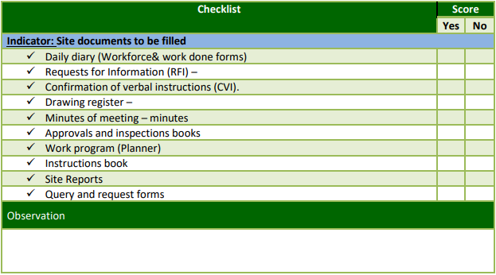

# LU3: Manage site records



**STRUCTURE OF LEARNING UNIT**

|  |
| --- |
| **Learning outcomes**   * 1. **Arrange site documents**   2. **Safeguard site documents**   3. **Report site records** |

## 

## Learning outcome 3.1 Arrange site documents

|  |  |  |
| --- | --- | --- |
| **Duration: 4hrs** | | |
| Learning outcome 3.1 objectives:  By the end of the learning outcome, the trainees will be able to:  3.1. Identify properly the methods of site documents arrangement.  3.2. Adequately arrangement of site documents. | | |
| **Resources** | | |
| **Equipment** | **Tools** | **Materials** |
| * Computers * Shelves * Printers * Projection screen * Projector | Workshop | * documents Books * Internet * Chalk boards * Pens * pencils * White board, |
| **Advance preparation:**   * Having complete equipment, tools and materials * Well prepared working place * Availability of facilities such as electricity. | | |



**Content 3.1: Arrange site documents**

**Introduction to records**

In this learning unit, we are going to see the Record management, record life cycle, the benefits of records management, the principles for effective records management and other areas which deem to be necessary

**Definition:** Record management refers to administrative management concerned with systematic planning, controlling, creating, maintenance, efficient and economic use and disposal of records throughout the entire life cycle of records of an organization (Samson, 2012)

Activities involved in controlling the life cycle of a record, beginning with its creation and ending with ultimate disposition

Leads to prevention of creation of unnecessary documentation

Early identification of papers lasting value and systematic planning of retirement procedures

Records management offers tangible benefits to organizations, from economic good practice in reducing storage costs of documents, to enabling administrative, financial and legal requirements to be met.

Poor management of record system makes the performance of duties more difficult, costs organizations time, money and other resources and e.t.c

**Records life cycle**

A basic concept in Records Management is the records life cycle. The life of a record goes through phases starting from when it is created or received by the Agency, through to its use, maintenance and temporary storage before finally being destroyed or archived permanently.

Life-cycle of a Record is summarized in the following steps:

a. Creation & receipt; capture into RM system

b. Distribution & use

c. Storage and maintenance

d. Retention and disposition



**Benefits of a Records Management Program**

Some benefits may be:

1. To increase efficiency and productivity;

2. To protect the organization from litigation;

3. To have evidence of transactions/ events for audit purposes;

4. To preserve the institutional memory of the organization;

5. To facilitate the resumption of operations in the event of a disaster; and

6. To ensure that employee benefits can be supported via information maintained in personal records.

(Caldas, 2003)

Methods of document arrangement:

* Chronological method: arrangement based on time
* Subject method: arrangement according to the name of subjects
* Alphabetical filling: based on alphabets
* Numerical filling: arranged according to the numerical
* Geographical filling: according to town, districts, regions, countries, zones….

**Records Centers and Archives**

The difference between a Records Center and an Archivesis that a Records Centeris a building specially designed for low-cost storage and maintenance of semi-current records pending their ultimate destruction or transfer to an archive repository. An Archivemay be either a collective of records, usually but not necessarily non-current records of continuing value selected for permanent preservation or a building housing such a repository.

The Purpose and Functions of the Records Center (and an Archive, as well), is to ensure that correspondence is properly arranged and stored, so that they can be located easily and promptly.

**Methods of document arrangement**

1) **Chronological method:** arrangement based on time

2) **Subject method:** arrangement according to the name of subjects

3) **Alphabetical filling:** based on alphabets

4) **Numerical filling:** arranged according to the numerical

5) **Geographical filling:** according to town, districts, regions, countries, zones….

The only time you seem to think about your important documents is when you need them. And, oftentimes, you can't find them when you need them because you either don't have anorganized and centralized system for storingyour important documents and/or the last time you needed them, you simply tossed it back into the sea of papers in your [home office](https://www.thebalancecareers.com/how-to-stay-organized-when-you-work-at-home-4145799) instead of putting it back where it belonged.

With all of your important papers spread throughout your house, you waste a lot of time and energy searching for them. You're also at risk of losing some of them completely. But with a few simple steps, you can organize your important paper documents

1. **Methods of document arrangement:**

Organizing office files can be a difficult task, especially if you have large amounts of files and documents, but it does not need to be a painful process. Planning ahead and deciding on a file system can help you organize your files to suit your business and ensure that you will find important documents more efficiently.

**Create file categories.**

 The first thing to do if you want to organize your files is decide what major categories you will use for sorting. Different kinds of offices will have different kinds of categories, but the general system is the same. You need to figure out a system that sorts your files in a meaningful way.

Different methods may be used:

* **Chronological method: arrangement based on time**

The word chronological comes from two Greek words. "Chronos" means time. "Logikos" means reason or order. That is what chronological order is all about. It arranges information according to time.

In this method, files and folders of documents are arranged in an order of their date, day and time. In an office, several letters and documents may be received and dispatched. They all are arranged according to time and date when they were received and dispatched chronological order is a method of [organization](https://www.thoughtco.com/organization-composition-and-speech-1691460) in which actions or events are presented as they occur or occurred in time and can also be called time or linear order.

* **Subject method**: arrangement according to the name of subjects

In this filling method, records are classified according to their subject, letters and documents are classified and arranged in files and folders into subject or sub-subject wise. In this filing, subject must be arranged alphabetically. It is widely used in those cases where subject is more important than the name of the person or organization. All documents relating to same subject are filed together in one file.

When the information needs to be sorted by similarity or relatedness, using category is the best way to organize it. We could argue that our brains work in similar way, we like grouping similar things together.

This method of organizing information is used across the physical and digital world. From shopping goods and industries to categories on Pinterest and hashtags on Twitter.

* **Alphabetical filling: based on alphabets**

As the name suggests, ordering information alphabetically is great way to provide random access to data. It is one of the best ways to organize information when the amount of data is big.

The filing method under which files and folders are arranged in order of alphabets of the names of person or institution concerned with such file is alphabetical classification. It is most popular and common method of filing. In case name of more than one person starts with same letter then second letter of name is taken into consideration. It is flexible method. It is used in both small and large organization.

For example, the word dictionary or the big phone book be it digital or physical.

When your filing system is established and you have created all your folders, then put them in order. You should sort the general folders alphabetically. Within each general folder, the subcategories should all be sorted alphabetically as well

* **Numerical filling**: arranged according to the numerical

The filing method under which files and folders are arranged in order of number is called

Numerical classification. All files and folders are given separate numbers. It is indirect method of classification of filing. In this filing alphabetical index is required. It includes name, address, phone number, subject and other information along with file number.

* **Geographical filling**: according to town, districts, regions, countries, zones….

Organizing information by its location. It can be physical or conceptual (spacial) location. We humans have evolved to organize location this way in our daily lives. From using maps for navigating and war strategies to placing our ingredients in the kitchen.

Location organizing is important when the information has multiple different sources and locales.

For example, when designing a particular service, we should consider the location of different goods and how they will be distributed. Designing Supermarket’s shelves is a good example of organizing information in physical location.

In this method, files are grouped according to the geographical location of firm, organization or person. Under this method name of places are written in file and are arranged in drawer either in alphabetical or numerical order whichever is suitable for organization. It is used in multinational companies or those organizations whose business and branches are locate in many places of the nation or the word.

Hierarchy or Continuum

When the information can be organized by comparing things across a common measure. If the information needs to be organized by magnitude.

For example: Small to large, Lowest to highest, Happy to unhappy etc

(Pennock, 2006)

Theoretical learning Activity

Trainees discuss on documents arrangement

Practical learning Activity

Practical exercises on documents arrangement

**Points to Remember (Take home message)**

* Methods of documents arrangement

Learning outcome 3.1: formative assessment

Q1: Define the following terms used in record management

1. Records center
2. Archives

**Answer**

1. Records Center is a building specially designed for low-cost storage and maintenance of semi-current records pending their ultimate destruction or transfer to an archive repository.
2. An Archive may be either a collective of records, usually but not necessarily non-current records of continuing value selected for permanent preservation or a building housing such a repository.

The Purpose and Functions of the Records Center (and an Archive, as well), is to ensure that correspondence are properly arranged and stored, so that they can be located easily and promptly.

1. Determine steps of records life cycle used in record management.

**Answer**

a. Creation &receipt

b. Distribution &use

1. Storage and maintenance
2. Retention and disposition

**Checklist:**

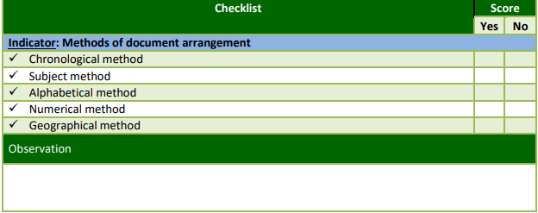

## Learning Outcome 3.2: Safe guard site documents

|  |  |  |
| --- | --- | --- |
| **Duration: 3hrs** | | |
| Learning outcome 3.2 objectives:  By the end of the learning outcome, the trainees will be able to:  1. Safe correctly data storage.  2. Identify properly the methods used for electronic data storage . | | |
| **Resources** | | |
| **Equipment** | **Tools** | **Materials** |
| * boards, * Projector * Computer | * Tape measure Decameter * Tape measure, | * Site documents * Chalk * Pens * White board * pencils |
| **Advance preparation:**   * Having complete equipment, tools and materials * Well prepared working place * Availability of facilities such as electricity. | | |



**Content 3.2: Safe guard site documents**

**3.2.1 Safe data storage**

* Binding
* Filing
* Electronic data storage: Scanning, mailing, Photocopying…….)

If you deal with confidential information in your workplace, you understand that you must take precautions to keep it from getting into the wrong hands.

* **Binding**

This is the process of physically assembling a book of codex format from an ordered stack of paper sheets that are folded together into sections or sometimes left as a stack

of individual sheets

paperback

With perfect bound books, the cover and pages are held together using a strong adhesive. These are the most popular books in book stores and are a more cost effective of binding compared to hardbacks. Paperbacks are commonly used for Novels, Poetry Collections and Children’s books



Hardback bound

A perfect bound book is cased into a board casing with strong glue. This is a durable, long lasting binding that gives the feel of a premium, quality product. Great for special editions,





Booklet (staple bound)

Paper is stapled and folded to create a staple bound document. These are durable, flexible and can lie flat, or be folded the other way for ease of use. Booklets are cost effective and perfect for Informational booklets, brochures, newsletters or magazines.

(Gyampoh-Vidogah, 2003)



Coil bound

A plastic coil is wound through both covers and every page to bind the book together. Works brilliantly for recipe books, staff handbooks and student diaries due to the ability for them to lay flat or open 360 degrees. Coils are also incredibly durable; making them excellent for books that will be used and opened frequently.

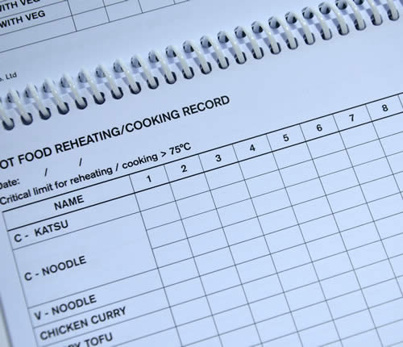

* **Filing**

Classification of files refers to the process of selecting heading under which documents are grouped or classified on the basis of common characteristics. The bases of classification are as follows

* Chronological method: arrangement based on time
* Subject method: arrangement according to the name of subjects
* Alphabetical filling: based on alphabets
* Numerical filling: arranged according to the numerical
* Geographical filling: according to town, districts, regions, countries, zones…
* Hierarchy or Continue
* **Electronic data storage: Scanning, mailing, Photocopying**…….)

**Outsource server security**

Assuming that your business or firm is not large enough to have a team dedicated to maintaining the security of your servers and monitor incoming and outgoing traffic, hire a network security company to ensure your data is adequately protected

Everyone in the workplace should understand how to recognize confidential legal information and treat it accordingly. Employees who have no reason to handle confidential information should not have access to it.

**Encrypt all files with confidential information.**

Any files you transmit with confidential legal information should not only be kept on secure servers, their contents also should be encrypted so they cannot be read in the event they are intercepted.

* This means ensuring your emails are encrypted as well. You should never use free email services such as gmail for business communications that involve confidential legal information, as the content of those emails is not secure.
* If staff who frequently deal with confidential legal information also work remotely or use mobile phones, you also must make sure the data on those systems is encrypted.
* Only give passwords and encryption keys to employees who need them for work-related reasons – don't make them readily available to the entire office or post them anywhere public

**Download anti-virus protection.**

 All computers in your office that are connected to the network should have an anti-virus program installed and updated on a regular basis to ensure confidential legal information cannot be corrupted.

* You can set your anti-virus software to update itself automatically, which means you don't have to rely on individual employees to keep their protection updated.
* In addition to anti-virus software, you also should ensure all the computers and devices in your office are connected using a secure, password-protected network with a firewall.
* Consider hiring a professional to set up your network rather than attempting to build it and maintain it yourself.

(Joia, 1998)

Theoretical learning Activity

Trainees in groups discuss about the method of filling documents

Practical learning Activity

A group of trainees arrange construction documents.

**Points to Remember:**

* Safe guard of site documents
* Method of electronic data storage

Learning outcome 3.2: formative assessment

**Q1.** The Good way of managed site is to keep and fill day to day construction site document. Enumerate and explain the method of data storage

**Answer**

✓ **Binding**: is the combination together of document by using specific tools

✓ **Filing**: means keeping document in a safe place and being able to find then easily and quickly (putting together to the reservoir)

✓ **Electronic data storage**: Scanning, mailing, Photocopying…

Q2. Identify three (3) examples of electronic data storage.

**Answer**

**Electronic data storage:**

a) Scanning

b) mailing

c) Photocopying

**Checklist:**

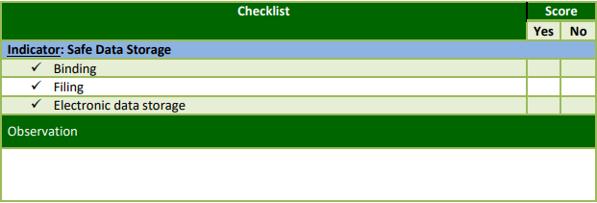

## Learning Outcome 3.3: Report site records

|  |  |  |
| --- | --- | --- |
| **Duration: 3hrs** | | |
| Learning outcome 3.3. Objectives:  By the end of the learning outcome, the trainees will be able to:   * Illustrate correctly the parts of site report. * Identify properly the content of site report. * Highlight adequately the importance of site report. | | |
| **Resources** | | |
| **Equipment** | **Tools** | **Materials** |
| * boards, * Projector * Computer | * Tape measure Decameter * Tape measure, | * Site documents * Chalk * Pens * White board * pencils |
| **Advance preparation:**   * Having complete equipment, tools and materials * Well prepared working place * Availability of facilities such as electricity. | | |



Content 3.3: Report site records

**Content of site report**

The construction daily report is a crucial documentation process. Daily reporting in construction helps stakeholders understand what happened on the site and the project’s health. Many in construction agree that the contract is the most important document in a project, and to kick off a project it is. However, a contract is the bare-bones of a project and doesn’t explain the nuances of a site. The construction daily report explains the details of the site and job, while providing important documentation to help subcontractors and stakeholders. Daily reports are one of the only ways to keep track of a construction site and the only way to track the trajectory of a project. While the contract is what should happen with the project, the construction daily report is what exactly happened on the site.

* Work progress
* Workforce
* Stock situation
* Supply status
* Weather conditions
* Materials usage
* Work quality
* Financial situation

Parts of site report

* Header
* Project details: project title, project start date, completion date, projects manager’s names
* Report details: report number, Reporting period (daily date, weekly dates….), Report Author, Reviewer
* Site details: overall site information (Safety& health, security issues, damages, supervision information)
* Construction activities: Work that is carried out, progress made, planned work & achieved work, difficulties that affected, Quality of work done, labor& subcontractors, financial issues

**Reporting** is part of the progress control system. Progress on the site should be recorded and reported to senior management on a regular basis. Progress reports will contain the following information:

**Content of site report**

1. Name of project

2. Report number

3. Date of report

4. Work in progress

5. Work completed since last report

6. Work which was scheduled to start but has not

7. Contract status at time of report

8. Workforce

9. Stock situation

10. Supply status

11. Weather conditions

12. Materials usage

13. Work quality

14. Financial situation

15. General comment

**What is a progress report?**

A progress report is exactly what it sounds like – a document that explains in detail how you far you’ve gone towards the completion of a project.

It outlines the activities you’ve carried out, the tasks you’ve completed, and the milestones you’ve reached vis-à-vis your project plan.

(Joia, 1998)

**Importance of site report**

1. tracking

2. identifies risks

3. cost management

4.visibility

5. control

6. learning

7. driver project success

(Gyampoh-Vidogah, 2003)

Theoretical learning Activity

* Trainees in groups brainstorm on Content of site report,

Practical learning Activity

Trainees in pair Filling site report

Points to Remember (Take home message)

* The different parts of site report
* The importance of site report
* The content of site report

Learning outcome 3.3: formative assessment

**Q1.** Highlight five (5) Parts of site report

**Answer**

* Header (title, cover page)
* Project details
* Report details
* Site details

**Q2.** Site records: are document required to prove any construction activities or other claims. As Technician Road construction what are the importance of good site report?

**Answer:**

1. tracking

2. identifies risks

3. cost management

4.visibility

5. control

6. learning

7. driver project success

**Q3.** Write down at least 6 necessary content of site report.

1. **Answer**

**Content of site report**

1. Name of project

2. Report number

3. date of report

4. work in progress

5. work completed since last report

6. work which was scheduled to start but has not

7. contract status at time of report

8. Workforce

9. Stock situation

10. Supply status

11. Weather conditions

12. Materials usage

13. Work quality

14. Financial situation

15. General comments

**Checklist:**

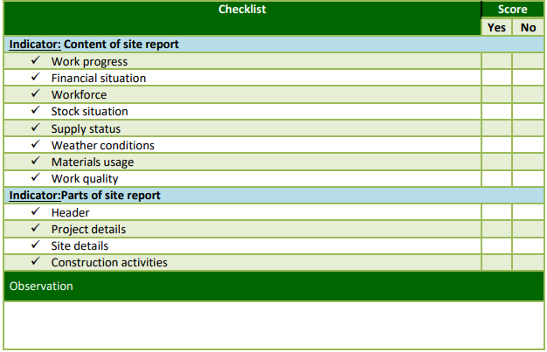

### Integrated situation

GAHINI HOSPITAL in KAYONZA district Eastern province award STAR CONSTRUCTION the project of Rehabilitation of Laboratory (15x10x3.5m), to be rehabilitated in 3 months) Due to unsatisfactory of the existing one, While the project was in progress, Insufficient data has been observed by the client (GAHINI HOSPITAL) therefore Gahini Hospital requested all necessary site data for the project. as a mason supervisor from star construction ltd you are requested to:

a) Identify the project documents on site

b) State the content in each document

c) Fill the content in each document

d) Arrange and manage these site records

e) Communicate these site records to the concerned parties

Assignment duration꞉ 6 hours

### Checklist:

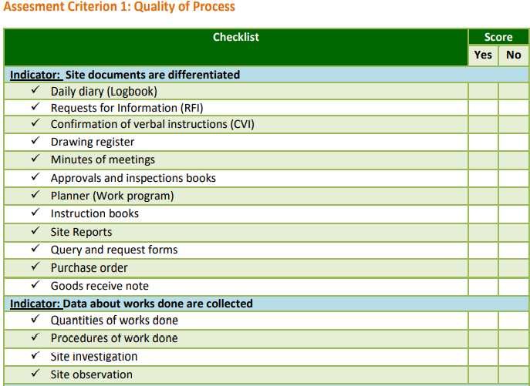

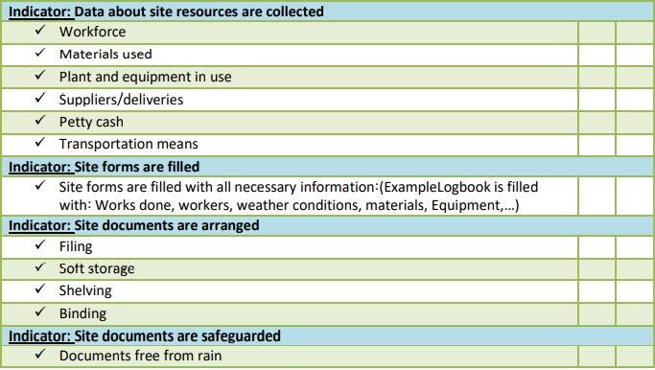

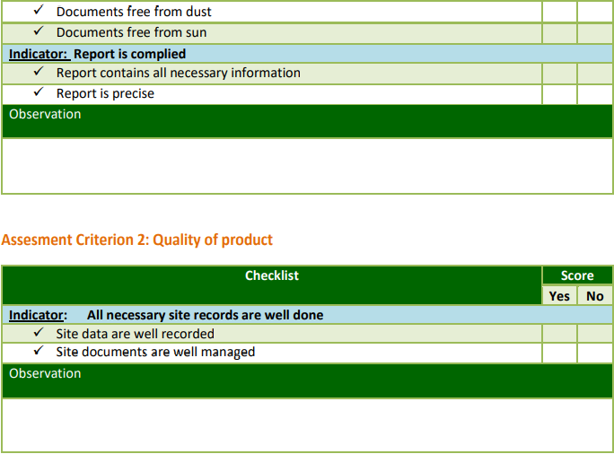

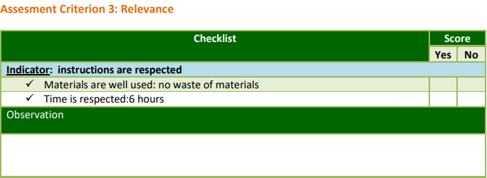

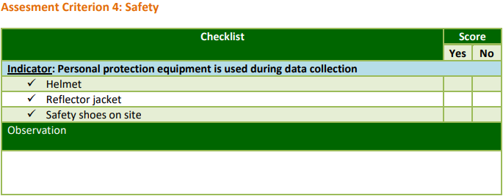

# References:

Beastall. (1998). Records management meets knowledge gathering. *Records ManagementJournal*, pp89-94.

Caldas, C. a. (2003). Automating hierarchical document classiﬁcation forconstruction management information systems. *Automation in Construction*, pp395-406.

Gyampoh-Vidogah. (2003). Implementing informationmanagement in construction: establishing problems, concepts and practice. *Journal ofConstruction Innovation*.

Joia. (1998). “Large scale engineering in project documentation and workﬂow at engineeringconsultancy companies. *International Journal of Information Management*, pp215-24.

Lam, H. a. (2002). Web-based information management system forconstruction projects”. *Computer Aided Civil and Infrastructure Engineering*.

Pennock, M. a. (2006). *Archiving web site resources: a records management view.* Edinburgh: Scotland.

Sommerville, J. C. (2004). The standardisation of constructionsnagging. *Journal of Structural Survey*.

Stewart, R. (2007). “IT enhanced project information management in construction: pathways toimproved performance and strategic competitiveness. *Automation in Construction*, pp511-517.

Veal. (2001). “Techniques of document management: a review of text retrieval and relatedtechnologies. *Journal of Documentation*.