

TEACHER’S GUIDE
RQF LEVEL FIVE
TRADE: SOFTWARE DEVELOPMENT
Module name:
DATABASE DEVELOPMENT
MODULE CODE: SFDDD501

Table of content
Table of Contents
Table of content 2
Acronyms 4
Introduction 5
Learning Unit 1: Perform database structure 7
Learning outcome 1.1 Introduce SQL 7
Indicative content 1.2: Create database 2
Indicative content 1.3: Create tables with attributes 6
Learning Unit 2: Apply DML queries 19
Indicative content 2.1: Explore organizational database 21
Indicative content 2.2: Retrieve row and column data from tables using SELECT statement 58
Indicative content 2.3: Create reports of sorted and restricted data 68
Indicative content 2.4: Use single-row functions to generate and retrieve customized data 76
Indicative content 2.5: Report aggregated data using group functions 94
Indicative content 2.6: Retrieve data from multiple tables using joins 104
Indicative content 2.7: Use subqueries to solve problems 114
Indicative content 2.8: Use of set operators 117
Indicative content 2.9: Use data manipulation language (DML) statements to update table data. 125
Indicative content 2.10: Execute database Stored procedure, index 129
Indicative content 3.1: Identify different data file formats 135
Indicative content 3.2: Correlate data between external format and database 138
Indicative content 3.3: Execute Import of data from external source 149
Indicative content 3.4: Execute export of data from external source 151

Acronyms

Introduction
This module covers the skills, knowledge and attitude to maintain a website which facilitates the requirement as a front-end website developer. The module will allow the learner to resolve website issues, to respond to the customer requests, to add new features and to execute customer service support.

Database development is a crucial aspect of modern software engineering and data-driven decision-making. It involves designing, implementing, and maintaining databases that store, organize, and retrieve large volumes of structured and unstructured data. Databases are at the heart of many business applications, e-commerce websites, social media platforms, and scientific research projects, among others. They enable developers to store and manage data efficiently, secure it from unauthorized access, and retrieve it quickly and accurately.

To develop a database, developers need to follow a systematic approach that involves several stages, such as requirement analysis, conceptual modelling, logical and physical design, implementation, testing, and maintenance. They need to select an appropriate database management system (DBMS) that matches the requirements and constraints of the project, such as scalability, performance, security, and compatibility. Moreover, they need to use standard query languages, such as SQL (Structured Query Language), to interact with the database and manipulate data. Overall, database development requires a blend of technical skills, analytical thinking, and creativity to design and implement effective data management solutions that meet the needs of various stakeholders.

Module Code and Title: SFDDD501 DEVELOP A DATABASE
Learning Units:
- Perform database structure
- Apply DML queries
- Interact with database
2
3
n

Learning Unit 1: Perform database structure
Picture/s reflecting the Learning unit 1

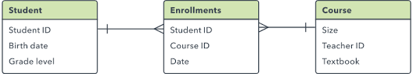
Figure 1. Database Structure

STRUCTURE OF LEARNING UNIT
Learning outcomes:
1.1 Introduce SQL
1.2 Create database
1.3 Create Tables with attributes
1.4 Use constraints
1.5 Refine Database Design

Learning outcome 1.1 Introduce SQL
Duration: 15 hrs
Learning outcome 1 objectives:
By the end of the learning outcome, the trainees will be able to:
Understand the basic concepts of SQL
Create and manage databases
Perform basic data manipulation
Understand basic database design principles
Use basic SQL clauses and operators
Resources
Equipment | Tools | Materials
Computers (Clients)  Web Servers | Database Management Systems (DBMS)  Development Environments (IDEs or text editors)  Virtualization tools (e.g., Wamp or Xampp)  Presentation tools (e.g., PowerPoint, Google Slides) | Documentary film  Papers  Printers  Books  Internet Pen  Boards  Chalks  YouTube tutorials  Projector
Advance preparation:
Preparing and installing some applications (Eg. Xampp or Wamp)
Cleaning and arrange the workplace
Brainstorming about the theory of the servers and database.



Indicative content 1.1: Introduction to SQL
 Summary for the trainer related to the indicative content (key notes using bullets such as ticks etc)

SQL Introduction

Structure Query Language(SQL) is a database query language used for storing and managing data in Relational DBMS.

SQL Definition

Structured Query Language (SQL) is a powerful and widely used programming language that provides a comprehensive set of commands for managing, retrieving, and manipulating data stored in relational databases. SQL is a fundamental tool for working with databases and is commonly used in various applications, including web development, data analysis, and business intelligence.
What Can SQL do?
SQL can execute queries against a database
SQL can retrieve data from a database
SQL can insert records in a database
SQL can update records in a database
SQL can delete records from a database
SQL can create new databases
SQL can create new tables in a database
SQL can create stored procedures in a database
SQL can create views in a database
SQL can set permissions on tables, procedures, and views

Advantages of SQL

SQL (Structured Query Language) is a powerful and widely used programming language for managing relational databases. It offers several advantages, including:

Versatility: SQL can be used to manage various types of relational databases, such as MySQL, Oracle, SQL Server, PostgreSQL, and SQLite, making it a versatile choice for working with different database systems.

Easy to Learn: SQL has a simple syntax that is easy to learn and understand, even for beginners. It uses a declarative approach, allowing users to specify what they want to retrieve or modify from a database, rather than having to specify how to do it.

Scalability: SQL databases are known for their ability to handle large amounts of data and high levels of concurrent users. They can be easily scaled to accommodate growing data requirements and increasing workload demands.

Data Integrity: SQL databases provide robust mechanisms for ensuring data integrity, including support for primary keys, foreign keys, constraints, and transactions. This helps maintain data consistency and accuracy, preventing data corruption and ensuring reliable data storage.

Security: SQL databases offer various security features, such as user authentication, authorization, and encryption, to protect sensitive data from unauthorized access, ensuring data privacy and security compliance.

Query Optimization: SQL databases come with advanced query optimization techniques that automatically optimize query execution plans for efficient and fast data retrieval, improving query performance and reducing response times.

Data Analysis: SQL provides powerful tools for data analysis and reporting, including support for advanced data aggregation, filtering, sorting, and joining, making it suitable for performing complex data analysis tasks.

Integration: SQL databases can be easily integrated with other applications and technologies, allowing for seamless data integration and interoperability with various programming languages, frameworks, and tools.
Description of SQL sublanguages
SQL consists of many type of statements, which classified as sub languages.
There are some sublanguages in SQL.
Types of SQL Sublanguage
Here are five types of widely used SQL queries.
Data Definition Language (DDL)
Data Manipulation Language (DML)
Data Control Language(DCL)
Transaction Control Language(TCL)
Data Query Language (DQL)
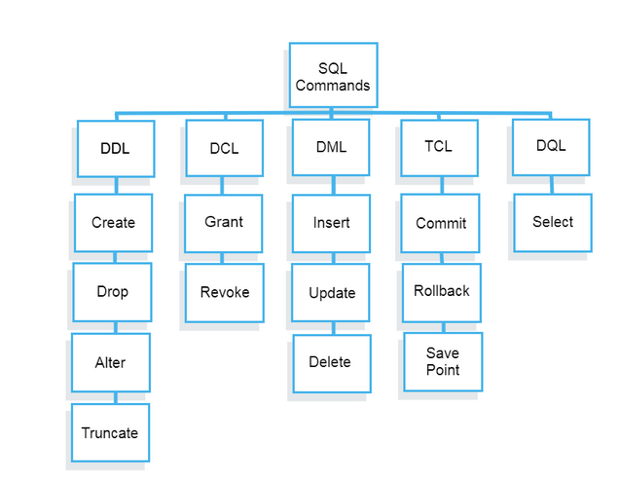
DDL: Data Definition Language
– Used to define Database objects like TABLE, VIEW,SEQUENCE,INDEX,SYNONYM creation or modification or removing.
–CREATE,ALTER,DROP,TRUNCATE,RENAME are the DDL commands
DML: Data Manipulation Language
-Used to manipulate the data in Database objects like table, view, index ..etc,.
-INSERT, UPDATE, DELETE are the DML commands.
TCL: Transaction Control Language
-Transaction control statement are used to apply the changes permanently save into database.
-COMMIT, ROLLBACK, SAVEPOINT, ROLLBACK TO are the TCL commands.
DCL: Data Control Language
Data control statements are use to give privileges to access limited data or share the information between users.
-GRANT,REVOKE ,AUDIT,COMMENT, ANALYZE are the DCL commands.
Description of SQL commands per sublanguage and Create a database
What is DDL?
Data Definition Language helps you to define the database structure or schema. Let’s learn about DDL commands with syntax.
Five types of DDL commands in SQL are:
CREATE
CREATE statements is used to define the database structure schema:
Syntax:
CREATE TABLE TABLE_NAME (COLUMN_NAME DATATYPES[,....]);
For example:
Create database university;
Create table students;
Create view for_students;
DROP
Drops commands remove tables and databases from RDBMS.
Syntax
DROP TABLE ;
For example:
Drop object_type object_name;
Drop database university;
Drop table student;
ALTER
Alters command allows you to alter the structure of the database.
Syntax:
To add a new column in the table
ALTER TABLE table_name ADD column_name COLUMN-definition;
To modify an existing column in the table:
ALTER TABLE MODIFY(COLUMN DEFINITION....);
For example:
Alter table guru99 add subject varchar;
TRUNCATE:
This command used to delete all the rows from the table and free the space containing the table.
Syntax:
TRUNCATE TABLE table_name;
Example:
TRUNCATE table students;
What is Data Manipulation Language?
Data Manipulation Language (DML) allows you to modify the database instance by inserting, modifying, and deleting its data. It is responsible for performing all types of data modification in a database.
There are three basic constructs which allow database program and user to enter data and information are:
Here are some important DML commands in SQL:
INSERT
UPDATE
DELETE
INSERT:
This is a statement is a SQL query. This command is used to insert data into the row of a table.
For example:
INSERT INTO students (RollNo, FIrstName, LastName) VALUES ('60', 'Tom', Erichsen');
UPDATE:
This command is used to update or modify the value of a column in the table.
Syntax:
UPDATE table_name SET [column_name1= value1, column_nameN = valueN]
[WHERE CONDITION]
For example:
UPDATE students
SET FirstName = 'Jhon', LastName= 'Wick'
WHERE StudID = 3;
DELETE:
This command is used to remove one or more rows from a table.
Syntax:
DELETE FROM table_name [WHERE condition];
For example:
DELETE FROM students
WHERE FirstName = 'Jhon';

What is DCL?
DCL (Data Control Language) includes commands like GRANT and REVOKE, which are useful to give “rights & permissions.” Other permission controls parameters of the database system.
Examples of DCL commands:
Commands that come under DCL:
Grant
Revoke
Grant:
This command is use to give user access privileges to a database.
Syntax:
GRANT SELECT, UPDATE ON MY_TABLE TO SOME_USER, ANOTHER_USER;
For example:
GRANT SELECT ON Users TO'Tom'@'localhost;
Revoke:
It is useful to back permissions from the user.
Syntax:
REVOKE privilege_name ON object_name FROM {user_name |PUBLIC |role_name}
For example:
REVOKE SELECT, UPDATE ON student FROM BCA, MCA;
What is TCL?
Transaction control language or TCL commands deal with the transaction within the database.
Commit
This command is used to save all the transactions to the database.
Syntax:
Commit;
For example:
DELETE FROM Students
WHERE RollNo =25;
COMMIT;
Rollback
Rollback command allows you to undo transactions that have not already been saved to the database.
Syntax:
ROLLBACK;
Example:
DELETE FROM Students
WHERE RollNo =25;
SAVEPOINT
This command helps you to sets a savepoint within a transaction.
Syntax:
SAVEPOINT SAVEPOINT_NAME;
Example:
SAVEPOINT RollNo;

What is DQL?
Data Query Language (DQL) is used to fetch the data from the database. It uses only one command:
SELECT:
This command helps you to select the attribute based on the condition described by the WHERE clause.
Syntax:
SELECT expressions
FROM TABLES
WHERE conditions;
For example:
SELECT FirstName
FROM Student
WHERE RollNo >15;


Theoretical learning Activity

Introduce the trainees of Imagine you're a trainer who wants to assess your trainees understanding of the introduction to SQL (Structured Query Language), a programming language used to manage and manipulate relational databases. You could ask your trainees to write a paragraph explaining the following concepts:
What is SQL and what is it used for?
What are the key components of an SQL statement?

Practical learning Activity

You work for a small online store that sells a variety of products. The company's database includes tables for customers, orders, products, and inventory. Your boss has asked you to perform the following tasks:

Retrieve a list of all the products in the inventory table.
Add a new product to the inventory table. The product is a t-shirt with the color blue, the size medium, and a price of Rwf 1900.
Update the customer table to change the phone number of a customer named John Benjamin. His new phone number is (+250) 788 888 888.
Delete a product from the inventory table. The product is a book titled "The Use of PHP in Industry."
Retrieve a list of all the orders placed by a customer named Benjamin. Include the order date, product name, and quantity.


Points to Remember (Take home message)

- SQL is a database language designed for the retrieval and management of data in a relational database.
- It helps users to access data in the RDBMS system
- In the year 1974, the term Structured Query Language appeared
- Five types of SQL queries are:
  - Data Definition Language (DDL)
- Data Manipulation Language (DML)
- Data Control Language(DCL)
- Transaction Control Language(TCL) and,
- Data Query Language (DQL)
- Data Definition Language(DDL) helps you to define the database structure or schema.
- Data Manipulation Language (DML) allows you to modify the database instance by inserting, modifying, and deleting its data.
- DCL (Data Control Language) includes commands like GRANT and REVOKE, which are useful to give “rights & permissions.”
- Transaction control language or TCL commands deal with the transaction within the database.
- Data Query Language (DQL) is used to fetch the data from the database.


Learning outcome 1 formative assessment
Written assessment
What are some examples of database management systems that use SQL?
Answer: MySQL, SQL Server, Oracle PostgreSQL, and others.
Which of the following is an example of a database management system that uses SQL?
a) Microsoft Word
b) Adobe Photoshop
c) Microsoft Excel
d) MySQL
Answer: d) MySQL

3. Answer by using True or False
A) SQL can only be used with relational databases.
Answer: True

B) SQL is case-insensitive.
Answer: False (SQL is generally not case-sensitive, but this can vary depending on the specific database management system being used.)
 Please mix different assessment tools for triangulation and relevancy of assessment
Practical assessment
Write an SQL statement to create a new table called "customers" with the following columns: "id" (integer, primary key), "first_name" (text), "last_name" (text), "email" (text), and "phone" (text).
Answer: CREATE TABLE customers ( id INTEGER PRIMARY KEY, first_name TEXT, last_name TEXT, email TEXT, phone TEXT );

Write an SQL statement to insert a new customer with the following information: "id" = 1, "first_name" = "John", "last_name" = "Doe", "email" = "johndoe@example.com", and "phone" = "555-1234" into the "customers" table.
Answer: INSERT INTO customers (id, first_name, last_name, email, phone) VALUES (1, 'John', 'Doe', 'johndoe@example.com', '555-1234');

Write an SQL statement to update the phone number of the customer with the "id" value of 1 in the "customers" table to "555-4321".
Answer: UPDATE customers SET phone = '555-4321' WHERE id = 1;

Indicative content 1.2: Create database
Summary for the trainer related to the indicative content (key notes using bullets such as ticks etc)
SQL databases are used to store and manage structured data in a relational format, with tables consisting of rows and columns.

Before creating a database, you need to choose a database management system (DBMS) that best fits your requirements. Common examples of DBMS include MySQL, PostgreSQL, Microsoft SQL Server, and Oracle Database.

Once you have selected a DBMS, you can use its specific syntax to create a database. Here's a general SQL query to create a database

CREATE DATABASE database_name;

Replace database_name with the name you want to assign to your database. For example:

CREATE DATABASE my_database;

The database name should follow the naming rules and conventions of the specific DBMS you are using. Generally, it should be unique within the DBMS and may only contain alphanumeric characters and underscores.

After executing the SQL query to create a database, the DBMS will create a new database with the specified name and allocate space for storing data.

You can then use SQL queries to create tables, define their structure (columns, data types, constraints, etc.), insert data, and perform various other database operations within the created database.

It's important to ensure that you have the necessary permissions and privileges to create a database in the DBMS you are using. Typically, this requires administrative or superuser privileges.

It's also essential to properly secure your database by setting up appropriate authentication, authorization, and access controls to protect your data from unauthorized access or modifications.

Finally, always remember to backup your database regularly to prevent data loss due to hardware failures, software errors, or other unexpected events.

 Theoretical learning Activity

What is normalization in database design and why is it important?
Answer: Normalization is the process of organizing a database to reduce redundancy and dependency among the data. It is important because it helps to eliminate data anomalies and inconsistencies, which can improve the accuracy and efficiency of the database. Normalization also helps to make the database more scalable, maintainable, and easier to understand.

What is the difference between a primary key and a foreign key in a relational database?
Answer: A primary key is a unique identifier for a record in a table, while a foreign key is a reference to a primary key in another table. In other words, a primary key is used to identify a specific record in a table, while a foreign key is used to establish a relationship between two tables. A foreign key ensures referential integrity by ensuring that the data in the child table corresponds to the data in the parent table.

3. Which SQL keyword is used to add new data to a table?
A) SELECT
B) UPDATE
C) DELETE
D) INSERT
Answer: D
Practical learning Activity
You are tasked with creating a database for a small online store. The store sells products in different categories and accepts orders from customers. What tables would you create in the database, and what fields would each table contain?

Points to Remember (Take home message)
SQL databases store and manage structured data in tables with rows and columns. Choose a suitable database management system (DBMS) before creating a database. Use the specific syntax of the DBMS to create a database, and ensure that the name follows the naming rules and conventions of the DBMS.
The DBMS will create a new database and allocate space for storing data.
Use SQL queries to create tables, define their structure, insert data, and perform various other database operations.
Backup your database regularly to prevent data loss due to hardware failures, software errors, or other unexpected events

Learning outcome 1 formative assessment
Written assessment
What is the purpose of a database in SQL?
Answer: The purpose of a database in SQL is to store and manage data in an organized and efficient manner
2. Which of the following SQL statements can be used to check if a database already exists before creating a new one?
A) CHECK DATABASE
B) SELECT DATABASE
C) SHOW DATABASES
D) LIST DATABASES
Answer: C (SHOW DATABASES)
3. When creating a new database in SQL, the CREATE DATABASE statement can be used to specify the default character set and collation for the database.
Answer: True

Please mix different assessment tools for triangulation and relevancy of assessment
Practical assessment
Assessment tools
Assay
Task to be performed
Observation checklist

Indicative content 1.3: Create tables with attributes
Summary for the trainer related to the indicative content (key notes using bullets such as ticks etc)
Explanation of variables

A variable can be thought of as a memory location that can hold values of a specific type. The value in a variable may change during the life of the program hence the name variable.

Database variables

When you are collecting data in a database, you need a unique identifier for each of the individual items you are collecting. This identifier is usually called a variable or database element. The identifier is called a variable because the data it contains (the data element) can vary depending on the individual record.
MySQL Variables
Variables are used for storing data or information during the execution of a program. It is a way of labeling data with an appropriate name that helps to understand the program more clearly by the reader. The main purpose of the variable is to store data in memory and can be used throughout the program.
Naming a variable
SQL variables naming rules
Like other programming languages, a variable in SQL must follow the naming rules as follows:
The variable name must be less than 31 characters. Try to make it as meaningful as possible within 31 characters.
The variable name must begin with an ASCII letter. It can be either lowercase or uppercase. Notice that SQL is case-insensitive, which means n_data and M_DATA refer to the same variable.
Followed by the first character are any number, underscore ( _), and dollar sign ( $) characters. Once again, do not make your variables hard to read and difficult to understand.
Each organization has its own development naming convention guidelines. Make sure that you comply with your organization’s naming convention guidelines.
For example, if you want to declare a variable that holds the first name of the employee with the VARCHAR2 data type, the variable name should be v_first_name.
SQL Variables Declaration
To declare a variable, you use a variable name followed by the data type and terminated by a semicolon ( ;). You can also explicitly add a length constraint to the data type within parentheses. The following illustrates some examples of declaring variables in a SQL anonymous block:
DECLARE
v_first_name varchar2(20);
v_last_name varchar2(20);
n_employee_id number;
d_hire_date date;
BEGIN
NULL;
END;
MySQL can use variables in some different ways, which are given below:
User-Defined Variable
Local Variable
User-Defined Variable
Sometimes, we want to pass values from one statement to another statement. The user-defined variable enables us to store a value in one statement and later can refer it to another statement.
MySQL provides a SET and SELECT statement to declare and initialize a variable. The user-defined variable name starts with @ symbol.
The user-defined variables are not case-sensitive such as @name and @NAME; both are the same. A user-defined variable declares by one person can not visible to another person. We can assign the user-defined variable into limited data types like integer, float, decimal, string, or NULL. The user-defined variable can be a maximum of 64 characters in length.
Syntax
The following syntax is used to declare a user-defined variable.
1. By using the SET statement
Syntax :SET @var_name = value;
The following syntax is used to declare a user-defined variable.
By using the SET statement
SET @var_name = value;
NOTE: We can use either = or := assignment operator with the SET statement.
2. By using the SELECT statement
SELECT @var_name := value;
Example1
Here, we are going to assign a value to a variable by using the SET statement.
SET @name='peter';
Then, we can display the above value by using the SELECT statement.
SELECT @name;
Output
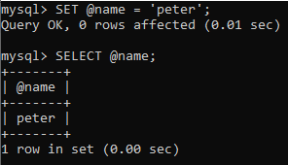

Example 2
Let us create table students in the MySQL database, as shown below:
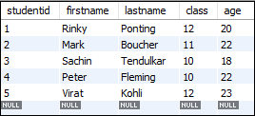
Run the following statement to get the maximum age of the student in the 'students' table and assign the age to the user-defined variable @maxage.
SELECT @maxage:= MAX(age) FROM students;
It will give the following output.
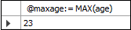
Now, run the SELECT statement that uses the @maxage variable to return the maximum age of the student.
SELECT firstname, lastname, age FROM students WHERE age = @maxage;
After successful execution of the above statement, we will get the following result:
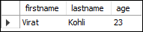
Example3
If we access the undeclared variable, it will give the NULL output.
SELECT @var1;

Output
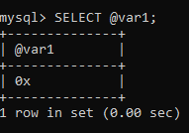
Local Variable
Local variable support in SQL procedures allows you to assign and retrieve SQL values in support of SQL procedure logic.
It is a type of variable that is not prefixed by @ symbol. The local variable is a strongly typed variable. The scope of the local variable is in a stored program block in which it is declared. MySQL uses the DECLARE keyword to specify the local variable. The DECLARE statement also combines a DEFAULT clause to provide a default value to a variable. If you do not provide the DEFAULT clause, it will give the initial value NULL. It is mainly used in the stored procedure program.
Syntax
We can use the DECLARE statement with the following syntax:
DECLARE variable_name datatype(size) [DEFAULT default_value];
In this syntax:
First, specify the name of the variable after the DECLARE keyword. The variable name must follow the naming rules of MySQL table column names.
Second, specify the data type and length of the variable. A variable can have any MySQL data types such as INT, VARCHAR , and DATETIME.
Third, assign a variable a default value using the DEFAULT option. If you declare a variable without specifying a default value, its value is NULL.
The following example declares a variable named totalSale with the data type DEC(10,2) and default value 0.0 as follows:
DECLARE totalSale DEC(10,2) DEFAULT 0.0;
MySQL allows you to declare two or more variables that share the same data type using a single DECLARE statement. The following example declares two integer variables x and y, and set their default values to zero.
DECLARE x, y INT DEFAULT 0;
Assigning variables
Once a variable is declared, it is ready to use. To assign a variable a value, you use the SET statement:
SET variable_name = value;
For example:
DECLARE total INT DEFAULT 0;
SET total = 10;
The value of the total variable is 10 after the assignment.
In addition to the SET statement, you can use the SELECT …….INTO statement to assign the result of a query to a variable as shown in the following example:
DECLARE productCount INT DEFAULT 0;

SELECT COUNT(*)
INTO productCount
FROM products;
In this example:
First, declare a variable named productCount and initialize its value to 0.
Then, use the SELECT INTO statement to assign the productCount variable the number of products selected from the products table.
Variable scopes
The scope of a local variable is the BEGIN ... END block within which it is declared. The variable can be referred to in blocks nested within the declaring block, except those blocks that declare a variable with the same name.
A variable has its own scope that defines its lifetime. If you declare a variable inside a stored procedure, it will be out of scope when the END statement of stored procedure reaches.
MySQL allows you to declare two or more variables that share the same name in different scopes. Because a variable is only effective in its scope. However, declaring variables with the same name in different scopes is not good programming practice.
A variable whose name begins with the @ sign is a session variable. It is available and accessible until the session ends.
Putting it all together
The following example illustrates how to declare and use a variable in a stored procedure:

CREATE PROCEDURE GetTotalOrder()
BEGIN

DECLARE totalOrder INT DEFAULT 0;

SELECT COUNT(*)
INTO totalOrder
FROM orders;
SELECT totalOrder;
END
How it works.
First, declare a variable totalOrder with a default value of zero. This variable will hold the number of orders from the orders table.
DECLARE totalOrder INT DEFAULT 0;
Second, use the SELECT INTO statement to assign the variable totalOrder the number of orders selected from the orders table:
SELECT COUNT(*)
INTO totalOrder
FROM orders;
Third, select the value of the variable totalOrder.
SELECT totalOrder;
Note that you will learn how to use variables practically in the subsequent tutorials. The example in this tutorial is just an illustration so that you understand the concept.
This statement calls the stored procedure GetTotalOrder():
CALL GetTotalOrder();

Summary

User-defined variables vs Local Variables in MySQL
The user defined variable is also known as session-specific variable. It is a type of loosely typed variable which can be initialized somewhere in session and contains the value of user defined variable until session ends.
The user defined variable is prefixed with symbol @. For Example:
@anyVariableName;
There are two approaches by which you can initialize the user-defined variable. You can use SET command or using SELECT query. The first approach is as follows:
SET @anyVariableName=anyValue;
The second approach is as follows:
SELECT @anyVariableName :=anyValue;
If you do not use colon (:) in SELECT query then it evaluates it as expression. The result will either be true or false.
NOTE: The main difference between local variables and user-defined variable is that local variable is reinitialized with NULL value each time whenever stored procedure is called while session-specific variable or user-defined variable does not reinitialized with NULL. A user-defined variable set by one user can not be seen by other user. Whatever session variable for a given user is automatically destroyed when user exits.
Here is the demo of session-specific variable and local variable with stored procedure. The query to create a stored procedure with local variable and user-defined variable is as follows:
mysql> DELIMITER //
mysql> CREATE PROCEDURE sp_LocalAndUserDefinedVariableDemo()
-> BEGIN
-> DECLARE localVariable int default 10;
-> SET localVariable=localVariable+10;
-> SET @userVariable=@userVariable+10;
-> SELECT localVariable;
-> SELECT @userVariable;
-> END;
-> //
Query OK, 0 rows affected (0.39 sec)
mysql> DELIMITER ;
Now set the value for user-defined variable. The query is as follows:
mysql> SET @userVariable=10;
Query OK, 0 rows affected (0.00 sec)
Now call the stored procedure. In first call, the user-defined variable will be 10+10=20 while local variable will 10+10=20.
Call the stored procedure using call command:
CALL sp_LocalAndUserDefinedVariableDemo();
The following is the output:
+---------------+
| localVariable |
+---------------+
| 20 |
+---------------+
1 row in set (0.32 sec)
+---------------+
| @userVariable |
+---------------+
| 20 |
+---------------+
1 row in set (0.34 sec)
Query OK, 0 rows affected (0.36 sec)
In second call, the user-defined variable will hold value 20 and add 10 like 20+10=30 while local variable again reinitialized with 10 and add 10 like 10+10=20.
Call the stored procedure and check the sample output:
CALL sp_LocalAndUserDefinedVariableDemo();
The following is the output:
+---------------+
| localVariable |
+---------------+
| 20 |
+---------------+
1 row in set (0.00 sec)
+---------------+
| @userVariable |
+---------------+
| 30 |
+---------------+
1 row in set (0.01 sec)
Query OK, 0 rows affected (0.02 sec)
In the third call, the user-defined variable will hold value 30 and add 10 like 30+10=40 while local variable again reinitialized with 10 and add 10 like 10+10=20.
Now you can say that in every procedure call local variable is re-initialized with some value which may be NULL or some other value like in my case I have provided default value which is 10. This means it sets the local variable with value 10 in every procedure call while user defined variable does not.

Points to Remember (Take home message)
- Variables are memory locations that can hold values of a specific type.
- In databases, variables are used as unique identifiers for individual items.
- In SQL, variable names must follow specific naming rules.
- Variables in SQL can be declared using a name and data type, with or without a length constraint.
- MySQL has user-defined and local variables.
- User-defined variables use the '@' symbol, can be assigned values with SET or SELECT statements, and are case-insensitive.
- Local variables are not prefixed by '@', are strongly typed, and their scope is limited to a stored program block.
- DECLARE is used to declare local variables, with the option to provide a default value.

Learning outcome 1 formative assessment
Written assessment
What is the difference between a primary key and a foreign key in a relational database, and how are they used to establish relationships between tables?
Answer: A primary key is a column or combination of columns that uniquely identifies each row in a table. It is used to enforce the integrity of the data in the table, and it ensures that each row has a unique identifier.

How can you use SQL to retrieve data from multiple tables that are linked by foreign key relationships, and what are some common SQL join types that can be used for this purpose?
Answer: To retrieve data from multiple tables that are linked by foreign key relationships, you can use SQL JOIN statements. JOINs allow you to combine data from two or more tables based on a common column that exists in both tables.

Which SQL keyword is used to filter data based on a specified condition?
a) WHERE
b) GROUP BY
c) ORDER BY
d) HAVING
Answer: a) WHERE
Please mix different assessment tools for triangulation and relevancy of assessment
Practical assessment

Suppose you work for a company that has a database containing information about its employees, including their names, salaries, and job titles. Your manager has asked you to provide a list of all employees who earn a salary of $100,000 or more per year.
Answer: SELECT name, job_title, salary FROM employees WHERE salary >= 100000;

Learning Unit 2: Apply DML queries
Picture/s reflecting the Learning unit 2
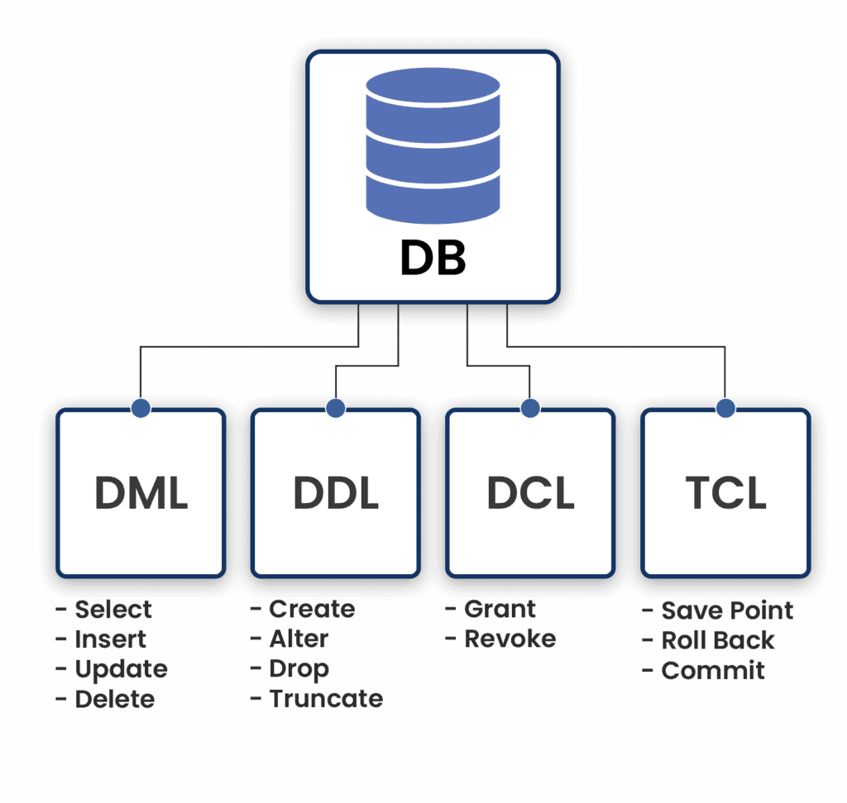
Figure 3: Apply DML queries

STRUCTURE OF LEARNING UNIT

Learning outcome 2.1 Execute database insert operation

Duration: 90 hrs
Learning outcome 1 objectives:
By the end of the learning outcome, the trainees will be able to:
Insert data into a database table
Use SQL commands to insert data
Understand data types
Avoid common errors
Understand database design
Troubleshoot insert operations.
Resources
Equipment | Tools | Materials
Computer  WEB Server | DBMS | Electricity  Internet  Marker pen  Board
Advance preparation:
Preparing and installing some applications (Eg. Xampp or Wamp)
Cleaning and arrange the workplace
Brainstorming about the theory of the servers and database.
Learning outcomes:
2.1. Execute database insert operation
2.2. Retrieve row and column data from tables using SELECT statement
2.3. Create reports of sorted and restricted data
2.4. Use single row functions to generate and retrieve customized data
2.5. Report aggregated data using group functions
2.6. Retrieve data from multiple tables using joins
2.7. Use subqueries to solve problems
2.8. Use of set operators
2.9. Use data manipulation language (DML) statements to update table data.
2.10. Execute database procedures, index

Indicative content 2.1: Explore organizational database
Summary for the trainer related to the indicative content (key notes using bullets such as ticks etc)

Concatenate variables
CONCAT takes a variable number of string arguments and concatenates (or joins) them into a single string. It requires a minimum of two input values; otherwise, CONCAT will raise an error. CONCAT implicitly converts all arguments to string types before concatenation. CONCAT implicitly converts null values to empty strings. If CONCAT receives arguments with all NULL values, it will return an empty string of type varchar().

The SQL CONCAT function concatenates two or more strings into one string.
The following illustrates the syntax of the CONCAT function:
CONCAT(string1,string2,..);
To concatenate strings, you pass the strings as a list comma-separated arguments to the function.
The CONCAT function returns a string which is the combination of the input strings. It returns NULL if one of the argument is NULL. (To handle NULL values more effectively you can use the IS NULL operator or COALESCE and NULLIF functions.)
Most relational database systems support the CONCAT function with some differences among them. For example, MySQL CONCAT function allows you to concatenate more than two strings whereas Oracle CONCAT function concatenates exactly two strings.
SQL CONCAT examples
The following statement uses the CONCAT function to return the full name of the employees by concatenating the first name, space, and last name.
SELECT
CONCAT(first_name, ' ', last_name) AS name
FROM employees
ORDER BY name;

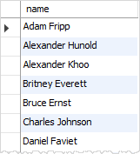
If you are using Oracle database, you have to apply the CONCAT function twice the achieve the same result. See the following query:
SELECT
CONCAT(CONCAT(first_name, ' '), last_name) AS name
FROM employees
ORDER BY name;
The inner CONCAT function concatenates the first name with space, and the outer CONCAT function concatenates the result of the inner CONCAT function with the last name.
It will be much cleaner if you use the concatenation operator in Oracle (and also PostgreSQL).
SELECT
(first_name || ' ' || last_name) AS name
FROM
employees
ORDER BY name;
In Microsoft SQL Server, you would use the following query:
SELECT
(first_name + ' ' + last_name) AS name
FROM
employees
ORDER BY name;
If you are using MySQL or PostgreSQL, you can use the CONCAT_WS function to concatenate strings with a separator.
CONCAT_WS(separator,string1,string2,...);
For example, you can use the CONCAT_WS function to construct the full name of the employee as follows:
SELECT
CONCAT_WS(' ',first_name,last_name) AS name
FROM
employees
ORDER BY name;

Explanation of data types
SQL data types dictate/order how a field's content will be handled, stored, and displayed in a database.
a)Numeric Data Types
Numeric Data types can be divided into 3 types:
Integer Data Types
Fixed Point Types
Floating Point Types
Integer Data Types
These data types support whole numbers without any decimal representation. There are various subtypes like INT, TINYINT, MEDIUMINT, SMALLINT, BIGINT
INT:
Syntax:
INT[(width)] [UNSIGNED] [ZEROFILL]
Facts:
Description | Range | Memory | Options
Most commonly used numeric type. Stores whole numbers  DEFAULT - Unsigned values | –2,147,483,648 to 2,147,483,647 | 4 bytes | If used with UNSIGNED option - Range changes to  0 to 4,294,967,295  Width option can be used with ZEROFILL to pad the entries with zero for values less than the width
Examples:
We will create a table with 1 column having INT data type and different options.
CREATE TABLE numbers_int(int_col INT)
INSERT into numbers_int values(100),(-324),(2456),(-100000);
select * from numbers_int
Output of the SELECT command:
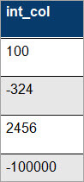
CREATE TABLE numbers_int_options(int_col_with_options INT(4) ZEROFILL );
INSERT into numbers_int_options values(1),(123),(1234),(12345);
select * from numbers_int_options;
Output of the above command:
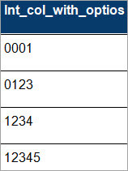
Other variations of INT:
There are multiple options available for INT depending on the specific requirements. These are typically used when memory or space is a concern, but for all practical purposes, INT is the most widely used.
The different variations of the INT data type that are available are listed below:
DataType | Range | Example | Memory / Bytes used
TINYINT | -128 – 127 | CREATE TABLE numbers_tinyint(tinyint_col TINYINT); | 1
SMALLINT | -32768 – 32767 | CREATE TABLE numbers_smallint(smallint_col SMALLINT); | 2
MEDIUMINT | -8388608 - 8388607 | CREATE TABLE numbers_mediumint(mediumint_col MEDIUMINT); | 3
BIGINT | -2^63 - (2^63-1) | CREATE TABLE numbers_bigint(bigint_col BIGINT); | 8
Floating Point Types
Floating Point Types are approximate value types and this depends on the no. of decimal point precision specified during the column type declaration.
There are 2 types of floating-point data types: FLOAT and DOUBLE which support different ranges and consume memory/storage.
FLOAT & DOUBLE
As per the new recommended syntax both FLOAT and DOUBLE precision can be specified using just FLOAT data types.
Syntax:
FLOAT(p)
Here, p -> precision
Facts:
Description | Memory | Options | Examples
FLOAT/DOUBLE represents floating point numbers with approximate values  I.e. when MySQL stores these values these values are approximated to nearest precision as per the type declared.  Precision between 0-23 represents FLOAT type whereas 24 to 53 would generate a double type consuming 8 bytes | Precision - 0-23 => 4 bytes  -Precision -24-53 => 8 bytes | -Floating point numbers can be SIGNED as well as UNSIGNED  -FLOAT is generally accurate up to 7 decimal places while DOUBLE is accurate up to 14 decimal points  -There is also another non standard way of declaring FLOAT and DOUBLE with the specification of precision points  FLOAT(n,d) - where n is total digits and d is no of decimal points | -Create table with a column DOUBLE data type  CREATE TABLE numbers_double(double_col FLOAT(30));  -Create table with a column DOUBLE data type and precision digits as 5  CREATE TABLE numbers_double(double_col DOUBLE(20,5));

Let’s see some examples of retrieving the values of double types:
CREATE TABLE numbers_double(double_col DOUBLE(20,5));
insert into numbers_double VALUES(123.45),(-145),(12.3456788);
select * from numbers_double;
Output of the SELECT statement:
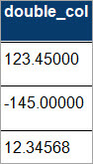
We can see here that the values are stored up to 5 decimal points as specified during the data type declaration.
Fixed Point Types
These data types are used to store an exact value with determined precision. These data types are usually used when exact precision storage is required. For example, bank accounts it’s a requirement to maintain balances with 2 decimal points, we need data to be stored with exact precision.
DECIMAL/NUMERIC
Syntax:
DECIMAL[(width[,decimals])] [UNSIGNED] [ZEROFILL]
Facts:
Description | Range | Memory | Options
DECIMAL is a numeric data type in MySQL and stores exact values with the precision specified.  The default scale or width for the DECIMAL data type is 10 and 0 precision.  Please note that the types of DECIMAL and NUMERIC can be used interchangeably. | Depends on the range specified  For example DECIMAL(5,2) would have a range of -999.99 to 999.99 | MySQL users binary format to store DECIMAL data type - It requires four bytes for every 9 digits - So for example, if we have DECIMAL(14,2) - would require a total of - 9(4) + 2(1) => 7 bytes | -Max value of width can be 265  -The number of decimals is optional and the default value is 0
Example:
CREATE TABLE numbers_decimal(dec_col DECIMAL(4,2))
INSERT INTO numbers_decimal values(-99),(50.50);
b) String Data Types
String data types, as the name suggests, are used to store strings/texts or blobs of textual information in the database. Depending upon the use case there are different such data types available CHAR, VARCHAR, BINARY, VARBINARY, TEXT, ENUM, SET & BLOB
Let’s understand each of these different data types with examples.
CHAR and VARCHAR

Both these types are used to store String values in the columns in MySQL, but they differ in how values are stored and retrieved.
CHAR & VARCHAR are declared with length, which indicates the maximum length of the String that you want to store in the column.
Syntax:
CHAR(n)
VARCHAR(n)
Here, n -> max no. of characters to be stored by the column

Facts:
Type | Description | Range | Examples
CHAR  Syntax - CHAR(n) | CHAR can store ‘n’ length String as defined during the declaration.  If the String is less than n character, then it's padded with spaces. | Length of CHAR data type can vary from 0 - 255  Depending on length, memory consumption would range from 0 - 255 bytes. | CREATE TABLE string_example(char_col CHAR(50));
VARCHAR  Syntax - VARCHAR(n) | VARCHAR allows you to store variable length Strings and consume memory against the actual size of String stored rather than the max value that’s specified during the column definition. | Length of VARCHAR data type can vary from 0 - 65535  Depending on length, memory consumption would range from 0 - 65535 bytes. | CREATE TABLE string_example(varchar_col VARCHAR(50));
BINARY And VARBINARY
Similar to CHAR and VARCHAR – these data types store Strings but in Binary format. The length of BINARY and VARBINARY data types is measured in bytes as opposed to number of characters in CHAR and VARCHAR data types.
Syntax:
BINARY(n)
VARBINARY(n)
Here, n -> max no. of bytes to be stored by the column.

Facts:
Type | Description | Range | Examples
BINARY  Syntax - BINARY(n) | BINARY can store ‘n’ binary bytes.  For values less than n they are right padded with 0 byte and stored | Length of BINARY data type can vary from 0 - 255  Depending on length, memory consumption would range from 0 - 255 bytes. | CREATE TABLE binary_string(binary_col BINARY(50));
VARBINARY  Syntax - VARBINARY(n) | VARBINARY allows you to store variable length binary Strings upto ‘n length (as specified in column definition) | Length of VARBINARY data type can vary from 0 - 65535  Depending on length, memory consumption would range from 0 - 65535 bytes. | CREATE TABLE variable_binary_string(varbinary_col VARBINARY(50));
Let’s understand the BINARY data type in more detail. We will create a table with a column each of binary and varbinary data type and inspect the contents.
CREATE TABLE binary_strings(binary_col BINARY(50), varbinary_col VARBINARY(50));
INSERT into binary_strings values("hello", "hello");
SELECT * from binary_strings;
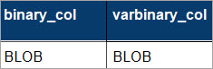
Now we have seen the output as BLOB which means – Binary Large OBject – and these are nothing but Binary/Hex representation of the String values that we have inserted in the columns.
Now we will inspect the values of these binary strings and see how they are stored.
First, let’s see the value present in ‘binary_col’ which is of BINARY data type.
c) List
A list is an ordered data structure with elements separated by a comma and enclosed within square brackets. For example, list1 and list2 shown below contains a single type of data.
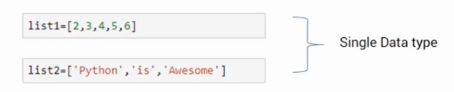
Here, list1 has integers while list2 has strings. Lists can also store mixed data types as shown in the list3 here.
d) data dictionary
What is data dictionary in database?Nearly 20% of the World Cove in SA Data Dictionary is a collection of names, definitions, and attributes about data elements that are being used or captured in a database, information system, or part of a research project. A Data Dictionary also provides metadata about data elements.
What is the use of data dictionary? Data dictionaries are used to provide detailed information about the contents of a dataset or database, such as the names of measured variables, their data types or formats, and text descriptions. A data dictionary provides a concise guide to understanding and using the data.
There are two types of data dictionaries: active and passive.
Passive data dictionary is a data dictionary that is not part of and managed by the DBMS. Unlike in the case of active data dictionary, changes in database structure need to be applied in passive data dictionary manually or with dedicated software.
An active data dictionary is a data dictionary that is automatically updated by the database management system every time the database is accessed, thereby keeping its information current. Active Data Dictionary: Interacts with the IS environment on a real-time basis.
It means, The information in an active data dictionary is up-to-date as it is automatically managed. The information in a passive data dictionary is not up-to-date as it is managed manually by the users.
e) BOOLEAN
MySQL Boolean data type stores a column value as TRUE or FALSE. This data type is generally suited for storing flag (true or false) values in the MySQL tables. For example – A Bank Account table having a column named is_savings_account can store either true or false.
The BOOLEAN value is stored in MySQL as 1 or 0 for TRUE and FALSE, respectively.
Syntax:
columnName BOOLEAN
Example:
CREATE TABLE account_details(accNo BIGINT, is_savings BOOLEAN);
INSERT into account_details values (123456,true), (110002, false), (234567, 1);
While inserting or retrieving values for BOOLEAN data type we can either use TRUE or FALSE or their numeric representations – i.e. 1 or 0.
select * from account_details where is_savings=1;

Output of above command:
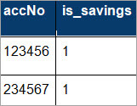
f) Tuple
A single entry in a table is called a Tuple or Record or Row. A tuple in a table represents a set of related data. For example, the below Employee table has 4 tuples/records/rows.
Below is an example of an Employee table.
ID | Name | Age | Salary
1 | Adam | 34 | 13000
2 | Alex | 28 | 15000
3 | Stuart | 20 | 18000
4 | Ross | 42 | 19020

Type of Operators
What is SQL operator?
An SQL operator is a special word or character used to perform tasks. These tasks can be anything from complex comparisons, to basic arithmetic operations. Think of an SQL operator as similar to how the different buttons on a calculator function.
SQL operators are primarily used within the WHERE clause of an SQL statement.
Introduction to SQL Arithmetic Operators
The arithmetic operators in SQL are used to perform mathematical operations such as addition, subtraction, multiplication, division, and modulus, etc. on the data stored in the database tables and these arithmetic operators can be used along with a WHERE clause in an SQL statement if there are multiple conditions which need to be satisfied in the query, but in case there is any Null value present in the table, upon performing arithmetic operations on the Null value, we will get the result as Null.
Arithmetic Operators in SQL
The various arithmetic operators in SQL are addition (+), subtraction (-), multiplication (*), division (/) and modulus (%) which are used to perform the mathematical operations on the data which is stored in the database tables. Let us go through the below examples to understand the working of various arithmetic operators in SQL.
1. Addition Operator (+)
The operator ‘+’ is used to perform addition operation on two operands. In the below example, we can see that the addition operator is used to add 100 and 220.
SELECT 100 + 220 as Addition;
The table contains various employees and their details. Let us perform the addition operation on the column SALARY. In the below query, 10000 is added to the SALARY column.
SELECT SALARY+10000 as new_salary FROM EMPLOYEES
Let us perform the addition of two columns using the addition operator SELECT SALARY+ID as added_salary FROM EMPLOYEES;
2. Subtraction Operator (-)
The subtraction operator ‘-’ is used to subtract the right-hand operand from the left-hand operand. Let us take the below example to perform subtraction of 99 from 260.
SELECT 260-99 as Subtract;
Let us now take the example of the previously stated table “EMPLOYEES”. In the below query, we can see that 5500 is subtracted from the SALARY column.
SELECT SALARY-5500 as Subtracted_Sal FROM EMPLOYEES;
In the below query, the subtraction operation of two columns i.e. SALARY and ID is shown.
SELECT SALARY-ID as New_Sal FROM EMPLOYEES;
We can see that in the above query, the ID column is subtracted from the SALARY columns and the result of the subtraction operation is as shown below.
Multiplication Operator (*)
This operator performs the multiplication of two operands. In the below example, we can see the multiplication of 99 and 89.
SELECT 99*89 as Multiplication;
Considering the previously stated EMPLOYEES table, let us perform the multiplication of the column SALARY with 15 as shown below.
SELECT SALARY*15 as Multiplied_Salary FROM EMPLOYEES;
The result of the above query can be seen below and we can see that 15 is multiplied with the SALARY column.
In the below query, we can see that the multiplication of two columns i.e. SALARY and ID from the table EMPLOYEES is done.
SELECT SALARY*ID as New_Salary FROM EMPLOYEES;
4. Division Operator (/)
This operator performs the division of the left-hand side operand by the right-hand side operand. In the below example, the division operation is performed where 79 is divided by 6.
SELECT 79/6 as Division;
The below result shows that the above operation gives the quotient of the division
Let us again consider the previously stated table “EMPLOYEES”. The below query shows the division operation performed where the column SALARY is divided by 50.
SELECT SALARY/50 as Sal_Div FROM EMPLOYEES;
5. Modulus Operator (%)
This arithmetic operator is used to get the remainder of the division of the left-hand side operand by the right-hand side operand.
SELECT 23%4 as result;
The above query shows that 23 when divided by 4, gives the remainder of the division which is 3 as output as displayed in the result.
The modulus operation is performed on the SALARY column of the EMPLOYEES table below.
SELECT SALARY%100 as result FROM EMPLOYEES;
The above query performs the modulus operation and when the salary of the employees is divided by 100, the result shows the remainder values of the division which is 0.
If a table contains any Null value, then on performing any arithmetic operations on
From the above output, we can see that in case a Null value is present, on performing multiplication or addition operation on it, we get the result as Null.
The arithmetic operators can be used along with the WHERE clause.
Let us take the example of the below table “STUDENTS”.
If we want to calculate the sum of the marks secured by the students greater than 150, then we can use the arithmetic operator along with the WHERE clause as shown in the below query.
SELECT NAME, MATHS_MARK+SCIENCE_MARK FROM STUDENTS WHERE MATHS_MARK+SCIENCE_MARK > 150;
The above query will give the output as below where the student who has secured the sum of the marks greater than 150 is displayed.
SQL Comparison Operators
In SQL, the comparison operators are useful to compare one expression with another expression using mathematical operators. we have a different type of comparison operators available those are :

SQL Equal (=) Operator
SQL Not Equal (!= or <>) Operator
SQL Greater Than (>) Operator
SQL Less Than (<) Operator
SQL Greater Than or Equal To (>=) Operator
SQL Less Than or Equal To (<=) Operator
SQL Not Less Than (!<) Operator
SQL Not Greater Than (!>) Operator

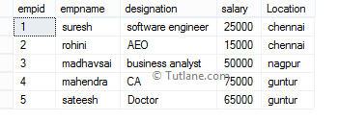
Now we will learn each comparison operator in SQL with proper examples
SQL Equal (=) Operator
In SQL, the equal operator is useful to check whether the given two expressions equal or not. If it’s equal, then the condition will be true and it will return matched records.

Example:

If we run following SQL statement for the equal operator it will return records where empid equals to 1.

SELECT * FROM EmployeeDetails WHERE empid = 1
When we execute the above SQL equal operator query, we will get the result like as shown below.

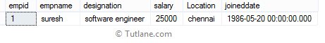
SQL Not Equal (!=) Operator
In SQL, not equal operator is used to check whether two expressions equal or not. If it’s not equal then the condition will be true and it will return not matched records.

Example:

If we run following SQL statement for not equal operator it will return a records where empid not equals to 1.

SELECT * FROM EmployeeDetails WHERE empid != 1
When we execute the above SQL not equal operator query, we will get the result like as shown below.

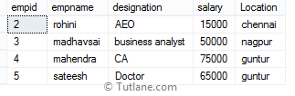
SQL Not Equal (<>) Operator
In SQL, not equal operator is used to check whether two expressions equal or not. If it’s not equal then condition will be true and it will return not matched records. Both != and <> operators are not equal operators and will return same result but != operator is not a ISO standard.

Example:

If we run following SQL statement for not equal operator it will return records where empid not equals to 1

SELECT * FROM EmployeeDetails WHERE empid <> 1
When we execute the above SQL, not equal operator query we will get the result like as shown below.

SQL Greater Than (>) Operator
In SQL, greater than operator is used to check whether the left-hand operator is higher than the right-hand operator or not. If left-hand operator higher than right-hand operator then condition will be true and it will return matched records.

Example:

If we run following SQL statement for greater than operator it will return records where empid greater than 2

SELECT * FROM EmployeeDetails WHERE empid > 2
When we execute the above SQL greater than the operator query, we will get the result like as shown below.

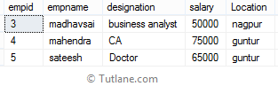
SQL Less Than (<) Operator
In SQL, less than operator is used to check whether the left-hand operator is lower than the right-hand operator or not. If left-hand operator lower than right-hand operator then condition will be true and it will return matched records.

Example:

If we run following SQL statement for less than operator it will return records where empid less than 2

SELECT * FROM EmployeeDetails WHERE empid < 2
When we execute the above SQL less than operator query, we will get the result like as shown below.

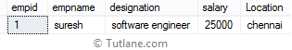
SQL Greater Than or Equal To (>=) Operator
In SQL, greater than or equal to the operator is used to check whether the left-hand operator is higher than or equal to the right-hand operator or not. If left-hand operator higher than or equal to right-hand operator then condition will be true and it will return matched records.

Example:
If we run following SQL statement for greater than or equal to the operator it will return records where empid higher than or equal to 2

SELECT * FROM EmployeeDetails WHERE empid >= 2
When we execute the above SQL greater than or equal to operator query, we will get the result like as shown below.

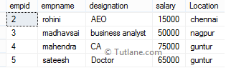

SQL Less Than or Equal To (<=) Operator
In sql, less than or equal to the operator is useful to check whether the left-hand operator is lower than or equal to the right-hand operator or not. If left-hand operator lower than or equal to right-hand operator then condition will be true and it will return matched records.

Example:
If we run following SQL statement for less than or equal to the operator it will return records where empid lower than or equal to 2

SELECT * FROM EmployeeDetails WHERE empid <= 2
When we execute above sql less than or equal to operator query, we will get the result like as shown below.

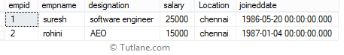
SQL Not Less Than (!<) Operator
In sql, not less than operator is used to check whether the left-hand operator not lower than the right-hand operator or not. If left-hand operator not lower than right-hand operator then condition will be true and it will return matched records.

Example:

If we run following SQL statement for not less than operator it will return records where empid not lower than 2

SELECT * FROM EmployeeDetails WHERE empid !< 2
When we execute the above SQL not less than operator query, we will get the result like as shown below.

SQL Not Greater Than (!>) Operator
In sql, not greater than operator is used to check whether the left-hand operator is not higher than the right-hand operator or not. If left-hand operator not higher than right-hand operator then condition will be true and it will return matched records.

Example:

If we run following SQL statement for not greater than operator it will return records where empid not higher than 2

SELECT * FROM EmployeeDetails WHERE empid !> 2
When we execute the above SQL not greater than operator query, we will get the result like as shown below.

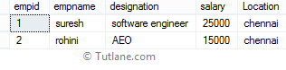

For more information related to comparison operators in sql server check the following information.

Operator | Description
Equal (=) Operator | The sql equal operator is used to check whether two expressions equal or not. If it’s equal then the condition will be true and it will return matched records.
Not Equal (!=) Operator | The sql not equal operator is used to check whether two expressions equal or not. If it’s not equal then condition will be true and it will return not matched records.
Not Equal (<>) Operator | The sql not equal operator is used to check whether two expressions equal or not. If it’s not equal then the condition will be true and it will return not matched records.
Greater Than (>) Operator | The sql Greater Than operator is used to check whether the left-hand operator is higher than the right-hand operator or not. If left-hand operator higher than right-hand operator then condition will be true and it will return matched records.
Less Than (<) Operator | The sql Less Than operator is used to check whether the left-hand operator is lower than the right-hand operator or not. If left-hand operator lower than right-hand operator then condition will be true and it will return matched records.
Greater Than or Equal To (>=) Operator | The sql Greater Than or Equal To operator is used to check whether the left-hand operator is higher than or equal to the right-hand operator or not. If left-hand operator higher than or equal to right-hand operator then condition will be true and it will return matched records.
Less Than or Equal To (<=) Operator | The sql Less Than or Equal To operator is used to check whether the left-hand operator is lower than or equal to the right-hand operator or not. If left-hand operator lower than or equal to right-hand operator then condition will be true and it will return matched records.
Not Less Than (!<) Operator | The sql Not Less Than operator is used to check whether the left-hand operator not lower than the right-hand operator or not. If left-hand operator not lower than right-hand operator then condition will be true and it will return matched records.
Not Greater Than(!>) Operator | The sql Not Less Than operator is used to check whether the left-hand operator not lower than the right-hand operator or not. If left-hand operator not lower than right-hand operator then condition will be true and it will return matched records.
SQL Logical Operators
The Logical Operators in SQL perform the Boolean operations, which give two results True and False. These operators provide True value if both operands match the logical condition.
SQL AND Operator
The AND operator in SQL would show the record from the database table if all the conditions separated by the AND operator evaluated to True. It is also known as the conjunctive operator and is used with the WHERE clause.
Syntax of AND operator:
SELECT column1, ...., columnN FROM table_Name WHERE condition1 AND condition2 AND condition3
AND ....... AND conditionN;
Let's understand the below example which explains how to execute AND logical operator in SQL query:
This example consists of an Employee_details table, which has three columns Emp_Id, Emp_Name, Emp_Salary, and Emp_City.
Emp Id | Emp Name | Emp Salary | Emp City
201 | Abhay | 25000 | Delhi
202 | Ankit | 45000 | Chandigarh
203 | Bheem | 30000 | Delhi
204 | Ram | 25000 | Delhi
205 | Sumit | 40000 | Kolkata
Suppose, we want to access all the records of those employees from the Employee_details table whose salary is 25000 and the city is Delhi. For this, we have to write the following query in SQL:
SELECT * FROM Employee_details WHERE Emp_Salary = 25000 OR Emp_City = 'Delhi';
Here,SQL AND operator with WHERE clause shows the record of employees whose salary is 25000 and the city is Delhi.
SQL OR Operator
The OR operator in SQL shows the record from the table if any of the conditions separated by the OR operator evaluates to True. It is also known as the conjunctive operator and is used with the WHERE clause.
Syntax of OR operator:
SELECT column1, ...., columnN FROM table_Name WHERE condition1 OR condition2 OR condition3 OR ....... OR conditionN;
Let's understand the below example which explains how to execute OR logical operator in SQL query:
This example consists of an Employee_details table, which has three columns Emp_Id, Emp_Name, Emp_Salary, and Emp_City.
Emp Id | Emp Name | Emp Salary | Emp City
201 | Abhay | 25000 | Delhi
202 | Ankit | 45000 | Chandigarh
203 | Bheem | 30000 | Delhi
204 | Ram | 25000 | Delhi
205 | Sumit | 40000 | Kolkata
If we want to access all the records of those employees from the Employee_details table whose salary is 25000 or the city is Delhi. For this, we have to write the following query in SQL:

SELECT * FROM Employee_details WHERE Emp_Salary = 25000 OR Emp_City = 'Delhi';
Here, SQL OR operator with WHERE clause shows the record of employees whose salary is 25000 or the city is Delhi.
SQL NOT Operator
The NOT operator in SQL shows the record from the table if the condition evaluates to false. It is always used with the WHERE clause.
Syntax of NOT operator
SELECT column1, column2 ...., columnN FROM table_Name WHERE NOT condition;
Let's understand the below example which explains how to execute NOT logical operator in SQL query:
This example consists of an Employee_details table, which has four columns Emp_Id, Emp_Name, Emp_Salary, and Emp_City.
Emp Id | Emp Name | Emp Salary | Emp City
201 | Abhay | 25000 | Delhi
202 | Ankit | 45000 | Chandigarh
203 | Bheem | 30000 | Delhi
204 | Ram | 25000 | Delhi
205 | Sumit | 40000 | Kolkata

Suppose, we want to show all the information of those employees from the Employee_details table whose Cityis not Delhi. For this, we have to write the following query in SQL:
SELECT * FROM Employee_details WHERE NOT Emp_City = 'Delhi' ;
In this example, we used the SQL NOT operator with the Emp_City column.
Suppose, we want to show all the information of those employees from the Employee_details table whose Cityis not Delhi and Chandigarh. For this, we have to write the following query in SQL:
SELECT * FROM Employee_details WHERE NOT Emp_City = 'Delhi' AND NOT Emp_City = 'Chandigarh';
In this example, we used the SQL NOT operator with the Emp_City column.
Membership operators
SQL IN Operator
The IN operator in SQL allows database users to specify two or more values in a WHERE clause. This logical operator minimizes the requirement of multiple OR conditions.
This operator makes the query easier to learn and understand. This operator returns those rows whose values match with any value of the given list.
Syntax of IN operator:
SELECT column_Name1, column_Name2 ...., column_NameN FROM table_Name WHERE column_name IN (list_of_values);
Let's understand the below example which explains how to execute IN logical operator in SQL query:
This example consists of an Employee_details table, which has three columns Emp_Id, Emp_Name, Emp_Salary, and Emp_City.
Emp Id | Emp Name | Emp Salary | Emp City
201 | Abhay | 25000 | Delhi
202 | Ankit | 45000 | Chandigarh
203 | Bheem | 30000 | Delhi
204 | Ram | 25000 | Delhi
205 | Sumit | 40000 | Kolkata

Suppose, we want to show all the information of those employees from the Employee_details table whose Employee Id is 202, 204, and 205. For this, we have to write the following query in SQL:
SELECT * FROM Employee_details WHERE Emp_Id IN (202, 204, 205);
Here, we used the SQL IN operator with the Emp_Id column.
Suppose, we want to show all the information of those employees from the Employee_details table whose Employee Id is not equal to 202 and 205. For this, we have to write the following query in SQL:
SELECT * FROM Employee_details WHERE Emp_Id NOT IN (202,205);
SQL ANY Operator
The ANY operator in SQL shows the records when any of the values returned by the sub-query meet the condition.
The ANY logical operator must match at least one record in the inner query and must be preceded by any SQL comparison operator.
Syntax of ANY operator:
SELECT column1, column2 ...., columnN FROM table_Name WHERE column_name comparison_operator
ANY ( SELECT column_name FROM table_name WHERE condition(s)) ;
SQL LIKE Operator
The LIKE operator in SQL shows those records from the table which match with the given pattern specified in the sub-query.
The percentage (%) sign is a wildcard which is used in conjunction with this logical operator.
This operator is used in the WHERE clause with the following three statements:
SELECT statement
UPDATE statement
DELETE statement
Syntax of LIKE operator:

SELECT column_Name1, column_Name2 ...., column_NameN FROM table_Name WHERE column_name
LIKE pattern;
Let's understand the below example which explains how to execute LIKE logical operator in SQL query:
This example consists of an Employee_details table, which has four columns Emp_Id, Emp_Name, Emp_Salary, and Emp_City.
Emp Id | Emp Name | Emp Salary | Emp City
201 | Sanjay | 25000 | Delhi
202 | Ajay | 45000 | Chandigarh
203 | Saket | 30000 | Delhi
204 | Abhay | 25000 | Delhi
205 | Sumit | 40000 | Kolkata

If we want to show all the information of those employees from the Employee_details whose name starts with ''s''. For this, we have to write the following query in SQL:
SELECT * FROM Employee_details WHERE Emp_Name LIKE 's%' ;
In this example, we used the SQL LIKE operator with Emp_Name column because we want to access the record of those employees whose name starts with s.
If we want to show all the information of those employees from the Employee_detailswhose name ends with ''y''. For this, we have to write the following query in SQL:

SELECT * FROM Employee_details WHERE Emp_Name LIKE '%y' ;
If we want to show all the information of those employees from the Employee_detailswhose name starts with ''S'' and ends with ''y''. For this, we have to write the following query in SQL:

SELECT * FROM Employee_details WHERE Emp_Name LIKE 'S%y' ;
SQL ALL Operator
The ALL operator in SQL compares the specified value to all the values of a column from the sub-query in the SQL database.
This operator is always used with the following statement:
SELECT,
HAVING, and
WHERE.
Syntax of ALL operator:
SELECT column_Name1, ...., column_NameN FROM table_Name WHERE column Comparison_operator
ALL (SELECT column FROM tablename)
Let's understand the below example which explains how to execute ALL logical operators in SQL query:
This example consists of an Employee_details table, which has four columns Emp_Id, Emp_Name, Emp_Salary, and Emp_City.
Emp Id | Emp Name | Emp Salary | Emp City
201 | Abhay | 25000 | Gurgaon
202 | Ankit | 45000 | Delhi
203 | Bheem | 30000 | Jaipur
204 | Ram | 29000 | Mumbai
205 | Sumit | 40000 | Kolkata
If we want to access the employee id and employee names of those employees from the table whose salaries are greater than the salary of employees who lives in Jaipur city, then we have to type the following query in SQL.
SELECT Emp_Id, Emp_Name FROM Employee_details WHERE Emp_Salary > ALL ( SELECT Emp_Salary
FROM Employee_details WHERE Emp_City = Jaipur)
Here, we used the SQL ALL operator with greater than the operator.
SQL BETWEEN Operator
The BETWEEN operator in SQL shows the record within the range mentioned in the SQL query. This operator operates on the numbers, characters, and date/time operands.
If there is no value in the given range, then this operator shows NULL value.
Syntax of BETWEEN operator:
SELECT column_Name1, column_Name2 ...., column_NameN FROM table_Name WHERE column_nameBETWEEN value1 and value2;
Let's understand the below example which explains how to execute BETWEEN logical operator in SQL query:
This example consists of an Employee_details table, which has three columns Emp_Id, Emp_Name, Emp_Salary, and Emp_City.
Emp Id | Emp Name | Emp Salary | Emp City
201 | Abhay | 25000 | Delhi
202 | Ankit | 45000 | Chandigarh
203 | Bheem | 30000 | Delhi
204 | Ram | 25000 | Delhi
205 | Sumit | 40000 | Kolkata
Suppose,we want to access all the information of those employees from the Employee_details table who is having salaries between 20000 and 40000. For this, we have to write the following query in SQL:
SELECT * FROM Employee_details WHERE Emp_Salary BETWEEN 30000 AND 45000;
Here, we used the SQL BETWEEN operator with the Emp_Salary field.
Assignment Operator (:=)
Syntax
var_name := expr
Theoretical learning Activity
Define the purpose of the insert operation in a database.
Discuss the syntax of the INSERT statement, including the keywords, and how it is used to insert data into a table.
Explain how to specify the table and column names in the INSERT statement, and the order in which they are specified.
Answers:
The purpose of executing a database insert operation is to add new data to a table in a database. This is done using the SQL INSERT statement.

The INSERT statement syntax involves the use of keywords such as INSERT INTO, VALUES, and SELECT. The INSERT INTO keyword is used to specify the name of the table to which the data will be inserted. The VALUES keyword is used to specify the values that will be inserted into the table. The SELECT keyword is used to insert data from another table.

To specify the table and column names in the INSERT statement, the table name is specified after the INSERT INTO keyword, followed by the column names in parentheses. The order of the column names should correspond to the order in which the values are being inserted.
Practical learning Activity
Design a database table with at least three columns that will store data related to a particular topic or domain. Consider what data types will be appropriate for each column, and whether any columns should be designated as primary keys or foreign keys. Once you have designed the table, create an INSERT statement that will insert a new record into the table. Include appropriate values for each column in the INSERT statement.
Answer:
Column name | Data type | Key | Description
product_id | int | PK | Unique identifier for each product
name | varchar(255) |  | Name of the product
price | decimal(10,2) |  | Price of the product, with 2 decimal points

INSERT INTO products (name, price) VALUES ('iPhone 13', 1099.00);
Points to Remember (Take home message)
CONCAT takes a variable number of string arguments and concatenates (or joins) them into a single string.
It requires a minimum of two input values; otherwise, CONCAT will raise an error.
CONCAT implicitly converts all arguments to string types before concatenation.
CONCAT implicitly converts null values to empty strings.
If CONCAT receives arguments with all NULL values, it will return an empty string of type varchar().
The SQL CONCAT function concatenates two or more strings into one string.
The CONCAT function returns a string which is the combination of the input strings.
The CONCAT function returns NULL if one of the arguments is NULL.
Most relational database systems support the CONCAT function with some differences among them.
SQL Data Types:
SQL data types dictate/order how a field's content will be handled, stored, and displayed in a database.
Numeric data types can be divided into 3 types: Integer Data Types, Fixed Point Types, and Floating Point Types.
Integer Data Types support whole numbers without any decimal representation.
There are various subtypes like INT, TINYINT, MEDIUMINT, SMALLINT, BIGINT.
Floating Point Types are approximate value types and depend on the no. of decimal point precision specified during the column type declaration.
There are 2 types of floating-point data types: FLOAT and DOUBLE which support different ranges and consume memory/storage.

Learning outcome 1 formative assessment
Written assessment
Assessment tools
True or false questions
Multiple choice
Open ended questions
Case studies
Please mix different assessment tools for triangulation and relevancy of assessment

Practical assessment
Assessment tools
Assay
Task to be performed
Observation checklist

Written assessment
Formative Assessment:
What are the different data types used to store string/textual data in a database?
What is the difference between CHAR and VARCHAR data types?
What are the BINARY and VARBINARY data types?
What is a data dictionary in a database?
Answers:
The most commonly used data types to store string/textual data in a database are:
CHAR: fixed-length character string.
VARCHAR: variable-length character string.
TEXT: variable-length character string with a larger storage capacity than VARCHAR.
The main difference between CHAR and VARCHAR data types is that CHAR stores a fixed length of characters, whereas VARCHAR stores a variable length of characters. For example, if you set a CHAR column to have a length of 10, it will always occupy 10 bytes of storage, even if you only store 5 characters in it. On the other hand, if you set a VARCHAR column to have a length of 10, it will only occupy the necessary storage for the number of characters you actually store in it.

The BINARY and VARBINARY data types are similar to CHAR and VARCHAR, respectively, but they store binary data instead of textual data. BINARY stores fixed-length binary data, while VARBINARY stores variable-length binary data.

A data dictionary is a database object that stores information about the database itself, such as the names and types of tables and columns, relationships between tables, and other metadata. It is used to help manage the database and ensure that data is stored and retrieved correctly. A data dictionary can be used to document the structure and contents of a database, which can be useful for maintenance and troubleshooting.

Indicative content 2.2: Retrieve row and column data from tables using SELECT statement
Summary for the trainer related to the indicative content (key notes using bullets such as ticks etc)
SQL SELECT
The most commonly used SQL command is SELECT statement. It is used to query the database and retrieve selected data that follow the conditions we want.
In simple words, we can say that the select statement used to query or retrieve data from a table in the database.
Let's see the syntax of select statement.
SELECT column list
FROM tables
WHERE conditions;
Optional clauses in SELECT statement
There are some optional clauses in SELECT statement:
WHERE Clause: It specifies which rows to retrieve.
GROUP BY Clause: Groups rows that share a property so that the aggregate function can be applied to each group.
HAVING Clause: It selects among the groups defined by the GROUP BY clause.
ORDER BY Clause: It specifies an order in which to return the rows.
Retrieving an Entire Table
The asterisk (*) appearing in the select_list is a wildcard used to inform the database that we would like to retrieve information from all of the columns in table identified in the FROM clause. We wanted to retrieve all of the information in the database, so it wasn't necessary to use a WHERE clause to restrict the rows selected from the table.
The describe table command
As the name suggests, DESCRIBE is used to describe something. Since in database we have tables, that’s why we use DESCRIBE or DESC(both are same) command to describe the structure of a table.
Syntax:
DESCRIBE TABLE NAME;
OR
DESC TABLE NAME;
Note: We can use either DESCRIBE or DESC(both are Case Insensitive).

e.g: Suppose our table whose name is one has 3 columns named FIRST_NAME, LAST_NAME and SALARY and all are of can contain null values.
Desc one;
Output:
Name Null Type
FIRST_NAME CHAR(25)
LAST_NAME CHAR(25)
SALARY NUMBER(6)

You can rename a table or a column temporarily by giving another name known as Alias. The use of table aliases is to rename a table in a specific SQL statement. The renaming is a temporary change and the actual table name does not change in the database. The column aliases are used to rename a table's columns for the purpose of a particular SQL query.

Syntax
The basic syntax of a table alias is as follows.
SELECT column1, column2....
FROM table_name AS alias_name
WHERE condition;
The basic syntax of a column alias is as follows.
SELECT column_name AS alias_name
FROM table_name
WHERE condition;
Example
Consider the following two tables.
Table 1 CUSTOMERS Table is as follows.
+----+----------+-----+-----------+----------+
| ID | NAME | AGE | ADDRESS | SALARY |
+----+----------+-----+-----------+----------+
| 1 | Ramesh | 32 | Ahmedabad | 2000.00 |
| 2 | Khilan | 25 | Delhi | 1500.00 |
| 3 | kaushik | 23 | Kota | 2000.00 |
| 4 | Chaitali | 25 | Mumbai | 6500.00 |
| 5 | Hardik | 27 | Bhopal | 8500.00 |
| 6 | Komal | 22 | MP | 4500.00 |
| 7 | Muffy | 24 | Indore | 10000.00 |
+----+----------+-----+-----------+----------+
Table 2 − ORDERS Table is as follows.
+-----+---------------------+-------------+--------+
|OID | DATE | CUSTOMER_ID | AMOUNT |
+-----+---------------------+-------------+--------+
| 102 | 2009-10-08 00:00:00 | 3 | 3000 |
| 100 | 2009-10-08 00:00:00 | 3 | 1500 |
| 101 | 2009-11-20 00:00:00 | 2 | 1560 |
| 103 | 2008-05-20 00:00:00 | 4 | 2060 |
+-----+---------------------+-------------+--------+
Now, the following code block shows the usage of a table alias.
SQL> SELECT C.ID, C.NAME, C.AGE, O.AMOUNT
FROM CUSTOMERS AS C, ORDERS AS O
WHERE C.ID = O.CUSTOMER_ID;
This would produce the following result.
+----+----------+-----+--------+
| ID | NAME | AGE | AMOUNT |
+----+----------+-----+--------+
| 3 | kaushik | 23 | 3000 |
| 3 | kaushik | 23 | 1500 |
| 2 | Khilan | 25 | 1560 |
| 4 | Chaitali | 25 | 2060 |
+----+----------+-----+--------+
Following is the usage of a column alias.
SQL> SELECT ID AS CUSTOMER_ID, NAME AS CUSTOMER_NAME
FROM CUSTOMERS
WHERE SALARY IS NOT NULL;
This would produce the following result.
+-------------+---------------+
| CUSTOMER_ID | CUSTOMER_NAME |
+-------------+---------------+
| 1 | Ramesh |
| 2 | Khilan |
| 3 | kaushik |
| 4 | Chaitali |
| 5 | Hardik |
| 6 | Komal |
| 7 | Muffy |
+-------------+---------------+

The SQL SELECT DISTINCT Statement
The SELECT DISTINCT statement is used to return only distinct (different) values.
Inside a table, a column often contains many duplicate values; and sometimes you only want to list the different (distinct) values.
SELECT DISTINCT Syntax
SELECT DISTINCT column1, column2, ...
FROM table_name;
SELECT TOP percentage clause
The SELECT TOP clause allows you to limit the number of rows or percentage of rows returned in a query result set.Because the order of rows stored in a table is unspecified, the SELECT TOP statement is always used in conjunction with the ORDER BY clause. Therefore, the result set is limited to the first N number of ordered rows.
The following shows the syntax of the TOP clause with the SELECT statement:
SELECT TOP (expression) [PERCENT]
FROM table_name ORDER BY column_name;

SQL LIMIT
The SQL LIMIT clause restricts how many rows are returned from a query. The syntax for the LIMIT clause is:
SELECT * FROM table LIMIT X;. X represents how many records you want to retrieve.

Theoretical learning Activity

What is the SQL statement used to retrieve all columns from a table?
a) SELECT ALL FROM table_name
b) SELECT FROM table_name
c) SELECT * FROM table_name
d) SELECT COLUMNS FROM table_name
Answer: c) SELECT * FROM table_name

Which SQL operator is used to filter data in the SELECT statement?
a) AND
b) OR
c) NOT
d) WHERE
Answer: d) WHERE
Practical learning Activity

Assume you have a table named "customers" with the following columns: customer_id, first_name, last_name, email, and phone_number. Write a SQL query that retrieves the first name and email columns for all customers whose last name is "Smith" and whose email ends with "@example.com". Sort the results in alphabetical order by first name.
Answer:
SELECT first_name, email FROM customers WHERE last_name = 'Smith' AND email LIKE '%@example.com' ORDER BY first_name ASC;

Points to Remember (Take home message)
The SELECT statement is used to query the database and retrieve selected data that follow the conditions we want.

Optional clauses in the SELECT statement include the WHERE, GROUP BY, HAVING, and ORDER BY clauses, which are used to specify which rows to retrieve, group rows that share a property, select among the groups defined by the GROUP BY clause, and specify an order in which to return the rows, respectively.

The DESC or DESCRIBE command is used to describe the structure of a table.

Aliases are temporary names given to tables or columns to rename them in a specific SQL statement. Table aliases are used to rename a table in a specific SQL statement, and column aliases are used to rename a table's columns for the purpose of a particular SQL query.

The basic syntax of a table alias is SELECT column1, column2... FROM table_name AS alias_name WHERE condition, and the basic syntax of a column alias is SELECT column_name AS alias_name FROM table_name WHERE condition.

Learning outcome 1 formative assessment
Written assessment
Write a SELECT statement to retrieve all the records from the "employees" table where the employee's job title is "Manager".

Write a SELECT statement to retrieve the "first_name", "last_name", and "email" columns from the "customers" table, but only for customers who have a postal code that starts with "9". The SQL statement to retrieve all columns and rows from the "customers" table:
SELECT * FROM customers;
The SQL statement to retrieve only the "customer_name" and "city" columns from the "customers" table, where the "country" is "USA":
SELECT customer_name, city FROM customers WHERE country = 'USA';

Please mix different assessment tools for triangulation and relevancy of assessment

Practical assessment
Assume you have a table called "students" with the following columns:
id (integer, primary key)
name (string)
age (integer)
gender (string)
major (string)
Write a SQL query to select the name and major of all female students who are over 21 years old.
Answer:
SELECT name, major FROM students
WHERE gender = 'female' AND age > 21;

Indicative content 2.3: Create reports of sorted and restricted data

Summary for the trainer related to the indicative content (key notes using bullets such as ticks etc)
Limit the Rows Retrieved by a Query
a.Using WHERE Clause
The SQL WHERE Clause
The WHERE clause is used to filter records.
It is used to extract only those records that fulfill a specified condition.
WHERE Syntax
SELECT column1, column2, ...
FROM table_name
WHERE condition;
Note: The WHERE clause is not only used in SELECT statements, it is also used in UPDATE, DELETE, etc.!
b.Using Comparison Operators
Comparison operators are used in WHERE clause that compare one expression to another.
Consider the following facts when using comparison operators in a SELECT statement:
Comparison operators are used in WHERE clause.
Comparison operations result in a value of 1 (TRUE), 0 (FALSE), or NULL.
The comparison must be conducted between values of the same data type.
When comparing values of different data types, you can use CAST() function to convert a value to a specific type.
If CAST() function is not used when you compare strings with numbers, strings are automatically converted to numbers. The same is also true for numbers where numbers are automatically converted to strings as necessary. More about using CAST() function in Single-Row Functions section.
By default, string comparisons are not case sensitive and it relies on the current character set of the column, table, database, or server.

Operator | Meaning
= | Equal to
<=> | NULL-safe equal to
> | Greater than
>= | Greater than or equal to
< | Less than
<= | Less than or equal to
<> | Not equal to
!= | Not equal to

c.Using LIKE Operator
The LIKE operator is used in a WHERE clause to search for a specified pattern in a column.
There are two wildcards often used in conjunction with the LIKE operator:
The percent sign (%) represents zero, one, or multiple characters
The underscore sign (_) represents one, single character
Note: MS Access uses an asterisk (*) instead of the percent sign (%), and a question mark (?) instead of the underscore (_).
The percent sign and the underscore can also be used in combinations!
LIKE Syntax
SELECT column1, column2, ...
FROM table_name
WHERE columnN LIKE pattern;
Tip: You can also combine any number of conditions using AND or OR operators.
Here are some examples showing different LIKE operators with '%' and '_' wildcards:
LIKE Operator Description
WHERE CustomerName LIKE 'a%' Finds any values that start with "a"
WHERE CustomerName LIKE '%a' Finds any values that end with "a"
WHERE CustomerName LIKE '%or%' Finds any values that have "or" in any position
WHERE CustomerName LIKE '_r%' Finds any values that have "r" in the second position
WHERE CustomerName LIKE 'a_%' Finds any values that start with "a" and are at least 2 characters in length
WHERE CustomerName LIKE 'a__%' Finds any values that start with "a" and are at least 3 characters in length
WHERE ContactName LIKE 'a%o' Finds any values that start with "a" and ends with "o" d.Using Boolean operators (AND, OR & NOT)
WHERE clause conditions can either be simple or contain multiple conditions. Multiple conditions can be built using the Boolean operators AND, OR, and NOT.
If two conditions are connected by the AND operator, rows are retrieved for which both conditions are true.
If two conditions are connected by the OR operator, all rows of a table are retrieved in which either the first or the second condition or both is true.
e.g using OR:
SELECT project_no, emp_no
FROM works_on
WHERE project_no = 'p1' OR project_no = 'p2';
e.g using not:
SELECT emp_no, emp_lname
FROM employee
WHERE NOT dept_no = 'd2';

e.g using AND:
SELECT emp_no, emp_fname, emp_lname
FROM employee
WHERE emp_no = 25348 AND emp_lname = 'Smith';
Sort the Rows Retrieved by a Query
a.SQL ORDER BY Keyword
The ORDER BY keyword is used to sort the result-set in ascending or descending order.
The ORDER BY keyword sorts the records in ascending order by default. To sort the records in descending order, use the DESC keyword.
ORDER BY Syntax
SELECT column1, column2, ...
FROM table_name
ORDER BY column1, column2, ... ASC/DESC;
Example1
SELECT * FROM Customers
ORDER BY Country DESC;
ORDER BY Several Columns
The following SQL statement selects all customers from the "Customers" table, sorted ascending by the "Country" and descending by the "CustomerName" column:
Example2
SELECT * FROM Customers
ORDER BY Country ASC, CustomerName DESC;

Theoretical learning Activity

What is the purpose of using the ORDER BY clause in SQL?
What is the difference between the WHERE and HAVING clauses in SQL?
How can you limit the number of rows returned by a SELECT statement in SQL?
Answer:
The ORDER BY clause in SQL is used to sort the result set of a SELECT statement based on one or more columns. It can be used to sort the data in ascending or descending order, and can also be used with other clauses like GROUP BY and HAVING to sort the result set based on aggregated values.

The WHERE and HAVING clauses in SQL are used to filter data based on certain conditions. The main difference between them is that the WHERE clause is used to filter rows before grouping and aggregating data, while the HAVING clause is used to filter groups of rows after they have been grouped and aggregated.

There are several ways to limit the number of rows returned by a SELECT statement in SQL. One way is to use the LIMIT clause, which is supported by some database systems like MySQL and PostgreSQL. The LIMIT clause specifies the maximum number of rows to return, and can be used with an optional offset to skip a certain number of rows. Another way is to use the TOP clause, which is supported by some database systems like Microsoft SQL Server.

Practical learning Activity
Imagine you have a large database of customer orders and you need to generate a report that shows the top 10 customers who have spent the most money on orders. How would you write an SQL query to generate this report, and what keywords and clauses would you use to sort and restrict the data appropriately?

Answer: SELECT c.customer_id, c.customer_name, SUM(o.total_amount) AS total_spent
FROM customers c INNER JOIN orders o ON c.customer_id = o.customer_id GROUP BY c.customer_id, c.customer_name ORDER BY total_spent DESC LIMIT 10;

Points to Remember (Take home message)
The WHERE clause is used to filter records in a SQL query, and it can be used in SELECT, UPDATE, DELETE, and other statements.
Comparison operators like =, >, and < can be used in the WHERE clause to compare values, but you need to make sure the values are of the same data type, or use the CAST() function to convert them.
The LIKE operator is used in the WHERE clause to search for patterns in a column, and it supports wildcards like % and _ to match any number of characters or a single character, respectively.
Boolean operators like AND, OR, and NOT can be used to combine multiple conditions in the WHERE clause.
The ORDER BY keyword is used to sort the result set in a SQL query, and it can be used with one or more columns to sort them in ascending or descending order.

Learning outcome 1 formative assessment
Written assessment
What is the purpose of sorting data in a SQL report?
How do you restrict data in a SQL report?
True or False: The WHERE clause is used to restrict data in a SQL report.
Answers:
Why is it important to create reports of sorted and restricted data in SQL?
Answer: Creating reports of sorted and restricted data is important in SQL for better data analysis and to easily identify trends and patterns in large datasets. Sorting data allows you to view the data in a specific order, such as alphabetically or numerically, which can help you understand the data better. Restricting data allows you to filter the data based on specific conditions, which can help you focus on the data that is most relevant to your analysis.

How can you sort data in a SQL report?
Answer: You can sort data in a SQL report using the ORDER BY clause. The ORDER BY clause is used to sort the result set in ascending or descending order based on one or more columns. For example, to sort the data in ascending order based on a column named "column_name", you can use the following SQL statement:

SELECT * FROM table_name ORDER BY column_name ASC;

Answer: False. The ORDER BY clause is used to sort the result set in ascending or descending order based on one or more columns. The WHERE clause, on the other hand, is used to restrict the result set based on specific conditions.
Please mix different assessment tools for triangulation and relevancy of assessment

Practical assessment
Suppose you have a database containing information about the employees in a company. Create a report that shows the top 5 highest paid employees in the company, sorted by salary in descending order.
Answer
SELECT employee_name, salary
FROM employees
ORDER BY salary DESC
LIMIT 5;

Indicative content 2.4: Use single-row functions to generate and retrieve customized data
Summary for the trainer related to the indicative content (key notes using bullets such as ticks etc)
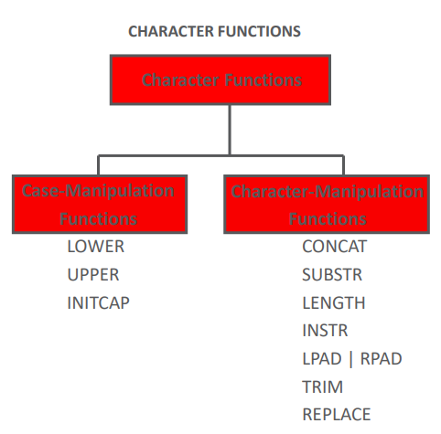
LOWER() function
LOWER() converts all the characters in a string to lowercase characters.
Syntax:
Select LOWER(string);
Argument
Name | Description
string | A string whose characters are going to be converted to lowercase.

Example: LOWER() function
The following MySQL statement returns the given string after converting all of its characters in lowercase.
Code:
SELECT LOWER('MYTESTSTRING');
Sample Output:
mysql> SELECT LOWER('MYTESTSTRING');
+-----------------------+
| LOWER('MYTESTSTRING') |
+-----------------------+
| myteststring |
+-----------------------+
1 row in set (0.01 sec)
Example of LOWER() on column of a table
The following MySQL statement returns those rows from the publisher table whose publishers does not belong to the USA. The column pub_name and after converting the pub_name column in lowercase is displayed in the output.
Code:
SELECT pub_name,LOWER(pub_name)
FROM publisher WHERE country<>'USA';
UPPER() function
MySQL UPPER() converts all the characters in a string to uppercase characters.
Syntax:
UPPER (string)
Argument
Name | Description
string | A string whose characters are to be converted to uppercase.
Example : MySQL UPPER() function
The following MySQL statement returns the given string after converting all of its characters in uppercase.
Code:
SELECT UPPER('myteststring');
Sample Output:
mysql> SELECT UPPER('myteststring');
+-----------------------+
| UPPER('myteststring') |
+-----------------------+
| MYTESTSTRING |
+-----------------------+
1 row in set (0.00 sec)
Example of MySQL UPPER() function with where clause
The following MySQL statement returns those rows from the publisher table whose publishers are not belonging the country USA. The column pub_name, and values of publisher names in uppercase have been shown in the output.
Code:
SELECT pub_name,UPPER(pub_name)
FROM publisher
WHERE country<>'USA';
INITCAP() function
The INITCAP function converts the first letter of each word in a string to uppercase, and converts any remaining characters in each word to lowercase. Words are delimited by white space characters, or by characters that are not alphanumeric.
Syntax
INITCAP( charExpression );
charExpression
The string to be converted. This can be a CHAR or VARCHAR data type, or another type that gets implicitly converted.
Results
The returned string has the same data type as the input charExpression.
Examples
splice VALUES( INITCAP('this is a test') );

---------------------------------------------------------------------
This Is A Test
Selected splice VALUES( INITCAP('tHIS iS a test') );

---------------------------------------------------------------------
This Is A Test
Character Manipulation Functions
Character-manipulation functions are used to extract, change, format, or alter in some way a character string.
One or more characters or words are passed into the function and the function will then perform its functionality on the input character strings and return the changed, extracted, counted, or altered value.
CONCAT: Joins two values together
Takes 2 character string arguments, and joins the second string to the first. could also be written using the concatenation operator – ‘Hello’ || ‘World’
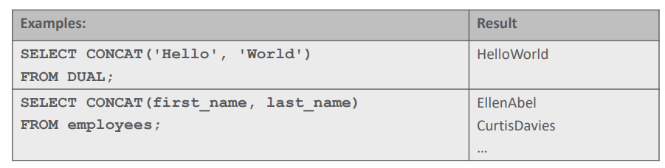
SUBSTR: Extracts a string of a determined length
The arguments are (character String, starting position, length).
The Length argument is optional, and if omitted, returns all characters to the end of the string.
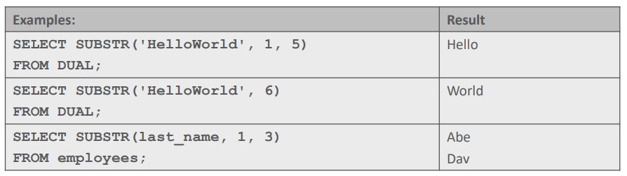
Example 1: extracts a substring of 5 characters from position 1 of ‘HelloWorld’.
Example 2: extracts a substring starting at position 6 of ‘HelloWorld’ to the end of the string.
Example 3: extracts a substring of the first 3 characters from employee last names.
LENGTH: Shows the length of a string as a number value
The function takes a character string as an argument, and returns the number of characters in that character string.
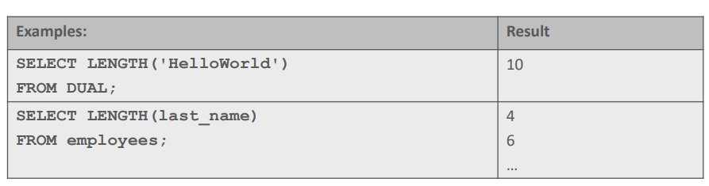
The second example returns the number of characters in each employees last name.
INSTR: Finds the numeric position of the specified character(s)
INSTR searches for the first occurrence of a substring within a character string and returns the position as a number.
If the substring is not found, the number zero is returned.
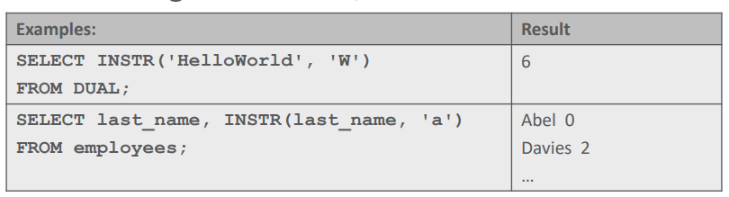
Example 1: a ‘W’ is the 6th character of the first string argument, so the function would return the number 6.
Example 2: returns the first occurrence of the character ‘a’ in employee last names. If the name does not contain ‘a’, zero is returned. Even though Abel contains an “A”, it is in the wrong case, hence the 0 is returned.
LPAD: Pads the left side of a character string, resulting in a right-justified value
LPAD requires 3 arguments: a character string, the total number of characters in the padded string, and the character to pad with.
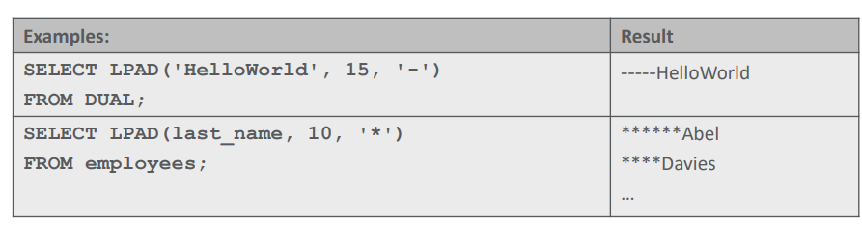
Example 1: the string ‘HelloWorld’ is left padded to 15 characters using the ‘-‘ symbol. As the string has a length of 10 characters, 5 ‘-‘ symbols are added to the left. .
Example 2: Employee last names are left padded to 10 characters using an ‘*’
RPAD: Pads the right-hand side of a character string, resulting in a left-justified value
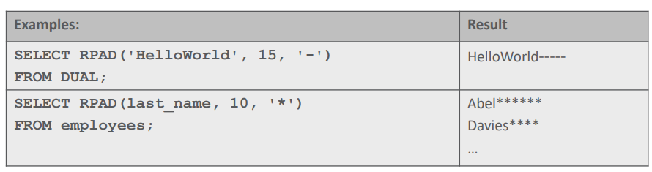
TRIM: Removes all specified characters from either the beginning, the end, or both beginning & end of a string
The syntax for the trim function is:
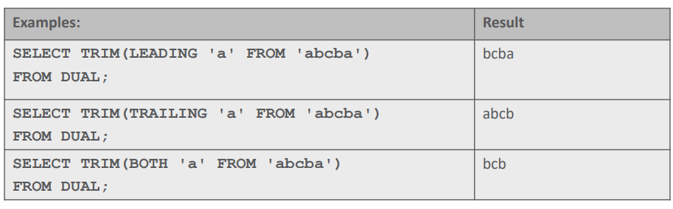
Example 1: removes the leading ‘a’ from the start of the string ‘abcba’
Example 2: removes the trailing ‘a’ from the end of the string ‘abcba’
Example 3: removes both the leading ‘a’ and the trailing ‘a’ from the string ‘abcba’.
If LEADING, TRAILING or BOTH are omitted, the function returns BOTH.
IF the specified character is not the leading (or trailing) character of the string, it is not trimmed, for example TRIM (LEADING ‘a’ FROM ‘xyz’) would return ‘xyz’
REPLACE: Replaces a sequence of characters in a string with another set of characters
The syntax for the REPLACE function is:
string1 is the string that will have characters replaced in it
string_to_replace is the string that will be searched for and taken out of string1
[replacement_string] is the new string to be inserted in string1
REPLACE (string1, string_to_replace, [replacement_string] )
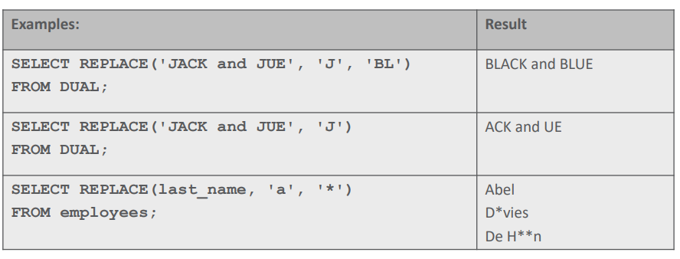
Example 1: Every instance of ‘J’ in the string ‘JACK and JUE’ is replaced with ‘BL’.
Example 2: If the replacement string argument is omitted, the string_to_replace is deleted, So every instance of ‘J’ in the string ‘JACK and JUE’ is removed.
Example 3: Every instance of the character ‘a’ in employee last names is replaced with a ‘*’ character.

Using Numeric Functions in a select statement
a. ROUND(): It returns a number rounded to a certain number of decimal places.
Syntax: SELECT ROUND(5.553);
Output: 6
b. Trunc/TRUNCATE(): It returns 7.53635 truncated to 2 places right of the decimal point.
Syntax: SELECT TRUNCATE(7.53635, 2);
Output: 7.53
c.CEIL()/CEILING(): It returns the smallest integer value that is greater than or equal to a number.
Syntax: SELECT CEIL(25.75);
Output: 26

d. FLOOR(): It returns the largest integer value that is less than or equal to a number.
Syntax: SELECT FLOOR(25.75);
Output: 25
e. MOD(): It returns the remainder of n divided by m.
Syntax: SELECT MOD(18, 4);
Output: 2

Using date functions in a select statement
a.MONTHS_BETWEEN,round,truncate and ceiling functions
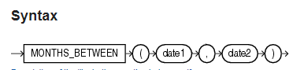
MONTHS_BETWEEN returns number of months between dates date1 and date2. If date1 is later than date2, then the result is positive. If date1 is earlier than date2, then the result is negative. If date1 and date2 are either the same days of the month or both last days of months, then the result is always an integer. Otherwise Oracle Database calculates the fractional portion of the result based on a 31-day month and considers the difference in time components date1 and date2.
Examples
The following example calculates the months between two dates:
SELECT MONTHS_BETWEEN
(TO_DATE('02-02-1995','MM-DD-YYYY'),
TO_DATE('01-01-1995','MM-DD-YYYY') ) "Months" FROM DUAL;
Months
----------
1.03225806
Whereas in mysql
Select timestampdiff(month,’date1’,’date’);
e.g:
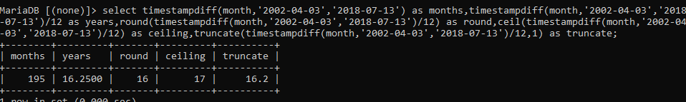
b. ADD_MONTHS Function
ADD_MONTHS function is used to return a date with a specified number of months added to it. The ADD_MONTHS function accepts two parameters which are the initial date and the number of months to be added to it.
The ADD_MONTHS function returns a value of the date data type.
The date argument can be a datetime value or any value that can be implicitly converted to DATE. The integer argument to be added can be an integer or any value that can be implicitly converted to an integer. The return type is always DATE, regardless of the data type of date. If the date specified in the argument is the last day of the month or if the resulting month has fewer days than the day component of date, then the result is the last day of the resulting month.
Syntax:
ADD_MONTHS( init_date, add_months )
Parameters Used
init_date – It is used to specify the initial date.
add_months – It is used to specify the number of months to be added to the initial date.
Return Value:
The ADD_MONTHS function returns a value of the date data type.

Example-1: Using positive numeric value in the add_months argument of the ADD_MONTHS function.
DECLARE
Test_Date date := '01-Aug-18';
Add_Month number := 3;
(ADD_MONTHS(Test_Date, Add_Month));
Output:
01.12.18
Whereas in mysql
Select Date_add(‘test_date’, interval add_month);
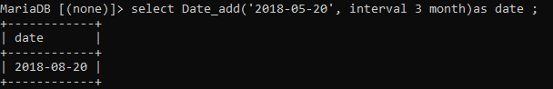
MySQL LAST_DAY() function
LAST_DAY() function
MySQL LAST_DAY() returns the last day of the corresponding month for a date or datetime value. If the date or datetime value is invalid, the function returns NULL.
Syntax:
LAST_DAY(date1)
Where date1 is a date.
Syntax Diagram:
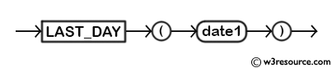
MySQL Version: 5.6
Video Presentation
Pictorial Presentation
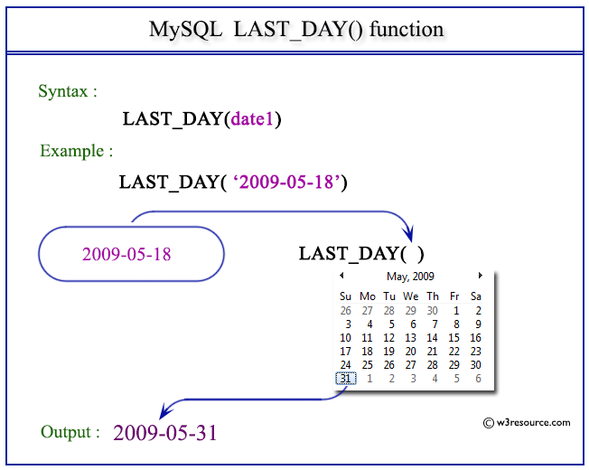
Example: MySQL LAST_DAY() function
The following statement will return the last date of the corresponding month of the given date 2009-05-18.
Code:
SELECT LAST_DAY('2009-05-18');
Copy
Sample Output:
mysql> SELECT LAST_DAY('2009-05-18');
+------------------------+
| LAST_DAY('2009-05-18') |
+------------------------+
| 2009-05-31 |
+------------------------+
1 row in set (0.00 sec)
NEXT_DAY
Syntax
NEXT_DAY returns the date of the first weekday named by char that is later than the date date. i.e. NEXT_DAY returns the date of the first instance of the specified day that is later than the given date. The return type is always DATE, regardless of the datatype of date. The argument char must be a day of the week in the date language of your session, either the full name or the abbreviation. The minimum number of letters required is the number of letters in the abbreviated version. Any characters immediately following the valid abbreviation are ignored. The return value has the same hours, minutes, and seconds component as the argument date.
Examples
This example returns the date of the next Tuesday after February 2, 2001:
SELECT NEXT_DAY('02-FEB-2001','TUESDAY') " NEXT DAY" FROM DUAL;
NEXT DAY
-----------
06-FEB-2001
Theoretical learning Activity
………………………………. (example: ask trainees to brainstorm about………. within groups)
……………………………….
……………………………….
Practical learning Activity
…………………………………… (Example: Trainees in pair perform …………………)

Points to Remember (Take home message)

LOWER() function converts all the characters in a string to lowercase characters.
Syntax: SELECT LOWER(string);
UPPER() function converts all the characters in a string to uppercase characters.
Syntax: SELECT UPPER(string);
INITCAP() function converts the first letter of each word in a string to uppercase, and converts any remaining characters in each word to lowercase. Syntax: INITCAP(charExpression);
CONCAT() function joins two values together.
Syntax: CONCAT(string1, string2);
SUBSTR() function extracts a string of a determined length.
Syntax: SUBSTR(string, starting_position, length);
LENGTH() function shows the length of a string as a number value. Syntax: LENGTH(string);
INSTR() function finds the numeric position of the specified character(s). Syntax: INSTR(string, substring);
LPAD() function pads the left side of a character string, resulting in a right-justified value. Syntax: LPAD(string, total_length, pad_character);
RPAD() function pads the right-hand side of a character string, resulting in a left-justified value. Syntax: RPAD(string, total_length, pad_character);
TRIM() function removes all specified characters from either the beginning, the end, or both beginning and end of a string. Syntax: TRIM([specify 'leading', 'trailing', or 'both'], characters_to_remove, string_to_modify).

Learning outcome 1 formative assessment
Written assessment
Which of the following single-row functions can be used to convert a character string to all uppercase letters?
a) UPPER()
b) LOWER()
c) INITCAP()
d) LENGTH()
Answer: a) UPPER()

Which of the following single-row functions can be used to extract the year from a date column?
a) YEAR()
b) MONTH()
c) DAY()
d) SYSDATE()
Answer: a) YEAR()
Please mix different assessment tools for triangulation and relevancy of assessment

Practical assessment
Assuming you have a table named "exam_results" with the following columns: student_name, exam_score, and exam_date, you can use single-row functions to retrieve customized data as follows:
Retrieve the highest exam score:
Retrieve the lowest exam score:
Retrieve the average exam score:
Retrieve the number of students who took the exam:
Answer:
SELECT MAX(exam_score) FROM exam_results;
SELECT MIN(exam_score) FROM exam_results;
SELECT AVG(exam_score) FROM exam_results;
SELECT COUNT(DISTINCT student_name) FROM exam_results;

Indicative content 2.5: Report aggregated data using group functions
Summary for the trainer related to the indicative content (key notes using bullets such as ticks etc)

From the table below, we are going to describe how each function works.
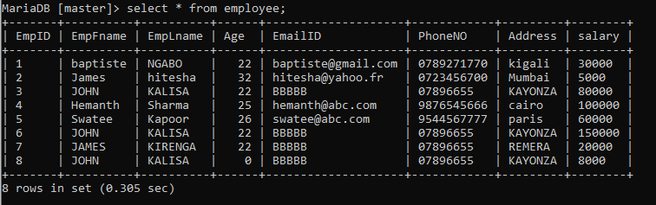
1. AVG function
AVG function calculate the average of the values in a specified column. Just it works only on numeric data types.
Syntax: select AVG (specified column name) from table name;
Example:
select avg(age) as AVERAGE from employee;
output:
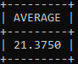
2. SUM function
SUM function calculate the total of all the values in the specified column. SUM works on numeric fields only. Null values are excluded from the result returned.
Syntax: Syntax: select sum (specified column name) from table name;
Example:
select sum(salary) as Addition from employee;
output:
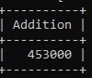
3. MIN function
The MIN function returns the smallest value in the specified table field.
Syntax: Syntax: select MIN (specified column name) from table name;
Example:
select MIN(age) as lowest_value from employee;
output:
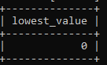
4. MAX function
It returns the largest value from the specified table field.
Syntax: : select MAX (specified column name) from table name;
Example:
select max(age) as largest_value from employee;
output:
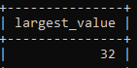
5. COUNT Function
The COUNT function returns the total number of values in the specified field. It works on both numeric and non-numeric data types.
COUNT (*) is a special implementation of the COUNT function that returns the count of all the rows in a specified table. COUNT (*) also considers Nulls and duplicates.
Syntax: select count(column name) from table name;
Example: select count(age) as number_of_rows from employee;

Output:
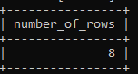
b. Use the DISTINCT keyword within group functions
The DISTINCT keyword allows us to drop duplicates from our results. This is achieved by grouping similar values together.
Example: select distinct(age) as age from employee;
Output:
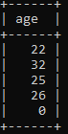
But,if any user to count the total number of each member , can use this above clause with other function which is called GROUP BY.
EXAMPLE:
select distinct(age) as age,COUNT(age) as number from employee group by age;
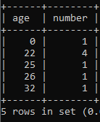
Grouping rows: GROUP BY clause and HAVING clause
. Use subqueries to solve problems
Logical operators
Logical operators are those that return true or false, such as the AND operator, which returns true when both expressions are met.
ALL
The ALL operator returns TRUE if all of the subquery values meet the specified condition. In the below example, we are filtering all users who have an age that is greater than the highest age of users in London.
SELECT first_name, last_name, age, location
FROM users
WHERE age > ALL (SELECT age FROM users WHERE location = ‘London’);
ANY/SOME
The ANY operator returns TRUE if any of the subquery values meet the specified condition. In the below example, we are filtering all products which have any record in the orders table. The SOME operator achieves the same result.
SELECT product_name
FROM products
WHERE product_id > ANY (SELECT product_id FROM orders);
AND
The AND operator returns TRUE if all of the conditions separated by AND are true. In the below example, we are filtering users that have an age of 20 and a location of London.
SELECT *
FROM users
WHERE age = 20 AND location = ‘London’;
BETWEEN
The BETWEEN operator filters your query to only return results that fit a specified range.
SELECT *
FROM users
WHERE age BETWEEN 20 AND 30;
EXISTS
The EXISTS operator is used to filter data by looking for the presence of any record in a subquery.
SELECT name
FROM customers
WHERE EXISTS
(SELECT order FROM ORDERS WHERE customer_id = 1);
IN
The IN operator includes multiple values set into the WHERE clause.
SELECT *
FROM users
WHERE first_name IN (‘Bob’, ‘Fred’, ‘Harry’);
LIKE
The LIKE operator searches for a specified pattern in a column. (For more information on how/why the % is used here, see the section on the wildcard character operator).
SELECT *
FROM users
WHERE first_name LIKE ‘%Bob%’;
NOT
The NOT operator returns results if the condition or conditions are not true.
SELECT *
FROM users
WHERE first_name NOT IN (‘Bob’, ‘Fred’, ‘Harry’);
OR
The OR operator returns TRUE if any of the conditions separated by OR are true.In the below example, we are filtering users that have an age of 20 or a location of London.
SELECT *
FROM users
WHERE age = 20 OR location = ‘London’;
IS NULL
The IS NULL operator is used to filter results with a value of NULL.
SELECT *
FROM users
WHERE age IS NULL;

Theoretical learning Activity

You are a manager at a retail store. One of your employees, Tom, has been consistently late for work, which is affecting the store's operations. You have already spoken to him about this issue, but it persists.
Learning Activity:
Review the company's policies and procedures related to employee punctuality and attendance.
Based on your understanding of the policies and procedures, draft a memo to Tom outlining the consequences of continued lateness.
Identify the possible reasons for Tom's lateness. Use the principles of motivation and behavior to analyze his behavior.
Identify strategies that you can use to motivate Tom to come to work on time. Consider using extrinsic and intrinsic motivators.
Role-play a conversation with Tom, where you use the strategies you identified to motivate him to come to work on time.
Evaluate the effectiveness of your strategies. Did they work? If not, what other strategies could you use?
Reflect on what you have learned from this scenario. How can you use this knowledge to improve your managerial skills in the future?
Practical learning Activity

You are a manager at a retail store. One of your employees, Tom, has been consistently late for work, which is affecting the store's operations. You have already spoken to him about this issue, but it persists.
Learning Activity:
Review the company's policies and procedures related to employee punctuality and attendance.
Based on your understanding of the policies and procedures, draft a memo to Tom outlining the consequences of continued lateness.
Identify the possible reasons for Tom's lateness. Use the principles of motivation and behaviour to analyse his behaviour.
Identify strategies that you can use to motivate Tom to come to work on time. Consider using extrinsic and intrinsic motivators.
Role-play a conversation with Tom, where you use the strategies you identified to motivate him to come to work on time.
Evaluate the effectiveness of your strategies. Did they work? If not, what other strategies could you use?
Reflect on what you have learned from this scenario. How can you use this knowledge to improve your managerial skills in the future?

Points to Remember (Take home message)
Group functions are used to calculate summary statistics for a set of data.
Group functions can be used in conjunction with the GROUP BY clause to group the data based on one or more columns.
The most commonly used group functions are COUNT, SUM, AVG, MAX, and MIN.
COUNT function returns the number of rows in the group, while SUM function returns the sum of values in the group.
AVG function calculates the average value of the group, while MAX and MIN functions return the maximum and minimum values respectively.
When using group functions, the SELECT statement should contain at least one grouping column and one aggregate function.
Group functions can be nested, allowing for more complex calculations.
Group functions can be used to generate reports that summarize data in a meaningful way, making it easier to analyse large datasets.

Learning outcome 1 formative assessment
Written assessment
How can group functions like SUM, AVERAGE, and COUNT be used to report aggregated data about student performance in exams across different subjects and academic years?

What are the advantages and limitations of using group functions to report aggregated data on student performance in exams, and how can these functions be optimized to provide meaningful insights for teachers, administrators, and policymakers?
Answer:
Group functions like SUM, AVERAGE, and COUNT can be used to report aggregated data about student performance in exams across different subjects and academic years by providing a summary of the results for a group of students. For example, the SUM function can be used to add up the total score of each student in a particular subject, while the AVERAGE function can be used to calculate the average score of all students in that subject. The COUNT function can be used to count the number of students who passed or failed the exam.

The advantages of using group functions to report aggregated data on student performance in exams include:
They provide a quick and easy way to summarize data across large numbers of students.
They allow for comparisons across different subjects and academic years.
They provide a basis for identifying trends and patterns in student performance over time.

Please mix different assessment tools for triangulation and relevancy of assessment
Practical assessment
How can I report the average score for each student in a class using group functions?
To report the average score for each student in a class using group functions, you can use the GROUP BY clause along with the AVG() function.
Answer:
SELECT student_name, AVG(score) as avg_score FROM exam_scores GROUP BY student_name;

Indicative content 2.6: Retrieve data from multiple tables using joins
Summary for the trainer related to the indicative content (key notes using bullets such as ticks etc)
The majority of commercially available database products use twelve basic techniques to implement the storage management layer. Among those techniques there is one which is called “Joins”.

JOIN is a statement/clause that is used to combine two or multiple tables and retrieve data based on a common columns in relational database.
JOIN provides meaningful data by combining multiple relational tables which are joined to bring out as single table. To retrieve the correct data, you must know the data requirements and correct join mechanisms.
Based on a common columns which are Primary key column in origin table (parent table) and Foreign key in destination table(child table) in relational database, joining can be occur:
Primary Key:
A primary key is specific column that contains unique values and that can not have NULL values in relational databases.
Foreign Key:
A foreign key is a column or group of columns in a relational database table that provides a link between data in two tables. It is means column or columns that references a column most often to the primary key of another table.

Types of Joins

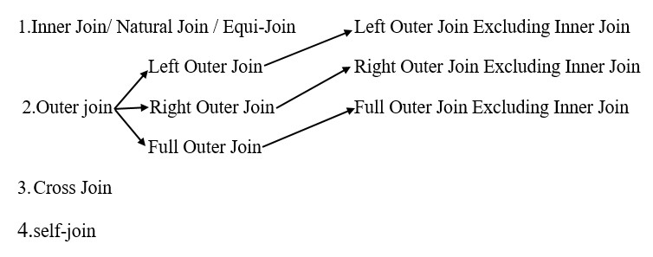
Now let’s describe one by one.

We will be considering the following three tables in order to show you how to perform the Join operations on such tables.

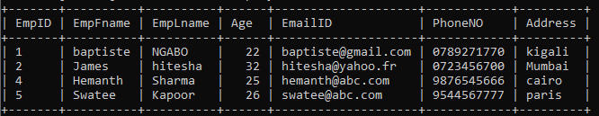
Employee Table
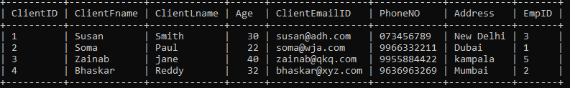

Project Table:

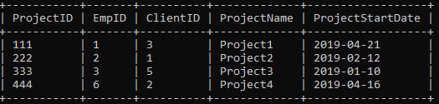

Client Table:

1. INNER JOIN
This type of join returns those records which have matching values in both tables. So, if you perform an INNER join operation between the Employee table(left table1) and the Project table (light table2), all the rows which have matching values in both the tables will be given as output.

Example:
Select Employee.EmpID,Employee.EmpLname,
Project.ProjectName,Project.ProjectStartDate from Employee INNER JOIN Project ON Employee.EmpID=Project.EmpID;

Output:
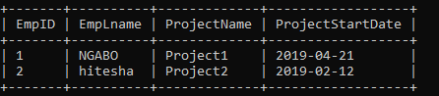

2.LEFT OUTER JOIN
The LEFT OUTER JOIN returns all the records from the left table1 and also those records which satisfy a condition from the right table. Also, for the records having no matching values in the right table2, the output or the result-set will contain the NULL values.

Example:
Select Employee.EmpID,Employee.EmpLname,
Project.ProjectName,Project.ProjectStartDate from Employee left outer JOIN Project ON Employee.EmpID=Project.EmpID;

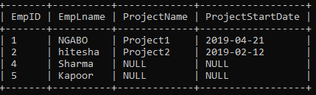

3. RIGHT OUTER JOIN
The RIGHT OUTER JOIN returns all the records from the right table2 and also those records which satisfy a condition from the left table1. Also, for the records having no matching values in the left table, the output or the result-set will contain the NULL values.

Example:
SelectEmployee.EmpID,Employee.EmpLname,
Project.ProjectName,Project.ProjectStartDate from Employee RIGHT outer JOIN Project ON Employee.EmpID=Project.EmpID;

Output:
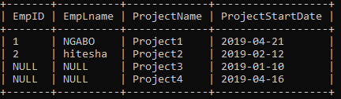

4. FULL OUTER JOIN
Full outer join produces the set of all records in left table and Right table2 with matching records from both sides where available. If there is no match, the missing side will contain null.

Example:
Select Employee.EmpID,Employee.EmpLname,
Project.ProjectName,Project.Project StartDate from Employee left outer JOIN Project ON Employee.EmpID=Project.EmpID UNION select Employee.EmpID,Employee.EmpLname,Project.ProjectName,Project.ProjectStartDate from Employee Right outer JOIN Project ON Employee.EmpID=Project.EmpID;

Output:
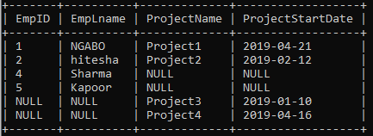

i) RIGHT Join Excluding Inner Join
This query will return all of the records in the right table2 that do not match any records in the left table1

Example:
selectEmployee.EmpID,Employee.EmpLname,
Project.ProjectName,Project.ProjectStartDate from Employee RIGHT outer JOIN Project ON Employee.EmpID=Project.EmpID where Employee.EmpID IS NULL;

Output:
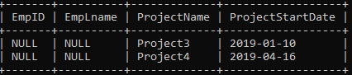

ii) Full Outer Excluding Inner Join
This query will return all of the records in left Table1 and right Table2 that do not have a matching record in the other table.

Example:
Select Employee.EmpID,Employee.EmpLname,
Project.ProjectName,Project.ProjectStartDate from Employee LEFT OUTER JOIN Project ON Employee.EmpID=Project.EmpID where Project.EmpID IS NULL UNION select Employee.EmpID,Employee.EmpLname,Project.ProjectName,Project.ProjectStartDate from Employee RIGHT OUTER JOIN Project ON Employee.EmpID=Project.EmpID where Employee.EmpID IS NULL;

Output:
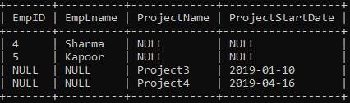

3. cross join
The cross join joins each row from table 1 to every row available in table 2. Therefore, the output is also known as a Cartesian product of both tables.

Let’s consider these 2 tables:

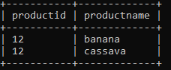

Theoretical learning Activity

Imagine you are working for a university that has a database with multiple tables, including a student table, a course table, and an enrolment table. The student table contains the student's name, ID, and major. The course table contains the course's name, ID, and department ID. The enrollment table contains the student ID, course ID, and grade. Write a SQL query to retrieve the names of students who have taken
Answer: This query uses an inner join to link the student table with the enrollment table on the ID column of the student table and the student_ID column of the enrollment table. It then uses another inner join to link the course table with the enrollment table on the ID column of the course table and the course_ID column of the enrollment table. Finally, it uses a third inner join to link the department table with the course table on the ID column of the department table and the department_ID column of the course table.

The WHERE clause filters the results to only include students who have taken a course in the Computer Science department, based on the name column of the department table. Note: This query assumes that the names of the tables and columns are exactly as described in the scenario. If they differ, you will need to adjust the query accordingly.

Practical learning Activity
you are working for a company that has a database with multiple tables, including an employee table, a department table, and a project table. The employee table contains the employee's name, ID, and department ID. The department table contains the department's name and ID. The project table contains the project's name, ID, and department ID. Write a SQL query to retrieve the names of employees who are working on projects in their own department.
Answer:
SELECT employee.name FROM employee INNER JOIN department ON employee.department_ID = department.ID INNER JOIN project ON employee.department_ID = project.department_ID WHERE employee.ID = project.ID

Points to Remember (Take home message)
JOIN is used to combine two or multiple tables and retrieve data based on a common column in relational database
There are 12 basic techniques to implement the storage management layer, and JOIN is one of them
Primary keys and foreign keys are used to establish relationships between tables
Four types of Joins are described: INNER JOIN, LEFT OUTER JOIN, RIGHT OUTER JOIN, and FULL OUTER JOIN

Learning outcome 1 formative assessment
Written assessment
1. Which type of join will retrieve all records from both tables, but only matching records will have values in the result set?
A) Inner Join
B) Outer Join
C) Cross Join
D) Self Join

2. Which join type will retrieve all records from one table and only matching records from the other table?
A) Inner Join
B) Outer Join
C) Cross Join
D) Self Join
Answer:
A) Inner Join
B) Outer Join

By Using True or False, Answer the following statements:
Joins allow you to retrieve data from multiple tables in a single query.
A LEFT JOIN returns all rows from the left table and matching rows from the
Answer:
True.
True.
Please mix different assessment tools for triangulation and relevancy of assessment

Practical assessment
A company has three tables named "Employees", "Departments", and "Salary" in their database. The "Employees" table contains information about all the employees, the "Departments" table contains information about all the departments in the company, and the "Salary" table contains information about the salary of each employee. Write a SQL query to retrieve the names of all the employees along with their department name and salary.
Answer: SELECT Employees.EmployeeName, Departments.DepartmentName, Salary.Amount
FROM Employees
JOIN Departments ON Employees.DepartmentID = Departments.DepartmentID
JOIN Salary ON Employees.EmployeeID = Salary.EmployeeID;

Indicative content 2.7: Use subqueries to solve problems
Summary for the trainer related to the indicative content (key notes using bullets such as ticks etc)

Subqueries

Subqueries are a powerful tool in SQL that allow you to create complex queries by using the results of one query as input for another query. By using subqueries, you can break down complex problems into smaller, more manageable parts and solve them step by step.

Subqueries can be used to filter data, aggregate results, and perform calculations. They can also be used in conjunction with other SQL statements such as SELECT, INSERT, UPDATE, and DELETE.

One common use of subqueries is to retrieve data from multiple tables that are related by a foreign key. For example, you can use a subquery to retrieve all orders placed by a specific customer by joining the orders and customers tables on the customer ID.

Another common use of subqueries is to perform calculations based on aggregated data. For example, you can use a subquery to calculate the average salary of all employees in a department, and then use that result to filter the employees table to only show those whose salary is above the department average.

Overall, subqueries are a powerful tool in SQL that can help you solve complex problems by breaking them down into smaller, more manageable parts.

Group Functions in subqueries
In a subquery, group functions can be used to perform calculations on a subset of data that is being queried. For example, if you have a table of orders and want to find the total value of orders for each customer, you can use a subquery with a group function to sum the values of orders for each customer.

Here's an example query that uses a subquery with a group function:
SELECT customer_name, (SELECT SUM(order_value) FROM orders WHERE orders.customer_id = customers.customer_id) as total_order_value
FROM customers;

In this query, the subquery (SELECT SUM(order_value) FROM orders WHERE orders.customer_id = customers.customer_id) is used to calculate the total value of orders for each customer. The subquery is nested inside the main query, which selects the customer name and the total order value for each customer. The subquery is correlated with the main query by the customer ID, so the SUM function is calculated for each customer separately.

Theoretical learning Activity
………………………………. (example: ask trainees to brainstorm about………. within groups)
……………………………….
……………………………….
Practical learning Activity

Points to Remember (Take home message)

Learning outcome 1 formative assessment
Written assessment
Assessment tools
True or false questions
Multiple choice
Open ended questions
Case studies
Please mix different assessment tools for triangulation and relevancy of assessment

Practical assessment
Assessment tools
Assay
Task to be performed
Observation checklist

Indicative content 2.8: Use of set operators
Summary for the trainer related to the indicative content (key notes using bullets such as ticks etc)

Using the Set Operators

Set operators are used to join the results of two (or more) SELECT statements.The SET operators available in Oracle 11g are UNION,UNION ALL,INTERSECT,and MINUS.
The UNION set operator returns the combined results of the two SELECT statements.Essentially,it removes duplicates from the results i.e. only one row will be listed for each duplicated result.To counter this behavior,use the UNION ALL set operator which retains the duplicates in the final result.INTERSECT lists only records that are common to both the SELECT queries; the MINUS set operator removes the second query's results from the output if they are also found in the first query's results. INTERSECT and MINUS set operations produce unduplicated results.
All the SET operators share the same degree of precedence among them.Instead,during query execution, Oracle starts evaluation from left to right or from top to bottom.If explicitly parentheses are used, then the order may differ as parentheses would be given priority over dangling operators.
Points to remember -
Same number of columns must be selected by all participating SELECT statements.Column names used in the display are taken from the first query.
Data types of the column list must be compatible/implicitly convertible by oracle. Oracle will not perform implicit type conversion if corresponding columns in the component queries belong to different data type groups.For example, if a column in the first component query is of data type DATE, and the corresponding column in the second component query is of data type CHAR,Oracle will not perform implicit conversion, but raise ORA-01790 error.
Positional ordering must be used to sort the result set. Individual result set ordering is not allowed with Set operators. ORDER BY can appear once at the end of the query. For example,
UNION and INTERSECT operators are commutative, i.e. the order of queries is not important; it doesn't change the final result.
Performance wise, UNION ALL shows better performance as compared to UNION because resources are not wasted in filtering duplicates and sorting the result set.
Set operators can be the part of sub queries.
Set operators can't be used in SELECT statements containing TABLE collection expressions.
The LONG, BLOB, CLOB, BFILE, VARRAY,or nested table are not permitted for use in Set operators.For update clause is not allowed with the set operators.
UNION
When multiple SELECT queries are joined using UNION operator, Oracle displays the combined result from all the compounded SELECT queries,after removing all duplicates and in sorted order (ascending by default), without ignoring the NULL values.
Consider the below five queries joined using UNION operator.The final combined result set contains value from all the SQLs. Note the duplication removal and sorting of data.
SELECT 1 NUM FROM DUAL
UNION
SELECT 5 FROM DUAL
UNION
SELECT 3 FROM DUAL
UNION
SELECT 6 FROM DUAL
UNION
SELECT 3 FROM DUAL;

NUM
-------
1
3
5
6
To be noted, the columns selected in the SELECT queries must be of compatible data type. Oracle throws an error message when the rule is violated.
SELECT TO_DATE('12-OCT-03') FROM DUAL
UNION
SELECT '13-OCT-03' FROM DUAL;

SELECT TO_DATE('12-OCT-03') FROM DUAL
*
ERROR at line 1:
ORA-01790: expression must have same datatype as corresponding expression
UNION ALL
UNION and UNION ALL are similar in their functioning with a slight difference. But UNION ALL gives the result set without removing duplication and sorting the data. For example,in above query UNION is replaced by UNION ALL to see the effect.
Consider the query demonstrated in UNION section. Note the difference in the output which is generated without sorting and deduplication.
SELECT 1 NUM FROM DUAL
UNION ALL
SELECT 5 FROM DUAL
UNION ALL
SELECT 3 FROM DUAL
UNION ALL
SELECT 6 FROM DUAL
UNION ALL
SELECT 3 FROM DUAL;

NUM
-------
1
5
3
6
3
INTERSECT
Using INTERSECT operator, Oracle displays the common rows from both the SELECT statements, with no duplicates and data arranged in sorted order (ascending by default).
For example,the below SELECT query retrieves the salary which are common in department 10 and 20.As per ISO SQL Standards, INTERSECT is above others in precedence of evaluation of set operators but this is not still incorporated by Oracle.
SELECT SALARY
FROM employees
WHERE DEPARTMENT_ID = 10
INTRESECT
SELECT SALARY
FROM employees
WHERE DEPARTMENT_ID = 20

SALARY
---------
1500
1200
2000
MINUS
Minus operator displays the rows which are present in the first query but absent in the second query, with no duplicates and data arranged in ascending order by default.
SELECT JOB_ID
FROM employees
WHERE DEPARTMENT_ID = 10
MINUS
SELECT JOB_ID
FROM employees
WHERE DEPARTMENT_ID = 20;

JOB_ID
-------------
HR
FIN
ADMIN

Matching the SELECT statement
There may be the scenarios where the compound SELECT statements may have different count and data type of selected columns. Therefore, to match the column list explicitly, NULL columns are inserted at the missing positions so as match the count and data type of selected columns in each SELECT statement. For number columns, zero can also be substituted to match the type of the columns selected in the query.
In the below query, the data type of employee name (varchar2) and location id (number) do not match. Therefore, execution of the below query would raise error due to compatibility issue.
SELECT DEPARTMENT_ID "Dept", first_name "Employee"
FROM employees
UNION
SELECT DEPARTMENT_ID, LOCATION_ID
FROM departments;

ERROR at line 1:
ORA-01790: expression must have same datatype as corresponding expression
Explicitly, columns can be matched by substituting NULL for location id and Employee name.
SELECT DEPARTMENT_ID "Dept", first_name "Employee", NULL "Location"
FROM employees
UNION
SELECT DEPARTMENT_ID, NULL "Employee", LOCATION_ID
FROM departments;
Using ORDER BY clause in SET operations
The ORDER BY clause can appear only once at the end of the query containing compound SELECT statements.It implies that individual SELECT statements cannot have ORDER BY clause. Additionally, the sorting can be based on the columns which appear in the first SELECT query only. For this reason, it is recommended to sort the compound query using column positions.
The compund query below unifies the results from two departments and sorts by the SALARY column.
SELECT employee_id, first_name, salary
FROM employees
WHERE department_id=10
UNION
SELECT employee_id, first_name, salary
FROM employees
WHERE department_id=20
ORDER BY 3;

Theoretical learning Activity
………………………………. (example: ask trainees to brainstorm about………. within groups)
……………………………….
……………………………….
Practical learning Activity
…………………………………… (Example: Trainees in pair perform …………………)

Points to Remember (Take home message)

Learning outcome 1 formative assessment
Written assessment
Assessment tools
True or false questions
Multiple choice
Open ended questions
Case studies
Please mix different assessment tools for triangulation and relevancy of assessment

Practical assessment
Assessment tools
Assay
Task to be performed
Observation checklist

Indicative content 2.9: Use data manipulation language (DML) statements to update table data.
Summary for the trainer related to the indicative content (key notes using bullets such as ticks etc)

Adding new rows in a table
· INSERT statement
• Changing data in a table
· UPDATE statement
• Removing rows from a table:
· DELETE statement
· TRUNCATE statement
• Database transaction control:
· COMMIT
· ROLLBACK
· SAVEPOINT
Difference between COMMIT and ROLLBACK in SQL
A transaction is a logical term with some sequence of instructions or queries to make a complete transaction execution. Each transaction starts with a specific task and ends when the group of tasks is completed. If any of the tasks fails, the transaction is a failure. To make a complete transaction in SQL, we need to perform various activities such as: starts the transaction, set the transaction, commit, the ROLLBACK, and the SAVEPOINT of the transaction.
COMMIT and ROLLBACK are the two terms used in the transactional statement to perform or undo the SQL transaction.
What is SQL COMMIT?
A COMMIT is the SQL command used in the transaction tables or database to make the current transaction or database statement as permanent. It shows the successful completion of a transaction. If we have successfully executed the transaction statement or a simple database query, we want to make the changes permanent. We need to perform the commit command to save the changes, and these changes become permanent for all users. Furthermore, once the commit command is executed in the database, we cannot regain its previous states in which it was earlier before the execution of the first statement.
Syntax
COMMIT;
What is SQL ROLLBACK?
the rollback command performs the current transaction's rollback action to return the transaction on its previous state or the first statement. a rollback command can only be executed if the user has not performed the commit command on the current transaction or statement.
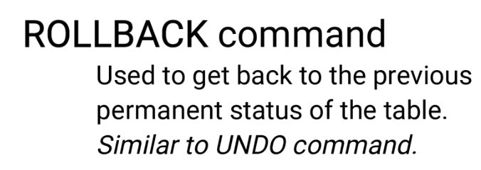
Syntax
ROLLBACK;

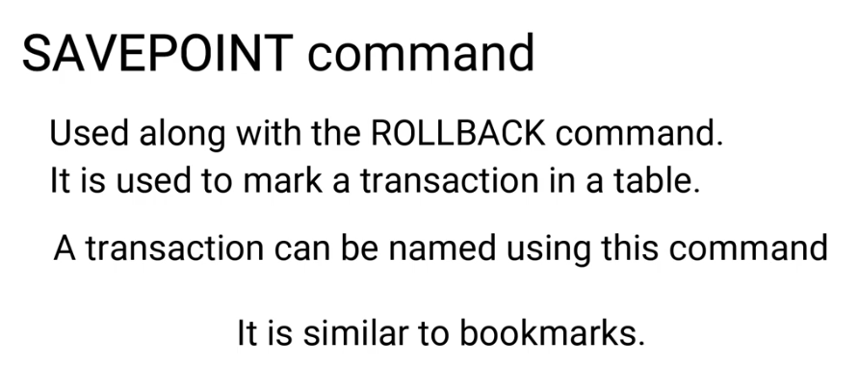

Theoretical learning Activity
………………………………. (example: ask trainees to brainstorm about………. within groups)
……………………………….
……………………………….
Practical learning Activity
…………………………………… (Example: Trainees in pair perform …………………)

Points to Remember (Take home message)

Learning outcome 1 formative assessment
Written assessment
Assessment tools
True or false questions
Multiple choice
Open ended questions
Case studies
Please mix different assessment tools for triangulation and relevancy of assessment

Practical assessment
Assessment tools
Assay
Task to be performed
Observation checklist

Indicative content 2.10: Execute database Stored procedure, index
Summary for the trainer related to the indicative content (key notes using bullets such as ticks etc)
A database index is a data structure that improves the speed of operations in a table. Indexes can be created using one or more columns, providing the basis for both rapid random lookups and efficient ordering of access to records.
While creating index, it should be taken into consideration which all columns will be used to make SQL queries and create one or more indexes on those columns.
Practically, indexes are also a type of tables, which keep primary key or index field and a pointer to each record into the actual table.
The users can not see the indexes, they are just used to speed up queries and will be used by the Database Search Engine to locate records very fast.
It supports different type of indexes like primary key index, unique index, normal index and full-text index.
Indexes help to speed up the retrieval of data from MySQL database server. When retrieving the data from a database table, MySQL first checks whether the index of table exists; If yes it will use index to select exact physical corresponding rows without scanning the whole table.
Creating Indexes
Mostly we create index when creating table. Any column in creating table statement declared as PRIMARY KEY, KEY, UNIQUE or INDEX will be indexed automatically by MySQL. In addition, you can add indexes to the tables which has data.
CREATE INDEX Syntax
Creates an index on a table. Duplicate values are allowed:
CREATE INDEX index_name
ON table_name (column1, column2, ...);
e.g:
create index is as follows
CREATE INDEX emp_no ON employees(emp_no).
In above statement UNIQUE specify that MySQL will create a constraint that all values in the index must be distinct. Duplicated NULL is allowed in all storage engine except BDB.The FULLTEXT index is supported only by MyISAM storage engine and only accepted columns which have data type is CHAR,VARCHAR or TEXT.The SPATIAL index supports spatial column and available in MyISAM storage engine. In addition, the column value must not be NULL.Then you name the index using index types such as BTREE, HASH or RTREE also based on storage engine.
Displaying INDEX Information
You can use the SHOW INDEX command to list out all the indexes associated with a table. The vertical-format output (specified by \G) often is useful with this statement, to avoid a long line.
SHOW INDEX FROM table_name\G;
DROP INDEX Statement
ALTER TABLE table_name
DROP INDEX index_name;
Advantages of MySQL Indexes
1. Indexes make search queries much faster.
2.Indexes like primary key index and unique index help to avoid duplicate row data.
3.Full-text indexes in MySQL, users have the opportunity to optimize searching against even large amounts of text located in any field indexed as such.

Disadvantages of MySQL indexes
Actually a separate file created when a new index created on the table column. that file stored only the field you’re interested in sorting on. So when we create index, it takes up disk space. but because of creating index on every column in every possible combination, the index file would grow much more quickly than the data file. In the case when a table is of large table size, the index file could reach the operating system’s maximum file size.

Theoretical learning Activity
………………………………. (example: ask trainees to brainstorm about………. within groups)
……………………………….
……………………………….
Practical learning Activity
…………………………………… (Example: Trainees in pair perform …………………)

Points to Remember (Take home message)

Learning outcome 1 formative assessment
Written assessment
Assessment tools
True or false questions
Multiple choice
Open ended questions
Case studies
Please mix different assessment tools for triangulation and relevancy of assessment

Practical assessment
Assessment tools
Assay
Task to be performed
Observation checklist

Learning Unit 3: Interact with database

Picture/s reflecting the Learning unit 1

STRUCTURE OF LEARNING UNIT
Learning outcomes:
3.1 Identify different data file formats
3.2 Correlate data between external format and database
3.3 Execute Import of data from external source
3.4 Execute Export of data to external source

Learning outcome 3.1 ………………………………………

Duration: ……….hrs
Learning outcome 1 objectives:
By the end of the learning outcome, the trainees will be able to:
1. ………………………………….
2. ………………………………….
3. ………………………………….
.
n. …………………………………
Resources
Equipment | Tools | Materials
Advance preparation:
.
.
.

Indicative content 3.1: Identify different data file formats
Summary for the trainer related to the indicative content (key notes using bullets such as ticks etc)

Identification of different data formats:
What is a sql format?
The SQL FORMAT statement is very powerful for displaying data in a meaningful way to end users (or even database administrators!).
i) What is an .SQL file?
A file with .sql extension is a Structured Query Language (SQL) file that contains code to work with relational databases. It is used to write SQL statements for CRUD (Create, Read, Update, and Delete) operations on databases. SQL files are common while working with desktop as well as web-based databases.
ii).CSV FILE:
The CSV (“Comma Separated Value”) file format originated in Microsoft Excel.
iii) .XLS and .XLSX files
XLS and XLSX are two file extensions that are used by the very popular spreadsheet application from Microsoft named Microsoft Excel. XLS is very popular as it has been the default format for Microsoft Excel since it was first created up till 2003. In the Microsoft Office 2007 release, Microsoft decided to change the default file format to a different format and adding and additional x for all their document extensions; for Excel, this ended up as XLSX.
XLS is based on BIFF (Binary Interchange File Format) and as such, the information is directly stored to a binary format. On the other hand, XLSX is based on the Office Open XML format, a file format that was derived from XML. The information in an XLSX file is stored in a text file that uses XML to define all its parameters.
As XLSX is stored in a text file format, Microsoft decided to remove macro support for this file format. Instead they assigned a totally different file extension that allows the use of macros; it is named XLSM. The older XLS file extension does not have this issue and it is able to hold spreadsheets that contain macros or not.
Summary:
XLS is the default file format for the 2003 version of Excel and older while XLSX for versions since 2007
XLS is readable by all Microsoft Excel versions while XLSX is only readable by versions 2007 and later
XLS is a proprietary binary format while XLSX is based on Office Open XML format
XLSX is not able to support macros while XLS is
iv) What Is a .BAK File?
A file with the .BAK file extension is a backup file. This file type is used by many different applications, all for the same purpose: to store a copy of one or more files for backup purposes.
Most BAK files are created automatically by a program that needs to store a backup.

Theoretical learning Activity
………………………………. (example: ask trainees to brainstorm about………. within groups)
……………………………….
……………………………….
Practical learning Activity
…………………………………… (Example: Trainees in pair perform …………………)

Points to Remember (Take home message)

Indicative content 3.2: Correlate data between external format and database
Summary for the trainer related to the indicative content (key notes using bullets such as ticks etc)
What is a Data Type?

Selecting an appropriate data type can be very important. When creating a table, you need to specify a table name and a data type that not only defines what data can be stored in the table column but also what influence it may have on database performance. A data type also indicates a data range to be stored in each column of the table. When specifying data types, you can set a field size.
In MySQL, there are various data types that are grouped in numeric (integer, float, boolean, etc.), date and time (DATETIME, DATE, etc.), string (CHAR, VARCHAR, etc.), spatial, and JSON. For example, if the column data type is numeric, it means that only numerical data can be stored in the column and you can define its maximum length in brackets.
The syntax of data types is as follows:
CREATE TABLE table_name (
column1_name data type(length),
column2_name data type(length),
);
Here is the example of the CREATE statement displaying MySQL data types:
CREATE TABLE products (
product_id INT AUTO_INCREMENT PRIMARY KEY,
product_item VARCHAR(255) NOT NULL,
use_by date,
price int,
description TEXT,
created_at TIMESTAMP DEFAULT CURRENT_TIMESTAMP
);
Data Types in MySQL
MySQL supports several standard SQL data types. Each column can contain only one data type. In MySQL, data types are grouped in different categories:
Numeric
Date and time
String
MySQL String Data Types (Text Formats)
In MySQL, string data types usually store data as long strings of text, for example, feedback or product description. Strings can consist of letters, numbers, or binary media files such as images, photos, or audio files.
The MySQL string data types are divided into:
TEXT
BLOB
CHAR and VARCHAR
BINARY and VARBINARY
ENUM
SET
TEXT Data Type
The MySQL TEXT data type is used to store long-text strings to display information about the table object, such as product descriptions, blog comments, etc. The storage size of the TEXT data type varies from 1 byte to 4 GB. Unlike the numeric data types, you do not have to set a length next to the TEXT data type in the table column. Moreover, TEXT values are not stored in the server’s memory but use the disk instead. Therefore, the TEXT data types require +1 additional byte to retrieve data.
In MySQL, there are four different TEXT data types: TINYTEXT, TEXT, MEDIUMTEXT, and LONGTEXT.
The table displays the allowable storage in bytes for the TEXT data types and cases when they can be used.
Type | Storage | Maximum number of characters | Overhead storage (in bytes) | Usage
TINYTEXT | 255 | 255 | 1 | To store short-text strings such as links, product description or summary
TEXT | 64 kB | 65535 | 2 | To store texts such as articles that do not exceed the specified length of characters
MEDIUMTEXT | 16 MB | 16777215 | 3 | To store large texts such as whitepapers or books
LONGTEXT | 4 GB | 4294967295 | 4 | To store huge texts such as computer programs or applications
BLOB Datatype in MySQL
Unlike the TEXT data types, which are non-binary string data types, the BLOB data types are binary strings. In MySQL, the BLOB data type represents a binary large object and can be used to store binary media data, such as audio or video links, images, or files.
The BLOB data types, including TINYBLOB, BLOB, MEDIUMBLOB, and LONGBLOB, have a variable length, i.e. additional bytes (from 1 to 4) are required to store a value length in the column. For example, the maximum size of data to be stored is as follows:
TINYBLOB => 255 bytes + 1 byte
BLOB => 65535 + 2 bytes
MEDIUMBLOB => 16777215 + 3 bytes
LONGBLOB => 4294967295 + 4 bytes
When comparing BLOB and TEXT data types, it should be noted that BLOB is defined as numeric values, while TEXT – as character strings having a character set. This should be taken into account when comparing and sorting information.
CHAR and VARCHAR data type
In MySQL, the CHAR data types store non-binary strings with a fixed length that reaches 255 characters, while the VARCHAR data types store non-binary strings with a variable length having a maximum size of up to 65535 characters.
For both data types, you need to set a size parameter in characters (in brackets) when creating a column. The size parameter represents the column length for a CHAR data type and the maximum column length for a VARCHAR data type. For example, CHAR(3) refers to up to 3 characters for the column value.
The main distinction between the CHAR and VARCHAR data types is a way of storing data. CHAR adds spaces to values on the right to the specified length, for example, CHAR(3) will be displayed as follows ‘table ‘. VARCHAR outputs the value as it is, without any additional spaces – VARCHAR(3) will be displayed as ‘table’.
It should be noted that when defining a datatype for a phone number in MySQL, VARCHAR is more preferable to integers as sometimes there may be special symbols or characters. In addition, VARCHAR simplifies validation.
BINARY and VARBINARY Types
Though CHAR and VARCHAR seem to be similar to BINARY and VARBINARY data types, they have some differences. BINARY and VARBINARY store binary strings, and length is measured in bytes.
ENUM Data Type in MySQL
The MySQL ENUM data types are strings with enumeration values. ENUM allows you to set a list of predefined values and then choose any of them. If you add an invalid value that is not included in the list, you will get an empty string.
For example, we want to create a table that will store information about the size of women’s clothes: small, medium, and large. In the table, we will insert the size column with the ENUM type. It means that this column will take only specified values.
-- create a table with the CREATE TABLE statement

CREATE TABLE clothes (
product_ID int PRIMARY KEY AUTO_INCREMENT,
name varchar(255) NOT NULL,
fabric text NOT NULL,
size enum ('small', 'medium', 'large') NOT NULL
);

-- insert into the table a new row with a valid value

INSERT INTO clothes (product_ID, name, fabric, size)
VALUES (1, 'dresses', 'cotton', 'small');
After that, retrieve data and see the result.
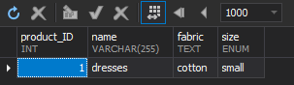
Now, insert another row with a value (‘extra large‘) that was not specified in the list and retrieve data.
-- add 'extra large' to the size column that is not included in the permitted values

INSERT INTO clothes (product_ID, name, fabric, size)
VALUES (2, 'dresses', 'silk', 'extra large');
As you can see, the output displays an empty string for the invalid value of the ENUM data type column.
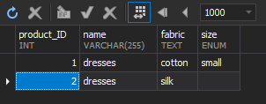
SET Data Type
The MySQL SET data types allow you to store zero or multiple values (separated by comma) you specified in a list of predefined values when creating a table. For example, suppose that customers can wear some dresses both in autumn and winter. In this case, we can insert in the aforementioned table clothes a new row season and assign the SET (‘autumn’, ‘winter’) data type to the column. In the output, we may see the following options:
''
'autumn'
'winter'
'autumn,winter'
MySQL Numeric Data Types (Number Formats)
MySQL supports numeric data types such as integers, decimals, and floating-point data types:
Integers represent numbers without fractions and can have SIGNED and UNSIGNED attributes. Usually, they may be used for IDs or counting numbers.
Decimals represent numbers with fractions and store exact numeric values in the column. They can be signed and unsigned and are usually used for columns that store monetary values. In the comparison with the floating-point numbers, decimals are more accurate.
Floating-point represent numbers with fractions but do not store exact numeric values. They can be signed and unsigned. Floating-point numeric values use a double-precision 64-bit format or a single-precision 32-bit format to store data. They may lead to a loss of precision during arithmetic operations.
Integer Data Types
Integer data types are numeric values without fractions. MySQL supports the following integer data types:
TINYINT
SMALLINT
INT
MEDIUMINT
BIGINT
They can be UNSIGNED, which allow only zero and positive numbers in a column, and SIGNED, which store zero, positive, and negative numbers. For more information about integer data types, see MySQL INT (INTEGER) Data Types with Different Examples.
Boolean Data Type
The boolean data types can only accept either true or false values. In a binary format, true refers to 1 and false – to 0. As a rule, they are used for logical operations.
MySQL does not have a boolean (or bool) data type. Instead, it converts boolean values into integer data types (TINYINT). When you create a table with a boolean data type, MySQL outputs data as 0, if false, and 1, if true.
Float Data Type
The Float data types represent single-precision approximate numeric values that require 4 bytes for storage. They can have SIGNED and UNSIGNED attributes.
Attribute | Minimum storage size | Maximum storage size
SIGNED | -3.402823466E+38 | -1.175494351E-38
UNSIGNED | 0 and 1.175494351E-38 | 3.402823466E+38
Note: Starting from MySQL version 8.0.17, UNSIGNED is deprecated for the FLOAT and DOUBLE data types.
When adding a column, you need to set values for the float data type in brackets – FLOAT(m,d) where ‘m‘ is the number of digits in total and ‘d‘ is the number of digits after the decimal point.
Double Data Type
The Double data types refer to the floating-point numeric data types and use 8 bytes to store double-precision values. The syntax for the double data type is DOUBLE PRECISION(m,d) where ‘m‘ is the total number of digits and ‘d‘ is the number of digits following the decimal point. For example, DOUBLE(7,5) means that it will store a value with seven digits and five decimals.
Attribute | Minimum storage size | Maximum storage size
SIGNED | -1.7976931348623157E+308 | -2.2250738585072014E-308
UNSIGNED | 0 and 2.2250738585072014E-308 | 1.7976931348623157E+308
Decimal Data Type
The DECIMAL data type can be used to store exact and fixed numeric values. When creating a table column, the syntax for the data type is DECIMAL(p,s) where ‘p‘ stands for precision, the maximum number of digits, and ‘s‘ stands for scale, the number of digits following the decimal.
As a result, the main difference between float and double data types is precision (from 0 to 23 for FLOAT, and from 24 to 53 for DOUBLE) and accuracy (up to approximately 7 decimals for FLOAT, and up to approximately 15 decimals for DOUBLE).
To sum up, decimals are better to use for fixed amounts, such as monetary and financial information (price, salary, etc,), while float and double – for approximate calculations where rounding values might have a negative impact.
BIT Data Type
The BIT data type is used to store binary values in the column and accepts either 0 or 1. The range of bit values for the column goes from 1 to 64. If the range is not set, the default value will be 1.
For example, create the working_hours table with the days column as BIT(7). In the days column, 1 serves as a working day and 0 – as a day-off.
CREATE TABLE working_hours (
employee_id int NOT NULL AUTO_INCREMENT,
first_name varchar(45) NOT NULL,
last_name varchar(45) NOT NULL,
month varchar(8),
week int,
days bit(7),
PRIMARY KEY (employee_id)
);
Suppose in April, employees can have two additional day-offs. Thus, insert a new row in the table using the INSERT INTO statement:
INSERT INTO working_hours (employee_id, first_name, last_name, month, week, days)
VALUES (1, 'Jordan', 'Sanders', 'April', 2, B'1111100');
Retrieve data by executing the SELECT statement:
SELECT * FROM working_hours wh;
In the output, we can see that the result is not displayed as binary, and MySQL treats the BIT data type as integers – 124.
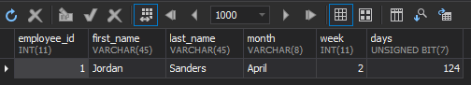
So, to retrieve data being converted to binary, we need to use the BIT() function and view the result.
SELECT employee_id, first_name, last_name, month, week, BIN(days) FROM working_hours wh
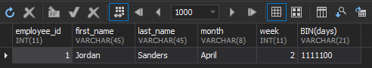
MySQL Date & Time Data Types
For managing date and time information in databases, MySQL date types are used that are divided into DATE, TIME, DATETIME, TIMESTAMP, and YEAR.
Type | Usage | Data type format | Range
DATE | Stores only date information in the table column | YYYY-MM-DD format (year, month, and date) | from ‘1000-01-01’ to ‘9999-12-31’
TIME | Displays only time | HH:MM:SS format (hours, minutes, and seconds) | from ‘-838:59:59’ to ‘838:59:59’
DATETIME | Stores both date and time in the column | YYYY-MM-DD HH:MM:SS ( year, month, and date, and hours, minutes, and seconds) | from ‘1000-01-01 00:00:00’ to ‘9999-12-31 23:59:59’
DATETIME | Stores both date and time values in the column | YYYY-MM-DD HH:MM:SS ( year, month, and date, and hours, minutes, and seconds) | from ‘1000-01-01 00:00:00’ to ‘9999-12-31 23:59:59’
TIMESTAMP | Stores both date and time values in the column. Conversion of the value from the zone of the connection server to UTC takes place. | YYYY-MM-DD HH:MM:SS ( year, month, and date, and hours, minutes, and seconds) | from ‘1970-01-01 00:00:01’ UTC to ‘2038-01-19 03:14:07’ UTC
YEAR | Stores only year values in the column | YYYY (year) | from ‘1901’ to ‘2155’

Theoretical learning Activity
………………………………. (example: ask trainees to brainstorm about………. within groups)
……………………………….
……………………………….
Practical learning Activity
…………………………………… (Example: Trainees in pair perform …………………)

Points to Remember (Take home message)

Indicative content 3.3: Execute Import of data from external source

Summary for the trainer related to the indicative content (key notes using bullets such as ticks etc)
Steps for exporting data to external source through phpmyadmin.
Step1: select/open database
Step2: click on export
Step3: Choose export method(quick or custom) and select format.
Step4: click on Go (file downloaded automatically)

Theoretical learning Activity
………………………………. (example: ask trainees to brainstorm about………. within groups)
……………………………….
……………………………….
Practical learning Activity
…………………………………… (Example: Trainees in pair perform …………………)

Points to Remember (Take home message)

Learning outcome 1 formative assessment
Written assessment
Assessment tools
True or false questions
Multiple choice
Open ended questions
Case studies
Please mix different assessment tools for triangulation and relevancy of assessment

Practical assessment
Assessment tools
Assay
Task to be performed
Observation checklist

Indicative content 3.4: Execute export of data from external source
Summary for the trainer related to the indicative content (key notes using bullets such as ticks etc)
Steps for importing data from external source through phpmyadmin.
step1: create database/type db name.
step2: Click on import
step3:Choose file(where file saved) ,open it and select format.
d.Step4: Click on Go (database created automatically)

Theoretical learning Activity
………………………………. (example: ask trainees to brainstorm about………. within groups)
……………………………….
……………………………….
Practical learning Activity
…………………………………… (Example: Trainees in pair perform …………………)

Points to Remember (Take home message)

Learning outcome 1 formative assessment
Written assessment
Assessment tools
True or false questions
Multiple choice
Open ended questions
Case studies
Please mix different assessment tools for triangulation and relevancy of assessment

Practical assessment
Assessment tools
Assay
Task to be performed
Observation checklist

References:

