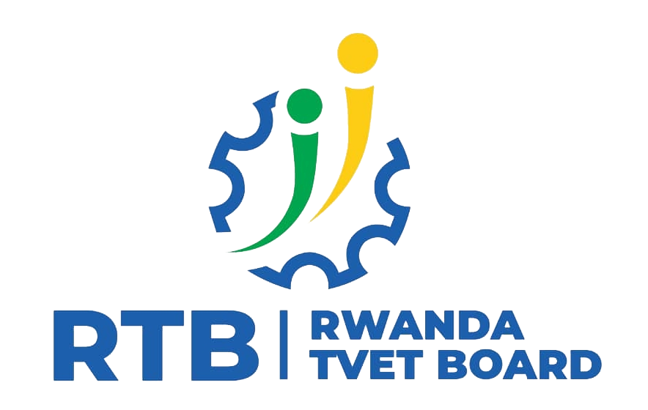

TRADE:SOFTWARAE DEVELOPMENT
Module name: Database server setup
MODULE CODE: SFDSS501
TEACHER’S GUIDE
RQF LEVEL 5

Table of content

Table of content 2
Acronyms 4
Introduction 5
Learning Unit 1: Describe database server concepts and standards 2
Learning outcome 1.1 Define database server terms 3
3
Indicative content 1.1.1: Define database server terms 3
Learning outcome 1.2 Describe database server architecture 8
Indicative content 1.2.1: Describe database server architecture 8
Learning outcome 1.3 Identify database server properties 12
Indicative content 1.3.1 : Identify database server properties 13
Learning Unit 2: Analyze database server requirements 16
Learning outcome 2.1 Explore organizational database 17
Indicative content 2.1.1: Explore organizational database 18
Learning outcome 2.2 Acquire database infrastructures 21
Indicative content 2.2.1: Acquire database infrastructures 22
Learning outcome 2.3 Select database server in line with customer needs 25
Indicative content 2.3.1: Select database server in line with customer needs 26
Learning Unit 3: Configure a database server 28
Learning outcome 3.1 Install a database server environment 28
Indicative content 3.1.1: Install a database server environment 29
Learning outcome 3.2: Backup and restore a database depending on business processes 58
Indicative content 3.2.1: Backup and restore a database depending on business processes 59
Learning outcome 3.3: Manage a database storage 62
Indicative content 3.3.1: Manage a database storage 63
Learning outcome 3.4: Upgrade and migrate a database server in accordance with business rules 66
Indicative content 3.4.1: Upgrade and migrate a database server in accordance with business rules 67
Learning Unit 4: Perform testing and documentation of work done 78
Learning outcome 4.1 Validate and test a database server 79
Indicative content 4.1.1: Validate and test a database server 80
Learning outcome 4.2: Document database server installation process review 84
Indicative content 4.2.1: Document database server installation process review 85
Learning outcome 4.3: Report procedures of the tasks accomplished in accordance with the installation to be done. 91
Indicative content 4.3.1: Report procedures of the tasks accomplished in accordance with the installation to be done 91
References: 96

Acronyms

- AMD: Advanced Micro Devices, Inc.
- API: Application Programming Interface
- BAK: Backup
- CD-ROM: Compact Disc-Read Only Memory
- CRUD: Create Read Update Delete
- DB: Database
- DBMS: Database Management System
- DDR4: Double Data Rate 4
- DMA: Data Migration Assistant
- DQS: Data Quality Services
- GB: Gigabyte
- Gbps: Gigabits per second
- HDD: Hard Disk Drive
- HTTP: HyperText Transfer Protocol
- LAN: Local Area Network
- Mbps: Megabits per second
- MDS: Master Data Services
- NAS: Network-attached storage
- NIC: Network Interface Card
- NoSQL: Not only SQL
- RAID: Redundant Array of Inexpensive/Independent Disks
- RAM: Random Access Memory
- RDBMS: Relational database management system
- RTDM: Run Time Database Manager
- SAN: Storage Area Network
- SAS: Serial-Attached SCSI
- SATA: Serial Advanced Technology Attachment
- SCSI: Small Computer System Interface
- SNMP: Simple Network Management Protocol
- SQL: Structured Query Language
- SSD: Solid-State Drive
- SSMS:SQL Server Management Studio
- SSMT:SQL Server Management Tools
- SSRS:SQL Server Reporting Services
- SSRS:SQL Server Reporting Services
- TB: Terabyte
- TCP/IP: Transmission Control Protocol/Internet Protocol
- USB: Universal Serial Bus
- VPN: Virtual Private Network
- Wifi: Wireless fidelity

Introduction

This module describes the skills, knowledge, and attitudes required to setup a database server, backup and restore a database, and migrate a database from one database server to another according to user needs.

Module Code and Title: SFDSS501 –DATABASE SERVER SETUP

Learning Units:
1.Describe database server concepts and standards
2.Analyze database server requirements
3.Configure a database server
4.Perform testing and documentation of work done
3
n

Learning Unit 1: Describe database server concepts and standards

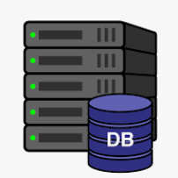

https://illustoon.com/?dl=7826

STRUCTURE OF LEARNING UNIT

Learning outcomes:
1.1 Define database server terms
1.2 Describe database server architecture
1.3 Identify database server properties

Learning outcome 1.1 Define database server terms

Duration: 5 hrs
Learning outline 1 objectives:
By the end of the learning outline, the trainees will be able to:
- define correctly the database server.
- differentiate correctly three types of application tiers.
- Outline three examples of types of database servers

Resources
Equipment | Tools | Materials
- Computers  - Projector | - DBMS | - Internet  - Electricity
Advance preparation:
. knowing the definition of server, DBMS




Indicative content 1.1.1: Define database server terms
 Summary for the trainer related to the indicative content (key notes using bullets such as ticks etc)

- Definitions of database servers

- Database server

A database server is a computer system that is dedicated to running database management software and serving data to other computers or applications over a network. It is designed to handle the storage, retrieval, and organization of large amounts of data and to provide controlled access to that data.

A database server typically runs a database management system (DBMS) that manages the database and provides tools for users to access and manipulate data.

- Application tiers

Application tiers refer to the logical layers or components that make up a multi-tiered software application. A multi-tiered application is an application that is divided into two or more logical layers, each of which provides a specific set of functions and services. These tiers are typically designed to work together to form a complete application.

The most common application tier model consists of three tiers: presentation, application, and data.

- The presentation tier, also known as the client tier, is responsible for presenting the user interface to the user. This tier typically consists of a web browser, mobile device, or desktop application that communicates with the application tier to retrieve and display data.

- The application tier, also known as the middle tier or logic tier, is responsible for processing and managing the application's business logic. This tier typically consists of one or more servers that receive requests from the presentation tier and communicate with the data tier to retrieve and store data.

- The data tier, also known as the database tier, is responsible for storing and retrieving data. This tier typically consists of a database server or servers that store the application's data and provide access to it through the application tier.

- Types of database servers

There are several types of database servers available, and they can be classified based on various criteria, such as data model, functionality, and deployment method. Here are some common types of database servers:

- Relational Database Server: This is the most common type of database server, which uses the relational model to store and manage data. Examples of relational database servers include Oracle, MySQL, SQL Server, and PostgreSQL.

- NoSQL Database Server: These database servers use non-relational data models to store and manage data. They are typically used for handling large amounts of unstructured or semi-structured data. Examples of NoSQL database servers include MongoDB, Cassandra, and Couchbase.

- Cloud Database Server: These database servers are deployed in the cloud and are managed by cloud service providers such as Amazon Web Services, Microsoft Azure, and Google Cloud Platform. They offer high scalability, availability, and flexibility to handle the increasing demands of modern applications.

- Object-Oriented Database Server: This type of database server stores and manages data as objects, rather than tables, which allows for better integration with object-oriented programming languages. Examples of object-oriented database servers include ObjectDB and Versant.

- In-memory Database Server: These database servers store and manage data in memory, rather than on disk, for faster access and processing. Examples of in-memory database servers include SAP HANA, Oracle TimesTen, and VoltDB.

- Graph Database Server: These database servers use graph-based data models to represent and manage data, making them suitable for handling complex relationships and networks. Examples of graph database servers include Neo4j, ArangoDB, and OrientDB.

- Database server responsibilities
- Client request handling
Client request handling refers to the process of managing and responding to requests made by client applications that are attempting to access or manipulate data stored in the database.

The client application sends a request to the database server, typically in the form of a query or command written in SQL or another database language. The database server then performs a series of steps to handle the request, including:

- Parsing the request: The database server reads the request and parses it to determine the intent of the request and the necessary resources needed to fulfil it.

- Query optimization: The database server optimizes the query by determining the most efficient way to retrieve the requested data. This may involve choosing the best indexes to use or optimizing the query execution plan.

- Executing the request: The database server executes the query or command, retrieves the requested data, and performs any necessary operations on it.

- Generating a response: The database server generates a response to the request, which may include the requested data or confirmation that the requested operation was successful.

- Sending the response: The database server sends the response back to the client application, which can then use the data or information provided by the response as needed.

- Database interaction
Data interaction refers to the process of accessing, modifying, and manipulating data stored in a database. This interaction can occur through various means, including client applications, queries, and commands.

Data interaction in a database server typically involves the following steps:

- Establishing a connection: A client application establishes a connection to the database server to access or manipulate data.

- Submitting a query or command: The client application sends a query or command to the database server, which instructs the server to perform a certain action, such as retrieving data, updating data, or deleting data.

- Processing the request: The database server processes the request, which may involve retrieving data from one or more tables, performing calculations or transformations on the data, or updating the data based on the command.

- Generating a response: The database server generates a response to the request, which typically includes the requested data or confirmation that the requested operation was successful.

- Sending the response: The database server sends the response back to the client application, which can then use the data or information provided by the response as needed.

- Client responses

Client response refers to the data or information that is returned to a client application after it submits a query or command to the database server.

The client response typically includes information about the success or failure of the request, as well as any data or results that were generated as a result of the query or command.

Theoretical learning Activity
- Brainstorm about database servers
- Group discussion about applications of a database server
Points to Remember (Take home message)
- Database server
- Presentation tier
- Application tier
- Data tier
- Relational Database Server
- NoSQL Database Server
- Cloud Database Server
- Object-Oriented Database Server
- In-memory Database Server
- Graph Database Server
- Data interaction

Learning outcome 1 formative assessment
Written assessment
Q1. Define the following terms.
- Application tiers
- Data interaction
Answer:
- Application tiers refer to the logical layers or components that make up a multi-tiered software application.
- Data interaction refers to the process of accessing, modifying, and manipulating data stored in a database.
Q2. Answer with True or False
- A database server is a computer system that is dedicated to running database management software and serving data to other computers or applications over a network.
- Example of relational database server is SQL Server.
- The presentation tier is also known as the application tier
Answer:
- A database server is a computer system that is dedicated to running database management software and serving data to other computers or applications over a network. True
- Example of relational database server is SQL Server. True
- The presentation tier is also known as the application tier. False
Q3. Outline three (3) examples of types of database servers.
Answer:
- Relational Database Server
- NoSQL Database Server
- Cloud Database Server
- Object-Oriented Database Server
- In-memory Database Server
- Graph Database Server

Learning outcome 1.2 Describe database server architecture
Duration: 5 hrs
Learning outline 2 objectives:
By the end of the learning outline, the trainees will be able to:
1. describe appropriately three types of database server architecture.
2. outline correctly two advantages of types of database server architecture.
3. outline correctly two disadvantages of types of database server architecture.
Resources
Equipment | Tools | Materials
- Computers  - Projector | - DBMS | - Internet  - Electricity  - Paper  - Pen
Advance preparation:
. knowing the definition of database sever
. having a computer

Indicative content 1.2.1: Describe database server architecture

Summary for the trainer related to the indicative content (key notes using bullets such as ticks etc)
- Description of types of database server architecture.

- Two tier/Client-Server Architecture
In this architecture, the database server is responsible for managing the data, while the client application handles the presentation logic and user interface. This architecture is more scalable and secure than the centralized architecture but requires more resources to maintain.

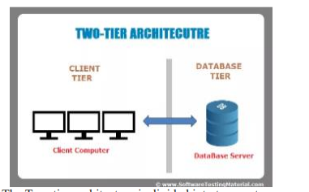

- Three-tier architecture
Three-tier architecture is a common type of database server architecture used in web-based applications. It consists of three layers or tiers:

- Presentation Tier or User Interface Tier: This tier is responsible for presenting data to users through a web browser or other client-side application. It includes web pages, forms, and other user interface components that allow users to interact with the application.
- Application Tier or Middle Tier: This tier is responsible for processing user requests, performing business logic, and accessing the database. It acts as an intermediary between the presentation tier and the data tier, processing user input and returning results to the presentation tier. This tier may include application servers, web servers, and other middleware components.
- Data Tier or Database Tier: This tier is responsible for storing and retrieving data from the database. It includes database servers, database management systems, and other data storage components. The data tier is responsible for maintaining the integrity of the data, enforcing business rules and constraints, and providing access to the application tier.

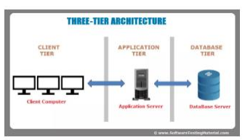

- N-tier architecture

N-tier architecture is a type of database server architecture that extends the three-tier architecture to include additional layers or tiers. In this architecture, each tier is responsible for a specific set of functions, and the tiers communicate with each other through well-defined interfaces.

Advantages and disadvantages of database server architecture

- Two tier/Client-Server Architecture
Advantages

- Centralized control: The server acts as a central point of control for the database, making it easier to manage and maintain the data.
- Scalability: The client-server architecture makes it easy to scale up the database system by adding more servers or clients as needed.
- Security: The server can enforce security policies, authentication, and access control, ensuring that only authorized users can access the database.
- Backup and recovery: With a centralized database, it is easier to backup and recovery data in case of a disaster or system failure.
Disadvantages

- Cost: Setting up and maintaining a client-server architecture can be costly, especially for small businesses with limited resources.
- Performance: Client-server architecture may result in slower response times, as the data has to travel between the client and the server over the network.
- Network dependency: The client-server architecture depends heavily on the network, and any issues with the network can affect the performance of the database system.
- Single point of failure: The server acts as a single point of failure, and if it goes down, the entire system may become inaccessible.
Advantages

- Scalability: Three-tier architecture allows for scalability by distributing the load among the tiers. As the number of users or requests increases, additional servers can be added to handle the load.

- Separation of concerns: By separating the presentation, application, and database layers, developers can focus on specific tasks and modify them independently without affecting the other layers.
- Security: Three-tier architecture provides a secure environment by ensuring that the database layer is protected from unauthorized access.
- Flexibility: Three-tier architecture allows for different components to be developed using different technologies, providing flexibility in development and implementation.

Disadvantages

- Complexity: Three-tier architecture adds complexity to the system, which may make it more difficult to design, develop, and maintain.
- Cost: Three-tier architecture requires more resources, such as additional servers and software, which may increase the cost of implementation and maintenance.
- Performance: Three-tier architecture may lead to slower response times due to the increased network traffic between the tiers.
- Network dependency: Three-tier architecture is highly dependent on the network, and any issues with the network can affect the performance of the database system.

Theoretical learning Activity
- Trainees will participate in group discussions to provide various database server architectures
Points to Remember (Take home message)
- Client-Server Architecture
- Three-tier architecture
- N-tier architecture

Learning outcome 2 formative assessment
Written assessment
Q1. Define the following term called N-tier architecture.
Answer:
N-tier architecture is a type of database server architecture that extends the three-tier architecture to include additional layers or tiers
Q2. Outline three (3) types of database server architecture.
Answer:
- Two tier/Client-Server Architecture
- Three-tier architecture
- N-tier architecture
Q3. Answer with True or False
- Database Tier is responsible for storing and retrieving data from the database.
- The client-server architecture makes it complex to scale up the database system by adding more servers or clients as needed.
- This architecture is more scalable and secure than the centralized architecture but requires more resources to maintain.
Answer:
- Database Tier is responsible for storing and retrieving data from the database. True
- The client-server architecture makes it complex to scale up the database system by adding more servers or clients as needed. False
- This architecture is more scalable and secure than the centralized architecture but requires more resources to maintain. False

Learning outcome 1.3 Identify database server properties
Duration: 5 hrs
Learning outline objectives:
By the end of the learning outline, the trainees will be able to:
- outline correctly four database server properties.
- define correctly the term filestream.

Resources
Equipment | Tools | Materials
- Computers  - Projector | - DBMS | - Internet  - Electricity
Advance preparation:
. knowing the definition of database sever
. having a computer

Indicative content 1.3.1 : Identify database server properties
Summary for the trainer related to the indicative content (key notes using bullets such as ticks etc)
- Identification of database server properties
- Property Grid
The Property Grid can be used to view and edit properties of the server instance or its components, such as databases, tables, and columns. For example, if you are using Microsoft SQL Server Management Studio, you can open the Property Grid for a database by right-clicking on the database in the Object Explorer and selecting "Properties."

In the Property Grid, you can view and modify properties such as the database name, collation, recovery model, and file locations.
- Memory requirements

A database server requires enough memory to store the database in memory, as well as to cache frequently accessed data and indexes. The more memory available, the more data that can be cached in memory, resulting in faster database access times.

- Processors
The server may be using a specific processor or a combination of processors, such as Intel Xeon or AMD EPYC.
- Server authentication
It is the process of verifying the identity of a database server before allowing clients to connect to it. This authentication process is important for ensuring the security and integrity of the data stored on the server.

There are different types of server authentication methods that can be used, including:

- Windows Authentication: This method uses the credentials of a Windows user account to authenticate the server. The user must have the necessary permissions to access the server.

- SQL Server Authentication: This method requires a username and password to authenticate the server. The credentials are stored in the server and verified against the user's input.

- Active Directory Authentication: This method uses Active Directory to authenticate the server. Users must have a valid Active Directory account and the necessary permissions to access the server.
- Connections

The connection property of a database server refers to the ability of a client application to establish a connection to the server in order to access the data stored on it. This property is essential for applications that require access to a database for retrieving, manipulating, and storing data.
- Database settings options

The database settings options of a database server refer to the various configurable options and settings that can be adjusted to optimize the performance, security, and reliability of the database server. These settings can be used to fine-tune the behaviour of the database server to meet the specific requirements of an application or organization.

Some common database settings options include:

- Buffer pool size: This option determines the amount of memory allocated to store data and index pages in memory to improve query performance.

- Backup and recovery settings: This option allows you to configure how often backups are taken, the types of backups performed, and how backups are stored and restored in case of data loss.

- Query optimization settings: This option provides options to tune the behavior of the query optimizer to improve query performance.

- Security settings: This option allows you to set permissions and access controls to ensure that only authorized users have access to the database server and data.
- High availability settings: This option provides options to configure replication, failover, and clustering options to ensure that the database server remains available and responsive even in the event of hardware or software failures.
- Logging and monitoring settings: This option provides options to monitor and log database activity, track performance metrics, and set up alerts for unusual activity or errors.

- Filestream
Filestream is a database server property that allows SQL Server to store and manage large binary data, such as documents, images, and video files, directly in the file system of the server. With filestream, the binary data is stored outside the database file and can be accessed and manipulated using standard Windows file system APIs.
- Database engine
The database engine is the core software component that manages the storage, retrieval, and manipulation of data within the database. The database engine is responsible for processing SQL queries, managing transactions, and enforcing data integrity rules.
At least one administrator account was selected when SQL Server was being installed. Perform the following step while logged into Windows as an administrator.

Theoretical learning Activity
- Ask trainees to brainstorm about database server properties within groups

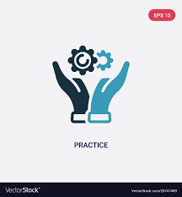Practical learning Activity
- Practical exercises to change database properties
Points to Remember (Take home message)
- Property Grid
- Processor
- Server authentication
- Connection
- Filestream
- Database engine

Learning outcome 3 formative assessment
Written assessment
Q1. What is database engine?
Answer:
The database engine is the core software component that manages the storage, retrieval, and manipulation of data within the database.
Q2. Explain four (4) common database settings options.
Answer:
- Buffer pool size: This option determines the amount of memory allocated to store data and index pages in memory to improve query performance.
- Backup and recovery settings: This option allows you to configure how often backups are taken, the types of backups performed, and how backups are stored and restored in case of data loss.
- Query optimization settings: This option provides options to tune the behavior of the query optimizer to improve query performance.
- Security settings: This option allows you to set permissions and access controls to ensure that only authorized users have access to the database server and data.
- High availability settings: This option provides options to configure replication, failover, and clustering options to ensure that the database server remains available and responsive even in the event of hardware or software failures.
- Logging and monitoring settings: This option provides options to monitor and log database activity, track performance metrics, and set up alerts for unusual activity or errors.
Q3. Which of the following are the right server processors?
- Intele Xeon
- Intel Xeon
- AMD EPYC
- AMD EPCY
Answer:
2)Intel Xeon
3)AMD EPYC
Please mix different assessment tools for triangulation and relevancy of assessment

Learning Unit 2: Analyze database server requirements

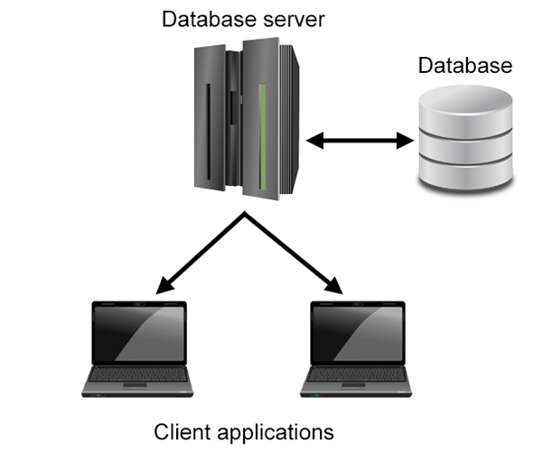

https://phoenixnap.com/kb/what-is-a-database-server

STRUCTURE OF LEARNING UNIT
Learning outcomes:
2.1 Explore organizational database
2.2 Acquire database infrastructures
2.3 Select database server in line with customer needs

Learning outcome 2.1 Explore organizational database

Duration: 2 hrs
Learning outcome 1 objectives:
By the end of the learning outcome, the trainees will be able to:
1. Explain clearly the priorities and confidentiality used in the organization information management policies
2. Explain clearly the current information flows as used in the organization information management policies
3. Explain clearly Risk assessment as used in the organization information management policies
4. Explain clearly the Information accessibility and Information distribution as used in the organization Information management policies
5. Explain properly the Monitoring procedures, Enforcement strategies, and Periodic progress review as used in the Exploration of system status.

Resources
Equipment | Tools | Materials
- Computers  - Projector | - Database server setup | - Electricity  - Internet  - Paper  - Pen
Advance preparation:
Trainer need to have the following elements:
- Database server setup,
- Computer
- Projector
- PPT

Indicative content 2.1.1: Explore organizational database

Summary for the trainer related to the indicative content (key notes using bullets such as ticks etc)

- Explanation of organization Information management policies

Organizations need to have well-defined policies for managing their information effectively. These policies should cover various aspects of information management, such as priorities, confidentiality, risk assessment, accessibility, and distribution. Let's take a closer look at each of these areas:

- Priorities and Confidentiality
Information management policies should prioritize data and information based on their importance to the organization. The policies should also define how confidential information is classified and protected from unauthorized access, use, or disclosure.

- Current Information Flows
It is essential to understand the current information flows within the organization, including how data is collected, processed, stored, and shared. Information management policies should provide guidelines for how information should be captured, processed, and used across different functions, departments, and systems.

- Risk Assessment
An essential component of information management policies is risk assessment, which involves identifying potential threats and vulnerabilities to information systems, data, and assets. Policies should provide guidelines for how to conduct risk assessments, how often they should be done, and how the organization should respond to identified risks.

- Information Accessibility
Information management policies should ensure that information is accessible to those who need it, when they need it, while still being protected from unauthorized access. This includes guidelines for granting access permissions, controlling access to sensitive information, and ensuring that information is available in formats that are usable by those who need it.

- Information Distribution
Information management policies should also cover the distribution of information, including how it is shared internally and externally. Policies should outline how information should be disseminated, who is authorized to share it, and how it should be shared securely.

- Exploration of system status

Exploration of a system refers to the process of understanding the various components, subsystems, and interactions that make up the system. This can involve studying the system's design, reviewing documentation and specifications, and analyzing the system's behavior under different conditions. The goal of exploration is to gain a comprehensive understanding of the system so that it can be effectively managed and optimized.

- Monitoring Procedures
Monitoring procedures involve monitoring the performance and health of a system in real-time. This can involve collecting data from various sensors and instruments, analyzing the data, and providing alerts or notifications when certain thresholds are exceeded. The goal of monitoring procedures is to detect and address issues as soon as possible, to prevent more serious problems from occurring.

- Enforcement Strategies
Enforcement strategies refer to the policies, procedures, and mechanisms in place to ensure that a system is being used and maintained according to its intended purpose. This can involve setting access controls and permissions, enforcing security policies, and implementing auditing and logging mechanisms. The goal of enforcement strategies is to ensure the system's reliability, security, and availability.

- Periodic Progress Review
Periodic progress reviews involve assessing the performance and effectiveness of a system at regular intervals. This can involve analyzing data on system usage, conducting surveys or interviews with users, and reviewing maintenance logs and other documentation. The goal of periodic progress reviews is to identify areas where the system can be improved, and to track progress towards achieving specific goals or objectives.

Theoretical learning Activity
- Group discussion on how an organization can keep information private

Practical learning Activity
- Practical exercises on system enforcement
Points to Remember (Take home message)
- Priorities and Confidentiality
- Current information flows
- Risk assessment
- Information accessibility
- Information distribution
- Monitoring procedures
- Enforcement strategies
- Periodic progress review

Learning outcome 1 formative assessment
Written assessment
Q1. Answer with True or False
- Current information flows within the organization, including how data is collected, processed, stored, and shared.
- Monitoring procedures involve monitoring the performance and health of a system in virtual-time.
- Periodic progress reviews involve assessing the performance and effectiveness of a system at regular intervals.
Answer:
- Current information flows within the organization, including how data is collected, processed, stored, and shared. True
- Monitoring procedures involve monitoring the performance and health of a system in virtual-time. False
- Periodic progress reviews involve assessing the performance and effectiveness of a system at regular intervals. True

Q2. What is the role of risk assessment in information management policies?
Answer:
It identifies the potential threats and vulnerabilities to information systems, data, and assets.

Please mix different assessment tools for triangulation and relevancy of assessment

Learning outcome 2.2 Acquire database infrastructures

Duration:5 hrs
Learning outcome 2 objectives:
By the end of the learning outcome, the trainees will be able to:
1. Define clearly the term database infrastructure
2. To know clearly how to acquire the Specifications of hardware components (like Servers, Storage subsystems, and Networking devices) as used in database infrastructures.
3. List properly the software components as used in the database infrastructures.
Resources
Equipment | Tools | Materials
- Computer  - Projector | - Database server setup | - Paper  - Pens  - Internet  - Electricity
Advance preparation:
Trainer need to have the following elements:
- Database server setup,
- Computer
- Projector
- PPT

Indicative content 2.2.1: Acquire database infrastructures
Summary for the trainer related to the indicative content (key notes using bullets such as ticks etc)
- Specifications of hardware components

Specifications of hardware components can vary widely depending on the specific manufacturer and model. However, I can provide some general information on each component :

- Servers
Servers are computers that are designed to handle specific tasks, such as hosting websites, running applications, or storing data. They typically have more powerful processors, larger amounts of memory (RAM), and larger storage capacities than standard desktop computers. Some common specifications of server hardware include:
- Processor: Intel Xeon or AMD EPYC
- Memory: 16 GB - 512 GB DDR4 RAM
- Storage: 1 TB - 24 TB HDD or SSD
- Network connectivity: Multiple Ethernet ports, typically 1 Gbps or higher
- Power supply: Redundant power supplies for increased reliability
- Form factor: Rackmount or blade servers for efficient use of space in data centers
- Storage subsystems
Storage subsystems are devices or systems that store and manage data. They can be used in servers, network-attached storage (NAS) devices, or storage area networks (SANs). Some common specifications of storage subsystems include:
- Disk type: Hard disk drive (HDD), solid-state drive (SSD), or hybrid drives
- Capacity: Usually measured in terabytes (TB)
- Interface: SATA, SAS, or NVMe for high-performance storage
- RAID support: Redundant Array of Independent Disks (RAID) provides data protection and/or increased performance
- Form factor: 2.5-inch or 3.5-inch drives, or M.2 cards for smaller form factors
- Encryption: Some storage subsystems support hardware encryption for increased security
- Networking devices
Networking devices are hardware components that enable devices to communicate with each other over a network. Some common networking devices include:
- Switches: Devices that connect devices within a local area network (LAN)
- Routers: Devices that connect networks and enable communication between them
- Firewalls: Devices that provide security by controlling access to a network
- Wireless access points: Devices that enable wireless devices to connect to a network
- Network Interface Cards (NICs): Devices that enable devices to connect to a network, either wired or wireless

Some common specifications of networking devices include:

- Number of ports: The number of devices that can be connected to the device
- Speed: Usually measured in megabits per second (Mbps) or gigabits per second (Gbps)
- Protocol support: The protocols that the device supports, such as Ethernet, Wi-Fi, or TCP/IP
- Security features: Firewalls, intrusion detection/prevention, or virtual private network (VPN) support
- Management features: Remote management, SNMP, or web-based management interfaces.

- Listing software components

- Procedures
Procedures are a type of program stored within the database that can be executed by the DBMS. They are used to automate tasks, enforce business rules, and ensure data integrity. Examples include stored procedures, triggers, and user-defined functions.

- Database Access Language

A database access language is a programming language used to access and manipulate data in the database. Examples include SQL (Structured Query Language), PL/SQL (Procedural Language/SQL), and T-SQL (Transact-SQL).

- Query Processor
The query processor is responsible for interpreting and optimizing queries written in the database access language. It analyzes the query and generates an execution plan that will retrieve the data as efficiently as possible.

- Run Time Database Manager
The Run Time Database Manager (RTDM) is a component of the DBMS that manages the execution of SQL statements and the interaction between the DBMS and the operating system. It is responsible for allocating memory, managing processes, and ensuring that the DBMS runs efficiently.

- Data Manager
The Data Manager is responsible for managing the storage of data in the database. It performs tasks such as creating, modifying, and deleting data files, and allocating storage space to the database.

These components work together to provide a comprehensive database infrastructure that can store, manage, and analyze large volumes of data.

Theoretical learning Activity
- Ask trainees to brainstorm about database server infrastructure within groups

Points to Remember (Take home message)
- Server
- Processor
- Memory
- Storage
- Power supply
- Disk type
- Capacity
- Firewalls
- Network Interface Cards (NICs)
- Database Access Language
- Query Processor
- Run Time Database Manager
- Data Manager

Learning outcome 2 formative assessment
Written assessment
Q1. Write in full words the following terms:
- GB
- RAM
- HDD
- SAN
- RAID
Answer:
- GB : Gigabytes
- RAM : Random Access Memory
- HDD : Hard disk drive
- SAN : Storage area network
- RAID : Redundant Array of Independent Disks
Q2. List down four (4) software components of database server.
Answer:
- Procedures
- Database Access Language
- Query Processor
- Run Time Database Manager
- Data Manager
Q3. Answer True or False
- A database access language is a programming language used to access and manipulate data in the store.
- The query processor is responsible for interpreting and optimizing queries written in the database access language.
- The Run Time Database Manager is a component of the DBMS that manages the execution of SQL statements and the interaction between the DBMS and the operating system.
Answer:
- A database access language is a programming language used to access and manipulate data in the store. False
- The query processor is responsible for interpreting and optimizing queries written in the database access language. True
- The Run Time Database Manager is a component of the DBMS that manages the execution of SQL statements and the interaction between the DBMS and the operating system. True
Please mix different assessment tools for triangulation and relevancy of assessment

Learning outcome 2.3 Select database server in line with customer needs

Duration:3 hrs
Learning outcome 3 objectives:
By the end of the learning outcome, the trainees will be able to:
1. Select properly the speed of database server in line with customer needs
2. Select properly the Reliability of database server in line with customer needs
3 Select properly the Market price of database server in line with customer needs.
4. Select properly the Storage and manipulation of database server in line with customer needs
Resources
Equipment | Tools | Materials
- Computer  - Projector | - Database server setup | - Paper  - Pens  - Internet  - Electricity
Advance preparation:
. Database server setup
. Computer
. Projector
.PPT

Indicative content 2.3.1: Select database server in line with customer needs
Summary for the trainer related to the indicative content (key notes using bullets such as ticks etc)

- Choose of database server to install
Choosing a database server depends on a variety of factors, including the specific needs and requirements of the user. Here are a few popular options based on the criteria you mentioned:

- Speed
If speed is a primary concern, then you might consider using an in-memory database like Redis. In-memory databases store data in RAM, which allows for very fast read and write speeds. Other options for high-speed databases include Apache Cassandra and Apache Ignite.

- Reliability
For reliability, a popular choice is PostgreSQL. It is known for its stability and robustness, and is widely used in production environments. MySQL is another reliable option, and it is commonly used in web applications and other high-traffic environments.

- Market Price
For a free and open-source database server, PostgreSQL and MySQL are both popular options. However, there are also commercial options available that may come with additional features and support, such as Microsoft SQL Server or Oracle Database.

- Data Analysis
If data analysis is a primary concern, you may want to consider a database server that supports analytical processing and querying, such as Apache Hive or Apache HBase. Another option is Apache Cassandra, which is designed for high-speed, high-volume data ingestion and querying.

- Storage and Manipulation
If you need to store and manipulate large amounts of data, then you might consider using a distributed database like Apache Hadoop or Apache Spark. These systems are designed to handle large-scale data processing and storage, and can be used for a variety of applications. Other options for large-scale data storage and manipulation include MongoDB and Amazon DynamoDB.

Ultimately, the choice of database server will depend on your specific needs and requirements. Consider factors like data volume, performance needs, reliability, cost, and feature set when making your decision.

Theoretical learning Activity
- Ask trainees to brainstorm about qualities of a database server within groups
Points to Remember (Take home message)
- Speed
- Reliability
- Market price
- Data analysis
- Storage

Learning outcome 3 formative assessment
Written assessment
Q1. What are four (4) elements to consider when you are installing database server?
Answer:
- Speed
- Reliability
- Market price
- Data analysis
- Storage
Q2. Choose the right database server of high-speed databases.
- MS Access
- Apache Cassandra
- MySQL
- MS Excel
Answer:
b) Apache Cassandra
Please mix different assessment tools for triangulation and relevancy of assessment

Learning Unit 3: Configure a database server

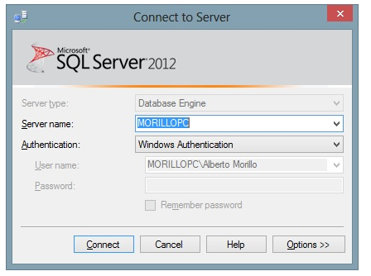
https://sqlcoffee.com/SQLServer2012_0010.htm

STRUCTURE OF LEARNING UNIT
Learning outcomes:
3.1 Install a database server environment
3.2 Backup and restore a database depending on business processes
3.3 Manage a database storage
3.4 Upgrade and migrate a database server in accordance with business rules

Learning outcome 3.1 Install a database server environment
Duration: 5 hrs
Learning outcome 3 objectives:
By the end of the learning unit, the trainees will be able to:
1.Identify properly database servers as used in the database server Installation.
2. Differentiate correctly local database server from remote database server.
3. Install properly the database server.
Resources
Equipment | Tools | Materials
- Computers  - Projector  - Server | - Database server setup  - Storage media | - Electricity  - Internet
Advance preparation:
- Database server setup
- Computers
- Projector
- Internet
- Books
- Storage media

Indicative content 3.1.1: Install a database server environment
Summary for the trainer related to the indicative content (key notes using bullets such as ticks etc)

- Identification of database servers

In a database server environment, there are two types of servers: local and remote.

- A local database server
It is installed on the same physical machine as the application that uses it. This type of database server is often used in smaller environments, where the application and the database are not very complex and there are not many users.

- A remote database server

It is installed on a separate machine, usually located in a data center. This type of database server is used in larger environments, where there are multiple applications and/or users that need to access the database. The remote database server can be accessed via a network connection, such as TCP/IP or HTTP.

To identify the database servers in a database server environment, you can check the installation documentation or configuration files of the applications that use the database. These files typically contain information about the database server's location, IP address, port number, and other settings. Additionally, you can use tools like network scanners or port scanners to detect open ports on machines that might be running database servers.

- Installation of database server

- Download the database server installation files from the vendor's website. Here we are installing Microsoft SQL Server 2012.
- Run the installation wizard, which will guide you through the installation process. The wizard will typically include the following steps:

Insert the SQL Server installation media. From the root folder, double-click Setup.exe. To install from a network share, locate the root folder on the share, and then double-click Setup.exe:
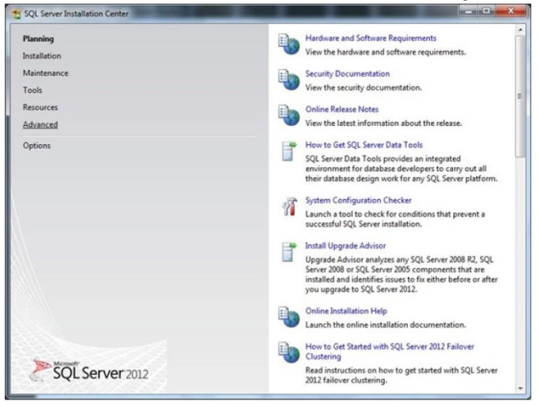
The Installation Wizard runs the SQL Server Installation Center. To create a new installation of SQL Server, select the Installation option on the left side, and then click New SQL Server stand-alone installation or add features to an existing installation:
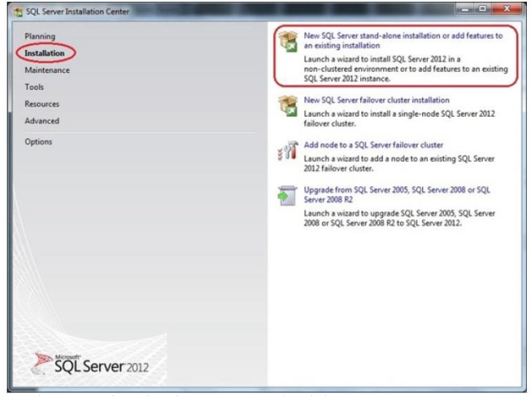

Setup is now preparing to launch Setup Support Rules window:

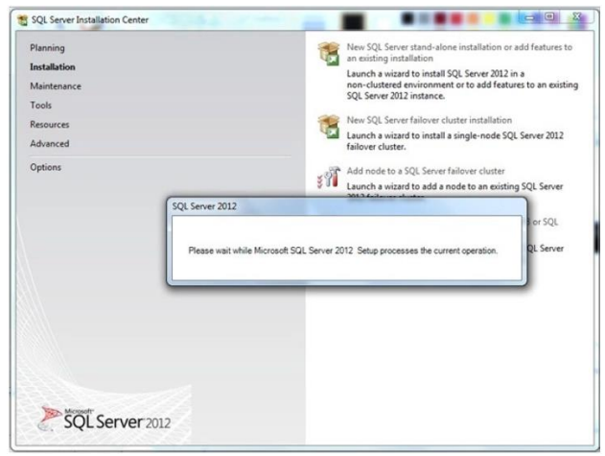

Now Setup Support Rules will run to identify problems that may occur during the Setup Support Files installation:

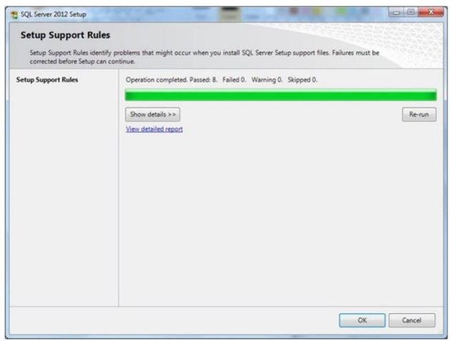

Once this step finishes click OK to proceed to Product Key window, In the Product Key window, enter the Product license key (if required), and click Next to continue:
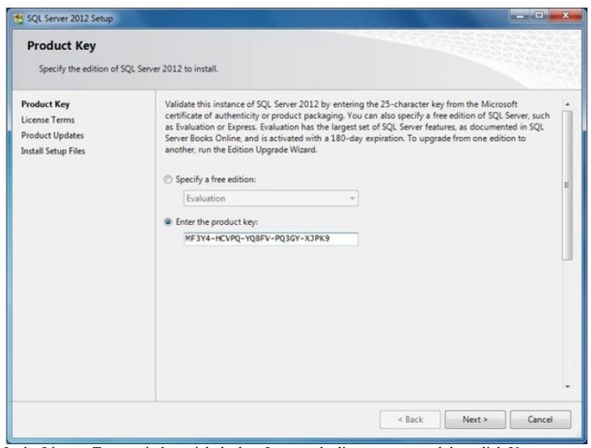

In the License Terms window, tick the box I accept the license terms and then click Next to continue:
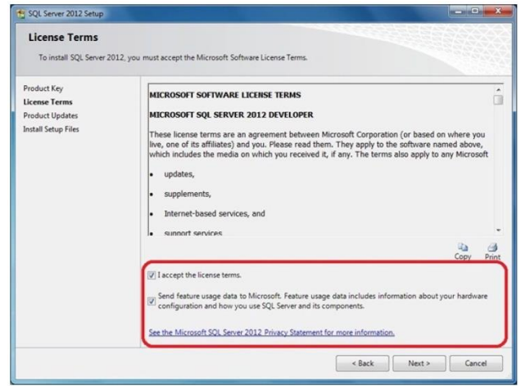

Note: You must accept the license agreement before you can continue the installation of SQL Server 2012. Send feature usage data to Microsoft option is optional. Click Next and then click Install to Install Setup Files:

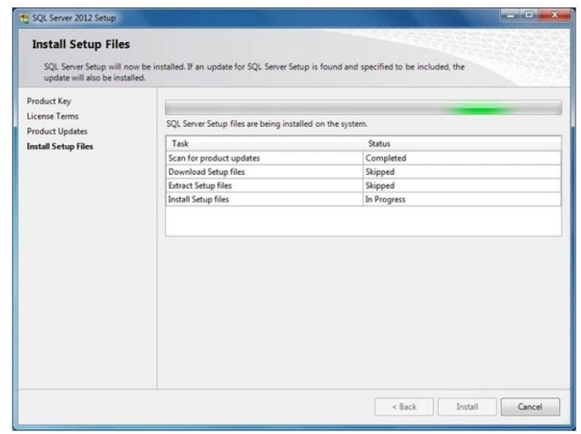

These files are necessary to perform the actual installation. Following the installation of the setup support files, you will be presented with another compatibility check. Following dialog appears once you successfully pass these checks. You can click the Show Details button under the green progress bar if you want to see the individual checks listed:

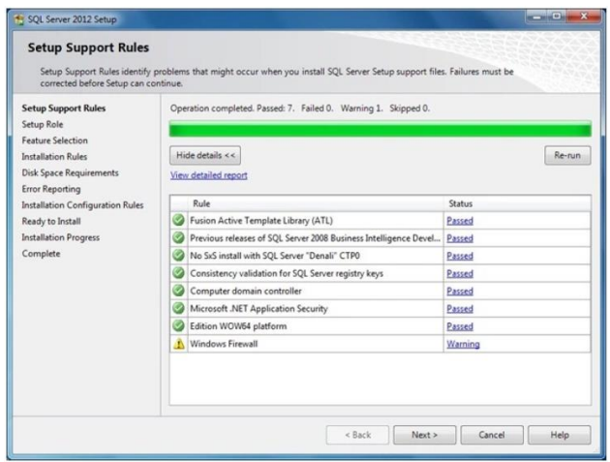

Click Next to continue to the Setup Role page:
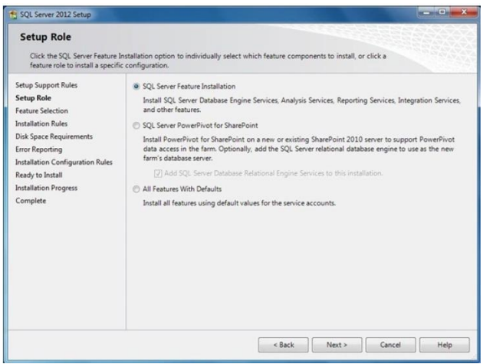

Select SQL Server Feature Installation option and then Next to continue to Feature Selection page:
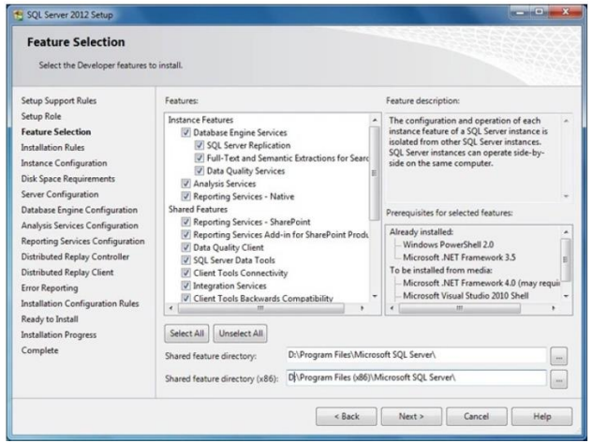

I’m going to select all features so that we can walk through a complete installation process. This will install the Database Engine Services, Analysis Services, Reporting Services, and a number of shared features including SQL Server Books Online. You can also specify the shared feature directory where share features components will be installed. Click Next to continue to the Installation Rules page, Setup verifies the system state of your computer before Setup continues:

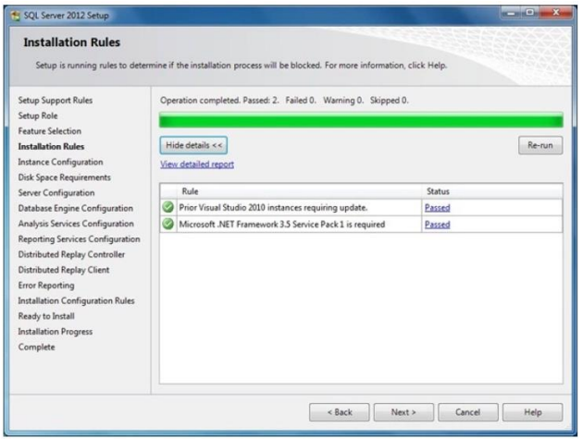

Click Next to continue to the Instance Configuration page. Each server machine can host one default instance of SQL Server, which resolves to the server name, and multiple named instances, which resolves to the pattern ServerName\InstanceName. In this sample installation, I will install a named instance of SQL Server 2012 called DEV01:

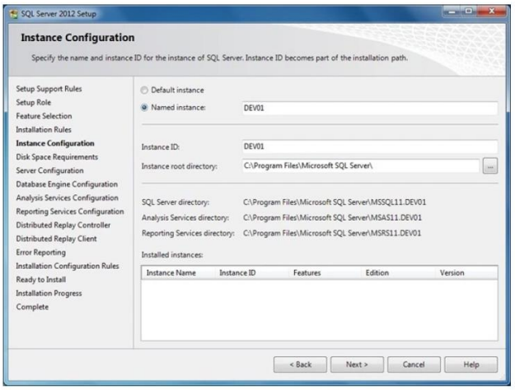

Note: This screen also report on other instances installed on this machine. Click Next to proceed to the Disk Space Requirements page:

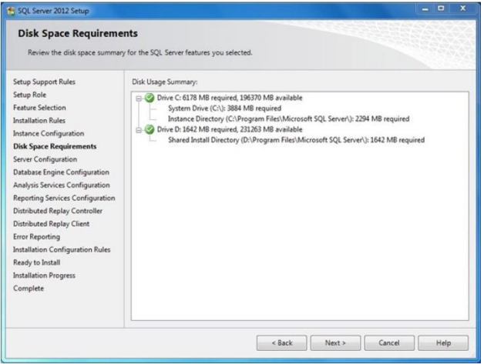

This is just an information page that does not require you to make any choices. Click Next to go to Server Configuration page:

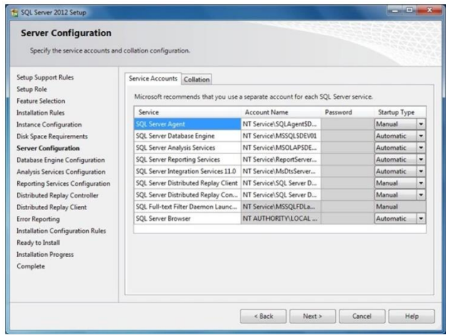

Here you specify service start-up and authentication. Microsoft recommends that each service account have separate user accounts as a security best practice as shown in the following figure:

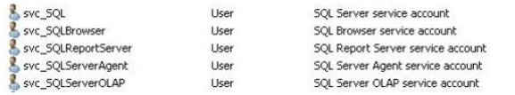

The SQL Server 2012 Books Online makes the following security recommendations:
- Run separate SQL Server services under separate Windows accounts.
- Run SQL Server services with the lowest possible privileges.
- Associate SQL Server services with Windows accounts.
- Require Windows Authentication for connections to the SQL Server.
For the purposes of this article, we will authenticate all services using LocalSystem account. You may have noticed the Collation tab here in this page. Click Collation tab and then click Customize button to specify the collation for your Database Engine and Analysis Services instance that best matches your application need:

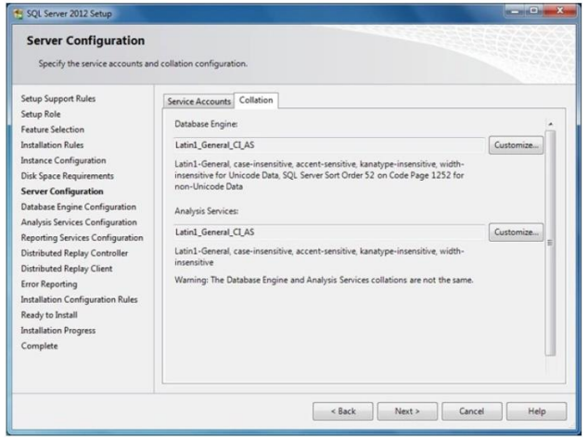

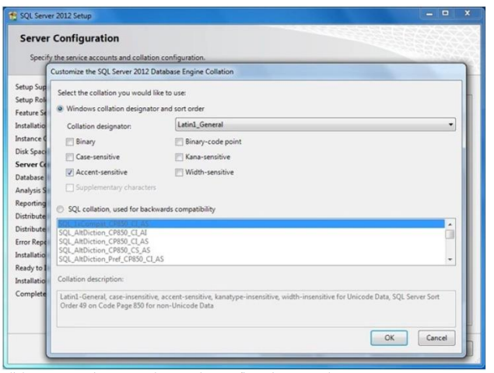

Click Next to continue to Database Engine Configuration page. The SQL Server 2012 authentication mode was configured for “Windows Authentication Mode” per Microsoft security best practice. For the purposes of this article, I will be choosing “Mixed Mode Authentication”. You will also need to specify the SQL Server administrators to be used; in this example I will use the current logged in user by clicking Add Current User button:

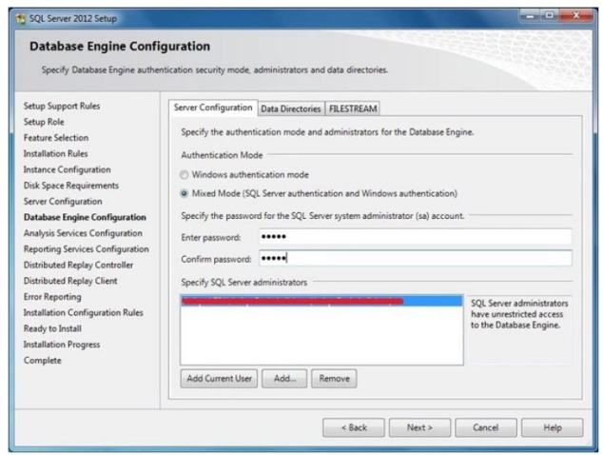

Click Data Dictionary tab and specify default database, log, backup, and tempdb locations:

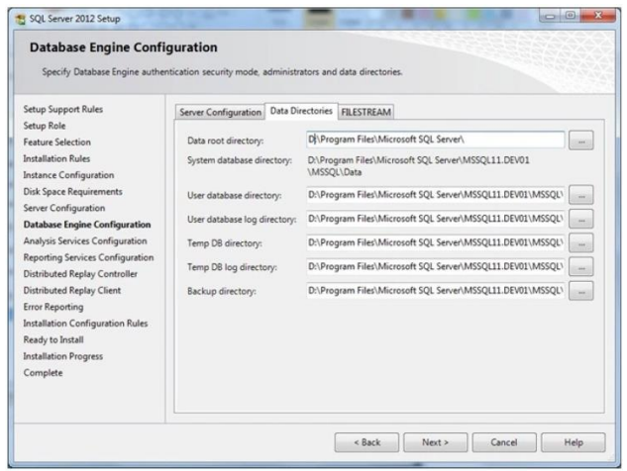
Click FILESTREAM tab and enable this feature as below:

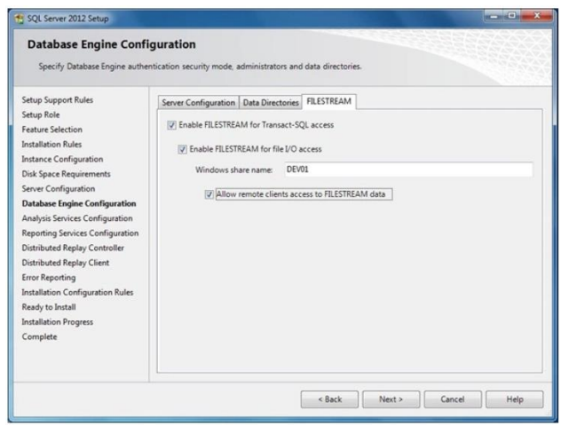
FILESTREAM feature is quiet useful when binaries or other data that does not fit neatly in a table structure. Click Next to proceed to Analysis Services Configuration page, this is similar to Database Engine Configuration page. Specify users or accounts that will have administrator permissions for Analysis Services in Account Provisioning page and specify non-default installation directories in Data Directories page:

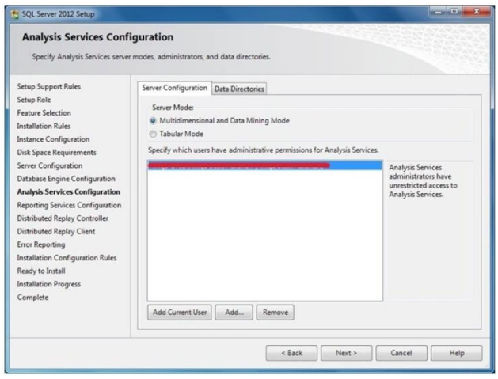

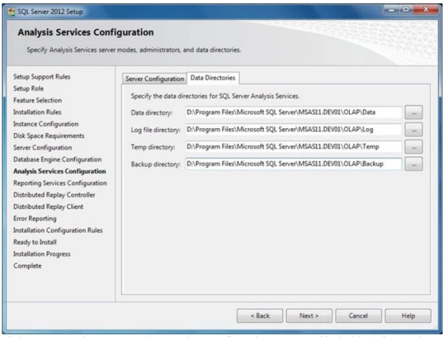

Click Next to continue to Reporting Services Configuration page, specify the kind of Reporting Services installation to create. For the purpose of this article, I will use Install and Configure option:

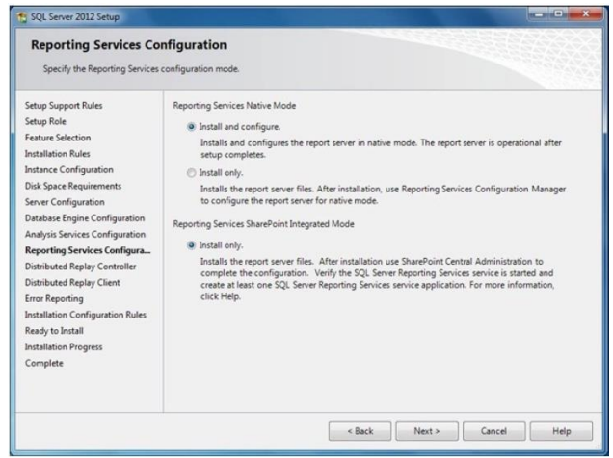

For more information about Reporting Services configuration modes and the options we have, see Reporting Services Configuration Options (SSRS). Click Next to proceed to Distributed Replay Controller page, specify the users you want to grant administrative permissions to for the Distributed Replay controller service and then click Next to continue:

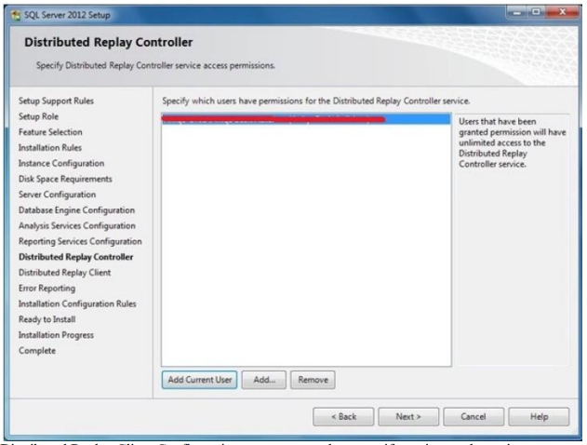
Distributed Replay Client Configuration page appears, here specify setting as shown in next figure:

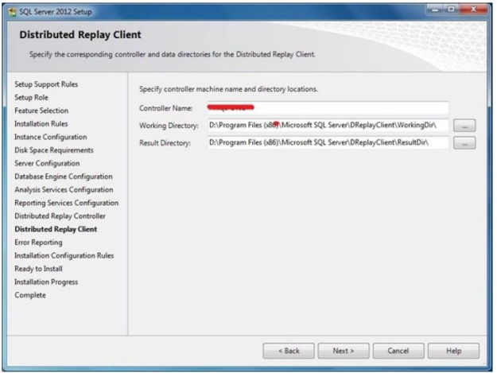

Click Next to advanced to Error Reporting page, tick the check box if you want to send Windows and SQL Server error reports to Microsoft:

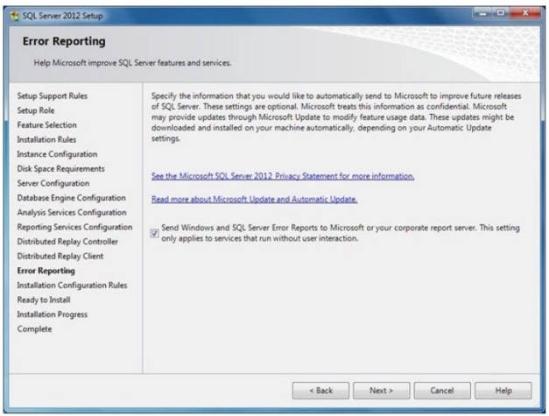

Click Next, Now System Configuration Checker will run some more rules that will validate your computer configuration with the SQL Server features you have specified:

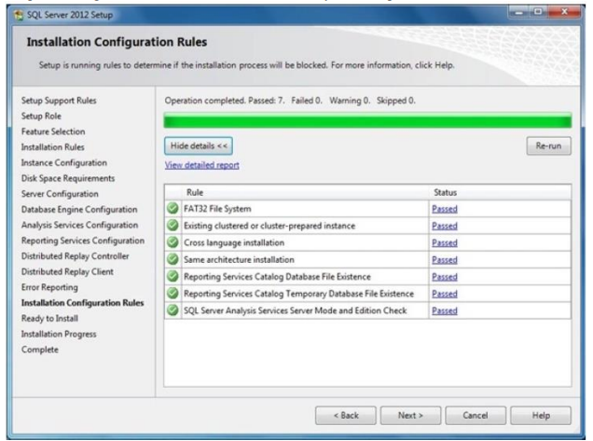

Correct any errors reported in the Installation Rules screen and click on Next to advanced to Ready to Install page. This page shows a tree view of installation options that were specified during Setup. On this page, Setup indicates whether the Product Update feature is enabled or disabled and the final update version:

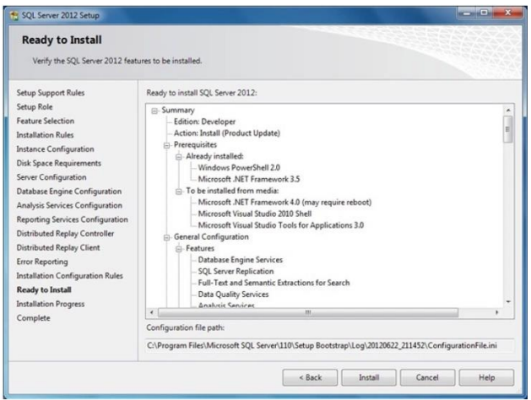

Click Install button to start SQL Server 2012 installation. The Setup will first install the required prerequisites for the selected features followed by the feature installation. The Installation Progress page provides status so that you can monitor installation progress as Setup continues:

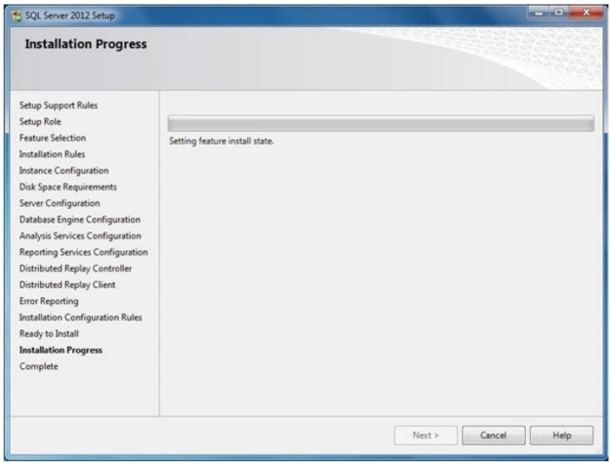

When the installation is complete, click on Next to Complete page:
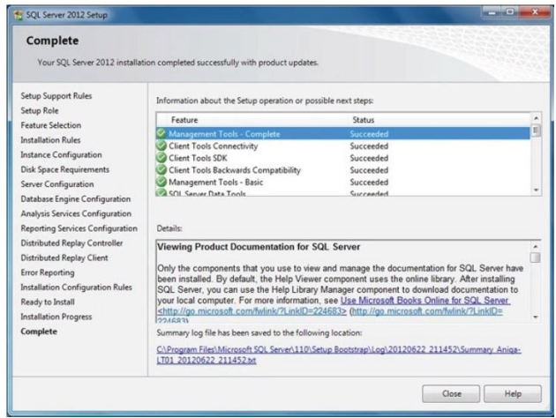

Click on the link to review the installation log if appropriate, and then click on Close. This finalizes the installation process for SQL Server 2012.

Theoretical learning Activity
- Ask trainees to brainstorm about local and remote database servers

Practical learning Activity
- Trainees will be given practical exercises to install SQL server
Points to Remember (Take home message)
- Local database server
- Remote database server
- Product key

Learning outcome 1 formative assessment
Written assessment
Q1. Differentiate local database server from remote database server.
Answer:
A local database server is a database server that is installed and runs on the same machine as the client application. This means that the database is stored on the same computer as the application that uses it, and both are accessed through the same network interface. The database server software is installed and configured locally, and the application connects to it via a local network or through the loopback interface while
A remote database server is a database server that is installed on a different machine than the client application. This means that the database is physically located on a different server machine and is accessed through the network. The database server software is installed, configured, and maintained on a remote machine, and the application connects to it over a network connection such as the Internet.
Q2. Which of the following is an open-source, relational database management system widely used for web applications?
a) Oracle Database
b) Microsoft SQL Server
c) MongoDB
d) MySQL
Answer:
d) MySQL
Please mix different assessment tools for triangulation and relevancy of assessment
Practical assessment
- Task to be performed
NYCT Ltd. is one of countrywide Construction Company. The company has a problem of having a centralized database server to manage employees and their payrolls, business project contracts and assets.
As a database developer, you are hired to setup a SQL server 2016 version 13.0.1601.5 on the following environment:
  - Operating System: Windows server 2016
  - RAM: 8GB
  - Processor: 1.4 GHz 64-bit processor
  - Compatible with x64 instruction set
  - Supports NX and DEP
  - Supports CMPXCHG16b, LAHF/SAHF, and PrefetchW
  - Supports Second Level Address Translation (EPT or NPT)
The task must be completed in 1hours.
- Observation checklist
Checklist | Score
 | Yes | No
Indicator: Tools, equipment and materials are selected
Tools
- SQL server setup
- Version
- Operating system
- RAM
- Processor
Materials
- SQL server deployment DVD
Equipment
- Computer
Indicator:SQL server is installed
- Features and services
- Properties
- Storage
Indicator: Database server is installed
- Responsiveness
- Run
Observation

Learning outcome 3.2: Backup and restore a database depending on business processes

Duration: 8 hrs
Learning outcome 2 objectives:
By the end of the learning outcome, the trainees will be able to:
1. Describe clearly the types of backups depending on business processes.
2. Identify properly the backup devices and media depending on business processes
3. Backup and restore a database depending on business processes.
Resources
Equipment | Tools | Materials
- Computers  - Projector  - Server | - Database server setup  - Storage media | - Electricity  - Internet
Advance preparation:
- Database server setup
- Computers
- Projector
- Internet
- Books
- Storage media

Indicative content 3.2.1: Backup and restore a database depending on business processes
Summary for the trainer related to the indicative content (key notes using bullets such as ticks etc)
- Description of types of backups

- Full Backup

A full backup is a complete backup of all data and files in a particular system, database or device. It captures everything, including data, files, settings, configurations, operating system files, and more. Full backups are typically performed on a regular schedule, such as daily or weekly, to ensure that all data is captured.

- Incremental Backup

An incremental backup is a backup of only the data that has changed since the last backup, whether it was a full or incremental backup. It saves time and storage space by backing up only the data that has changed, instead of performing a full backup each time. Incremental backups are usually faster than full backups and require less storage space.

- Differential Backup

A differential backup is similar to an incremental backup in that it only backs up data that has changed since the last full backup. However, it differs in that it backs up all data that has changed since the last full backup, not just the changes since the last backup. This can make differential backups larger and slower than incremental backups, but they can be faster to restore since only the last full backup and the last differential backup need to be restored.

- Mirror Backup

A mirror backup, also known as a "clone," is a complete and exact copy of a system, device, or database. It mirrors all data and files, including settings, configurations, and operating system files. A mirror backup is useful for creating an identical copy of a system, which can be used as a failover or disaster recovery solution. It can be a time-consuming and resource-intensive process, as it creates a duplicate of all data and files.

- Identification of backup devices and media

Backup devices and media are used to store important data in case of a system failure, disaster or data loss. Here are some commonly used backup devices and media :

- Magnetic tapes
Magnetic tapes are one of the oldest and most reliable forms of backup storage. They use a magnetic coating to store data and are capable of storing large amounts of data. Magnetic tapes are ideal for long-term storage and can withstand high temperatures and humidity.

- Disk drives
Disk drives are one of the most commonly used backup devices today. They use magnetic disks to store data and are available in various sizes and storage capacities. Disk drives are easy to use, provide quick access to data, and are relatively inexpensive.

- CD-ROM
CD-ROMs are a popular choice for backing up data due to their low cost, portability, and ease of use. They are suitable for storing small amounts of data and are ideal for archiving purposes.

- Solid state storage
Solid state storage devices, such as USB flash drives, are becoming increasingly popular for backup storage due to their small size, portability, and high storage capacity. They use flash memory to store data and are very durable, making them ideal for transporting data between locations.

When choosing a backup device or media, it is important to consider the storage capacity, speed, durability, and cost. It is also important to choose a backup device that is compatible with your computer system and backup software.

- Backup and restore a database

- To backup a database in SQL Server, you can follow these steps:

- Open SQL Server Management Studio and connect to the SQL Server instance where the database you want to backup is located.
- In the Object Explorer pane, expand the Databases node to display a list of all databases on the server.
- Right-click on the database that you want to backup and select Tasks > Backup from the context menu. This will open the Backup Database window.
- In the Backup Database window, choose the type of backup you want to perform, such as Full or Differential.
- Select a backup destination, such as a disk file or a tape drive.
- Specify any backup options you want to use, such as compression or encryption.
- Click the OK button to start the backup process.
- To restore a database from a .BAK file, you can follow these steps:

- Open SQL Server Management Studio and connect to the SQL Server instance where you want to restore the database.
- In the Object Explorer pane, right-click on the Databases node and select Restore Database from the context menu. This will open the Restore Database window.
- In the Restore Database window, specify the source of the backup by selecting the Device option and clicking the ellipsis button to browse to the .BAK file.
- Select the backup sets to restore from the backup file.
- Choose the destination database for the restore operation.
- Specify any restore options you want to use, such as overwriting an existing database or preserving the original file paths.
- Click the OK button to start the restore process.

Theoretical learning Activity
- Brainstorm about different types of database backup
- List backup devices and media
Practical learning Activity
- Trainees will be given practical exercises to backup and restore a database
Points to Remember (Take home message)
- Full Backup
- Incremental Backup
- Differential Backup
- Mirror Backup
- Restore
- Magnetic tapes
- Disk drives
- CD-ROM
- Solid state storage

Learning outcome 2 formative assessment
Written assessment
Q1. Which of the following is a type of backup that copies all data and marks the files as backed up?
a) Differential backup
b) Full backup
c) Incremental backup
d) Mirror backup
Answer:
b) Full backup
Q2. Which type of backup copies only the data that has changed since the last full or incremental backup?
a) Differential backup
b) Full backup
c) Incremental backup
d) Mirror backup
Answer:
c) Incremental backup
Q3. Outline four (4) backup devices and media.
Answer:
- Magnetic tapes
- Disk drives
- CD-ROM
- Solid state storage
Please mix different assessment tools for triangulation and relevancy of assessment
Practical assessment
- Assessment tools
- Task to be performed

X Ltd is a data collection company. The company has a problem of losing some data, as a database developer, you are hired to backup and restore those lost data by using SQL server management studio.
- Observation checklist
Checklist | Score
 | Yes | No
- SQL server management studio is opened
- Database is selected
- Type of backup is selected
- Back up database is done
- Restore a database is completed
Observation

Learning outcome 3.3: Manage a database storage

Duration:4 hrs
Learning outcome 3 objectives:
By the end of the learning outcome, the trainees will be able to:
1. Define clearly the term database storages as used in database storage management
2. Identify properly the database storages as used in database storage management
3. Differentiate clearly database storages as used in database storage management
Resources
Equipment | Tools | Materials
- Computers  - Projector  - Server | - Storage media | - Electricity  - Internet
Advance preparation:
- Computers
- Projector
- Internet
- Books
- Storage media

Indicative content 3.3.1: Manage a database storage
Summary for the trainer related to the indicative content (key notes using bullets such as ticks etc)

- Identify database storages

- Table spaces
A table space is a logical storage unit within a database that is used to group related objects together. Each table space consists of one or more data files.

- Temporary table space groups
A temporary table space group is a collection of temporary table spaces that are used for sorting and other temporary storage needs.

- Data files
A data file is a physical file that stores the data for a database object, such as a table or index.

- Rollback segments
Rollback segments are used to maintain the consistency of a database by providing a way to undo changes made to the database. They are used to support transactions and are typically created in the temporary table space.

- Redo log groups
A redo log group is a set of one or more redo log files that record changes to the database. Redo logs are used to recover data in the event of a system failure.

- Disk groups
A disk group is a collection of physical disks that are managed as a single logical unit. Disk groups are used to store database files and provide redundancy and performance benefits.

- Archive logs
Archive logs are copies of the redo log files that have been archived and stored for future use. They are used to recover data in the event of a disaster or other catastrophic event.

Theoretical learning Activity
- Brainstorm about database storages
Practical learning Activity
- Trainees will conduct practical exercises on database storage properties
Points to Remember (Take home message)
- Table spaces
- Temporary table space groups
- Data files
- Rollback segments
- Redo log groups
- Disk groups
- Archive logs

Learning outcome 2 formative assessment
Written assessment
Q1. Define the following terms:
- Data file
- Redo log group
- Disk group
Answer:
- Data file is a physical file that stores the data for a database object, such as a table or index.
- Redo log group is a set of one or more redo log files that record changes to the database. Redo logs are used to recover data in the event of a system failure.
- Disk group is a collection of physical disks that are managed as a single logical unit.
Q2. What is the purpose of a rollback segment?
a) To store temporary data for a transaction
b) To store a log of all database changes
c) To store data backups
d) To store undo information for a transaction
Answer:
d) To store undo information for a transaction
Q3. What is a tablespace in a database?
a) A collection of tables and indexes that belong to the same schema
b) A logical storage unit that contains one or more data files
c) A physical storage unit that contains database objects
d) A backup copy of the database stored on disk
Answer:
b) A logical storage unit that contains one or more data files
Please mix different assessment tools for triangulation and relevancy of assessment

Learning outcome 3.4: Upgrade and migrate a database server in accordance with business rules

Duration:8hrs
Learning Outcome 4 objectives:
By the end of the learning outcome, the trainees will be able to:
1.Apply properly the database Version and edition upgrades in accordance with business rules
2. Apply properly the data migration assistant in accordance with business rules
3. Upgrade properly the database engine in accordance with business rules

Resources
Equipment | Tools | Materials
- Computers  - Projector  - Server | - Database server setup  - Storage media | - Electricity  - Internet
Advance preparation:
- Database server setup
- Computers
- Projector
- Internet
- Books
- Storage media

Indicative content 3.4.1: Upgrade and migrate a database server in accordance with business rules
Summary for the trainer related to the indicative content (key notes using bullets such as ticks etc)
- Application for database upgrade and migration

- Version and edition upgrades

A version upgrade involves upgrading the version of the database software to a newer version. This typically involves installing a new version of the database software on the server and migrating the data to the new version. For example, upgrading from Microsoft SQL Server 2016 to Microsoft SQL Server 2019 would be a version upgrade. Version upgrades often include new features and functionality, improved performance, and bug fixes.

An edition upgrade involves upgrading the edition of the database software to a higher edition. This typically involves upgrading to an edition of the database software that offers additional features or functionality. For example, upgrading from Microsoft SQL Server Standard Edition to Microsoft SQL Server Enterprise Edition would be an edition upgrade. Edition upgrades often include additional features such as advanced security, high availability, and scalability.

It is important to note that version and edition upgrades can be complex and may require careful planning and testing to ensure that the upgrade is successful and minimizes downtime and disruption to the business. It is important to thoroughly review the documentation and upgrade guides provided by the database software vendor before proceeding with an upgrade. Additionally, it may be beneficial to engage with a qualified database administrator or consultant to assist with the upgrade process.

- Using data migration assistant

The Data Migration Assistant (DMA) is a tool provided by Microsoft that can be used to assess and migrate databases to a newer version of SQL Server or Azure SQL Database. Here are the general steps for using the DMA tool to migrate a database:

Download and install the DMA tool:
First, download and install the DMA tool from the Microsoft website.

Create a new DMA project:
Open the DMA tool and create a new project. Enter the name of the project, select the type of migration, and specify the source and target database information.

Run the assessment:
Once you have created the project, run the assessment. The DMA tool will analyze the source database and identify any compatibility issues or potential problems that may arise during the migration process.

Resolve any issues:
If the assessment identifies any issues or problems, review the recommendations provided by the DMA tool and take the necessary steps to resolve them. This may involve updating the database schema, modifying the application code, or changing the database settings.

Run the migration:
Once you have resolved any issues identified by the DMA tool, you can run the migration process. The DMA tool will migrate the schema, data, and other database objects to the target database.

Verify the migration:
After the migration is complete, verify that the target database is functioning correctly and that all data has been transferred successfully.

The DMA tool provides a user-friendly interface and detailed documentation to guide you through the migration process. However, it is important to thoroughly review the documentation and understand the migration process before proceeding to ensure a successful migration.

- Upgrade analysis services

Analysis services is a business intelligence and data analytics platform provided by Microsoft as part of the SQL Server product suite. Upgrading analysis services involves migrating from an older version of Analysis Services to a newer version, which can provide access to new features and capabilities, improved performance, and bug fixes.

The Upgrade Analysis Services process involves the following steps:

- Review the upgrade documentation: Before upgrading Analysis Services, it is important to review the upgrade documentation provided by Microsoft. The documentation will provide guidance on the upgrade process and highlight any potential issues that may arise during the upgrade.

- Test the upgrade process: Before upgrading the production environment, it is recommended to test the upgrade process in a test environment to ensure a smooth transition.

- Back up the Analysis Services databases: Before upgrading, it is important to back up the Analysis Services databases to ensure that you have a restore point in case something goes wrong during the upgrade.

- Upgrade the Analysis Services instance: The next step is to upgrade the Analysis Services instance to the newer version. This involves installing the new version of Analysis Services and upgrading the databases.

- Verify the upgraded Analysis Services instance: Once the upgrade is complete, it is important to verify that the upgraded Analysis Services instance is functioning correctly. This involves testing the performance and functionality of the Analysis Services instance to ensure that it meets the business requirements.

- Update any dependent applications: After the upgrade is complete, it may be necessary to update any dependent applications or tools that interact with Analysis Services.

It is important to thoroughly review the upgrade documentation and test the upgrade process before proceeding with the upgrade to ensure a successful upgrade with minimal downtime and disruption to the business.

- Upgrade database engine

Upgrading the database engine in a database server involves migrating the database engine from an older version to a newer version. The database engine is the core component of the database server that is responsible for managing the storage, retrieval, and processing of data.

Upgrading the database engine involves the following steps:

- Review the upgrade documentation: Before upgrading the database engine, it is important to review the upgrade documentation provided by the database software vendor. The documentation will provide guidance on the upgrade process and highlight any potential issues that may arise during the upgrade.

- Test the upgrade process: Before upgrading the production environment, it is recommended to test the upgrade process in a test environment to ensure a smooth transition.

- Back up the databases: Before upgrading, it is important to back up the databases to ensure that you have a restore point in case something goes wrong during the upgrade.

- Upgrade the database engine: The next step is to upgrade the database engine to the newer version. This involves installing the new version of the database engine and upgrading the databases.

- Verify the upgraded database engine: Once the upgrade is complete, it is important to verify that the upgraded database engine is functioning correctly. This involves testing the performance and functionality of the database engine to ensure that it meets the business requirements.

- Update any dependent applications: After the upgrade is complete, it may be necessary to update any dependent applications or tools that interact with the database engine.

It is important to carefully review the upgrade documentation and test the upgrade process before proceeding with the upgrade to ensure a successful upgrade with minimal downtime and disruption to the business. Additionally, it may be beneficial to engage with a qualified database administrator or consultant to assist with the upgrade process.

- Upgrade data quality services

Data Quality Services (DQS) is a component of SQL Server that provides data cleansing and matching functionality to improve the quality of data in a database. Upgrading DQS involves migrating from an older version of DQS to a newer version, which can provide access to new features and capabilities, improved performance, and bug fixes.

The upgrade process for DQS involves the following steps:

- Review the upgrade documentation: Before upgrading DQS, it is important to review the upgrade documentation provided by Microsoft. The documentation will provide guidance on the upgrade process and highlight any potential issues that may arise during the upgrade.

- Test the upgrade process: Before upgrading the production environment, it is recommended to test the upgrade process in a test environment to ensure a smooth transition.

- Back up the DQS databases: Before upgrading, it is important to back up the DQS databases to ensure that you have a restore point in case something goes wrong during the upgrade.

- Upgrade the DQS instance: The next step is to upgrade the DQS instance to the newer version. This involves installing the new version of DQS and upgrading the databases.

- Verify the upgraded DQS instance: Once the upgrade is complete, it is important to verify that the upgraded DQS instance is functioning correctly. This involves testing the performance and functionality of the DQS instance to ensure that it meets the business requirements.

- Update any dependent applications: After the upgrade is complete, it may be necessary to update any dependent applications or tools that interact with DQS.

- Upgrade Integration Services

Integration Services is a component of SQL Server that provides data integration and transformation services.

The upgrade process for integration services involves the following steps:

- Review the upgrade documentation: Before upgrading integration services, it is important to review the upgrade documentation provided by Microsoft. The documentation will provide guidance on the upgrade process and highlight any potential issues that may arise during the upgrade.

- Test the upgrade process: Before upgrading the production environment, it is recommended to test the upgrade process in a test environment to ensure a smooth transition.

- Back up the integration services packages: Before upgrading, it is important to back up the integration services packages to ensure that you have a restore point in case something goes wrong during the upgrade.

- Upgrade the integration services instance: The next step is to upgrade the integration services instance to the newer version. This involves installing the new version of integration services and upgrading the integration services packages.

- Verify the upgraded integration services instance: Once the upgrade is complete, it is important to verify that the upgraded integration services instance is functioning correctly. This involves testing the performance and functionality of the integration services instance to ensure that it meets the business requirements.

- Update any dependent applications: After the upgrade is complete, it may be necessary to update any dependent applications or tools that interact with integration services.

- Upgrade master data services

Master Data Services (MDS) is a component of SQL Server that provides a centralized system for managing master data entities and hierarchies. Upgrading MDS involves migrating from an older version of MDS to a newer version, which can provide access to new features and capabilities, improved performance, and bug fixes.

The upgrade process for MDS involves the following steps:

- Review the upgrade documentation: Before upgrading MDS, it is important to review the upgrade documentation provided by Microsoft. The documentation will provide guidance on the upgrade process and highlight any potential issues that may arise during the upgrade.

- Test the upgrade process: Before upgrading the production environment, it is recommended to test the upgrade process in a test environment to ensure a smooth transition.

- Back up the MDS databases: Before upgrading, it is important to back up the MDS databases to ensure that you have a restore point in case something goes wrong during the upgrade.

- Upgrade the MDS instance: The next step is to upgrade the MDS instance to the newer version. This involves installing the new version of MDS and upgrading the databases.

- Verify the upgraded MDS instance: Once the upgrade is complete, it is important to verify that the upgraded MDS instance is functioning correctly. This involves testing the performance and functionality of the MDS instance to ensure that it meets the business requirements.

- Update any dependent applications: After the upgrade is complete, it may be necessary to update any dependent applications or tools that interact with MDS.

- Upgrade Power Pivot for SharePoint

Power Pivot for SharePoint is a feature in SharePoint Server that allows users to share and collaborate on Power Pivot workbooks, which are Excel workbooks that contain data models created using Power Pivot. Upgrading Power Pivot for SharePoint involves migrating from an older version of Power Pivot for SharePoint to a newer version, which can provide access to new features and capabilities, improved performance, and bug fixes.

The upgrade process for Power Pivot for SharePoint involves the following steps:

- Review the upgrade documentation: Before upgrading Power Pivot for SharePoint, it is important to review the upgrade documentation provided by Microsoft. The documentation will provide guidance on the upgrade process and highlight any potential issues that may arise during the upgrade.

- Test the upgrade process: Before upgrading the production environment, it is recommended to test the upgrade process in a test environment to ensure a smooth transition.

- Back up the Power Pivot workbooks and data: Before upgrading, it is important to back up the Power Pivot workbooks and data to ensure that you have a restore point in case something goes wrong during the upgrade.

- Upgrade Power Pivot for SharePoint: The next step is to upgrade Power Pivot for SharePoint to the newer version. This involves installing the new version of Power Pivot for SharePoint and upgrading the data.

- Verify the upgraded Power Pivot for SharePoint instance: Once the upgrade is complete, it is important to verify that the upgraded Power Pivot for SharePoint instance is functioning correctly. This involves testing the performance and functionality of the Power Pivot for SharePoint instance to ensure that it meets the business requirements.

- Update any dependent applications: After the upgrade is complete, it may be necessary to update any dependent applications or tools that interact with Power Pivot for SharePoint.

- Upgrade replicated databases

Replication is a feature in SQL Server that allows database objects to be copied and synchronized across multiple database instances. Upgrading replicated databases involves migrating from an older version of SQL Server to a newer version while maintaining the replication configuration and ensuring that the replicated data remains synchronized.

The upgrade process for replicated databases involves the following steps:

- Review the upgrade documentation: Before upgrading replicated databases, it is important to review the upgrade documentation provided by Microsoft. The documentation will provide guidance on the upgrade process and highlight any potential issues that may arise during the upgrade.

- Test the upgrade process: Before upgrading the production environment, it is recommended to test the upgrade process in a test environment to ensure a smooth transition.

- Determine the replication topology: It is important to determine the replication topology, which refers to the specific configuration of replication in the environment, including the type of replication used and the roles of the publisher, distributor, and subscriber.

- Upgrade the publisher: The next step is to upgrade the publisher, which is the database instance that initiates the replication process. This involves upgrading the SQL Server instance and upgrading the publisher database.

- Upgrade the distributor: After upgrading the publisher, the distributor, which is responsible for managing the replication process, needs to be upgraded. This involves upgrading the SQL Server instance and the distribution database.

- Upgrade the subscribers: Once the distributor is upgraded, the subscribers, which are the database instances that receive the replicated data, can be upgraded. This involves upgrading the SQL Server instances and the subscriber databases.

- Verify replication is working correctly: Once the upgrade is complete, it is important to verify that replication is working correctly. This involves checking that the replicated data is synchronized across all instances and that there are no errors or issues.

- Upgrade and migrate reporting services

SQL Server Reporting Services (SSRS) is a server-based reporting platform that allows users to create, manage, and deliver reports to various stakeholders within an organization. Upgrading and migrating SSRS involves moving from an older version of SSRS to a newer version while ensuring that the existing reports, data sources, and subscriptions are preserved and continue to function as expected.

The upgrade and migration process for SSRS involves the following steps:

- Review the upgrade and migration documentation: Before upgrading and migrating SSRS, it is important to review the upgrade and migration documentation provided by Microsoft. The documentation will provide guidance on the upgrade and migration process and highlight any potential issues that may arise during the process.

- Test the upgrade and migration process: Before upgrading and migrating the production environment, it is recommended to test the upgrade and migration process in a test environment to ensure a smooth transition.

- Prepare the new environment: The next step is to prepare the new environment, which involves installing the newer version of SSRS and configuring it to match the existing environment. This includes configuring data sources, security, and other settings.

- Backup existing SSRS content: Before migrating SSRS content to the new environment, it is important to back up the existing SSRS content, including reports, data sources, and subscriptions.

- Migrate SSRS content: The next step is to migrate the SSRS content from the existing environment to the new environment. This can be done using the Reporting Services Configuration Manager, which allows you to move content between SSRS instances.

- Verify the migrated content: Once the content is migrated to the new environment, it is important to verify that the migrated content is working correctly. This involves testing the reports, data sources, and subscriptions to ensure that they function as expected.

- Update any dependent applications: After the upgrade and migration is complete, it may be necessary to update any dependent applications or tools that interact with SSRS.

- Upgrade SQL Server management tools

SQL Server Management Tools (SSMT) are a set of applications and utilities used to manage and administer SQL Server instances and databases. These tools include SQL Server Management Studio (SSMS), SQL Server Profiler, SQL Server Configuration Manager, and others.

Upgrading SQL Server Management Tools involves updating the tools to a newer version to take advantage of new features and bug fixes, and to ensure compatibility with the latest versions of SQL Server. The upgrade process for SQL Server Management Tools typically involves the following steps:

- Review the upgrade documentation: Before upgrading SQL Server Management Tools, it is important to review the upgrade documentation provided by Microsoft. The documentation will provide guidance on the upgrade process and highlight any potential issues that may arise during the upgrade.

- Test the upgrade process: Before upgrading the production environment, it is recommended to test the upgrade process in a test environment to ensure a smooth transition.

- Determine which tools need to be upgraded: Depending on the specific environment, it may not be necessary to upgrade all of the SQL Server Management Tools. It is important to determine which tools need to be upgraded and to ensure that they are compatible with the version of SQL Server being used.

- Upgrade the tools: Once the tools to be upgraded have been identified, the next step is to upgrade the tools themselves. This typically involves running the installation program for the new version of the tool and following the prompts to complete the installation.

- Verify the upgraded tools: Once the tools are upgraded, it is important to verify that they are working correctly. This involves testing the functionality of the tools to ensure that they are functioning as expected.

- Upgrade SQL server using the installation wizard (setup)

Upgrading SQL Server using the installation wizard, involves upgrading an existing SQL Server instance to a newer version. This process typically involves the following steps:

- Review the upgrade documentation: Before upgrading SQL Server using the installation wizard, it is important to review the upgrade documentation provided by Microsoft. The documentation will provide guidance on the upgrade process and highlight any potential issues that may arise during the upgrade.

- Backup the existing databases: Before upgrading SQL Server, it is important to backup all existing databases to ensure that they can be restored in case of any issues during the upgrade process.

- Launch the installation wizard: Once the databases are backed up, the next step is to launch the installation wizard for the newer version of SQL Server. The installation wizard can be launched by running the setup.exe file included in the installation media for the new version of SQL Server.

- Select the upgrade option: After launching the installation wizard, select the upgrade option from the list of available options. The wizard will detect the existing version of SQL Server and prompt for confirmation to upgrade to the newer version.

- Review and configure installation options: Next, review and configure the installation options as necessary. This includes selecting the SQL Server features to be upgraded, specifying the installation directories, and configuring any additional options.

- Perform the upgrade: Once the installation options are configured, the upgrade process can be initiated by clicking the "Install" button. The installation wizard will guide the user through the upgrade process, which may take some time depending on the size of the databases being upgraded.

- Verify the upgrade: After the upgrade is complete, it is important to verify that the upgraded SQL Server instance is functioning correctly. This involves testing the databases and SQL Server features to ensure that they are working as expected.

- Upgrade to a different edition of SQL server (setup)

Upgrading to a different edition of SQL Server involves upgrading an existing instance to a higher or lower edition of SQL Server. This process can be performed using the installation wizard (Setup).
The steps involved in upgrading to a different edition of SQL Server using Setup include:

- Review the upgrade documentation: Before upgrading to a different edition of SQL Server using Setup, it is important to review the upgrade documentation provided by Microsoft. The documentation will provide guidance on the upgrade process and highlight any potential issues that may arise during the upgrade.

- Backup the existing databases: Before upgrading to a different edition of SQL Server, it is important to backup all existing databases to ensure that they can be restored in case of any issues during the upgrade process.

- Launch the installation wizard: Once the databases are backed up, the next step is to launch the installation wizard for the new edition of SQL Server. The installation wizard can be launched by running the setup.exe file included in the installation media for the new edition of SQL Server.

- Select the upgrade option: After launching the installation wizard, select the "Upgrade from a previous version of SQL Server" option. The wizard will detect the existing version of SQL Server and prompt for confirmation to upgrade to the new edition.

- Enter the new product key: When prompted, enter the product key for the new edition of SQL Server.

- Review and configure installation options: Next, review and configure the installation options as necessary. This includes selecting the SQL Server features to be upgraded, specifying the installation directories, and configuring any additional options.

- Perform the upgrade: Once the installation options are configured, the upgrade process can be initiated by clicking the "Install" button. The installation wizard will guide the user through the upgrade process, which may take some time depending on the size of the databases being upgraded.

- Verify the upgrade: After the upgrade is complete, it is important to verify that the upgraded SQL Server instance is functioning correctly. This involves testing the databases and SQL Server features to ensure that they are working as expected.

Theoretical learning Activity
- Ask trainees to brainstorm about database upgrade and migration
Practical learning Activity
- Trainees will conduct practical exercises on database upgrade and migration
Points to Remember (Take home message)

- Version upgrade
- Edition upgrade
- Data migration assistant
- Analysis services
- Database engine
- Integration Services
- Power Pivot for SharePoint
- Replicated databases
- SQL Server Reporting Services

Learning outcome 4 formative assessment
Written assessment
Q1. What are the steps used to upgrade database engine?
Answer:
- Review the upgrade documentation
- Test the upgrade process
- Back up the databases
- Upgrade the database engine
- Verify the upgraded database engine
- Update any dependent applications
Q2. What is the purpose of upgrading data quality services in a database server?
a) To improve the performance of the database
b) To enhance the accuracy and reliability of data
c) To reduce the cost of maintaining the database
d) All of the above
Answer: b) To enhance the accuracy and reliability of data
Q3. Which of the following is a benefit of upgrading the version of a database server?
a) Improved data quality
b) Increased database performance
c) Decreased database size
d) Simplified database management

Answer: b) Increased database performance

Please mix different assessment tools for triangulation and relevancy of assessment

Practical assessment
- Assessment tools
- Task to be performed

ITEL ltd is a company that develop powerful databases. They need to hire a person to install MDA (Microsoft data migration assistant) tool that will help in the migration of database from Source server called ABC server to the target server called DEF Server. Suppose that you are hired, install the tool and migrate database.

- Observation checklist
Checklist | Score
 | Yes | No
Indicator: Installation of DMA
- Data migration assistant setup is downloaded
- Microsoft Data migration assistant is completely installed
- DMA is opened
- Migration is selected
- Source and target server type is selected
- Source and target server details is well done
- Migration complete within a given time
Observation

Learning Unit 4: Perform testing and documentation of work done

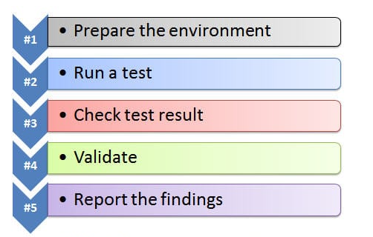

https://www.softwaretestinghelp.com/database-testing-process/

STRUCTURE OF LEARNING UNIT
Learning outcomes:
  - Validate and test a database server
  - Document database server installation process review
  - Report procedures of the tasks accomplished in accordance with the installation to be done

Learning outcome 4.1 Validate and test a database server

Duration:3 hrs
Learning outcome 1 objectives:
By the end of the learning outcome, the trainees will be able to:
1. Run properly SQL server features and recovery report as used in validating and testing database server
2. Apply properly of database server updates as used in validating and testing database server
3. Test clearly database server functionality and configuration correctness
Resources
Equipment | Tools | Materials
- Computer  - Projector | - Database server setup | - Internet  - Electricity  - Paper  - Pen
Advance preparation:
- Database server setup
- Computers
- Projector
- Internet
- Books

Indicative content 4.1.1: Validate and test a database server

Summary for the trainer related to the indicative content (key notes using bullets such as ticks etc)

- Run SQL server features and recovery report

- SQL server installation centre installed

- Open SQL Server Installation Center on the server where SQL Server is installed.
- Click on "Tools" in the left-hand pane.
- Click on "Installed SQL Server features discovery report" in the right-hand pane.
- Follow the prompts to generate the report.

This report will provide you with a list of all installed SQL Server components, their versions, and their current status.

- SQL Server features discovery report

To check the recovery status of your SQL Server, you can use SQL Server Management Studio (SSMS) by following these steps:

- Open SSMS and connect to your SQL Server instance.
- Right-click on the instance name in Object Explorer and select "Properties."
- In the "Properties" window, select "Database Settings" from the left-hand pane.
- Under "Recovery model," you will see the current recovery model set for your database.
The recovery model determines how SQL Server handles transactions and backups. There are three recovery models in SQL Server: Simple, Full, and Bulk-Logged. Simple recovery model does not allow for point-in-time recovery and only allows for restoring the latest backup. Full and Bulk-Logged recovery models allow for point-in-time recovery but require more frequent backups to be taken.

- Application of database server updates
Database server updates are essential for maintaining the performance and stability of the database server. These updates often include bug fixes, feature enhancements, and performance improvements. It is important to apply these updates regularly to ensure that the database server is running efficiently and is free from vulnerabilities.

- Security updates

Security updates are critical updates that address security vulnerabilities in the database server. These updates are essential to protect the database server from malicious attacks, data breaches, and other security threats. Security updates are typically released as soon as possible after a vulnerability is discovered, and it is important to apply these updates as soon as possible to minimize the risk of a security breach.

- Critical updates

Critical updates are updates that address critical issues in the database server. These issues may include performance problems, data corruption, or other critical issues that can cause the database server to fail or become unstable.

- Test database server functionality and configuration correctness

To test database server functionality and configuration correctness, you can perform the following steps:

- Check server logs: Check the server logs for any errors or warnings related to the configuration or functionality of the database server. This can provide you with insight into any issues that might be affecting the performance of the server.

- Monitor server resources: Monitor the server resources such as CPU, memory, and disk usage to ensure that the server has enough resources to handle the workload. If the server is running low on resources, this can cause performance issues.

- Test database connectivity: Test the database connectivity to ensure that clients can connect to the server and perform operations on the database. You can use a database client tool such as SQL Server Management Studio or MySQL Workbench to test the connectivity.

- Test database functionality: Test the functionality of the database by performing basic operations such as inserting, updating, and deleting data. This can help you identify any issues with the database schema or data integrity.

- Test query performance: Test query performance by running queries against the database and measuring the time it takes to return the results. You can use database profiling tools such as SQL Server Profiler or MySQL Query Analyzer to analyze the performance of queries and identify any bottlenecks.

- Query optimization

To optimize queries, you can perform the following steps:
- Use indexes: Indexes can help speed up query performance by allowing the database to quickly find the data that is being queried. Make sure that you have the appropriate indexes created for the tables that are being queried.
- Use parameterized queries: Parameterized queries can help prevent SQL injection attacks and improve query performance by allowing the database to reuse query plans.
- Use stored procedures: Stored procedures can help improve query performance by allowing the database to reuse query plans and reducing network traffic.
- Optimize query structure: Optimize the structure of your queries by using efficient joins, filtering conditions, and aggregations.

Theoretical learning Activity
- Ask trainees to brainstorm about database server updates
Practical learning Activity
- Trainees will be given practical exercises to locate database server installed features
Points to Remember (Take home message)
- SQL Server Management Studio (SSMS)
- Security updates
- Critical updates
- Query optimization

Learning outcome 1 formative assessment
Written assessment
Q1. Define the following terms:
- Security updates
- Critical updates
Answer:
- Security updates are critical updates that address security vulnerabilities in the database server. These updates are essential to protect the database server from malicious attacks, data breaches, and other security threats.
- Critical updates are updates that address critical issues in the database server. These issues may include performance problems, data corruption, or other critical issues that can cause the database server to fail or become unstable.
Q2. Answer with True or False
- The SQL Server features discovery report provides information about the features installed and enabled on the SQL Server instance.
- The SQL Server features discovery report can be generated using SQL Server Management Studio.
- The SQL Server features discovery report includes information about the usage of each feature.
- The SQL Server features discovery report can be used to identify features that are not compatible with the current version of SQL Server.
- The SQL Server features discovery report can be customized to include additional information about the SQL Server instance.
- The SQL Server features discovery report can only be generated by a user with administrative privileges on the SQL Server instance.
Answer:
- The SQL Server features discovery report provides information about the features installed and enabled on the SQL Server instance. True
- The SQL Server features discovery report can be generated using SQL Server Management Studio. True
- The SQL Server features discovery report includes information about the usage of each feature. False
- The SQL Server features discovery report can be used to identify features that are not compatible with the current version of SQL Server. True
- The SQL Server features discovery report can be customized to include additional information about the SQL Server instance. False
- The SQL Server features discovery report can only be generated by a user with administrative privileges on the SQL Server instance. True
Q3. Which of the following is a valid method for monitoring a database server?
A. Using performance monitoring tools
B. Reviewing server logs
C. Setting up alerts for critical events
D. All of the above
Answer: D
Please mix different assessment tools for triangulation and relevancy of assessment
Practical assessment
- Assessment tools
- Assay
- Task to be performed
- Observation checklist

Learning outcome 4.2: Document database server installation process review

Duration:3 hrs
Learning outcome 2 objectives :
By the end of the learning outcome, the trainees will be able to:
1. Develop properly the guidelines for configuring database server as used in Document database server installation process review
2. Review clearly the database server release notes as used in Document database server installation process review.
3. Describe clearly the of database server installation wizard procedures as used in Document database server installation process review
4. Write properly the technical journal and recommendation as used in document database server installation process review.
Resources
Equipment | Tools | Materials
- Computer  - Projector | - Database server setup | - Internet  - Electricity  - Paper  - Pen
Advance preparation:
- Database server setup
- Computers
- Projector
- Internet
- Books

Indicative content 4.2.1: Document database server installation process review
Summary for the trainer related to the indicative content (key notes using bullets such as ticks etc)
- Development of the guidelines for configuring database server
- Operational guides
Operational guides in configuration of database server refer to a set of instructions or best practices that help optimize the performance, security, and reliability of a database server.

Some common operational guides for configuring a database server include:

- Hardware and software requirements: This includes specifying the minimum and recommended hardware and software requirements for the database server, such as CPU, RAM, disk space, and operating system.
- Security considerations: This includes guidelines for securing the database server, such as setting up user accounts and permissions, configuring firewalls, and implementing encryption.
- Database design: This includes recommendations for designing and structuring databases for optimal performance, such as defining indexes and partitions, and selecting appropriate data types.
- Backup and recovery: This includes setting up backup and recovery procedures to ensure that data can be recovered in the event of a disaster or system failure.

- Monitoring and optimization: This includes ongoing monitoring and optimization of the database server, such as identifying and resolving performance bottlenecks, tuning database parameters, and maintaining system logs.

- Training manuals

Training manuals for configuring a database server typically provide instructions and guidelines on how to set up and maintain a database server. They may cover topics such as installation and configuration of the database software, database schema design, backup and recovery procedures, performance tuning, and security considerations.

These manuals are designed to help database administrators and other IT professionals understand the details of configuring and managing a database server. They may include step-by-step instructions, screenshots, and examples to illustrate how to perform various tasks.

A well-written training manual can be an essential resource for ensuring that the database server is properly configured, secure, and optimized for performance. It can also be a useful reference tool for troubleshooting issues that may arise during the operation of the server.

- Review of database server release notes
- Hardware and software requirements
This includes specifying the minimum and recommended hardware and software requirements for the database server, such as CPU, RAM, disk space, and operating system.

- Getting started with database server
Reviewing the release notes of a database server can be a helpful way to get started with a new version of the database server. Here are some steps you can follow:

- Identify the new features and changes: Review the release notes carefully to identify the new features and changes that have been introduced in the new version of the database server. Pay attention to any changes in the syntax of SQL commands or any new options that have been added.

- Verify compatibility: Check if the new version of the database server is compatible with your existing applications, libraries, and drivers. If there are any compatibility issues, you may need to modify your code or upgrade your drivers.

- Plan the upgrade process: Plan the process of upgrading to the new version of the database server. Consider factors such as downtime, backup and recovery procedures, and the impact on your users.

- Perform a test upgrade: Before performing the actual upgrade, perform a test upgrade in a non-production environment. This will help you identify any issues or conflicts that may arise during the upgrade process.

- Updated compiler

In the release notes of a database server, an updated compiler may be mentioned as a new feature or improvement. It is important to review the release notes carefully to understand the changes made to the compiler, as these changes may impact the performance or behavior of the database server.

Some potential benefits of an updated compiler may include faster query processing times, improved memory management, better support for new programming languages or technologies, and increased security.

- Description of database server installation wizard procedures
- Add features to database server instance

To add features to a database server instance, follow these steps:

- Open the database management console or control panel.
- Choose the database server instance that you want to add features to.
- Look for the option to add new features or components, usually under the "Installation" or "Configuration" menu.
- Select the features that you want to add from the list provided.
- Follow the prompts to install the selected features.
- Wait for the installation process to complete.
- Verify that the new features have been added and configure them as needed.

- Repair a failed feature

If a feature in the database server has failed, you can try repairing it by following these steps:

- Open the database management console or control panel.
- Choose the database server instance that has the failed feature.
- Look for the option to repair the installation or configuration, usually under the "Maintenance" or "Repair" menu.
- Select the option to repair the failed feature or component.
- Follow the prompts to complete the repair process.
- Wait for the repair process to complete.
- Verify that the failed feature has been repaired and is functioning correctly. If not, consider reinstalling or troubleshooting the issue further.

- Write technical journal and recommendation
- Sections of technical journal
- Introduction to the problem
In technical journal, we review the installation process of a document database server. We focus on the material and methods used during the installation, the results obtained, and the discussions that follow.

- Material and methods to solve the problem
We used a set of instructions provided by the document database server vendor to install the software on an operating system. We followed the instructions step-by-step, noting any deviations from the instructions or issues encountered during the installation process.
- Results

The installation process was successful, and the database server was installed on the operating system. We tested the functionality of the server by performing basic CRUD (Create, Read, Update, Delete) operations on a sample database. The server responded promptly to the queries, indicating that the installation was successful.

- Discussions
The installation process was straightforward, and the provided instructions were clear and easy to follow. However, we encountered some issues during the installation process, such as missing dependencies and outdated package versions. We had to troubleshoot these issues by consulting online forums and documentation, which added to the installation time.

We recommend that the vendor provides a list of system requirements and dependencies needed for the installation process, as this would make the process more seamless for users. Additionally, the instructions could be updated to include troubleshooting tips for common issues encountered during the installation process.

- Acknowledgements to supporters
We would like to acknowledge the technical support provided by the vendor's customer support team during the installation process.

Theoretical learning Activity
- Ask trainees to brainstorm about guidelines to configure database server
Practical learning Activity
- Trainees will be given practical exercises on technical journal
- Trainees will be given practical exercises on new feature addition and repair a failed feature
Points to Remember (Take home message)
- Operational guides
- Training manuals
- Hardware and software requirements
- Compatibility
- Updated compiler

Learning outcome 2 formative assessment
Written assessment
Q1. Outline all steps used to add features to database server instance.
Answer:
- Open the database management console or control panel.
- Choose the database server instance that you want to add features to.
- Look for the option to add new features or components, usually under the "Installation" or "Configuration" menu.
- Select the features that you want to add from the list provided.
- Follow the prompts to install the selected features.
- Wait for the installation process to complete.
- Verify that the new features have been added and configure them as needed.
Q2. If the server logs show an error related to a specific database file, what should you do?
A. Delete the file and recreate it.
B. Restore the file from a backup.
C. Ignore the error and try starting the server again.
D. Reinstall the database software.
Answer: B. Restore the file from a backup.
Q3. Answer with True or False the following statements:
- Reviewing database server release notes requires only software, not any hardware.
- The hardware and software requirements for reviewing database server release notes are the same as those for actually running the database server.
- Reviewing database server release notes requires a web browser to access the release notes online.
- There are no specific software requirements for reviewing database server release notes.
- The hardware and software requirements for reviewing database server release notes vary depending on the specific database server being used.
Answer:
- Reviewing database server release notes requires only software, not any hardware. False
- The hardware and software requirements for reviewing database server release notes are the same as those for actually running the database server. False
- Reviewing database server release notes requires a web browser to access the release notes online. True
- There are no specific software requirements for reviewing database server release notes. False
- The hardware and software requirements for reviewing database server release notes vary depending on the specific database server being used. True
Please mix different assessment tools for triangulation and relevancy of assessment
Practical assessment
- Assessment tools
- Task to be performed
AB Ltd. is one of countrywide Construction Company. The company has a problem of having a centralized database server to manage employees and their payrolls, business project contracts and assets.
As a database developer, you are hired to setup a SQL server 16 version 13.0.1601.5 on the following environment:
  - Operating System: Windows server 2016
  - RAM: 8GB
  - Processor: 1.4 GHz 64-bit processor
  - Compatible with x64 instruction set
  - Supports NX and DEP
  - Supports CMPXCHG16b, LAHF/SAHF, and PrefetchW
  - Supports Second Level Address Translation (EPT or NPT)
Write technical journal and recommendation of Microsoft SQL server 2016 installation.
The task must be completed in 4hours.
- Observation checklist
Checklist | Score
 | Yes | No
- Introduction to the problem
- Material and methods to solve the problem
- Results
- Discussions
- Acknowledgements to supporters
Observation

Learning outcome 4.3: Report procedures of the tasks accomplished in accordance with the installation to be done.

Duration:4 hrs
Learning outcome 3 objectives:
By the end of the learning outcome, the trainees will be able to:
1. Review clearly installed database server and previous versions according to the Report procedures of the tasks accomplished
2. Suggest clearly the database server improvements according to the Report procedures of the tasks accomplished
3. Describe the database server solutions and benefits according to the Report procedures of the tasks accomplished
4. Propose properly the new technology of database server according to the Report procedures of the tasks accomplished
Resources
Equipment | Tools | Materials
- Computer  - Projector | - Database server setup | - Internet  - Electricity  - Paper  - Pen
Advance preparation:
- Database server setup
- Computers
- Projector
- Internet
- Books

Indicative content 4.3.1: Report procedures of the tasks accomplished in accordance with the installation to be done

Summary for the trainer related to the indicative content (key notes using bullets such as ticks etc)

- Review of installed database server and previous versions

To review the installed database server and previous versions, you can follow these steps:

- Check the system documentation: Check the documentation of your operating system to find out which database servers are installed by default.

- Check the installation directory: Check the installation directory of the database server to find out which version is installed. This information can usually be found in the readme file or the documentation.

- Check the system environment variables: Check the system environment variables to see if the database server is included in the PATH variable. This will give you a clue about which version of the database server is being used.
- Use command line tools: Use command line tools to check the version of the database server. For example, for MySQL, you can use the command "mysql --version" to check the version of the MySQL server installed on your system.
- Check the database logs: Check the database logs to see which version of the database server is running. The version information is usually included in the log files.
- Check the database management tools: If you are using a database management tool like phpMyAdmin, you can check the server version in the user interface.

- Suggestions on database server improvements

There are several suggestions for improving database server performance and reliability

- Upgrade hardware: Upgrading the hardware on the server can improve performance. For example, upgrading the CPU, RAM, or storage can increase processing power, memory capacity, and storage space respectively.

- Optimize database design: Properly designed databases can improve performance and reliability. Normalize the database structure, use appropriate data types, and avoid redundant data.

- Use indexes: Indexes speed up queries by allowing the database server to quickly find the data it needs. Ensure that the appropriate columns are indexed.

- Optimize queries: Optimize queries to minimize the number of database accesses and reduce the amount of data returned. Use join operations only when necessary and avoid using wildcard characters in searches.

- Use caching: Use caching to reduce the number of database accesses. Caching stores frequently accessed data in memory, which reduces the time required to access the database.

- Optimize storage: Optimize the storage system to ensure that the database server can access data quickly. Use RAID or other fault-tolerant storage systems to prevent data loss.

- Implement backup and recovery procedures: Implement backup and recovery procedures to ensure that data is not lost due to hardware failures or other issues. Regularly backup data to a separate physical or cloud storage location.

- Implement security measures: Protect the database server from unauthorized access, ensure that sensitive data is encrypted, and implement appropriate access controls.

- Monitor performance: Regularly monitor the performance of the database server to identify potential issues and optimize performance. Use monitoring tools to track server resources, query performance, and other metrics.

- Description of database server solutions and benefits

There are various database server solutions available, including:

- Relational database management system (RDBMS): This type of database server uses tables to store data and uses SQL (Structured Query Language) to retrieve and manipulate data. Popular RDBMS solutions include Oracle, MySQL, and Microsoft SQL Server.

- NoSQL database management system: This type of database server is designed to handle large volumes of unstructured and semi-structured data, and can be more flexible and scalable than RDBMS solutions. Popular NoSQL solutions include MongoDB, Cassandra, and Redis.

- Cloud database solutions: These are database servers that are hosted in the cloud, and can provide benefits such as automatic backups, scalability, and easy accessibility from anywhere with an internet connection. Examples of cloud database solutions include Amazon RDS, Google Cloud SQL, and Microsoft Azure SQL Database.

Benefits of using a database server solution include:

- Data organization: A database server can help organize data in a structured way, making it easier to search, retrieve, and analyze data.

- Data security: A database server can provide data security features, such as access control, encryption, and data backups, which can help protect against data breaches and loss.

- Scalability: Many database server solutions can scale to handle large volumes of data and high traffic, which can be important for growing businesses.

- Improved performance : A well-designed database server can improve the performance of applications that rely on the database, by optimizing queries and reducing latency.

- Collaboration: A database server can facilitate collaboration among multiple users, by allowing multiple users to access and update data simultaneously.

- Propositions on database server
- Database server alternatives
There are various alternatives to traditional relational database servers, including NoSQL databases, graph databases, and object-oriented databases.

- NoSQL databases are designed to handle large volumes of unstructured or semi-structured data, and they provide high availability and scalability.
- Graph databases are optimized for storing and querying relationships between data entities, such as social networks or recommendation systems.
- Object-oriented databases store data as objects, which can be easily manipulated and extended, making them suitable for complex data structures.

- New technologies

- Blockchain technology is becoming increasingly popular for storing and managing decentralized and immutable data.
- In-memory databases store data in memory instead of on disk, providing faster access and processing times.
- Serverless databases, such as AWS DynamoDB or Google Firestore, allow developers to build applications without worrying about server infrastructure.
- Multi-cloud databases, such as CockroachDB, can replicate data across multiple cloud providers, ensuring high availability and resilience.

Theoretical learning Activity
- Ask trainees to brainstorm about current database server and previous versions
Points to Remember (Take home message)

- System documentation
- Directory
- Command line tools
- Database management tools
- Caching
- Relational database management system
- Cloud database solutions
- Data organization
- Data security
- Blockchain
- Serverless databases

Learning outcome 3 formative assessment
Written assessment
Q1. Give three (3) database server alternatives.
Answer:
- NoSQL databases
- Graph databases
- Object-oriented databases
Q2. List down four (4) database server new technologies.
Answer :
- Blockchain technology
- In-memory databases
- Serverless databases
- Multi-cloud databases
Q3. What is a benefit of using a database server solution ?
a. Improved security
b. Increased processing speed
c. Better data organization
d. All of the above
Answer: d. All of the above

Please mix different assessment tools for triangulation and relevancy of assessment

References:
- https://www.ibm.com/topics/three-tier-architecture
- https://www.sqlshack.com/how-to-install-sql-server-2012-express-edition/
- https://www.techtarget.com/searchdatamanagement/definition/database
- https://www.cliffsnotes.com/file/188815761/Unit-9-Database-administration-and-securitypdfdocx/
- https://freecontent.manning.com/wp-content/uploads/backup-types.pdf
- https://sqlcoffee.com/SQLServer2012_0010.htm
- https://www.tutorialspoint.com/ms_sql_server/ms_sql_server_tutorial.pdf

